NovaTech Revenue Intelligence Dashboard

Step-by-Step Guide — how this project was built, click by click
Student: Ecem Bökenheide
Course: Future AWS Agentic AI Business Professional → Business Intelligence and Knowlege Management Foundations with Amazon Quick → Project: Revenue Intelligence Dashboard for NovaTech Solutions
This document logs, in order, every step taken to complete the project — what was clicked, which option was chosen, and why — so it can be reproduced independently. Screenshots are included where relevant. The full Verification Log table is included at the end.

Step 0 — Read the reference materials
1. Opened the Instructions, Project Overview, Environment Setup, and Project Rubric pages in the Udacity classroom to understand the full task list, deliverables, and grading criteria.
2. Opened Lesson Resources → Download and downloaded Project-Starter-Resources.zip — it contains the 3 starter CSVs, the data dictionary, Sarah Chen's dashboard requirements brief, the company background brief, and the two log templates.
3. Read the Data Dictionary (field definitions, expected row counts: CRM 499, Marketing 2,240, Support 3,000; known data-quality issues: 24 nulls in annual_income, 59 nulls in ticket_resolved_date; shared join key account_id), Sarah Chen's brief (the 3 dashboard views and their required metrics/filters), and the Company Background (NovaTech Solutions context).
Key decisions this informed: join key across all 3 datasets is account_id; Marketing and Support each contain ~150–204 "orphan" account IDs (ACCT-101–115) not present in CRM, which is intentional per the data dictionary and directly affects the join-type decision later; calculated fields to build: days_to_close (CRM), campaign_roi (Marketing), resolution_time_hours (Support).

Step 1 — Open the AWS lab environment
1. In the Udacity lesson, clicked the Cloud Resources tab (bottom toolbar) → Open Cloud Console. This is the Vocareum-provided, pre-configured AWS account for the lab (no personal AWS account needed) — it has a $25 budget cap and session time limits.
2. This opened a new browser tab/window that federates into Amazon Quick (QuickSight) at us-west-2.quicksight.aws.amazon.com/sn/account/UdacityQuicksightLab/start/home.
Note: the federation link is single-use and expires quickly — if it shows "The link has expired," go back to Cloud Resources and click Open Cloud Console again to mint a fresh link.

Step 2 — Finding the pre-indexed knowledge bases
1. Clicked New chat in the left nav of Amazon Quick.
2. Clicked the data-scope selector under the question box (default "All data") → opens an "Add Quick assets" picker with tabs: Recents, Favorites, Spaces, Topics, Dashboards, Knowledge Bases, Actions, Datasets.
3. The Knowledge Bases tab was empty. In this lab's Amazon Quick setup, the instructor's pre-indexed sources are exposed as regular Datasets, not separate "Knowledge Base" objects — this matches the Environment Setup page: "Locate the pre-indexed knowledge bases under Datasets and in Quick Chat."
4. On the Datasets tab (page 2, since this is a shared/reused Vocareum lab account with prior activity), found the actual instructor-provided sources: novatech_crm_deals.csv, novatech_support_tickets.csv, novatech_marketing_campaigns.csv — all owned by "Others", created 6 months ago. These are treated as the "pre-indexed knowledge bases — created by the instructor, do not modify."
Also present, and deliberately ignored: same-named datasets owned by "Me" from 10 days ago, plus a pre-built "NovaTech Unified Account-Level Dataset" and "Account Risk Summary" owned by "Others" — leftovers from someone else's earlier pass through this shared lab. This project's own deliverables are built from a fresh upload of the starter CSVs instead of reusing them.
5. Checked the boxes for all three "Others" / 6-months-ago datasets at once, then clicked Save, scoping the chat to all three instructor knowledge bases together.
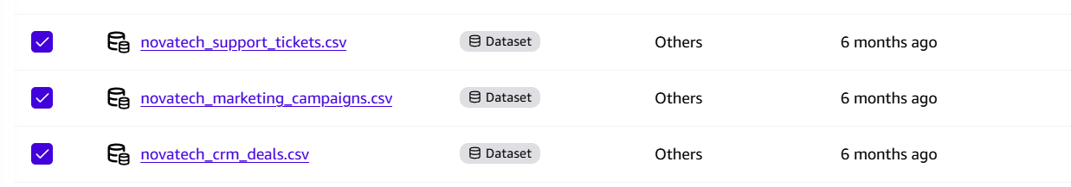
Fig. 1 — "Add Quick assets" picker, Datasets tab, page 2: all three instructor novatech_*.csv datasets (owned by "Others", 6 months old) checked before clicking Save.

Step 3 — Verify the knowledge bases (Verification Log)
Asked 6 questions — 2 per knowledge base — each chosen because the correct answer was already known from the data dictionary (cross-checked against the raw CSVs with pandas beforehand), so Q's answer could be objectively marked Match / No Match rather than just judged as "sounds plausible." Question mix was deliberately varied: row counts, category breakdowns, date ranges, null counts.

CRM Deals
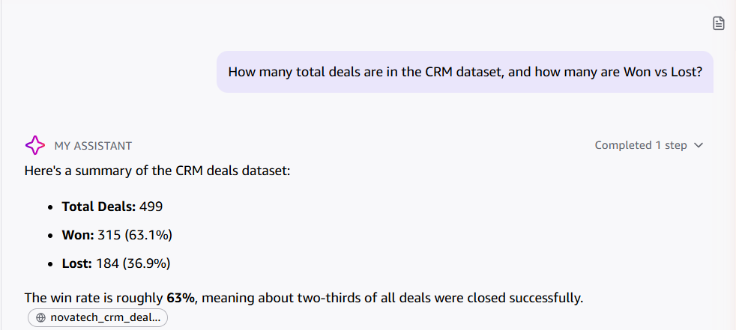
Fig. 2 — Q1: total deals + Won/Lost breakdown. Match: 499 total, 315 Won (63.1%), 184 Lost (36.9%).
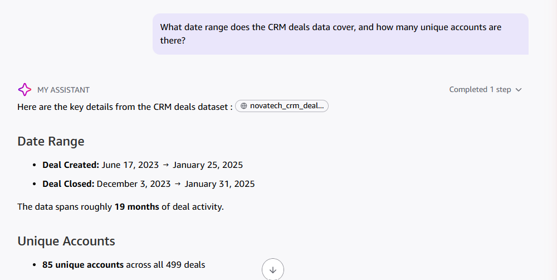
Fig. 3 — Q2: date range + unique accounts. Match: Jun 17 2023 → Jan 25 2025, 85 unique accounts.

Marketing Campaigns
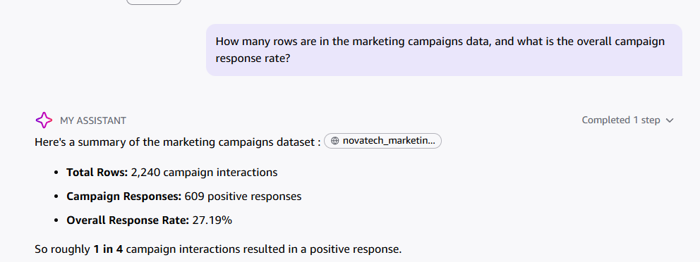
Fig. 4 — Q3: row count + response rate. Match: 2,240 rows, 27.19% response rate.
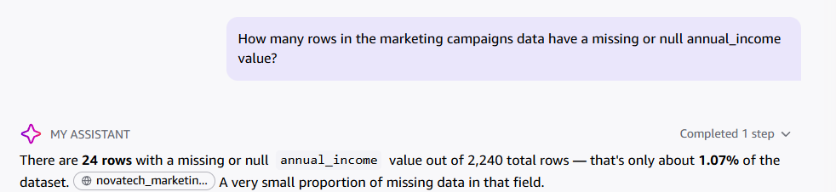
Fig. 5 — Q4: null count on annual_income. Match: 24 rows, 1.07%.

Support Tickets
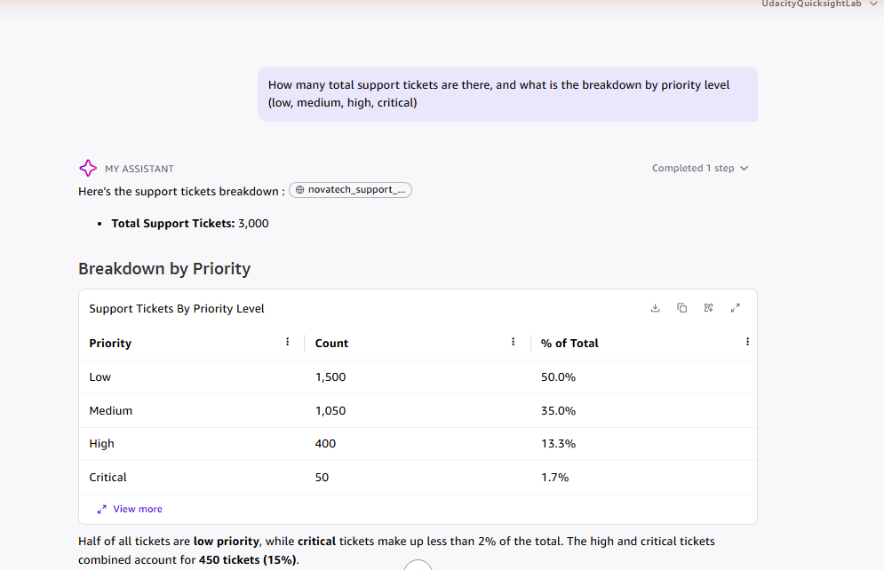
Fig. 6 — Q5: total tickets + priority breakdown. Match: 3,000 total; Low 1,500 / Medium 1,050 / High 400 / Critical 50.
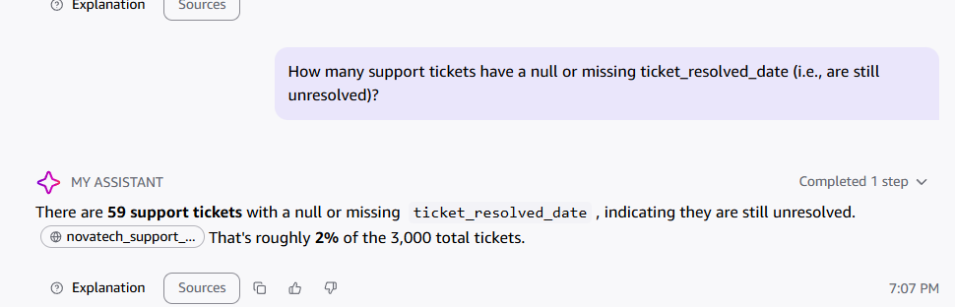
Fig. 7 — Q6: null count on ticket_resolved_date. Match: 59 rows, ~2%.
Result: 6 / 6 Match — Q answered every checkable fact correctly across all three knowledge bases, including one bonus detail on Q1 (deal_closed_date range) that wasn't asked for but was accurate.

Step 4 — Upload own CRM Deals dataset + fix data types
This is where the student's own submission begins: instead of reusing the instructor's 6-month-old "Others" datasets or the leftover "Me" datasets from 10 days ago (see Step 2), a fresh copy of each starter CSV is uploaded and prepared from scratch.
1. Went to Data → New dataset → Upload a file → selected novatech_crm_deals.csv.
2. On the "Confirm file upload settings" dialog, clicked "Edit settings and prepare data" (not the default "Next") to land in the full data-prep editor before importing to SPICE.
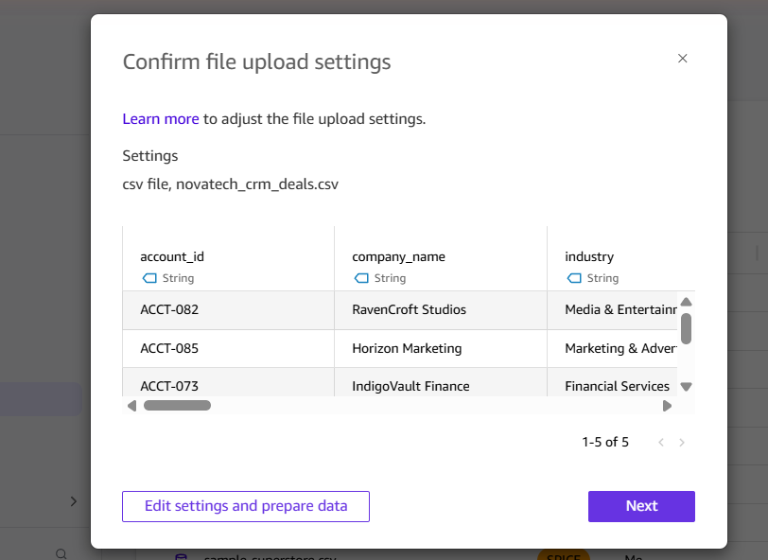
Fig. 8 — File-upload confirmation dialog, before entering the editor.
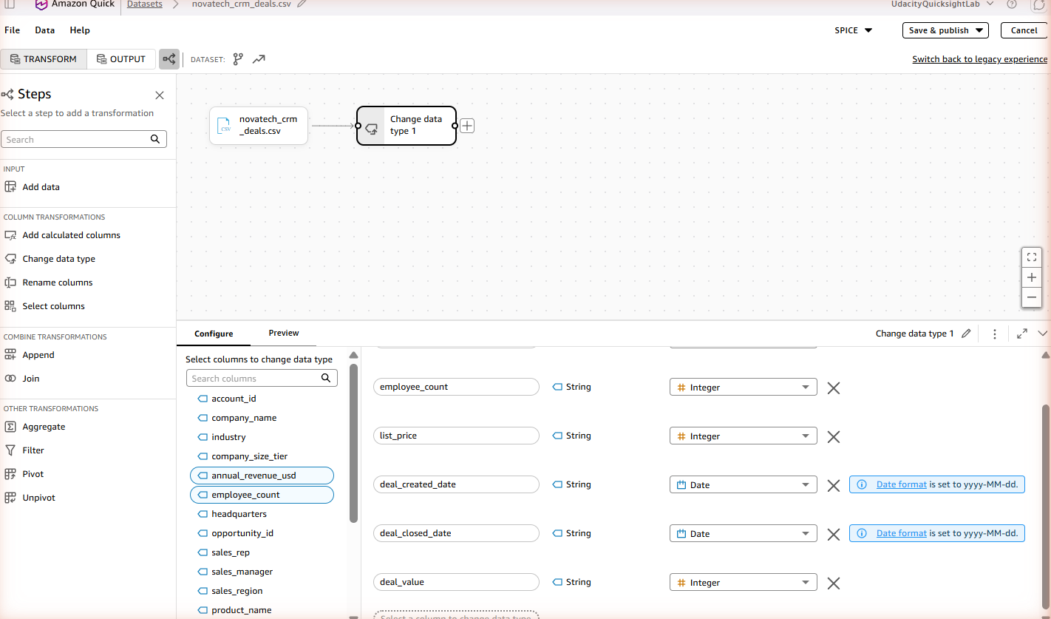
Fig. 9 — Data-prep editor just after entering, with QuickSight's initial auto-suggested type changes (employee_count, list_price, deal_created_date, deal_closed_date, deal_value).
3. Compared each suggested type against the data dictionary and corrected them:
- annual_revenue_usd: String → Decimal (dictionary: Float, currency in millions USD)
- employee_count: String → Integer — already correct
- list_price: String → Integer — already correct
- deal_created_date, deal_closed_date: String → Date, format yyyy-MM-dd — already correct
- deal_value: originally auto-suggested as Integer — corrected to Decimal. Every value in this CSV happens to be a whole number, so Integer wouldn't have caused an error, but the data dictionary formally types it as Float (a currency/revenue amount), so Decimal matches the documented schema rather than this sample's coincidental shape.
- All other columns left as String — correct per data dictionary.
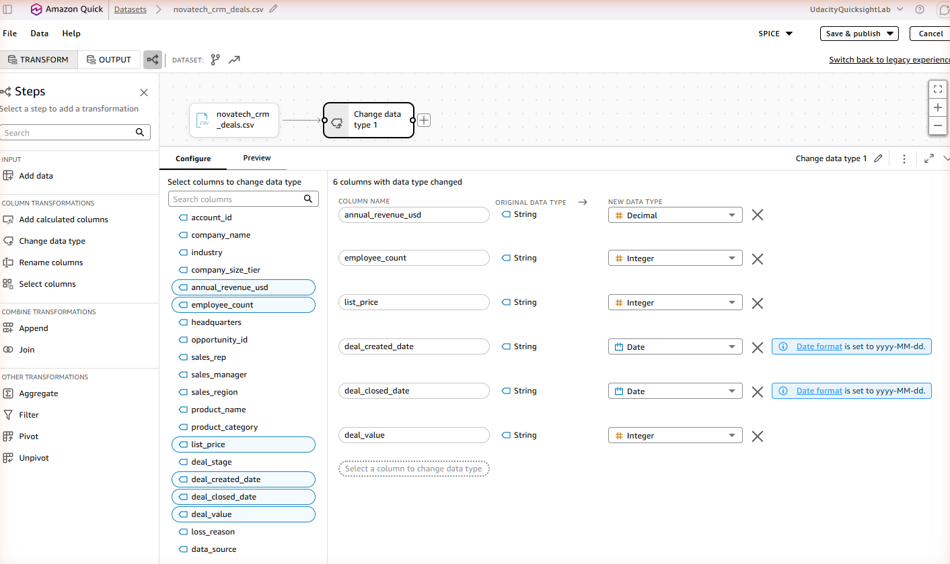
Fig. 10 — After fixing annual_revenue_usd to Decimal (deal_value still shows Integer at this point).
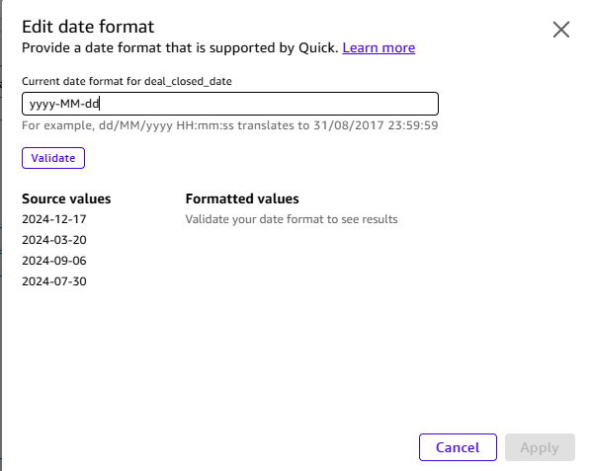
Fig. 11 — Checked the date-format dialog for deal_closed_date, confirmed yyyy-MM-dd was already correct, cancelled without changes.
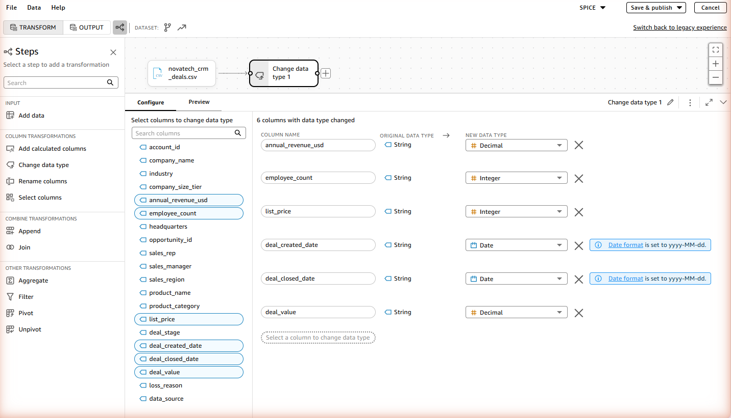
Fig. 12 — Final state: all 6 changed columns correct, including deal_value now as Decimal.
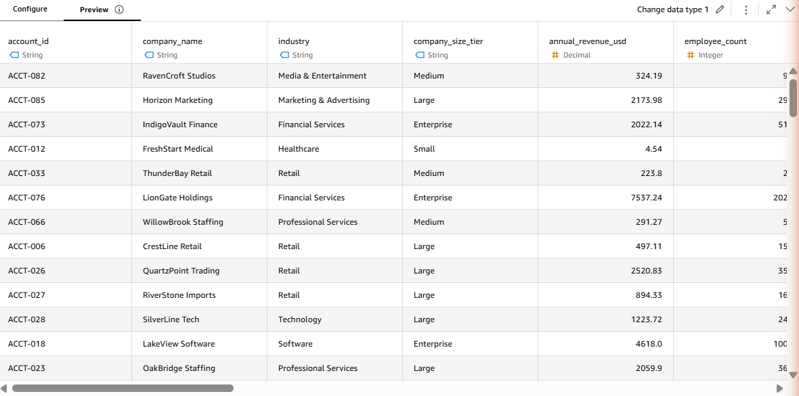
Fig. 13 — Preview tab confirming the corrected data renders sensibly.

Step 5 — Calculated field: days_to_close (CRM)
Why this metric, specifically — not an arbitrary choice:
- Sarah Chen's brief (Sales Pipeline view) asks for it verbatim: "Days to close — how long does it take us to close a deal from creation to close? Is that getting better or worse?"
- The data dictionary spells out the exact formula in its notes on deal_closed_date: "Students can compute days-to-close as deal_closed_date − deal_created_date."
- The rubric requires ≥2 calculated fields that derive a business metric the raw data doesn't already contain, and names days-to-close as the canonical CRM example.
None of the raw columns is "days to close" — it only exists once you subtract two dates, which is exactly what a calculated field is for.
1. Clicked "Add calculated columns" in the left panel.
2. Named the field days_to_close.
3. Formula: dateDiff({deal_created_date}, {deal_closed_date}, "DD")
4. Applied — verified resulting values in Preview against known won/lost examples (average ≈72 days for Won, ≈58 days for Lost, per the earlier pandas check).
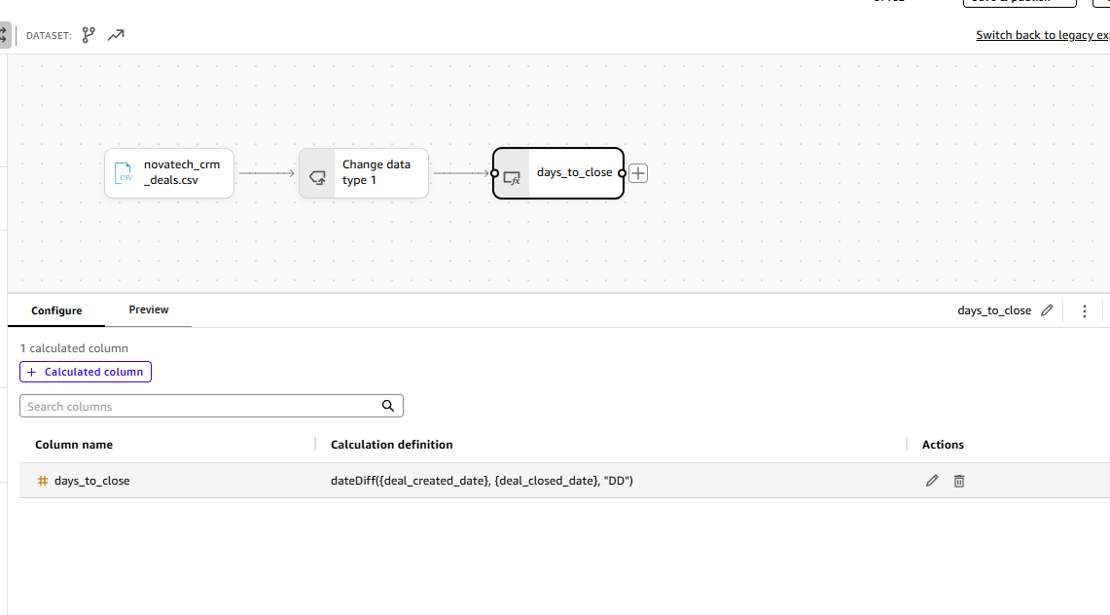
Fig. 14 — days_to_close calculated column configuration: dateDiff({deal_created_date}, {deal_closed_date}, "DD").
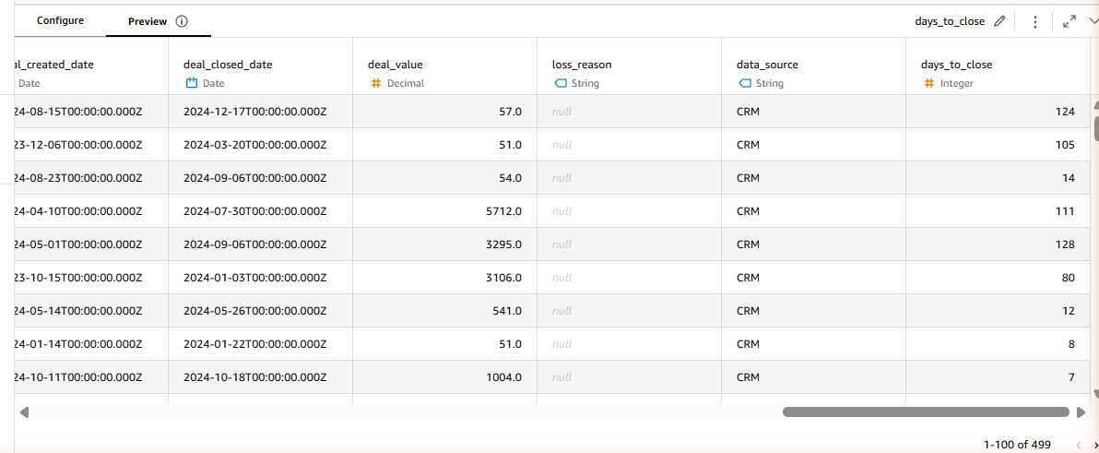
Fig. 15 — Preview showing realistic day counts (124, 105, 14, 111, 128, 80, 12, 8, 7…).

Step 6 — Publish CRM Deals dataset
1. Clicked Save & publish (top right) → Publish & visualize → Create.
2. Confirmation banner: "Saved and published successfully."
3. Navigated to Data → Datasets, opened the newly published novatech_crm_deals.csv (owner: Me).
4. Dataset detail page confirms: 21 columns (the 20 original + days_to_close), and under Refresh: "499 rows imported (100% success)" — an exact match with both the data dictionary and Q's answer in Verification Log entry #1. This closes out the Verification Log's Cross-Check section.
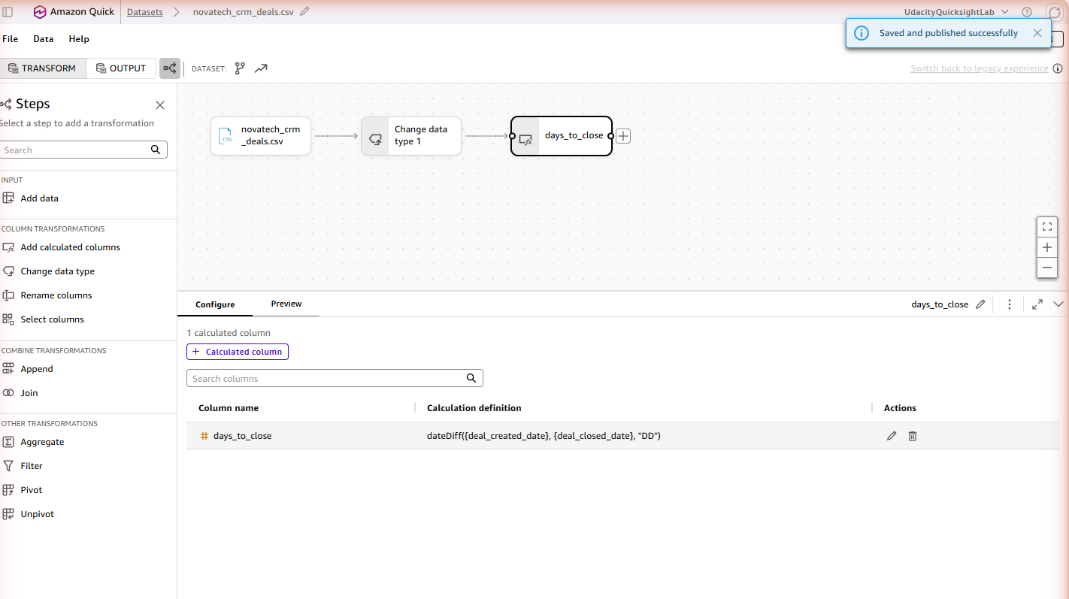
Fig. 16 — "Saved and published successfully" confirmation.
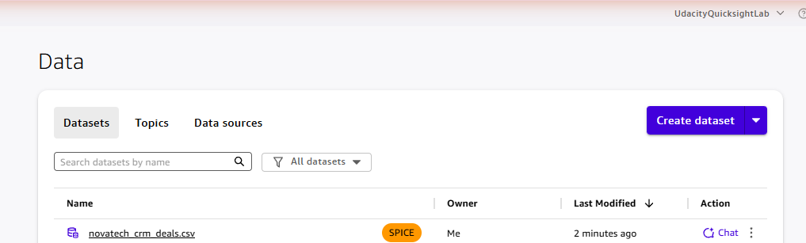
Fig. 17 — Dataset list showing the student's own novatech_crm_deals.csv (owner: Me, SPICE).
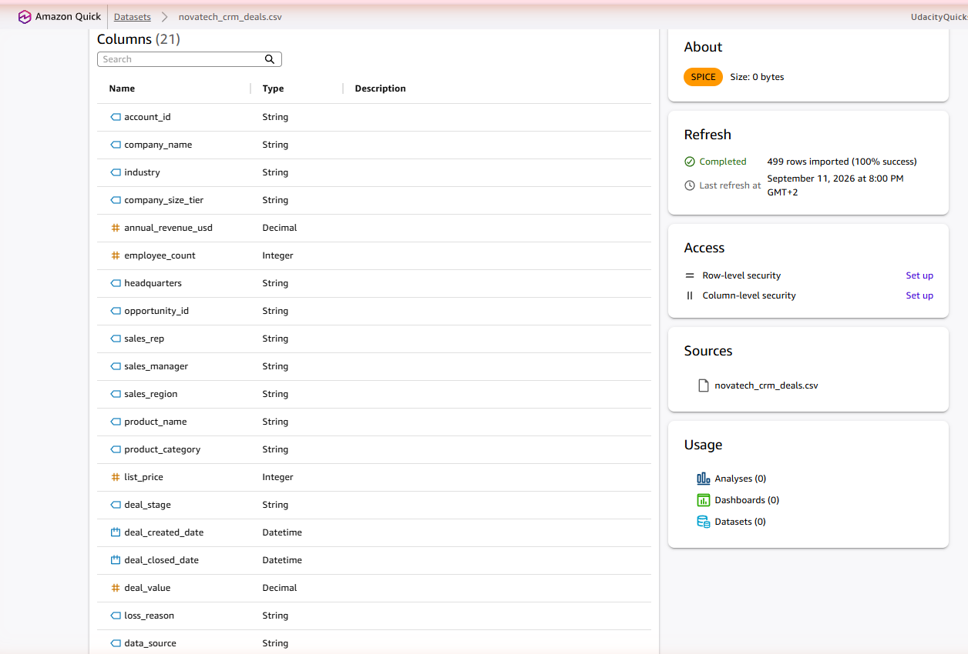
Fig. 18 — Dataset detail page: 21 columns, "499 rows imported (100% success)" — cross-check confirmed against Q's answer.

Step 7 — Upload own Marketing Campaigns dataset + fix data types
1. Went to Data → Create dataset → Upload a file → selected novatech_marketing_campaigns.csv → "Edit settings and prepare data".
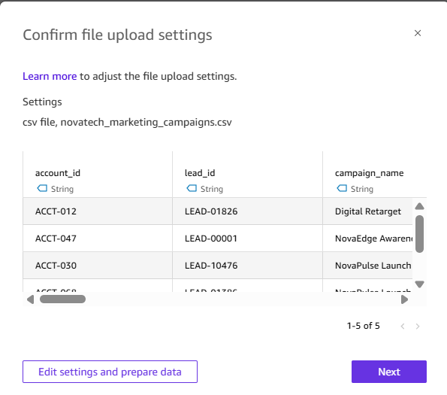
Fig. 19 — File-upload confirmation dialog for novatech_marketing_campaigns.csv, before entering the editor.
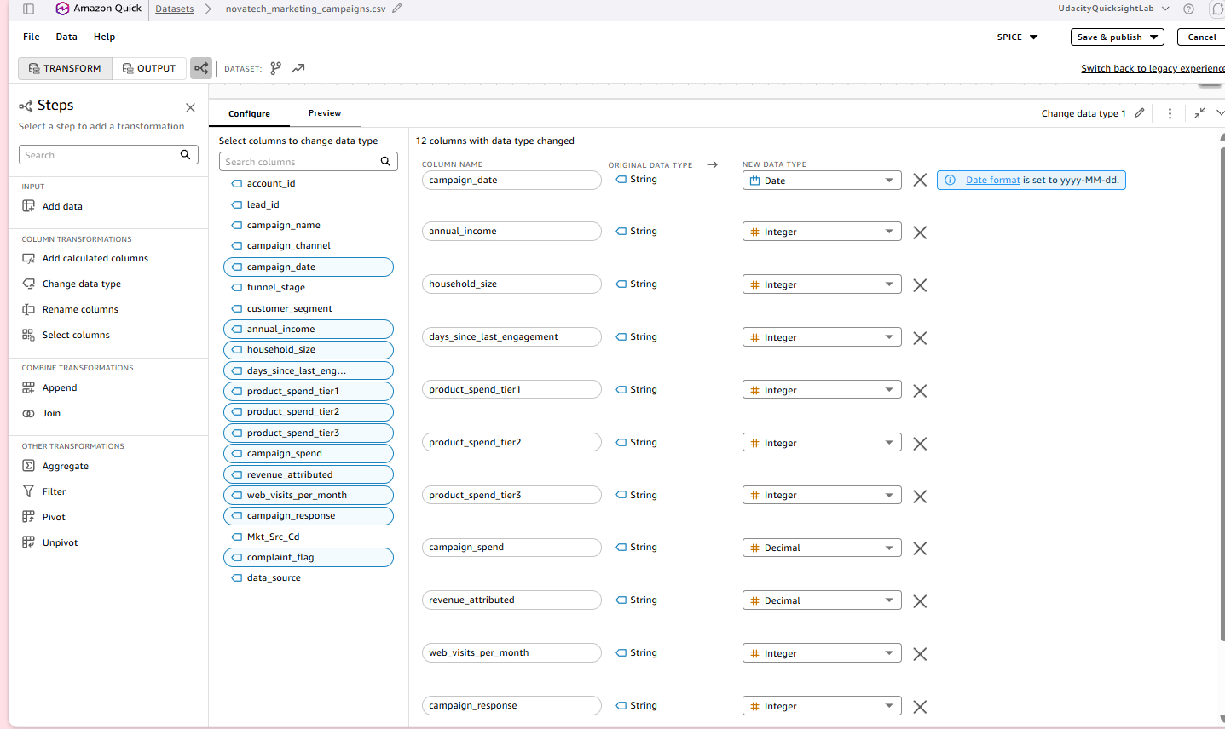
Fig. 20 — Data-prep editor just after entering, with QuickSight's initial auto-suggested type changes across 12 columns.
2. QuickSight auto-suggested type changes for 12 columns. Checked each against the data dictionary:
- campaign_date → Date (yyyy-MM-dd) — already correct
- household_size, days_since_last_engagement, product_spend_tier1/2/3, web_visits_per_month, campaign_response, complaint_flag → Integer — all correct per dictionary
- campaign_spend, revenue_attributed → Decimal — correct per dictionary (Float)
- annual_income → auto-suggested as Integer, corrected to Decimal (dictionary: Float — annual income can carry decimals in general).
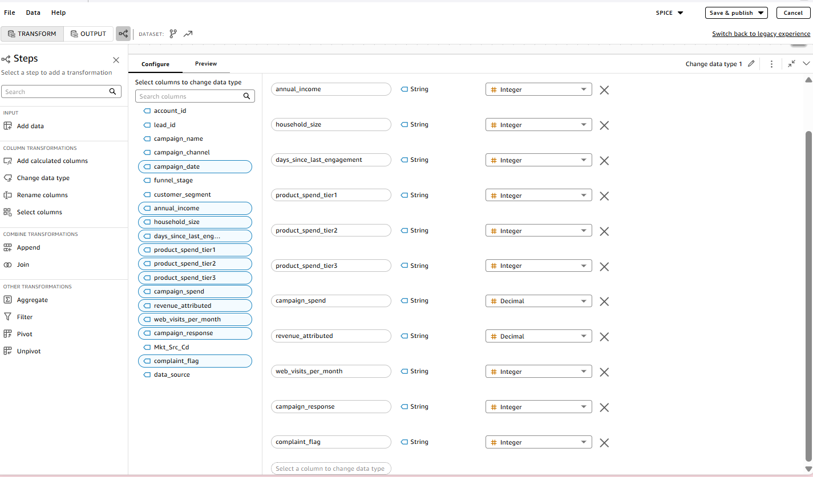
Fig. 21 — Scrolled through the type list, confirming complaint_flag and the other Integer columns were already correct.
3. Decision point — keep or drop annual_income / household_size? Initially proposed dropping both as low-analytical-value B2C demographic fields, since neither appears in Sarah's brief or any dashboard view and customer_segment already covers segmentation. On review, decided to keep both — there's no technical harm in leaving them (QuickSight doesn't penalize extra columns, and they simply won't be used in any visual), so the call was made to preserve the original schema rather than remove data. This is a judgment call, documented here rather than silently applied.
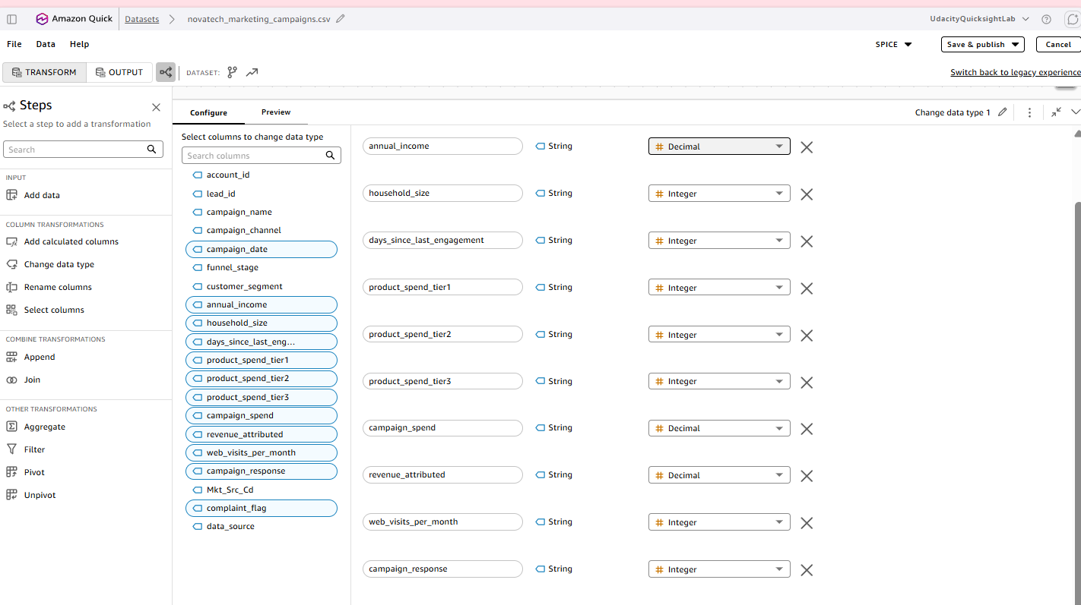
Fig. 22 — Final state: all 12 columns correct, including annual_income → Decimal.

Step 8 — Calculated field: campaign_roi (Marketing)
Why this metric, specifically — not an arbitrary choice:
- Sarah Chen's brief (Marketing Funnel view) explicitly asks: "Are there any campaigns where we spent more than we earned back? What's the return on our marketing spend?" — a direct ask for a per-campaign ROI figure.
- The data dictionary lists campaign_spend and revenue_attributed as the two raw fields a return-on-spend metric should be derived from — ROI is not itself a raw column, it only exists once these two are combined.
- The rubric requires ≥2 calculated fields across the project that derive a business metric the raw data doesn't already contain; campaign_roi is the Marketing-side counterpart to CRM's days_to_close (Step 5).
Standard ROI formula used: (revenue − spend) / spend, i.e. net return as a fraction of what was spent. A value of 0 means break-even, 1.0 means the campaign returned double its spend, and a negative value means the campaign lost money (spent more than it earned back) — exactly the scenario Sarah's brief asks to flag.
1. In the Marketing dataset's data-prep editor, clicked "Add calculated columns" in the left panel.
2. Named the field campaign_roi.
3. Formula: (revenue_attributed - campaign_spend) / campaign_spend
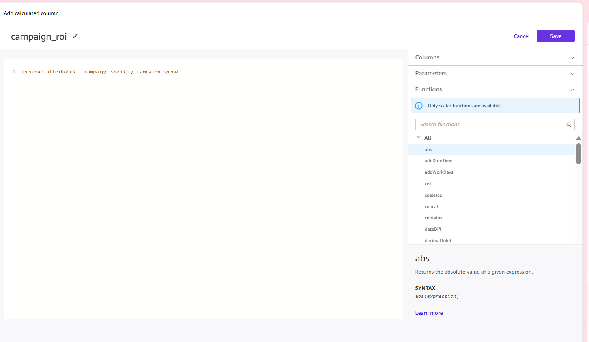
Fig. 23 — campaign_roi calculated column configuration: (revenue_attributed - campaign_spend) / campaign_spend.
4. Before clicking Save, verified it was correct that most rows would come out negative (ROI ≈ −1.0 for the majority). This is expected, not a bug: most rows are non-responders (campaign_response = 0), so revenue_attributed = 0 for them, giving (0 − spend) / spend = −1.0 exactly — a "lost 100% of what was spent, earned nothing back" result. The rows with campaign_response = 1 show less-negative values (e.g. −0.422, −0.700, −0.934), driven by how much revenue that responder generated relative to their allocated spend.
5. Clicked Save in the calculated-column editor, confirmed campaign_roi appeared as the dataset's 1 calculated column, then checked Preview before publishing.
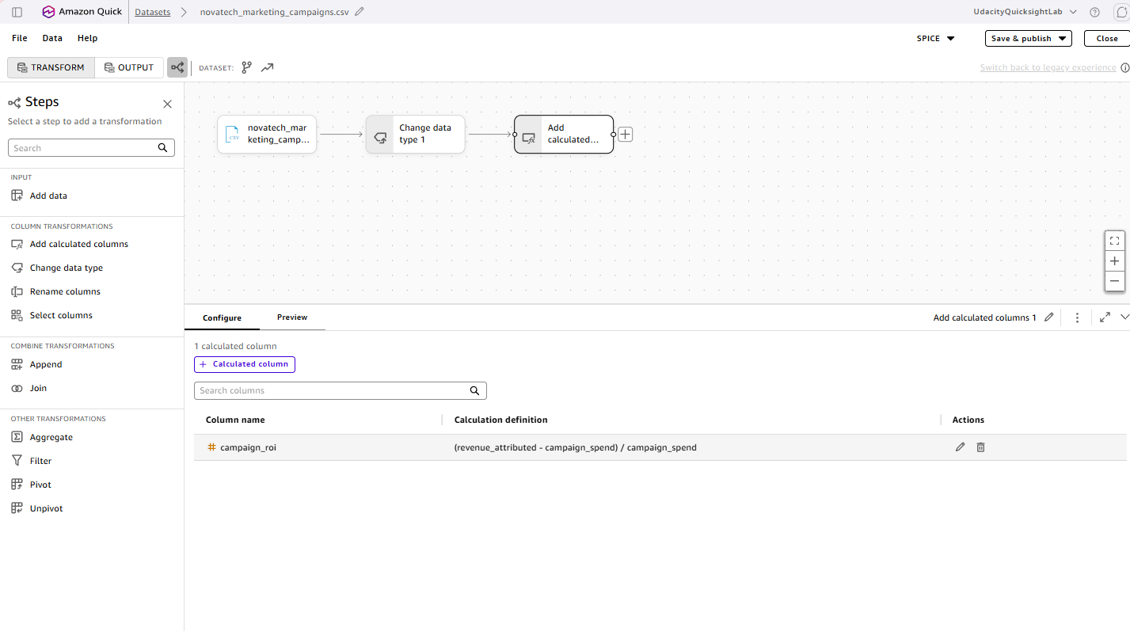
Fig. 24 — Steps canvas / Configure tab after Save, showing campaign_roi listed as the dataset's 1 calculated column.
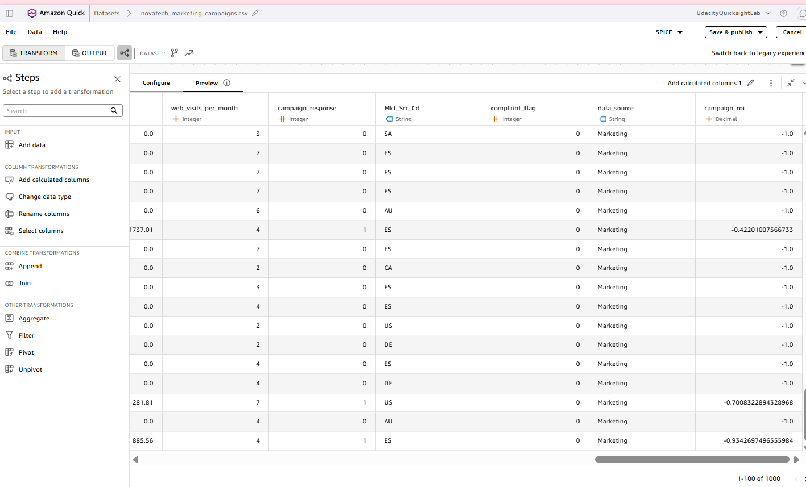
Fig. 25 — Preview tab: campaign_roi mostly -1.0 (non-responders), with less-negative values like -0.422, -0.700, -0.934 for actual responders — matching the expectation reasoned through above.

Step 9 — Publish Marketing Campaigns dataset + verify row count
1. Clicked Save & publish (top right) on the Marketing dataset editor.
2. Confirmation banner: "Saved and published successfully."
3. Navigated to Data → Datasets, opened the newly published novatech_marketing_campaigns.csv (owner: Me).
4. Dataset detail page confirms: 21 columns (the 20 original + campaign_roi), and under Refresh: "2240 rows imported (100% success)" — an exact match with both the data dictionary's expected row count and Q's answer in Verification Log entry #3 (2,240 rows). Same row-count cross-check pattern used for CRM in Step 6, applied here to Marketing.
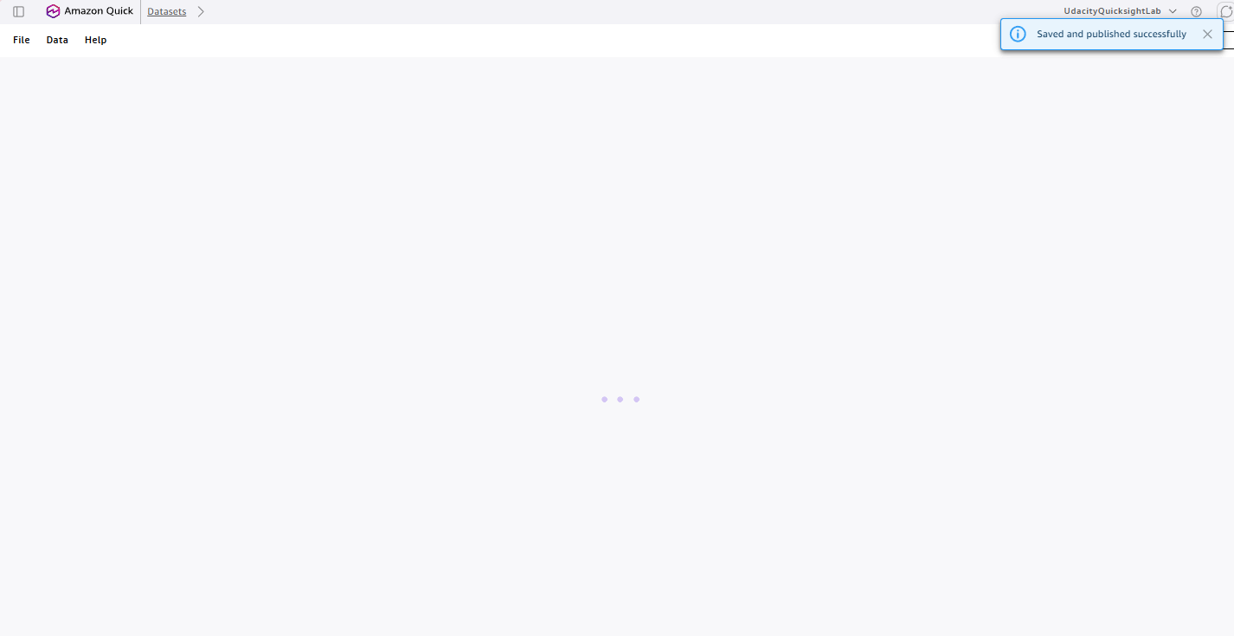
Fig. 26 — "Saved and published successfully" confirmation.
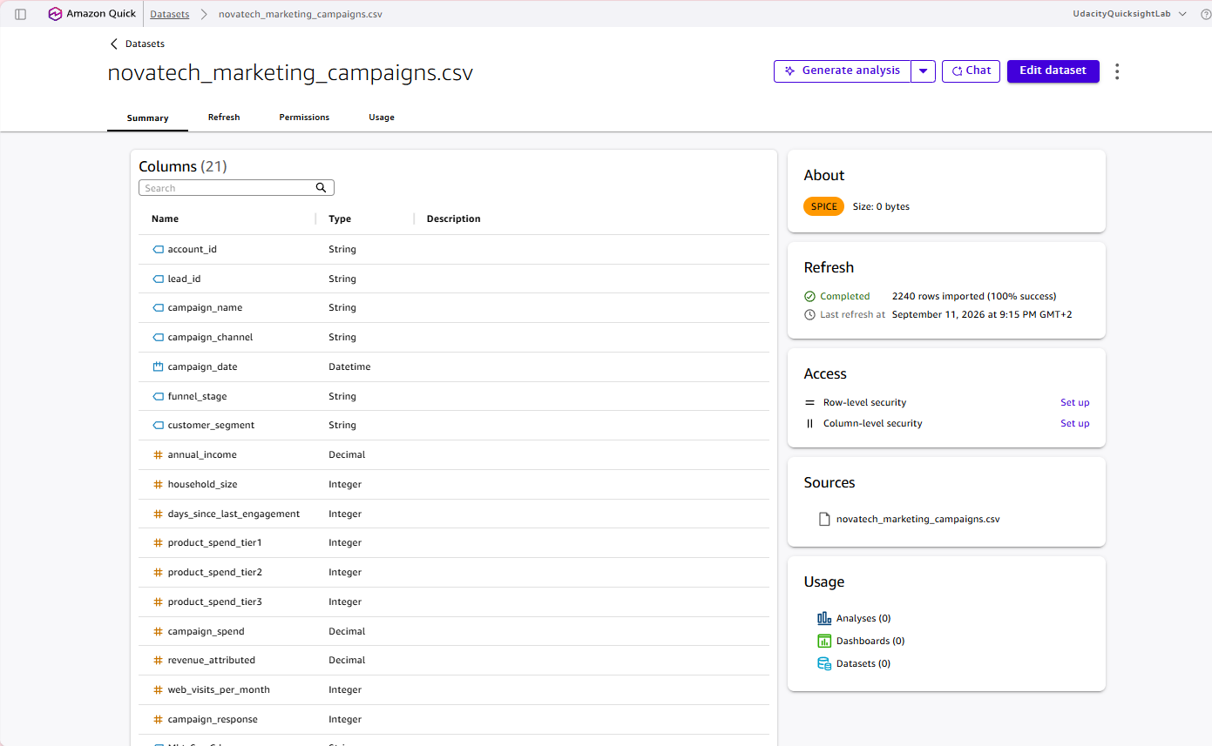
Fig. 27 — Dataset detail page: Columns (21) incl. campaign_roi, Refresh panel showing "2240 rows imported (100% success)".

Appendix — Verification Log (full table)
Minimum requirement: at least 6 entries covering all three knowledge bases. Result: 6/6, all Matches.
# | Knowledge Base | Question Asked | Expected Answer | Q's Actual Answer | Match? | Notes
1 | NovaTech CRM Deals | How many total deals are in the CRM dataset, and how many are Won vs Lost? | 499 total deals — 315 Won, 184 Lost | Total Deals: 499. Won: 315 (63.1%). Lost: 184 (36.9%). | Yes | Exact match, incl. win rate.
2 | NovaTech CRM Deals | What date range does the CRM deals data cover, and how many unique accounts are there? | 2023-06-17 to 2025-01-25; 85 unique accounts | Deal Created: Jun 17 2023 → Jan 25 2025; 85 unique accounts | Yes | Exact match.
3 | NovaTech Marketing Campaigns | How many rows are in the marketing campaigns data, and what is the overall campaign response rate? | 2,240 rows; 27.2% response rate (609/2,240) | Total Rows: 2,240. Responses: 609. Rate: 27.19%. | Yes | Exact match.
4 | NovaTech Marketing Campaigns | How many rows in the marketing campaigns data have a missing or null annual_income value? | 24 rows (1.1%) | 24 rows, 1.07% of 2,240 | Yes | Exact match.
5 | NovaTech Support Tickets | How many total support tickets are there, and what is the breakdown by priority level? | 3,000 total — low 1,500, medium 1,050, high 400, critical 50 | 3,000 total. Low 1,500 (50%), Medium 1,050 (35%), High 400 (13.3%), Critical 50 (1.7%) | Yes | Exact match, table shown.
6 | NovaTech Support Tickets | How many support tickets have a null or missing ticket_resolved_date (still unresolved)? | 59 rows (2.0%) | 59 tickets, ~2% of 3,000 | Yes | Exact match.

Cross-Check: Total row count of the CRM Deals dataset (entry #1). Chat said 499 total deals. QuickSight's dataset detail page for the student's own uploaded novatech_crm_deals.csv shows "499 rows imported (100% success)" under Refresh. Consistent — exact match.

