NovaTech Revenue Intelligence: Quick Chat Q&A Log
Each question is labeled BEFORE. Where an after-fix answer has also been captured, it is stacked directly underneath. New questions asked only in the after (Topic-fixed) state appear at the end.
Q: Which campaign channel drives the most revenue?
BEFORE
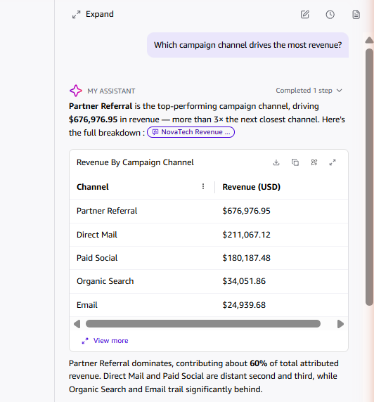
AFTER
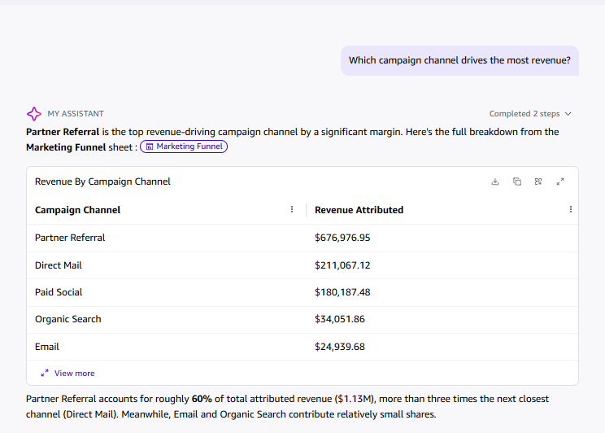
Q: Which campaign channel has the highest average response rate?
BEFORE
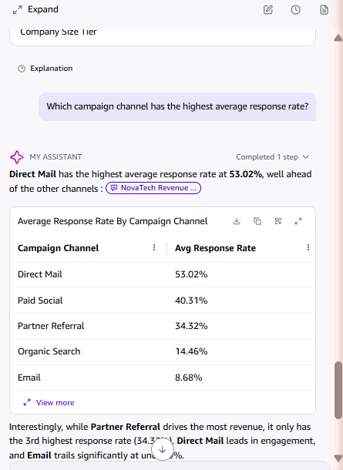
AFTER
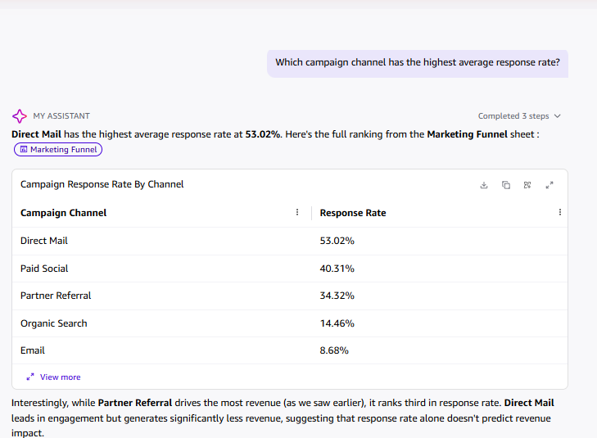

Q: What is the win rate in the Sales Pipeline sheet?
BEFORE
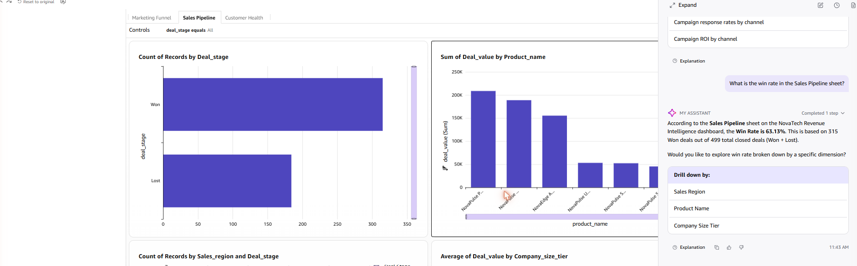
AFTER
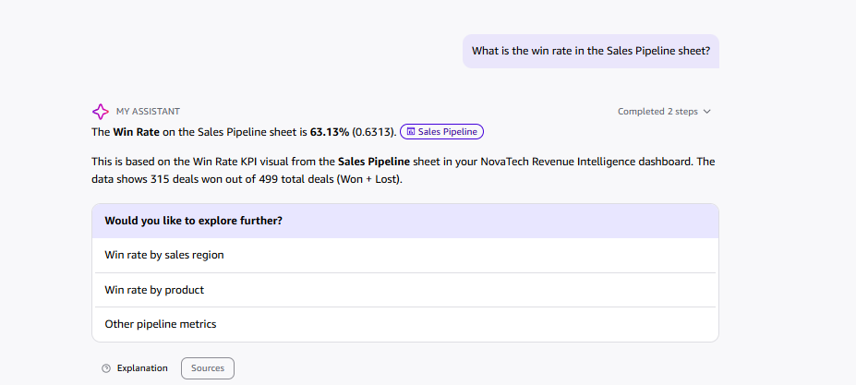
Q: What is the average deal size by company size tier?
BEFORE
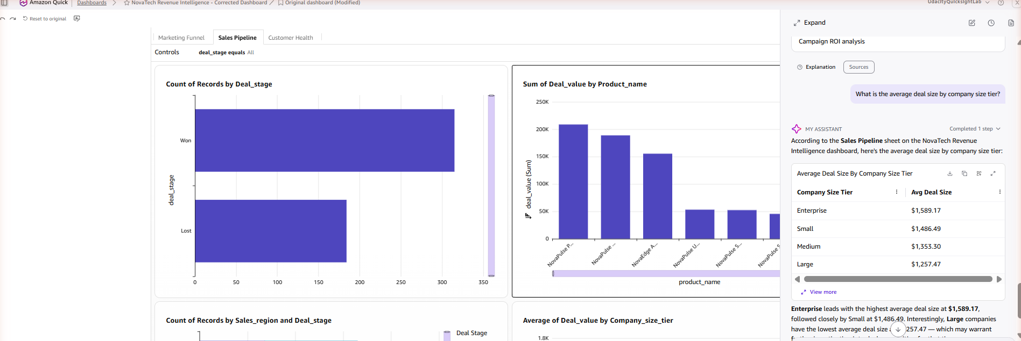
Q: Which product area receives the most support tickets, and what is the average resolution time for critical priority tickets?
BEFORE
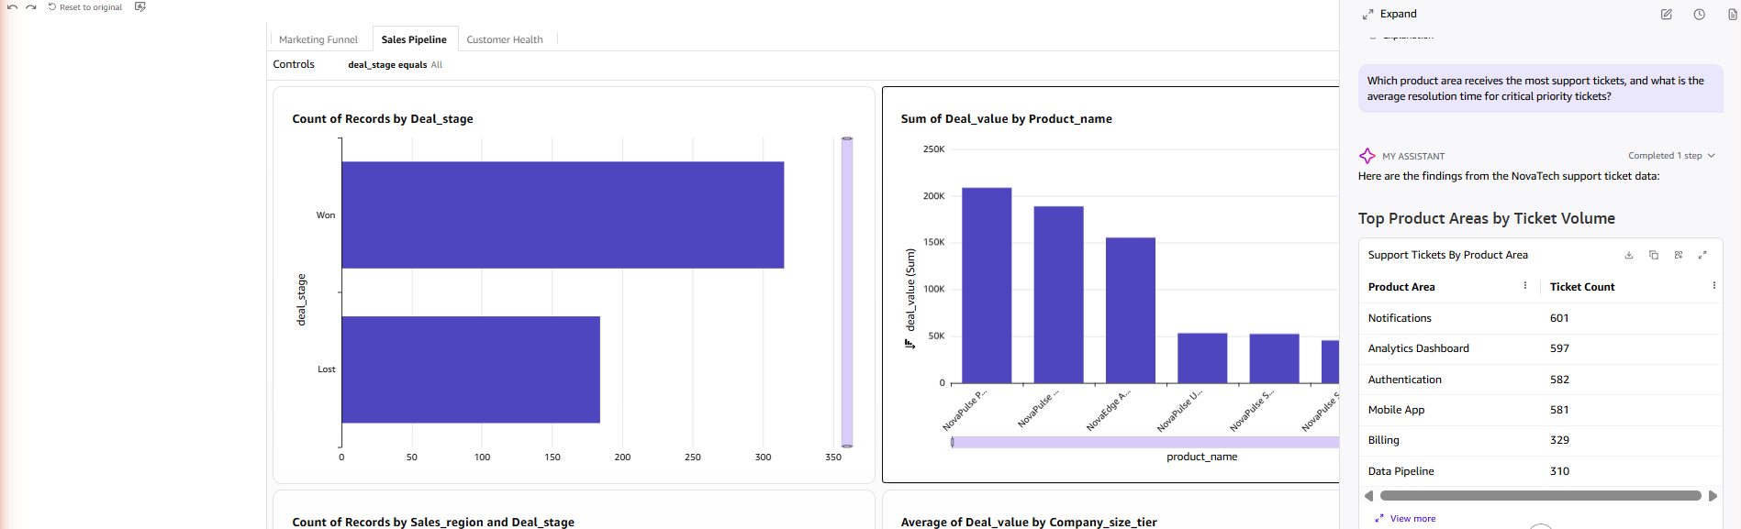
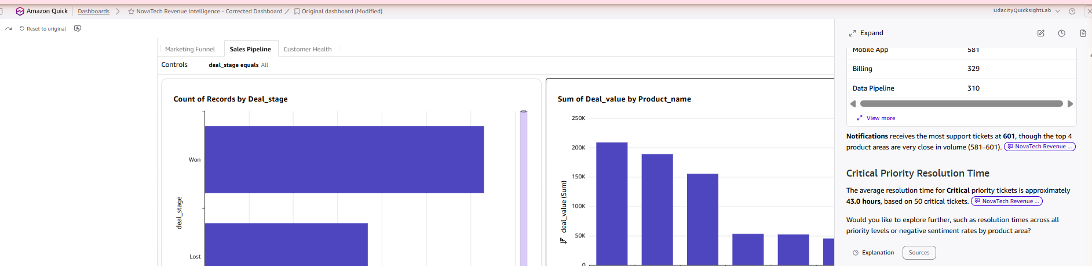
AFTER
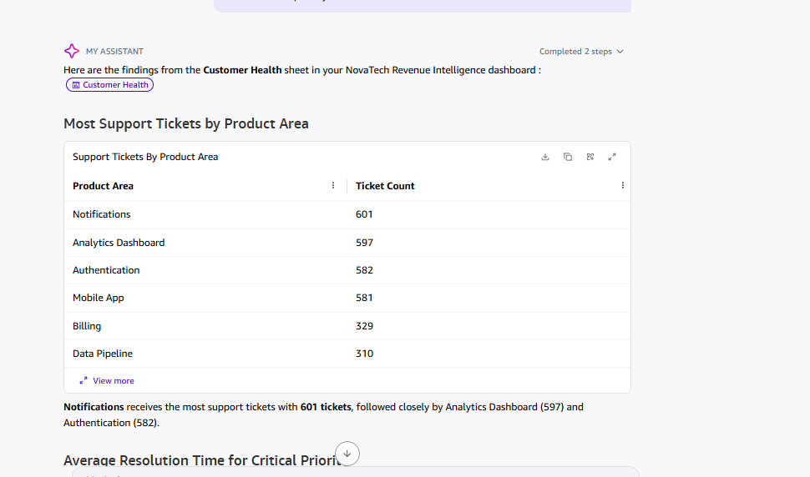
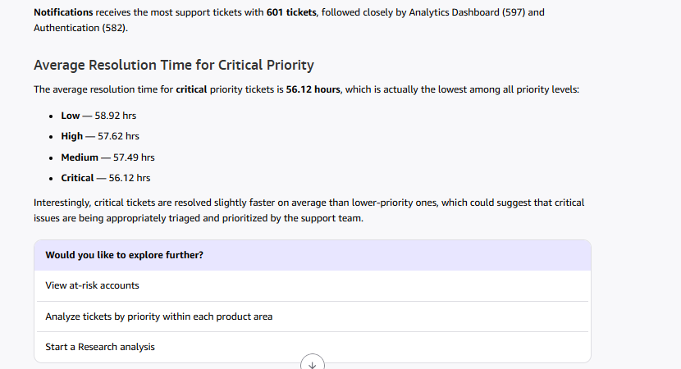
Note: the before answer reported 43.0 hrs average resolution for critical tickets (based on a 50-ticket subset); the after answer reports 56.12 hrs as part of a full priority breakdown, consistent with a separate "average resolution time" query (56.13 hrs). Minor inconsistency, likely due to different underlying filters/sample sizes used by Quick Chat between runs.
Q: Which accounts have both high support ticket volume and high total deal value at risk? (cross-dataset)
BEFORE
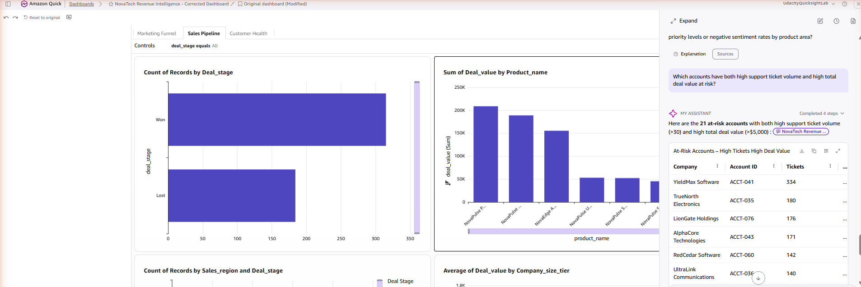
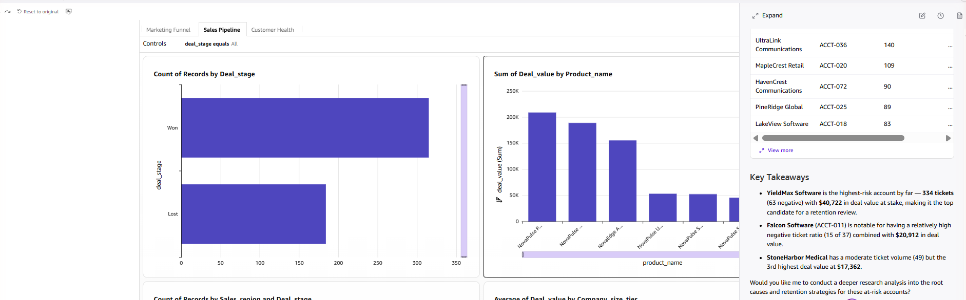
AFTER
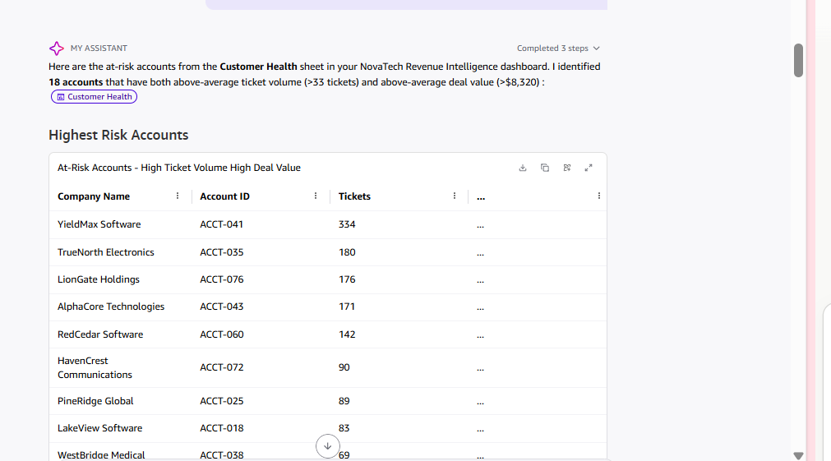
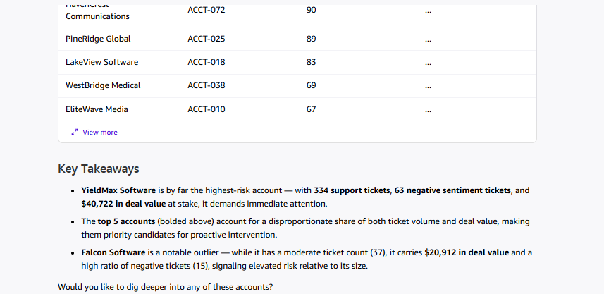
Q: Which campaign has the worst ROI, and what is the average campaign ROI overall?
BEFORE
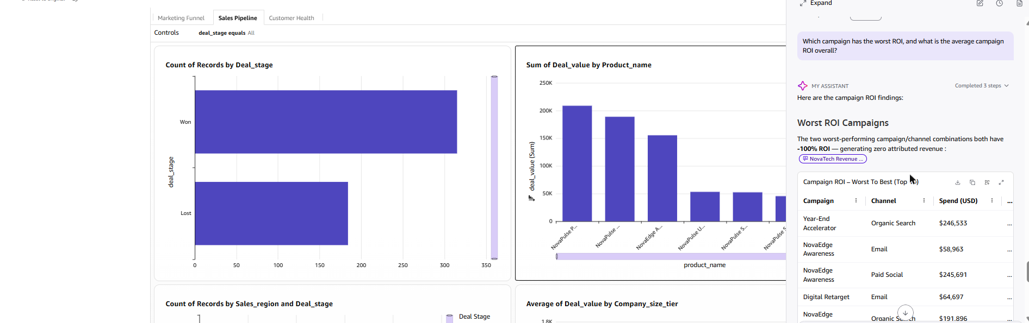
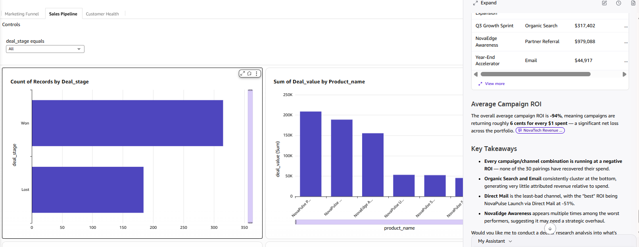
AFTER
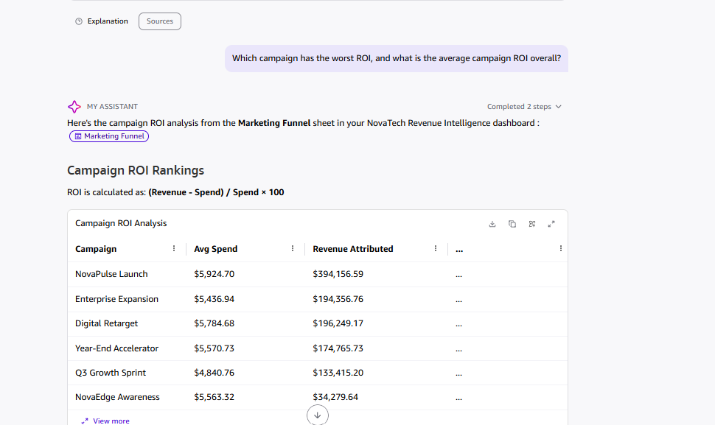
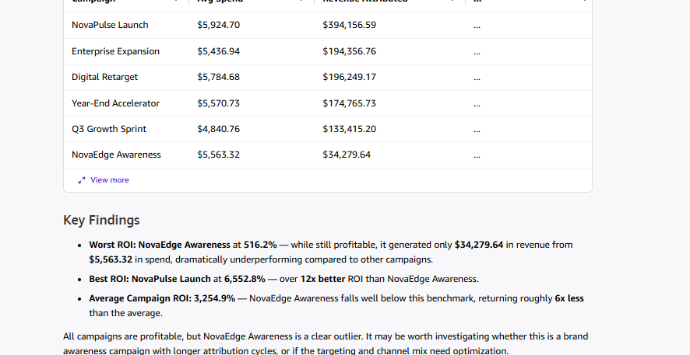
Note – methodology discrepancy: for this identical question, the before answer computed ROI per campaign–channel pairing (30 combinations, large spend totals), yielding an all-negative result (average −94%). The after answer computed ROI per campaign only using average spend per campaign, yielding an all-positive result (average +3,254.9%; worst NovaEdge Awareness at 516.2%, best NovaPulse Launch at 6,552.8%). Same question, two different aggregation levels — this inconsistency in Quick Chat's methodology should be called out explicitly in the written analysis rather than treated as a real before/after change.
New Questions (After / Topic-Fixed State Only)
Q: What is the conversion rate by campaign channel?
AFTER
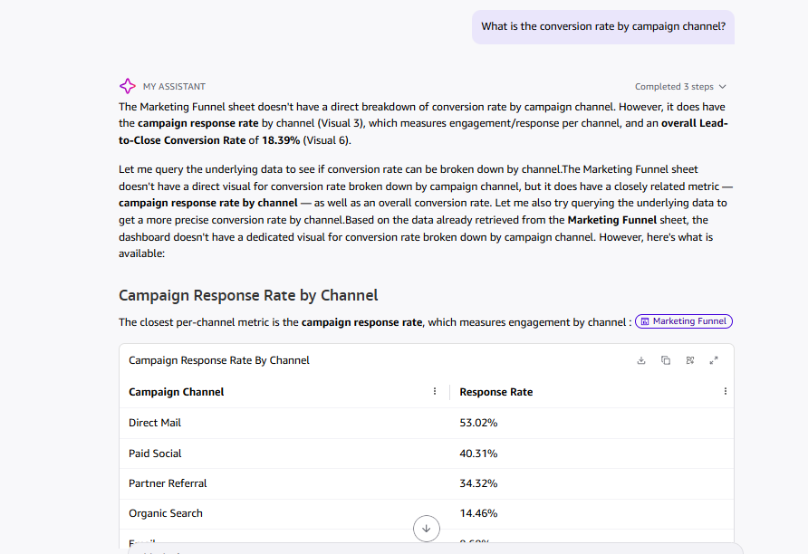
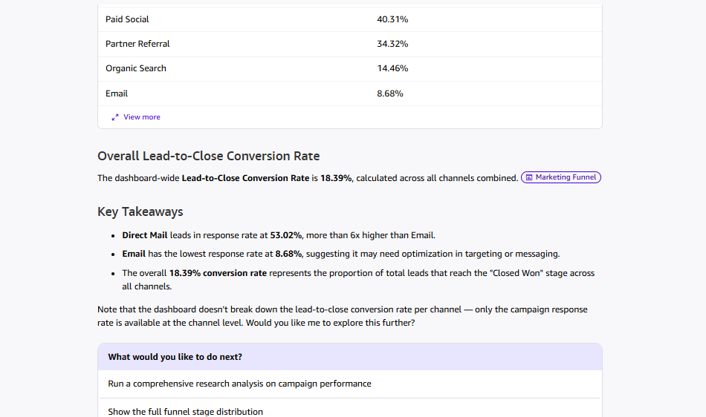
Q: What is the total pipeline value by deal stage?
AFTER
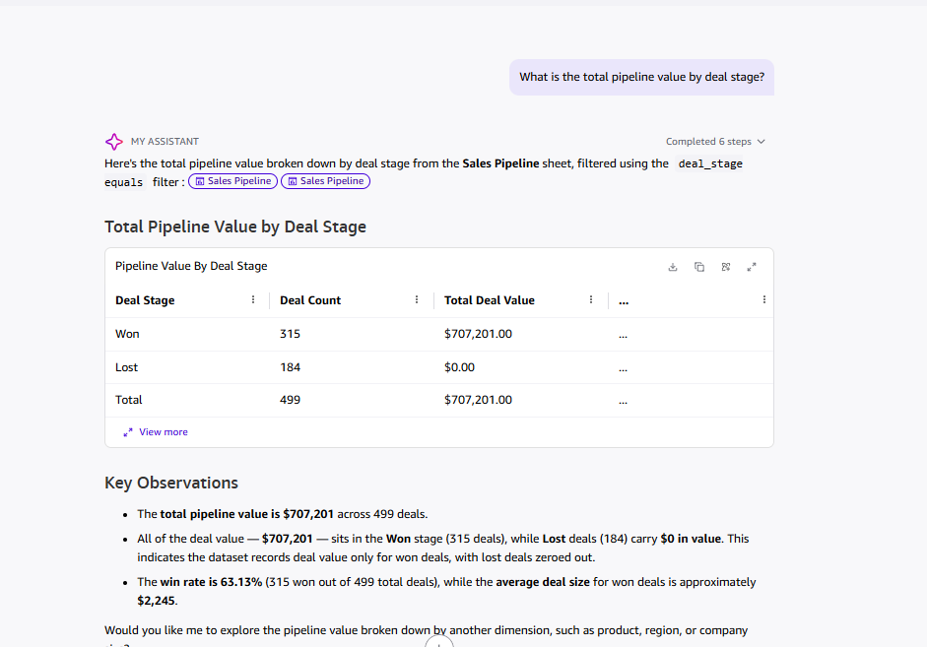
Q: What is the negative sentiment rate by account, and which accounts have the highest negative sentiment rate?
AFTER
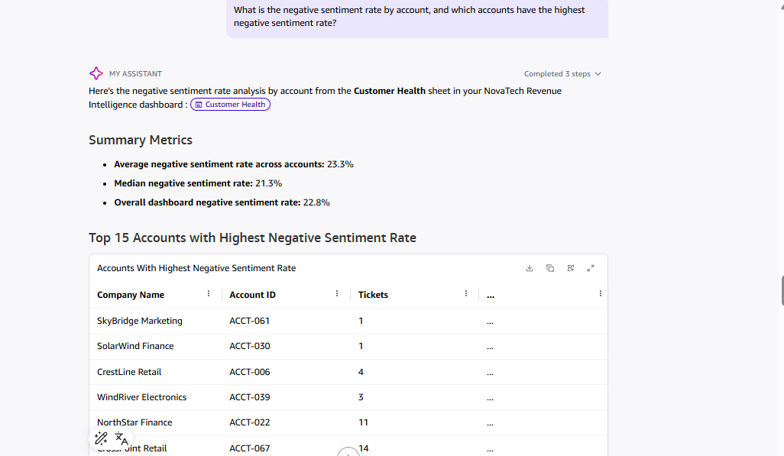
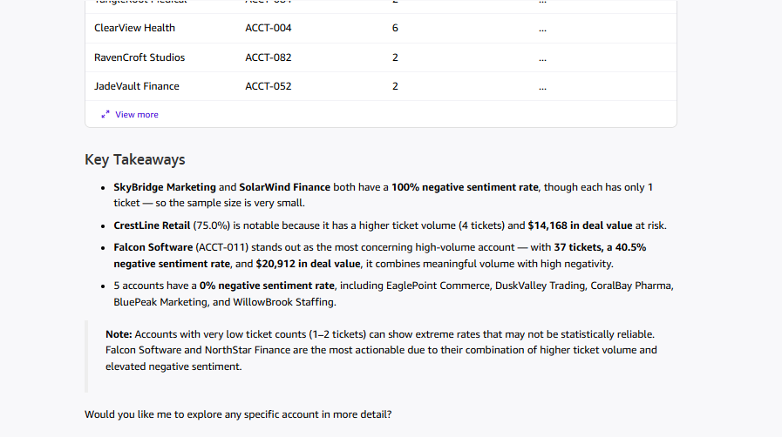
Q: How does an account's support ticket risk profile relate to whether their deal was Won or Lost? (cross-dataset)
AFTER
