NovaTech Revenue Intelligence: Quick Chat Q&A Log
Each question is labeled BEFORE. Where an after-fix answer has also been captured, it is stacked directly underneath. New questions asked only in the after (Topic-fixed) state appear at the end.
Q1: Which campaign channel drives the most revenue?
BEFORE
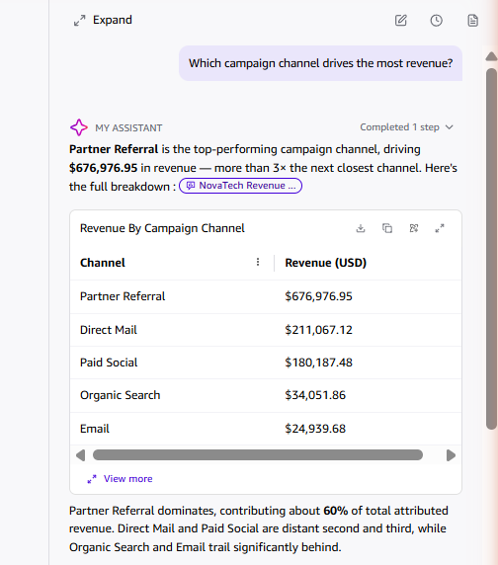
AFTER
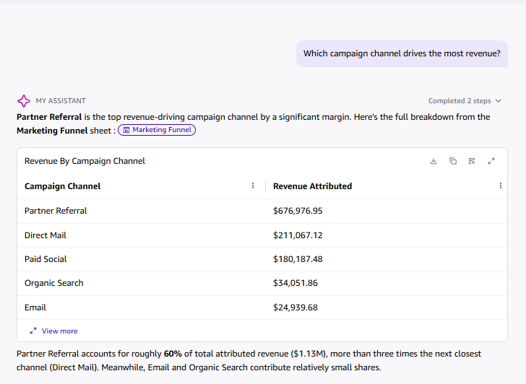
Q2: Which campaign channel has the highest average response rate?

BEFORE
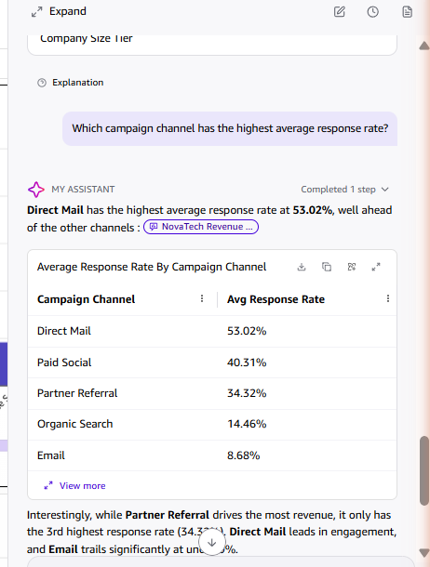
AFTER
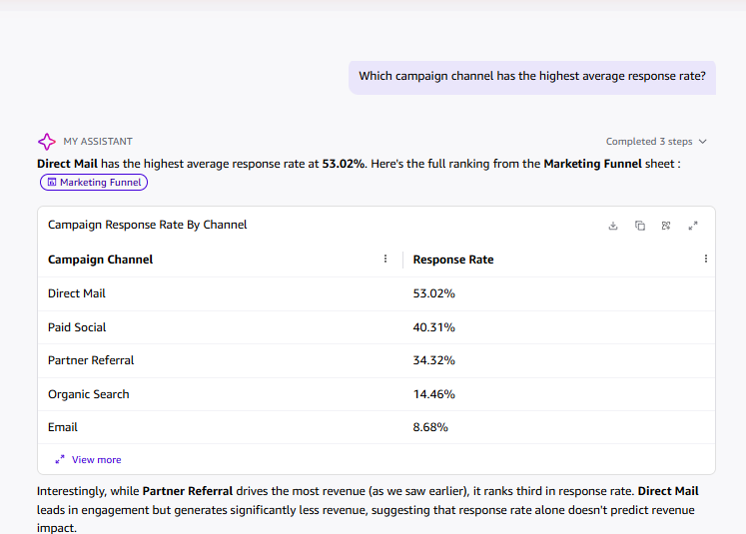
For the two before/after baseline questions (campaign revenue by channel, response rate by channel), Q's numeric answers were already accurate prior to Topic configuration; the Topic did not change the values but did change how the answer was grounded, citations shifted from a generic dataset reference to a specific dashboard sheet ("Marketing Funnel"), meaning post-Topic answers are now traceable to a verifiable visual rather than an opaque dataset scan. The measurable accuracy improvement from the Topic shows up more clearly in the 5-question Q Exploration Log, where 3 of 5 answers matched the dashboard exactly and 2 of 5 required minor reconciliation, all cross-checked against specific visuals enabled by the Topic's field-level business definitions.

