NovaTech Revenue Intelligence Dashboard
Student: Ecem Bökenheide
Course: Future AWS Agentic AI Business Professional → Business Intelligence and Knowlege Management Foundations with Amazon Quick → Project: Revenue Intelligence Dashboard for NovaTech Solutions
This document logs, in order, every step taken to prepare data which is the second step of the project, what was clicked, which option was chosen, and why. Screenshots are included where relevant. The full Verification Log table is included at the end.

Step 0 - Read the reference materials
1. Opened the Instructions, Project Overview, Environment Setup, and Project Rubric pages in the Udacity classroom to understand the full task list, deliverables, and grading criteria.
2. Opened Lesson Resources → Download and download Project-Starter-Resources.zip. It contains the 3 starter CSVs, the data dictionary, Sarah Chen's dashboard requirements brief, the company background brief, and the two log templates. Based on the information from Sarah Chen, the datasets are the following:

Dataset | Business Context from Sarah Chen
CRM Deals | The CRM contains every deal the company has pursued, including the product purchased, the final outcome (won or lost), and the reason for the outcome.
Marketing Campaigns | The marketing platform tracks campaign performance, including channel investment, lead responses, and revenue attributed to each campaign.
Support Tickets | The support system records every customer ticket, including the issue, its severity, resolution time, and the customer’s reported experience.

3. Read the Data Dictionary (field definitions, expected row counts: CRM 499, Marketing 2,240, Support 3,000; shared join key account_id), Sarah Chen's brief (the 3 dashboard views and their required metrics and filters), and the Company Background (NovaTech Solutions context).
Known data quality issues documented in the dictionary:
- annual_income (Marketing): 24 rows missing (1.1%), flagged as intentional, realistic missing data
- ticket_resolved_date (Support): 59 rows missing (2.0%), blank for tickets still unresolved, not a data error
- account_id orphans: 150 rows in Marketing (6.7%) and 204 rows in Support (6.8%) use account IDs (ACCT 101 through ACCT 115) that don't exist in the CRM dataset; this is intentional, since not every marketing lead or support ticket is expected to trace back to a known CRM account
- loss_reason (CRM): blank in 315 rows, but only because it's populated exclusively for Lost deals, so this is expected structure rather than a quality gap
Key decisions this informed: the join key across all 3 datasets is account_id; the orphan ID pattern in Marketing and Support directly shapes the choice of join type later; calculated fields to build: days_to_close (CRM), campaign_roi (Marketing), resolution_time_hours (Support).

Step 1 — Open the AWS lab environment
1. In the Udacity lesson, clicked the Cloud Resources tab (bottom toolbar) → Open Cloud Console. This is the Vocareum-provided, pre-configured AWS account for the lab (no personal AWS account needed) — it has a $25 budget cap and session time limits.
2. This opened a new browser tab/window that federates into Amazon Quick (QuickSight) at us-west-2.quicksight.aws.amazon.com/sn/account/UdacityQuicksightLab/start/home.
Note: the federation link is single-use and expires quickly — if it shows "The link has expired," go back to Cloud Resources and click Open Cloud Console again to mint a fresh link.

Step 2 — Finding the pre-indexed knowledge bases
1. Clicked New chat in the left nav of Amazon Quick.
2. Clicked the data-scope selector under the question box (default "All data") → opens an "Add Quick assets" picker with tabs: Recents, Favorites, Spaces, Topics, Dashboards, Knowledge Bases, Actions, Datasets.
3. The Knowledge Bases tab was empty. In this lab's Amazon Quick setup, the instructor's pre-indexed sources are exposed as regular Datasets, not separate "Knowledge Base" objects — this matches the Environment Setup page: "Locate the pre-indexed knowledge bases under Datasets and in Quick Chat."
4. On the Datasets tab (page 2, since this is a shared/reused Vocareum lab account with prior activity), found the actual instructor-provided sources: novatech_crm_deals.csv, novatech_support_tickets.csv, novatech_marketing_campaigns.csv — all owned by "Others", created 6 months ago. These are treated as the "pre-indexed knowledge bases — created by the instructor, do not modify."
Also present, and deliberately ignored: same-named datasets owned by "Me" from 10 days ago, plus a pre-built "NovaTech Unified Account-Level Dataset" and "Account Risk Summary" owned by "Others" — leftovers from someone else's earlier pass through this shared lab. This project's own deliverables are built from a fresh upload of the starter CSVs instead of reusing them.
5. Checked the boxes for all three "Others" / 6-months-ago datasets at once, then clicked Save, scoping the chat to all three instructor knowledge bases together.
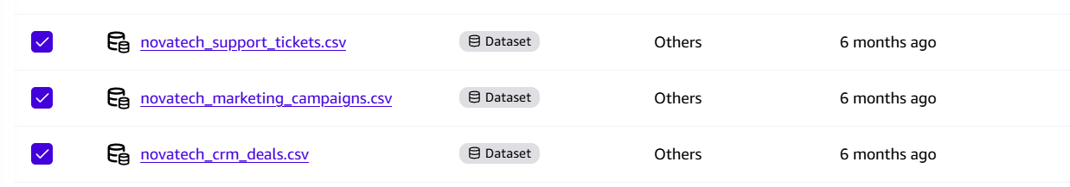
Fig. 1 — "Add Quick assets" picker, Datasets tab, page 2: all three instructor novatech_*.csv datasets (owned by "Others", 6 months old) checked before clicking Save.

Step 3 — Verify the knowledge bases (Verification Log)
Asked 6 questions — 2 per knowledge base — each chosen because the correct answer was already known from the data dictionary (cross-checked against the raw CSVs with pandas beforehand), so Q's answer could be objectively marked Match / No Match rather than just judged as "sounds plausible." Question mix was deliberately varied: row counts, category breakdowns, date ranges, null counts.

CRM Deals
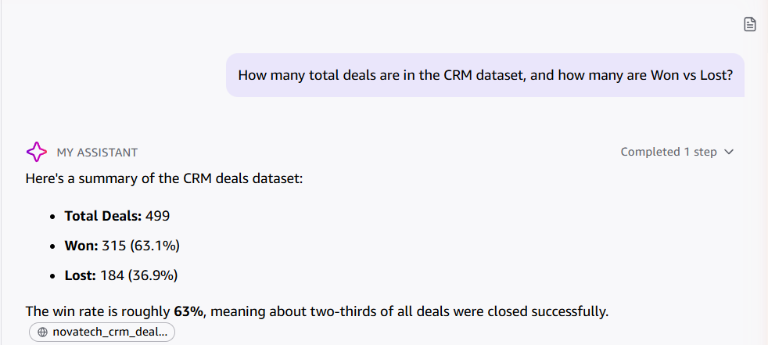
Fig. 2 — Q1: total deals + Won/Lost breakdown. Match: 499 total, 315 Won (63.1%), 184 Lost (36.9%).
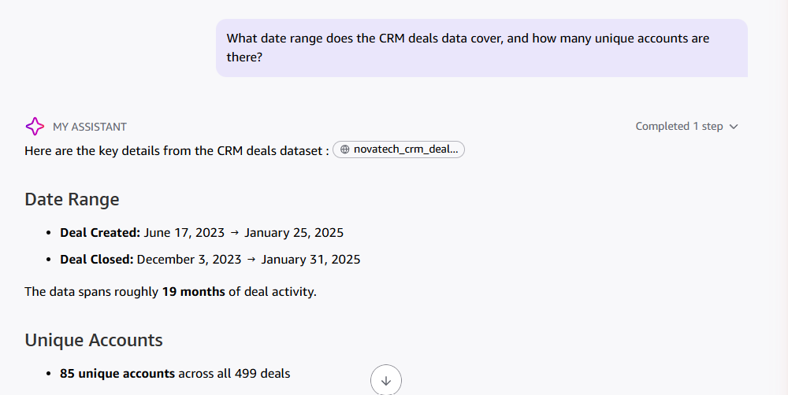
Fig. 3 — Q2: date range + unique accounts. Match: Jun 17 2023 → Jan 25 2025, 85 unique accounts.

Marketing Campaigns
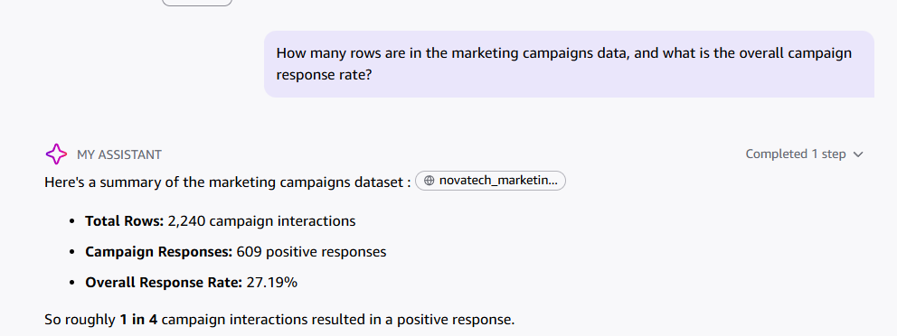
Fig. 4 — Q3: row count + response rate. Match: 2,240 rows, 27.19% response rate.
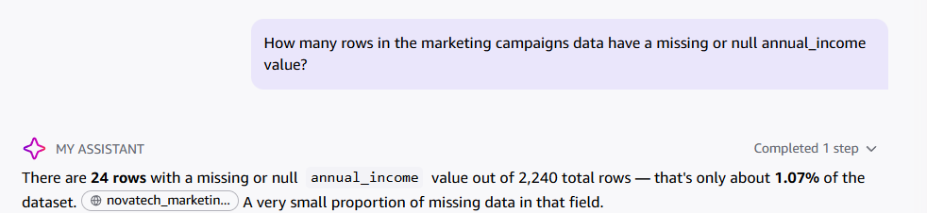
Fig. 5 — Q4: null count on annual_income. Match: 24 rows, 1.07%.

Support Tickets
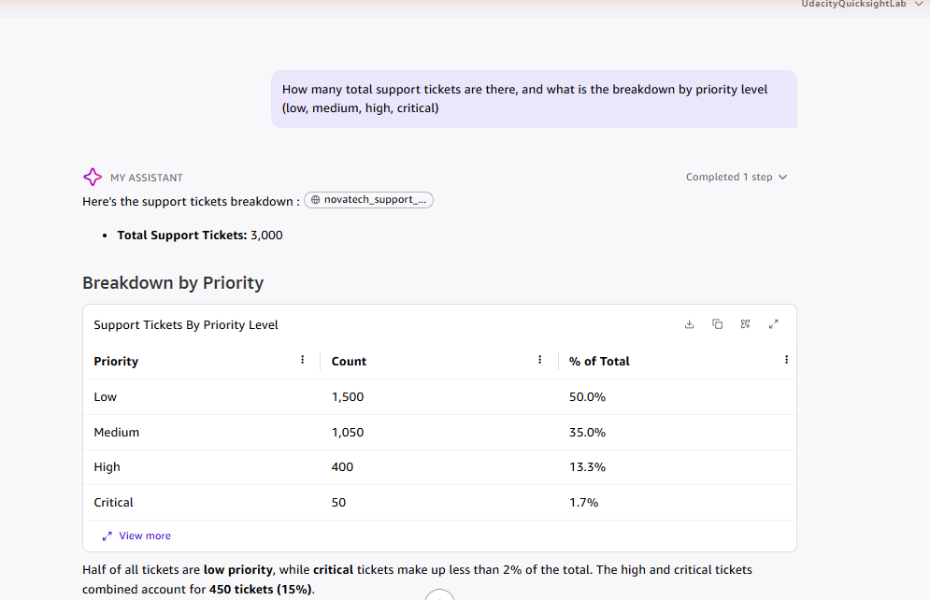
Fig. 6 — Q5: total tickets + priority breakdown. Match: 3,000 total; Low 1,500 / Medium 1,050 / High 400 / Critical 50.
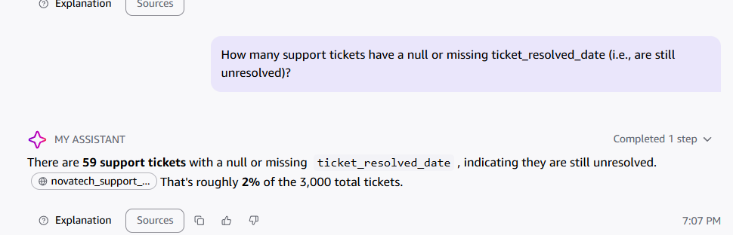
Fig. 7 — Q6: null count on ticket_resolved_date. Match: 59 rows, ~2%.
Result: 6 / 6 Match — Q answered every checkable fact correctly across all three knowledge bases, including one bonus detail on Q1 (deal_closed_date range) that wasn't asked for but was accurate.

Step 4 — Upload own CRM Deals dataset + fix data types
This is where the student's own submission begins: instead of reusing the instructor's 6-month-old "Others" datasets or the leftover "Me" datasets from 10 days ago (see Step 2), a fresh copy of each starter CSV is uploaded and prepared from scratch.
1. Went to Data → New dataset → Upload a file → selected novatech_crm_deals.csv.
2. On the "Confirm file upload settings" dialog, clicked "Edit settings and prepare data" (not the default "Next") to land in the full data-prep editor before importing to SPICE.
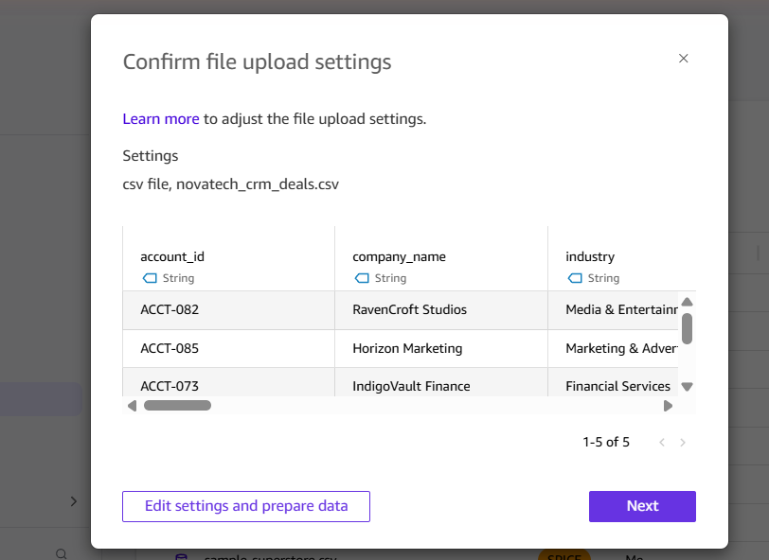
Fig. 8 — File-upload confirmation dialog, before entering the editor.
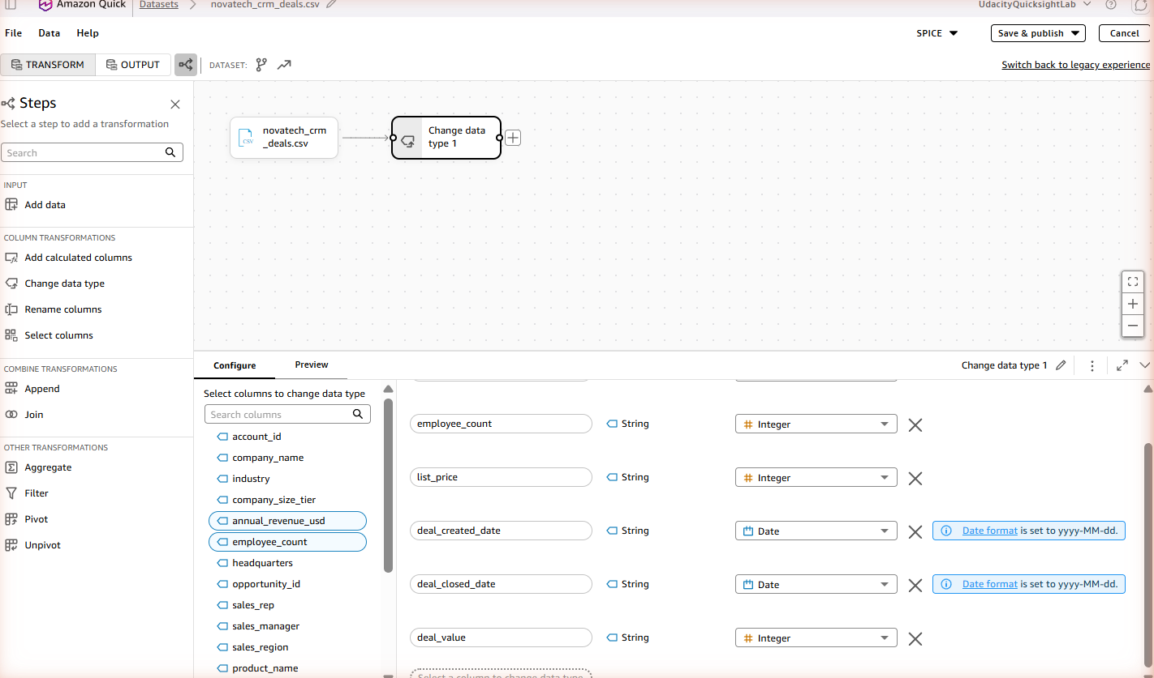
Fig. 9 — Data-prep editor just after entering, with QuickSight's initial auto-suggested type changes (employee_count, list_price, deal_created_date, deal_closed_date, deal_value).
3. Compared each suggested type against the data dictionary and corrected them:
- annual_revenue_usd: String → Decimal (dictionary: Float, currency in millions USD)
- employee_count: String → Integer — already correct
- list_price: String → Integer — already correct
- deal_created_date, deal_closed_date: String → Date, format yyyy-MM-dd — already correct
- deal_value: originally auto-suggested as Integer — corrected to Decimal. Every value in this CSV happens to be a whole number, so Integer wouldn't have caused an error, but the data dictionary formally types it as Float (a currency/revenue amount), so Decimal matches the documented schema rather than this sample's coincidental shape.
- All other columns left as String — correct per data dictionary.
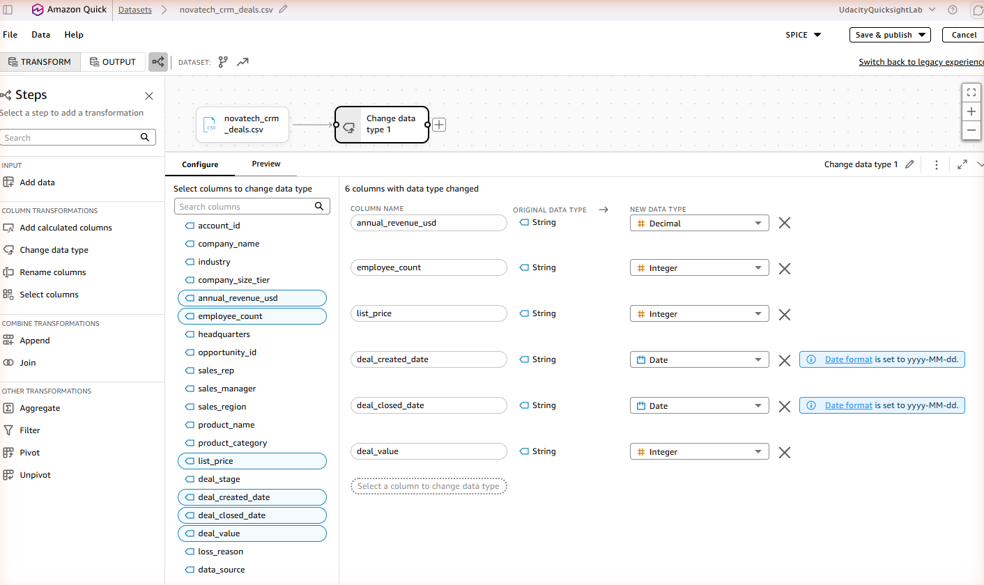
Fig. 10 — After fixing annual_revenue_usd to Decimal (deal_value still shows Integer at this point).
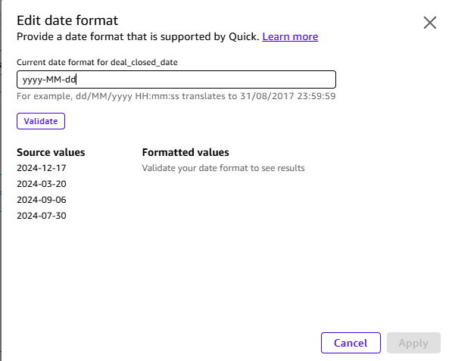
Fig. 11 — Checked the date-format dialog for deal_closed_date, confirmed yyyy-MM-dd was already correct, cancelled without changes.
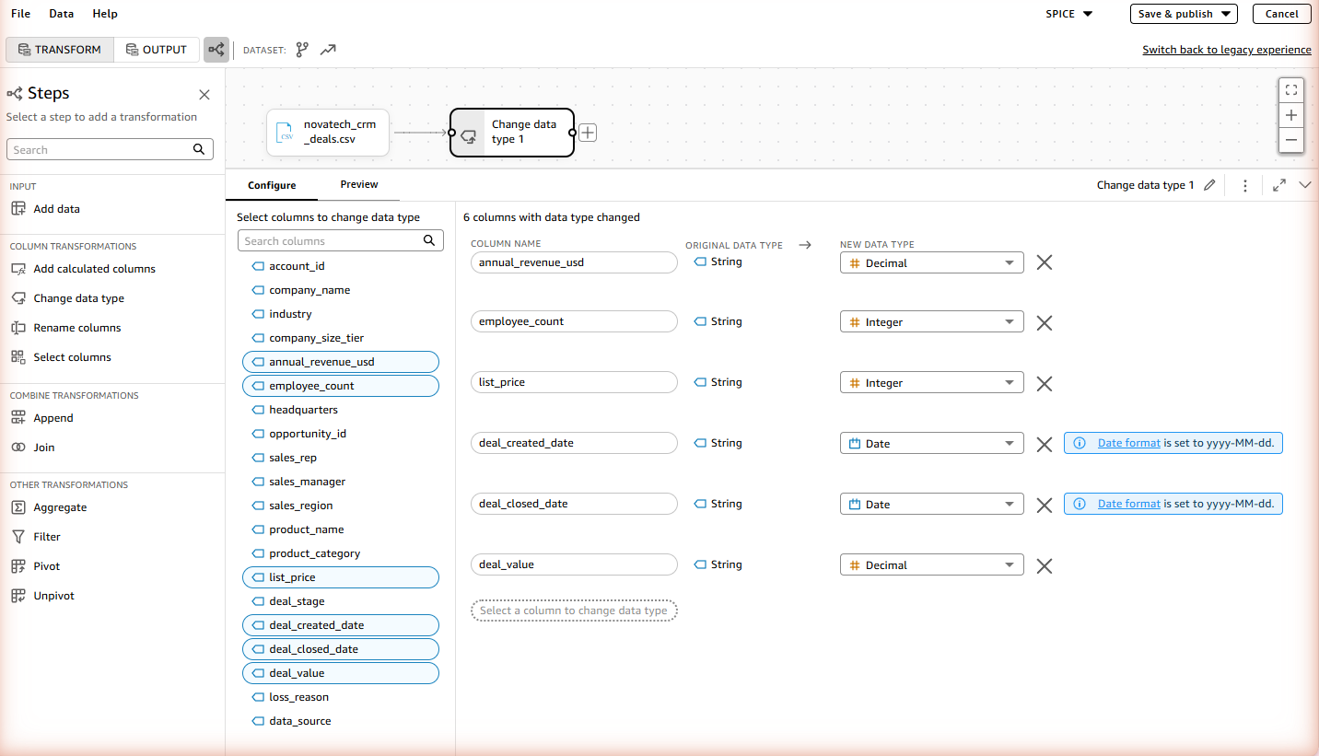
Fig. 12 — Final state: all 6 changed columns correct, including deal_value now as Decimal.
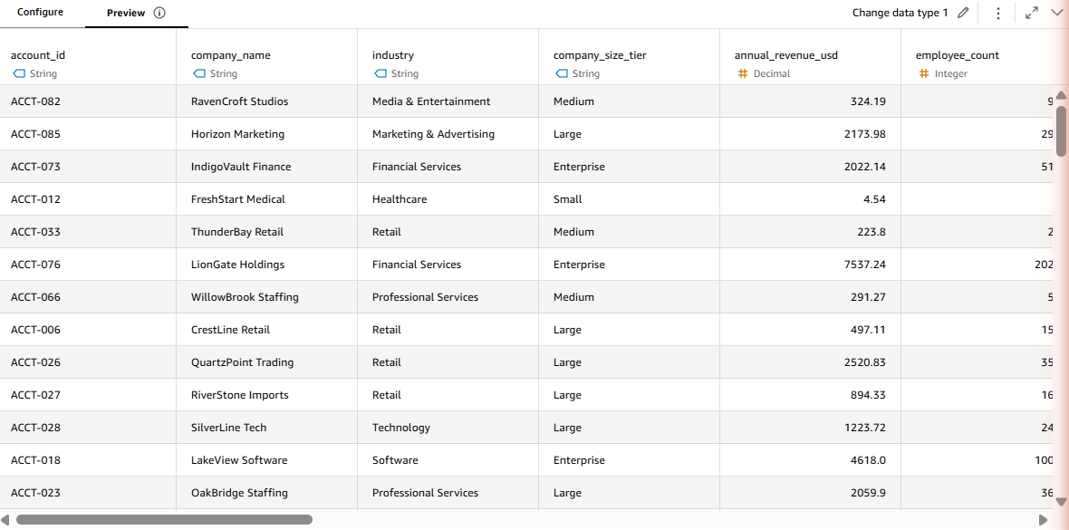
Fig. 13 — Preview tab confirming the corrected data renders sensibly.

Step 5 — Calculated field: days_to_close (CRM)
Why this metric, specifically — not an arbitrary choice:
- Sarah Chen's brief (Sales Pipeline view) asks for it verbatim: "Days to close — how long does it take us to close a deal from creation to close? Is that getting better or worse?"
- The data dictionary spells out the exact formula in its notes on deal_closed_date: "Students can compute days-to-close as deal_closed_date − deal_created_date."
- The rubric requires ≥2 calculated fields that derive a business metric the raw data doesn't already contain, and names days-to-close as the canonical CRM example.
None of the raw columns is "days to close" — it only exists once you subtract two dates, which is exactly what a calculated field is for.
1. Clicked "Add calculated columns" in the left panel.
2. Named the field days_to_close.
3. Formula: dateDiff({deal_created_date}, {deal_closed_date}, "DD")
4. Applied — verified resulting values in Preview against known won/lost examples (average ≈72 days for Won, ≈58 days for Lost, per the earlier pandas check).
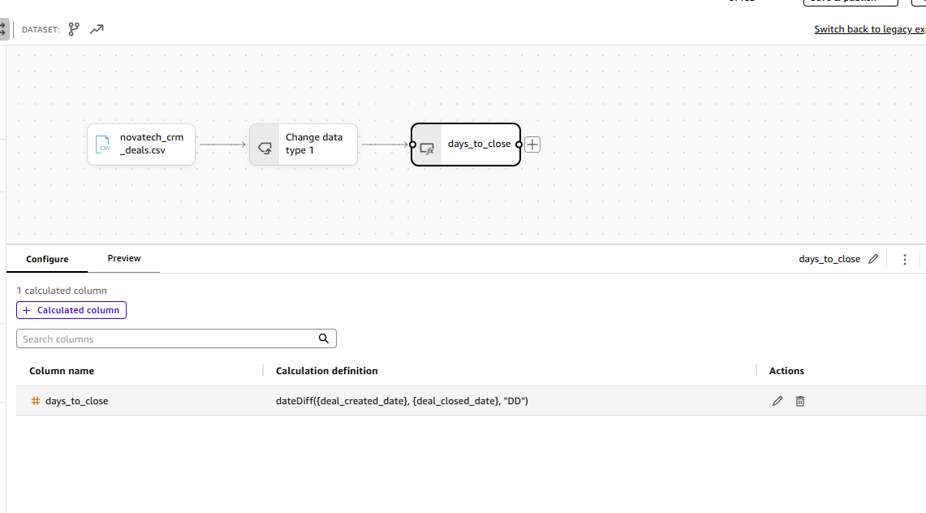
Fig. 14 — days_to_close calculated column configuration: dateDiff({deal_created_date}, {deal_closed_date}, "DD").
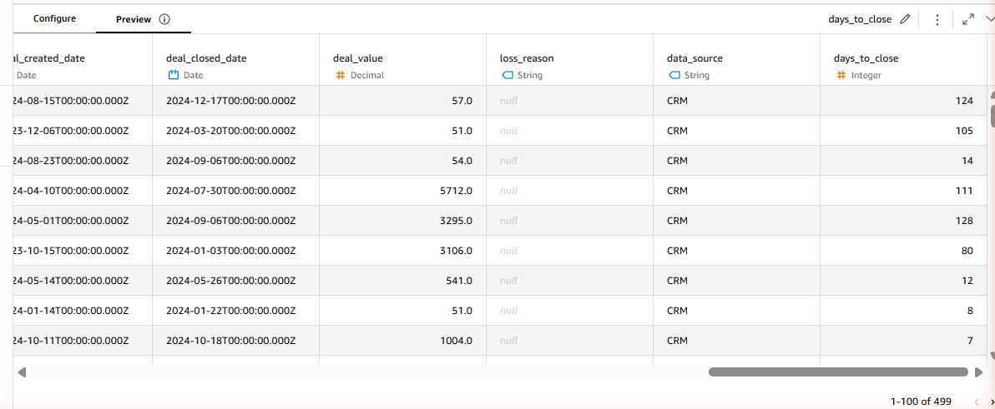
Fig. 15 — Preview showing realistic day counts (124, 105, 14, 111, 128, 80, 12, 8, 7…).

Step 6 — Publish CRM Deals dataset
1. Clicked Save & publish (top right) → Publish & visualize → Create.
2. Confirmation banner: "Saved and published successfully."
3. Navigated to Data → Datasets, opened the newly published novatech_crm_deals.csv (owner: Me).
4. Dataset detail page confirms: 21 columns (the 20 original + days_to_close), and under Refresh: "499 rows imported (100% success)" — an exact match with both the data dictionary and Q's answer in Verification Log entry #1. This closes out the Verification Log's Cross-Check section.
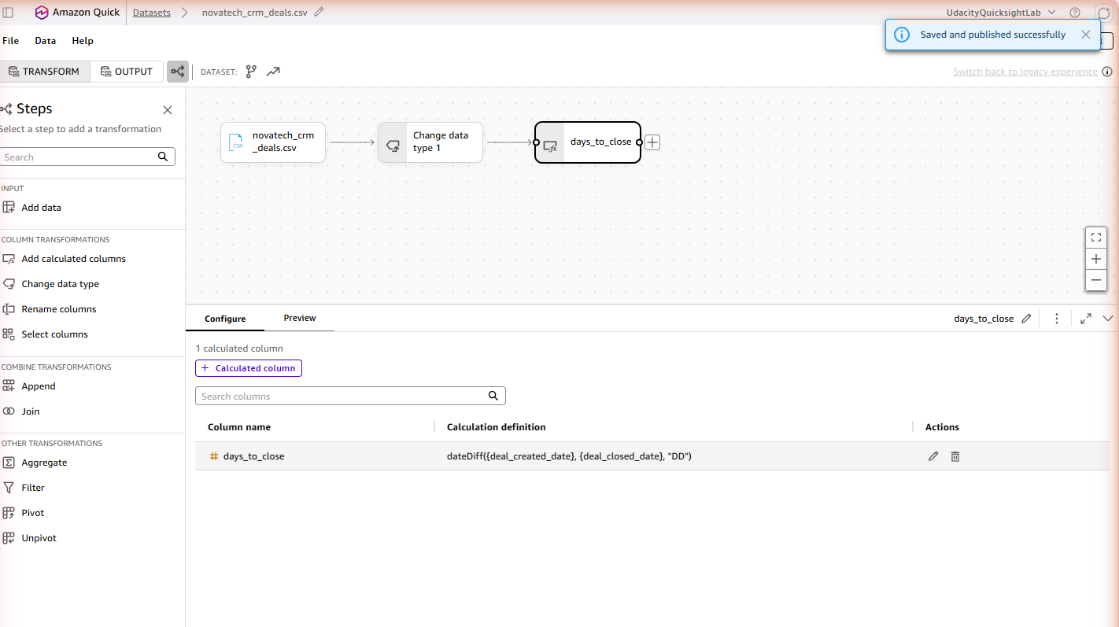
Fig. 16 — "Saved and published successfully" confirmation.
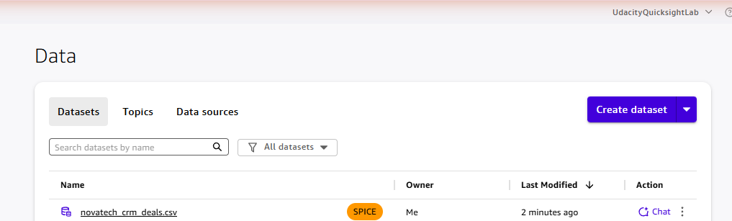
Fig. 17 — Dataset list showing the student's own novatech_crm_deals.csv (owner: Me, SPICE).
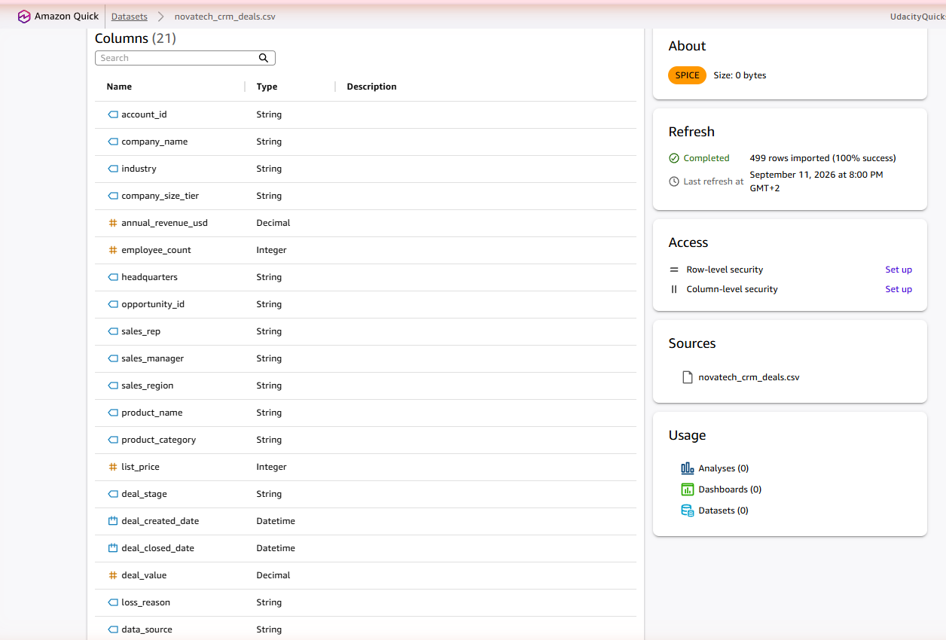
Fig. 18 — Dataset detail page: 21 columns, "499 rows imported (100% success)" — cross-check confirmed against Q's answer.

Step 7 — Upload own Marketing Campaigns dataset + fix data types
1. Went to Data → Create dataset → Upload a file → selected novatech_marketing_campaigns.csv → "Edit settings and prepare data".
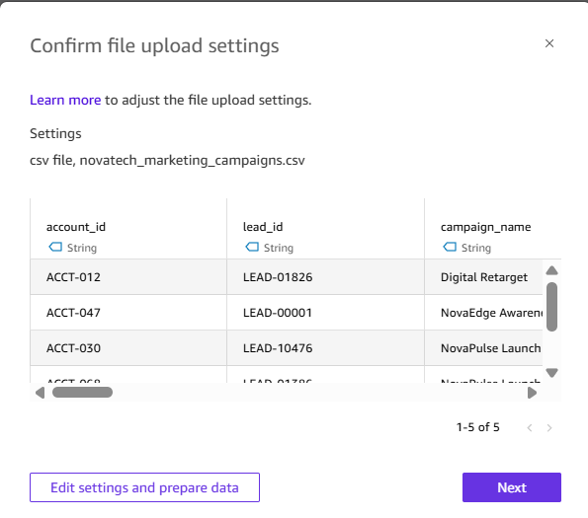
Fig. 19 — File-upload confirmation dialog for novatech_marketing_campaigns.csv, before entering the editor.
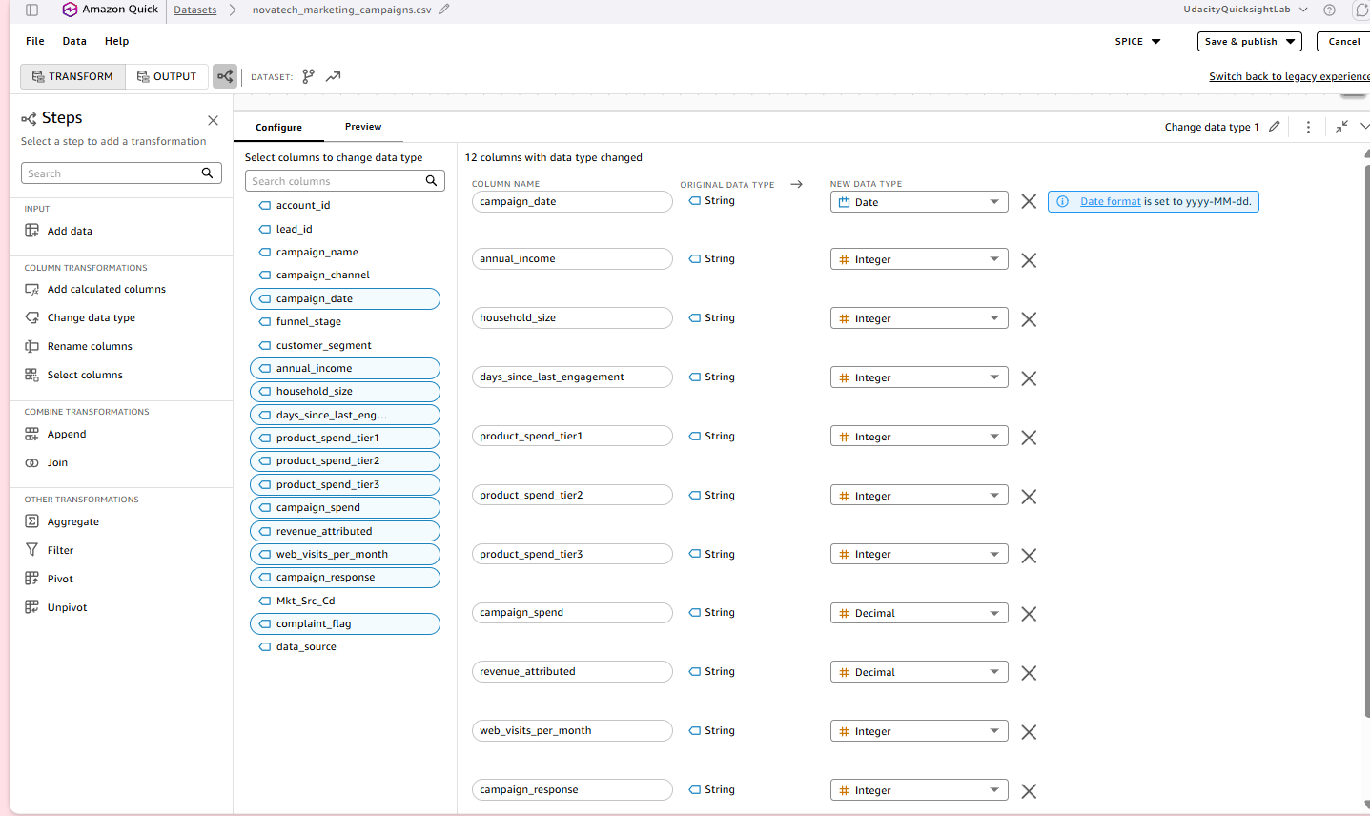
Fig. 20 — Data-prep editor just after entering, with QuickSight's initial auto-suggested type changes across 12 columns.
2. QuickSight auto-suggested type changes for 12 columns. Checked each against the data dictionary:
- campaign_date → Date (yyyy-MM-dd) — already correct
- household_size, days_since_last_engagement, product_spend_tier1/2/3, web_visits_per_month, campaign_response, complaint_flag → Integer — all correct per dictionary
- campaign_spend, revenue_attributed → Decimal — correct per dictionary (Float)
- annual_income → auto-suggested as Integer, corrected to Decimal (dictionary: Float — annual income can carry decimals in general).
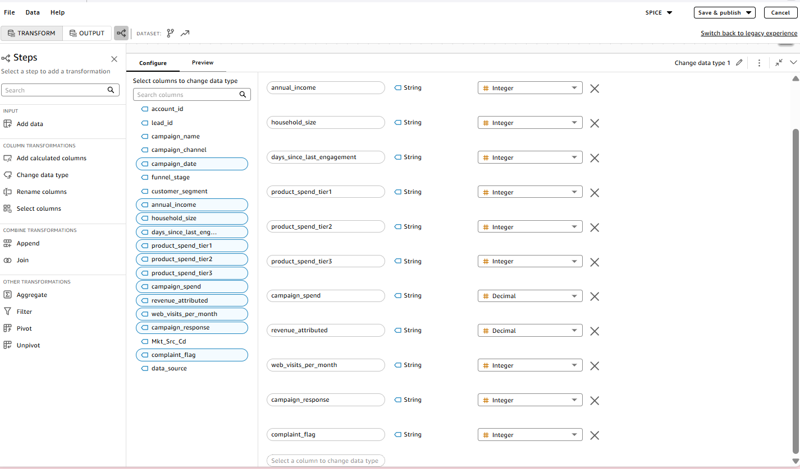
Fig. 21 — Scrolled through the type list, confirming complaint_flag and the other Integer columns were already correct.
3. Decision point — keep or drop annual_income / household_size? Initially proposed dropping both as low-analytical-value B2C demographic fields, since neither appears in Sarah's brief or any dashboard view and customer_segment already covers segmentation. On review, decided to keep both — there's no technical harm in leaving them (QuickSight doesn't penalize extra columns, and they simply won't be used in any visual), so the call was made to preserve the original schema rather than remove data. This is a judgment call, documented here rather than silently applied.
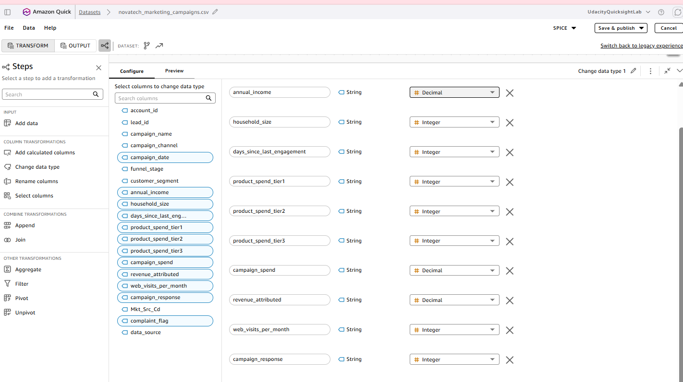
Fig. 22 — Final state: all 12 columns correct, including annual_income → Decimal.

Step 8 — Calculated field: campaign_roi (Marketing)
Why this metric, specifically — not an arbitrary choice:
- Sarah Chen's brief (Marketing Funnel view) explicitly asks: "Are there any campaigns where we spent more than we earned back? What's the return on our marketing spend?" — a direct ask for a per-campaign ROI figure.
- The data dictionary lists campaign_spend and revenue_attributed as the two raw fields a return-on-spend metric should be derived from — ROI is not itself a raw column, it only exists once these two are combined.
- The rubric requires ≥2 calculated fields across the project that derive a business metric the raw data doesn't already contain; campaign_roi is the Marketing-side counterpart to CRM's days_to_close (Step 5).
Standard ROI formula used: (revenue − spend) / spend, i.e. net return as a fraction of what was spent. A value of 0 means break-even, 1.0 means the campaign returned double its spend, and a negative value means the campaign lost money (spent more than it earned back) — exactly the scenario Sarah's brief asks to flag.
1. In the Marketing dataset's data-prep editor, clicked "Add calculated columns" in the left panel.
2. Named the field campaign_roi.
3. Formula: (revenue_attributed - campaign_spend) / campaign_spend
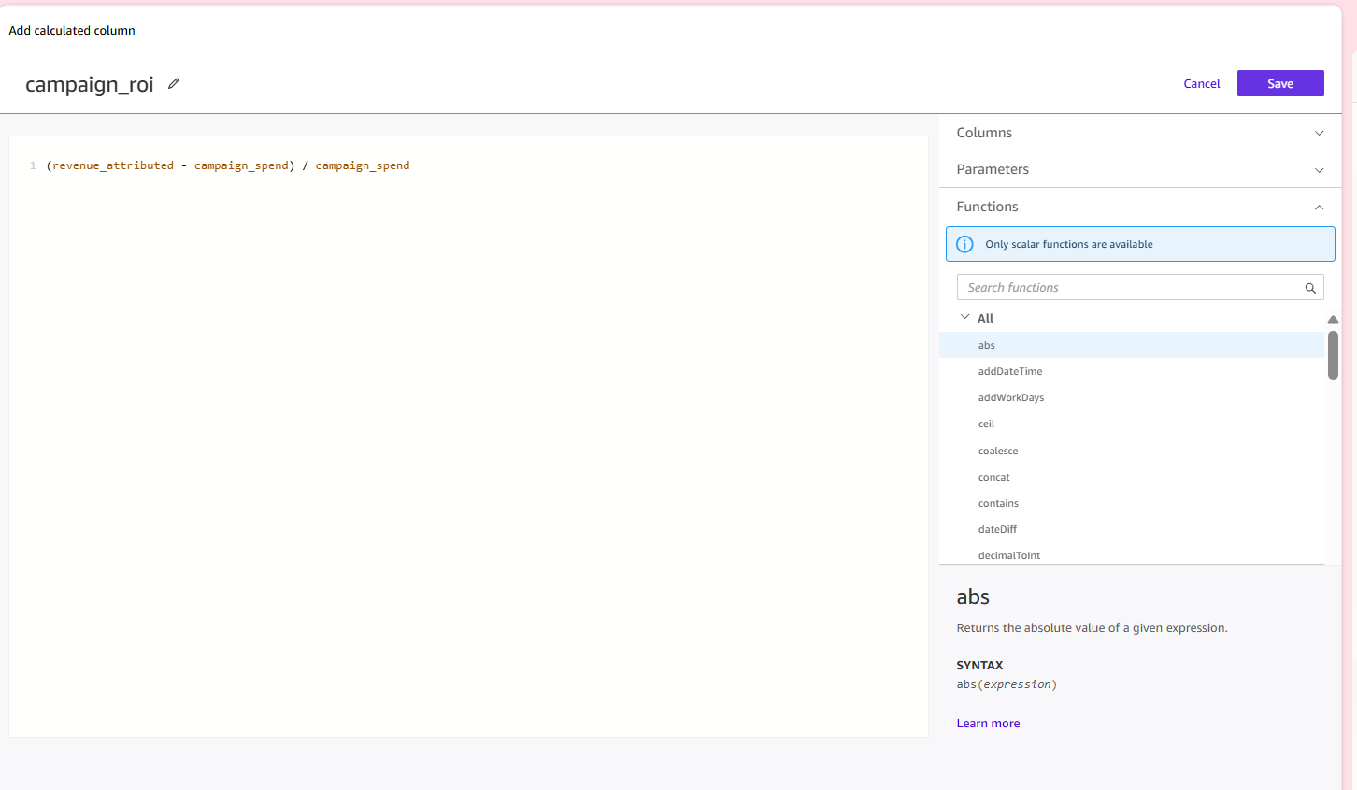
Fig. 23 — campaign_roi calculated column configuration: (revenue_attributed - campaign_spend) / campaign_spend.
4. Before clicking Save, verified it was correct that most rows would come out negative (ROI ≈ −1.0 for the majority). This is expected, not a bug: most rows are non-responders (campaign_response = 0), so revenue_attributed = 0 for them, giving (0 − spend) / spend = −1.0 exactly — a "lost 100% of what was spent, earned nothing back" result. The rows with campaign_response = 1 show less-negative values (e.g. −0.422, −0.700, −0.934), driven by how much revenue that responder generated relative to their allocated spend.
5. Clicked Save in the calculated-column editor, confirmed campaign_roi appeared as the dataset's 1 calculated column, then checked Preview before publishing.
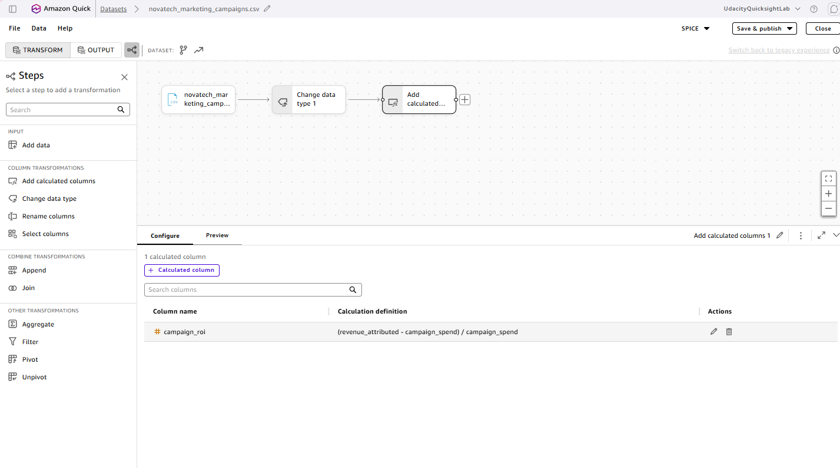
Fig. 24 — Steps canvas / Configure tab after Save, showing campaign_roi listed as the dataset's 1 calculated column.
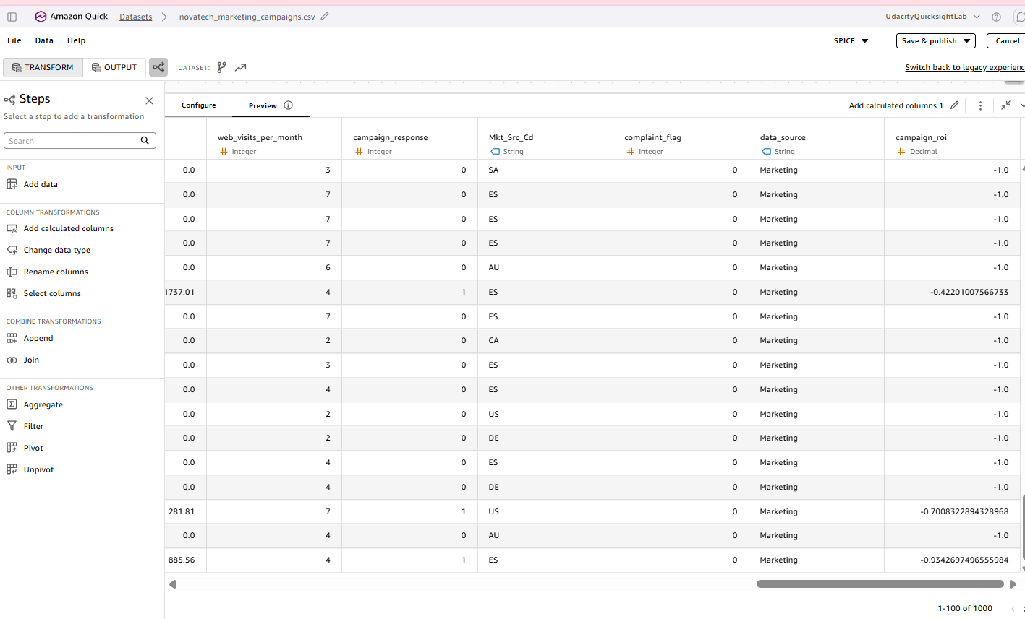
Fig. 25 — Preview tab: campaign_roi mostly -1.0 (non-responders), with less-negative values like -0.422, -0.700, -0.934 for actual responders — matching the expectation reasoned through above.

Step 9 — Publish Marketing Campaigns dataset + verify row count
1. Clicked Save & publish (top right) on the Marketing dataset editor.
2. Confirmation banner: "Saved and published successfully."
3. Navigated to Data → Datasets, opened the newly published novatech_marketing_campaigns.csv (owner: Me).
4. Dataset detail page confirms: 21 columns (the 20 original + campaign_roi), and under Refresh: "2240 rows imported (100% success)" — an exact match with both the data dictionary's expected row count and Q's answer in Verification Log entry #3 (2,240 rows). Same row-count cross-check pattern used for CRM in Step 6, applied here to Marketing.
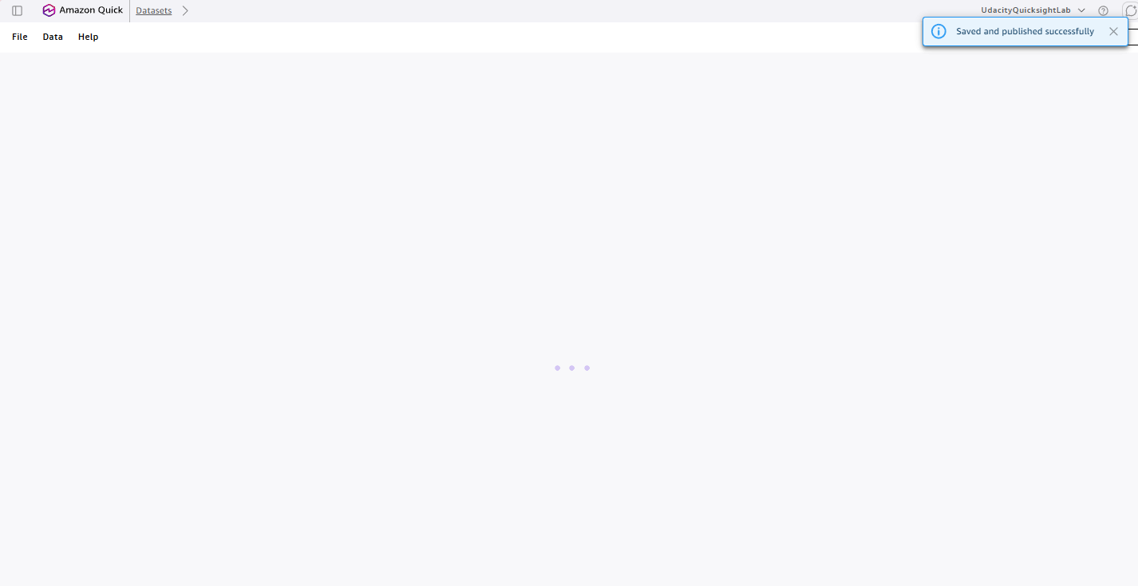
Fig. 26 — "Saved and published successfully" confirmation.
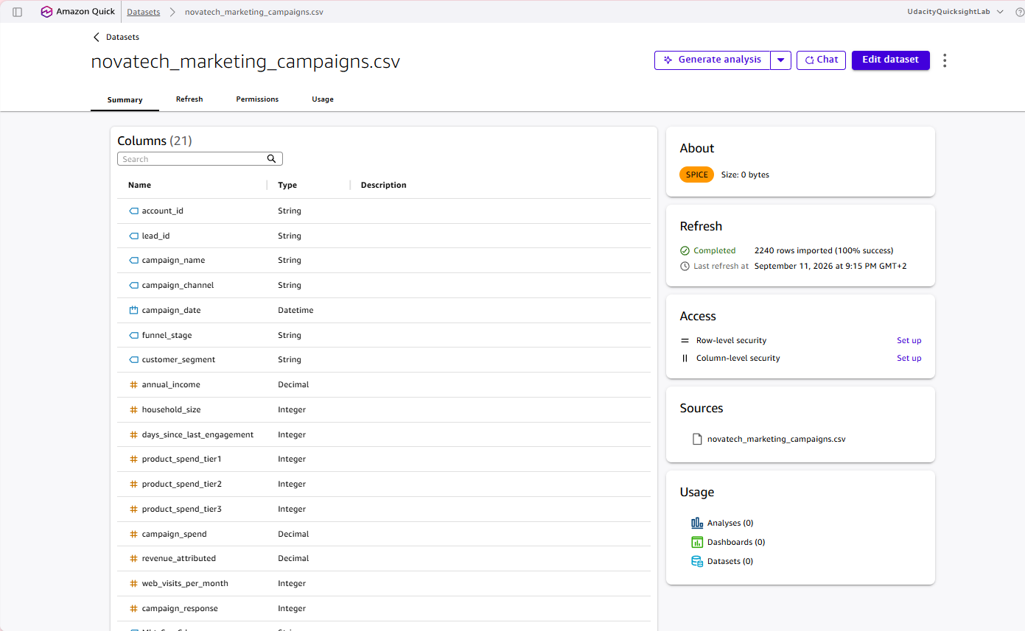
Fig. 27 — Dataset detail page: Columns (21) incl. campaign_roi, Refresh panel showing "2240 rows imported (100% success)".

Step 10 — Upload own Support Tickets dataset + check data types
1. Went to Data → Create dataset → Upload a file → selected novatech_support_tickets.csv → "Edit settings and prepare data".
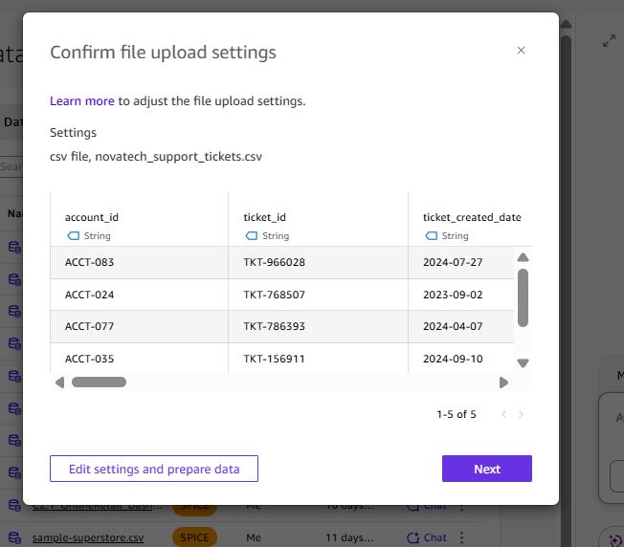
Fig. 28 — File-upload confirmation dialog for novatech_support_tickets.csv, before entering the editor.
2. QuickSight auto-suggested type changes for 9 columns. Checked every one against the data dictionary — unlike CRM (deal_value) and Marketing (annual_income), no corrections were needed this time; all 9 auto-suggested types already matched the dictionary exactly.
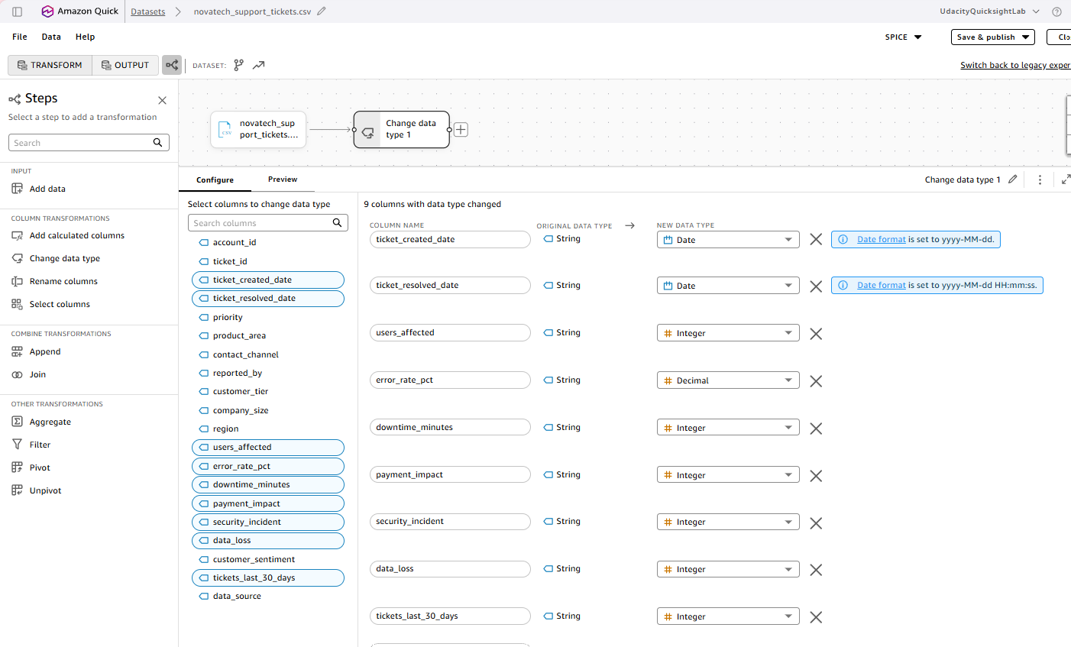
Fig. 29 — Data-prep editor with the 9 auto-suggested type changes (first 8 visible: ticket_created_date, ticket_resolved_date → Date; users_affected, downtime_minutes, payment_impact, security_incident, data_loss → Integer; error_rate_pct → Decimal).
- ticket_created_date → Date (yyyy-MM-dd) — correct
- ticket_resolved_date → Date (yyyy-MM-dd HH:mm:ss) — correct; the dictionary calls this field "DateTime," but QuickSight represents it as the same Date type with a datetime-including format string, exactly like the CRM date fields.
- users_affected, downtime_minutes, payment_impact, security_incident, data_loss, tickets_last_30_days → Integer — all correct per dictionary (confirmed tickets_last_30_days by scrolling to the bottom of the list, since it didn't fit in the first screenshot).
- error_rate_pct → Decimal — correct (dictionary: Float).
- All other columns left as String — correct per data dictionary.

Step 11 — Calculated field: resolution_time_hours (Support)
Why this metric, specifically — not an arbitrary choice:
- The data dictionary spells out the exact formula in its notes on ticket_resolved_date: "Students can compute resolution time as ticket_resolved_date − ticket_created_date."
- Sarah Chen's brief (Customer Health view) asks for a "Resolution Time by Priority" visual — this calculated field is what makes that visual possible.
- The rubric requires ≥2 calculated fields deriving a business metric the raw data doesn't already contain; resolution_time_hours is the Support-side counterpart to CRM's days_to_close (Step 5) and Marketing's campaign_roi (Step 8) — one derived business metric per dataset.
None of the raw columns is "resolution time" — it only exists once ticket_created_date is subtracted from ticket_resolved_date.
1. Clicked "Add calculated columns" in the left panel.
2. Named the field resolution_time_hours.
3. Formula: dateDiff({ticket_created_date}, {ticket_resolved_date}, "HH") — hours between ticket open and resolution. For the 59 rows where ticket_resolved_date is blank (still unresolved), the result comes out blank/null automatically — correct behavior, not an error.
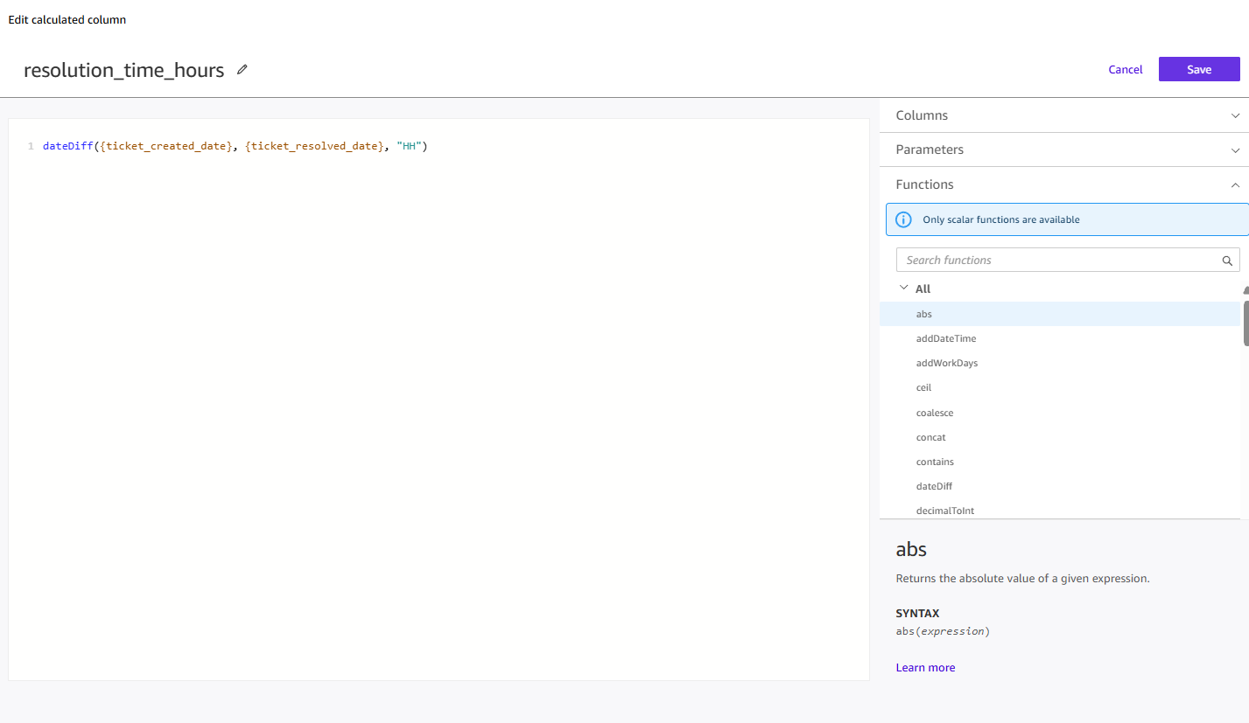
Fig. 30 — resolution_time_hours calculated column configuration: dateDiff({ticket_created_date}, {ticket_resolved_date}, "HH").
4. Clicked Save, then checked the Preview tab: resulting values ranged from single digits to low hundreds of hours (e.g. 7, 13, 14, 35, 58, 64, 81, 93, 103, 113, 115, 123, 124 in the sampled rows) — consistent with the pandas-computed average of ~56–60 hours across all priority levels calculated ahead of time.
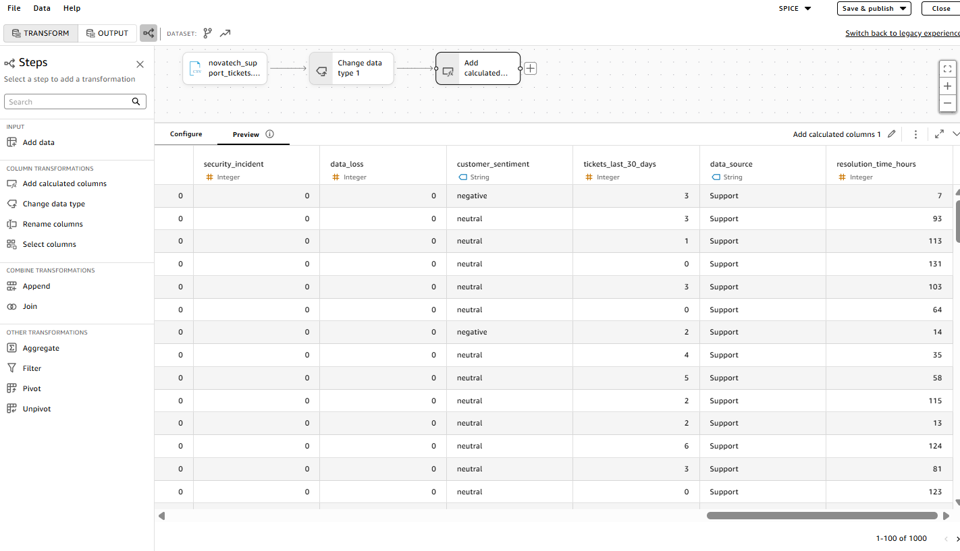
Fig. 31 — Preview tab showing the new resolution_time_hours Integer column with realistic hour values.

Step 12 — Publish Support Tickets dataset + verify row count
1. Clicked Save & publish (top right) on the Support Tickets dataset editor.
2. Confirmation banner: "Saved and published successfully."
3. Navigated to Data → Datasets, opened the newly published novatech_support_tickets.csv (owner: Me).
4. Dataset detail page confirms: 21 columns (the 20 original + resolution_time_hours), and under Refresh: "3000 rows imported (100% success)" — an exact match with both the data dictionary's expected row count and Q's answer in Verification Log entry #5 (3,000 total tickets). Same row-count cross-check pattern used for CRM (Step 6) and Marketing (Step 9), now applied to all three source datasets.
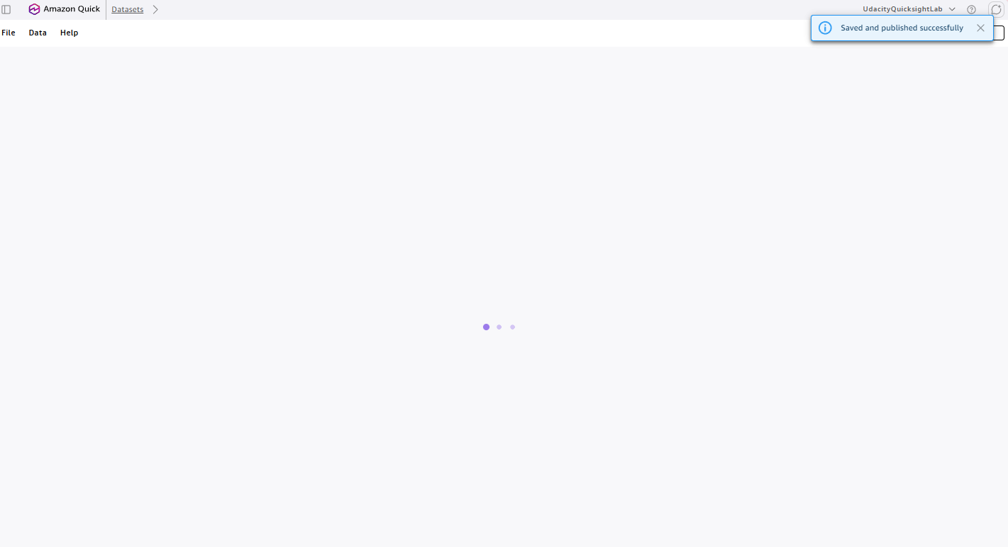
Fig. 32 — "Saved and published successfully" confirmation.
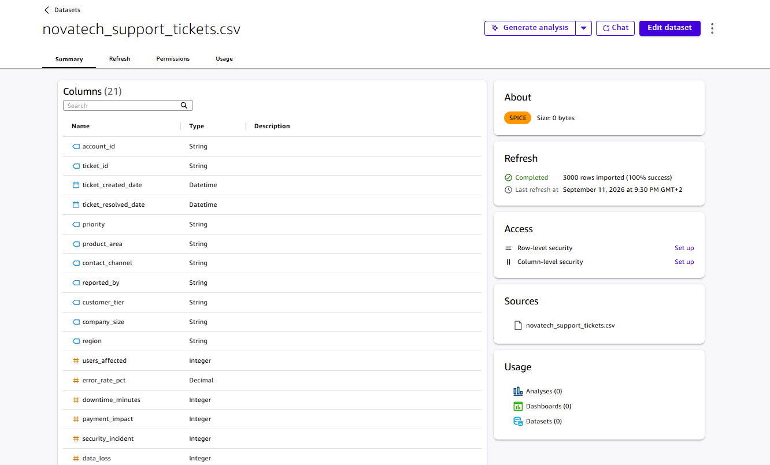
Fig. 33 — Dataset detail page: Columns (21), Refresh panel showing "3000 rows imported (100% success)".
All three source datasets are now uploaded, type-corrected, enriched with one derived calculated field each, and published to SPICE: CRM Deals (499 rows, days_to_close), Marketing Campaigns (2,240 rows, campaign_roi), Support Tickets (3,000 rows, resolution_time_hours).

Step 13 — Build the unified dataset: Join CRM + Marketing (Join 1)
Join strategy (simulated with pandas beforehand, before touching QuickSight):
- Anchor: CRM Deals. Every dollar Sarah's team tracks starts at a deal, so a left join guarantees no deal silently disappears even if an account has no marketing touch or no support ticket on file.
- CRM LEFT JOIN Marketing on account_id → simulated ~13,738 rows.
- Result LEFT JOIN Support on account_id → simulated ~63,420 rows.
- Why LEFT, not INNER: an INNER join would drop deals for accounts with zero rows in Marketing or Support — a real, expected case, not a data error — which would quietly undercount CRM Deals rows in the unified dataset.
- Why the row count grows (fan-out) is fine: the rubric expects the unified dataset to have more rows than any individual source. Any visual later built from it uses COUNT DISTINCT on the relevant ID field instead of plain COUNT(*), so the fan-out never silently inflates a KPI.
Getting to the right starting screen (a wrong turn to avoid): Data → Create dataset only lets you pick a data source (a file upload or connector) — it does not list already-published datasets, so searching for novatech_crm_deals there finds nothing. The correct path is different:
1. Went to Data → Datasets (the list, not "Create dataset").
2. Found the student's own novatech_crm_deals.csv, clicked its ⋮ menu.
3. Chose "Use in a new dataset" — not "Edit". "Edit" would open and modify the original CRM dataset in place; "Use in a new dataset" uses it as a starting point for a brand-new dataset, leaving the original CRM dataset (used for its own single-source KPIs) untouched.
4. Renamed the new dataset to NovaTech Unified Account Dataset.
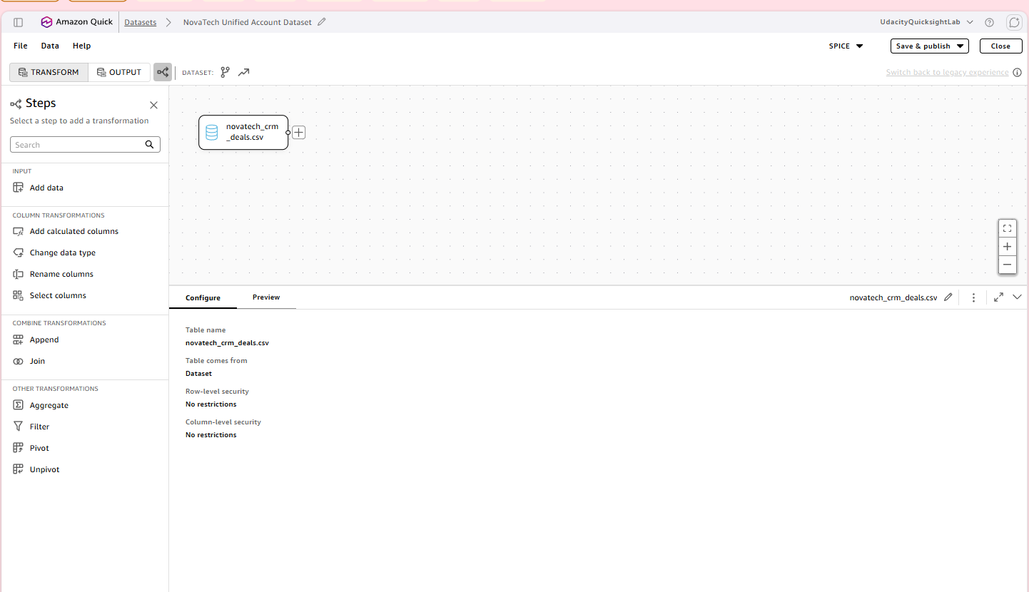
Fig. 34 — ⋮ context menu on the CRM dataset row, "Use in a new dataset" option.
5. Clicked "Add data" in the left panel → Dataset tab → selected novatech_marketing_campaigns.csv → Select.
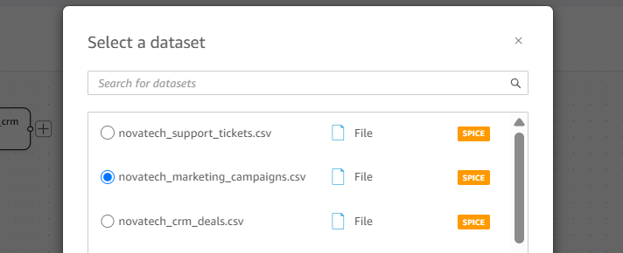
Fig. 35 — Select a dataset dialog, Marketing selected — ignoring the leftover "Joined Data" artifacts from someone else's earlier pass through this shared lab.
6. Clicked "Join" in the left panel.
7. Configured: Left table = novatech_crm_deals.csv, Right table = novatech_marketing_campaigns.csv, Join type: Left join, Join keys: account_id = account_id.
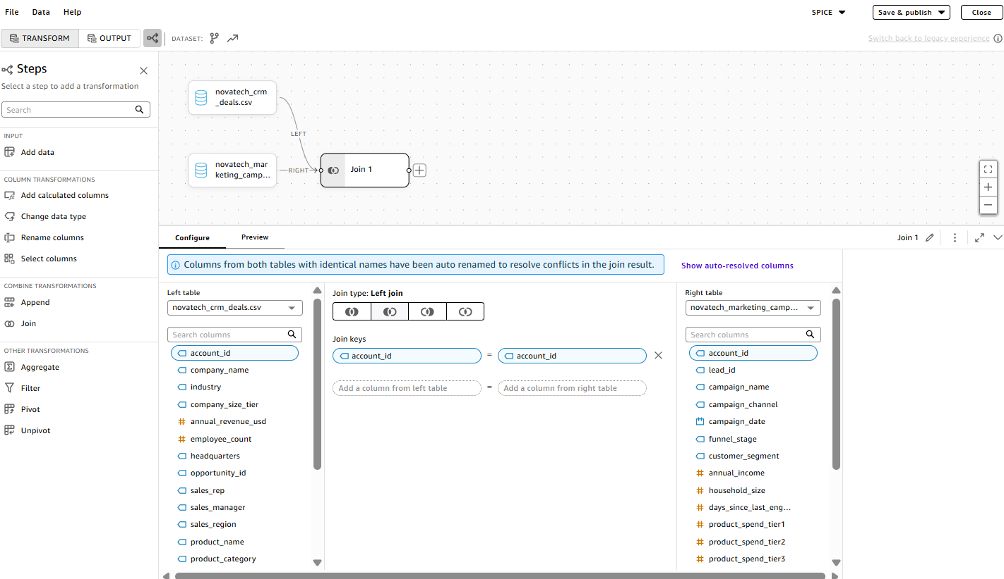
Fig. 36 — Join 1 configuration, correct as described.
8. Checked the Preview: confirmed the expected fan-out (e.g. account ACCT-082 appearing 5 times in a row, once per matching marketing touchpoint) and the expected nulls (a CRM row with no Marketing match shows blank Marketing-side columns) — both are correct LEFT JOIN behavior, not errors.
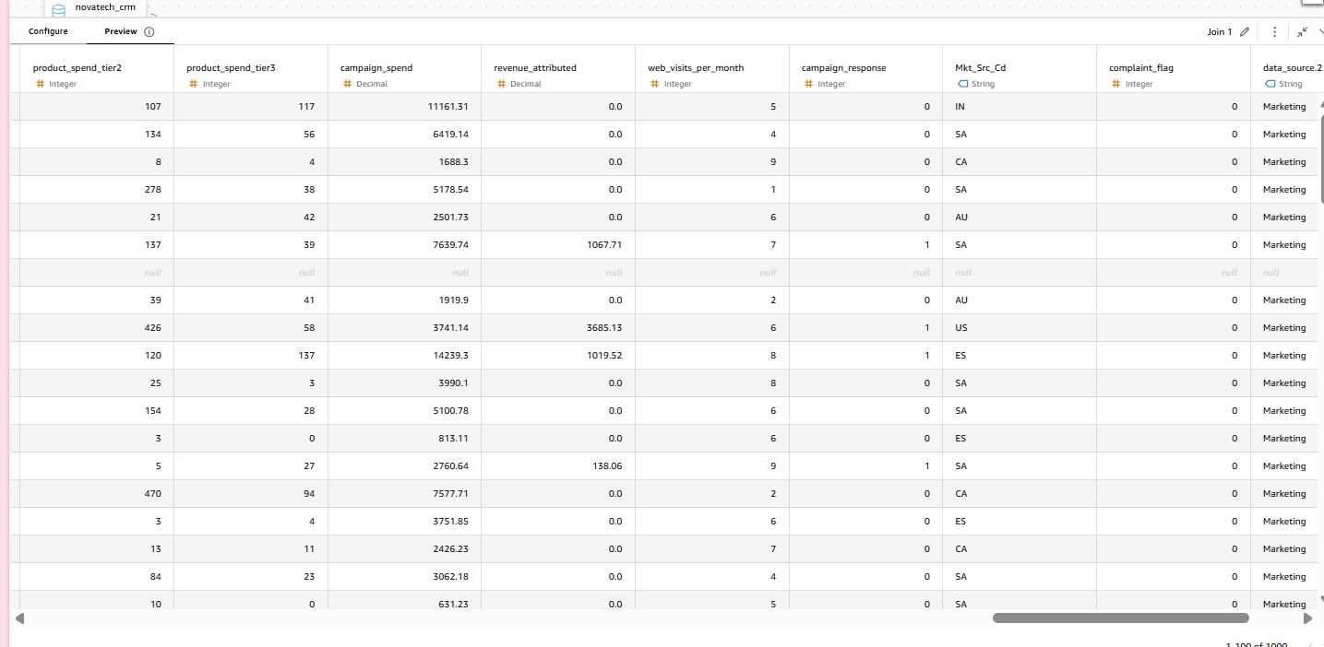
Fig. 37 — Preview tab showing the fan-out and a null-filled row for an unmatched account.
9. Opened "Show auto-resolved columns": since both tables have an account_id column, QuickSight automatically renamed the CRM (left table) one to account_id.1 and the Marketing (right table) one to account_id.2. This matters for the next join — Support Tickets must be matched against account_id.1 (the CRM-originated column, always populated) and not account_id.2 (the Marketing-originated column, null wherever Join 1 had no match).
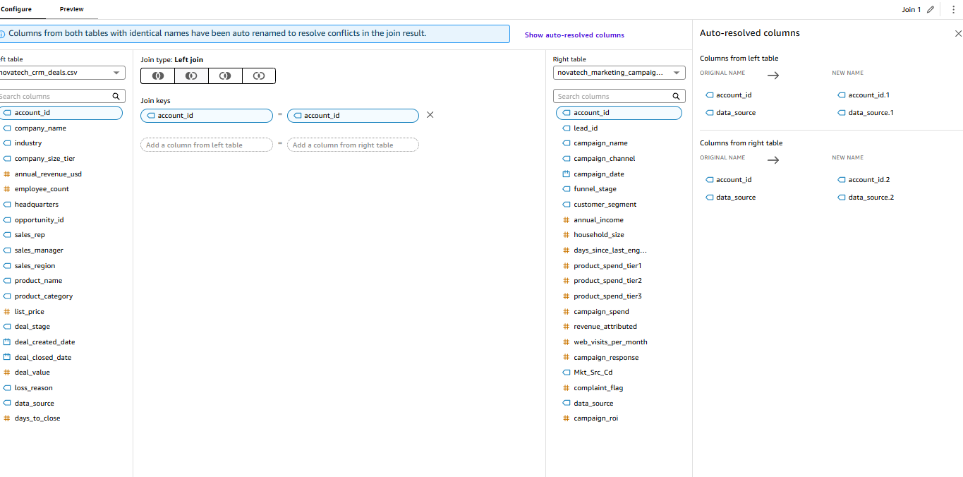
Fig. 38 — Auto-resolved columns panel showing the account_id → account_id.1 / account_id.2 rename.
Caution: the browser tab was accidentally closed before publishing at this point, and the whole in-progress join configuration was lost — QuickSight's data-prep editor does not autosave a draft. Steps 1–9 above had to be redone from scratch. Lesson: stay in the editor tab until Save & publish has been clicked.

Step 14 — Join Support Tickets (Join 2) + publish + verify row count
1. Clicked "Add data" again → Dataset → selected novatech_support_tickets.csv → Select.
2. Clicked "Join" again to create Join 2.
3. Common mistake caught and corrected: the first attempt had Left table = novatech_support_tickets.csv, Right table = Join 1 — backwards. In a Left join, the left side is the side whose rows are all preserved; putting Support Tickets on the left would have made Support the anchor instead of CRM, silently dropping any CRM deal with zero support tickets. Corrected to: Left table = Join 1 (the CRM+Marketing result), Right table = novatech_support_tickets.csv, Join type: Left join, Join keys: account_id.1 (the CRM-originated column from Join 1) = account_id (Support Tickets' own).
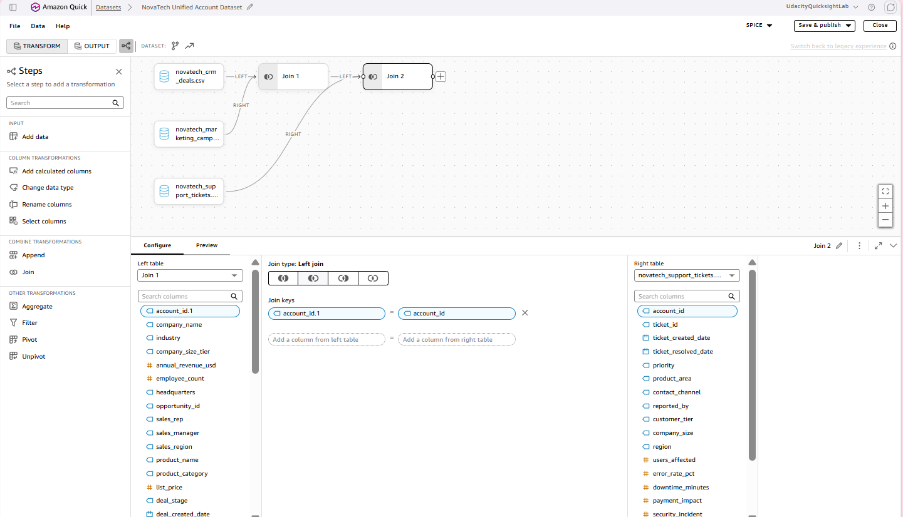
Fig. 39 — Join 2 correctly configured: Left table = Join 1, Right table = Support Tickets, keys account_id.1 = account_id.
4. Checked the Preview one more time, then clicked Save & publish.
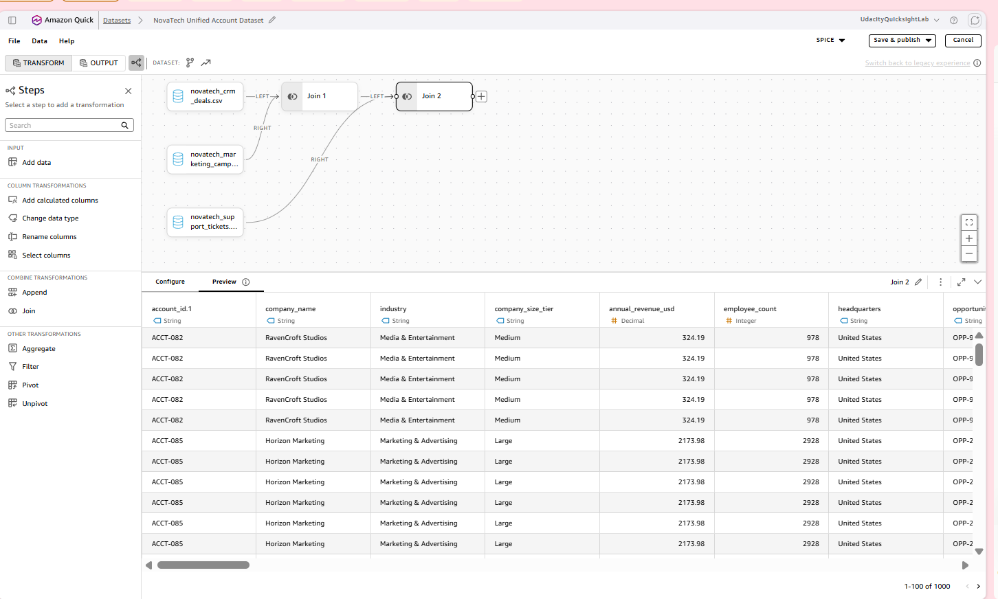
Fig. 40 — Preview of the fully 3-way-joined result, Save & publish visible top-right.
5. Navigated to Data → Datasets, opened NovaTech Unified Account Dataset. Dataset detail page confirms: 63 columns (all fields from CRM, Marketing, and Support combined, including the three calculated fields), and under Refresh: "63420 rows imported (100% success)" — an exact match with the pandas join-strategy simulation computed ahead of time, confirming the join was built correctly. The Sources panel lists all three underlying CSVs, confirming this is genuinely a 3-way join and not an accidental 2-way one.
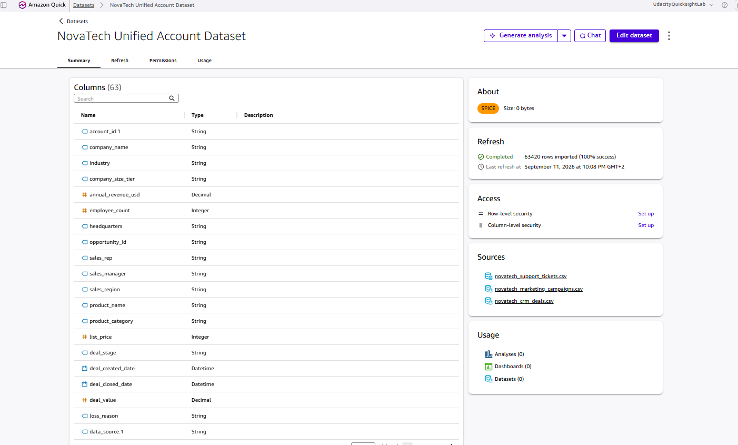
Fig. 41 — Dataset detail page: Columns (63), Refresh panel showing "63420 rows imported (100% success)", Sources listing all three CSVs.
Task #6 (unified joined dataset) is now complete — the row count matched the pre-computed pandas simulation exactly (63,420).

Appendix — Verification Log (full table)
Minimum requirement: at least 6 entries covering all three knowledge bases. Result: 6/6, all Matches.
# | Knowledge Base | Question Asked | Expected Answer | Q's Actual Answer | Match? | Notes
1 | NovaTech CRM Deals | How many total deals are in the CRM dataset, and how many are Won vs Lost? | 499 total deals — 315 Won, 184 Lost | Total Deals: 499. Won: 315 (63.1%). Lost: 184 (36.9%). | Yes | Exact match, incl. win rate.
2 | NovaTech CRM Deals | What date range does the CRM deals data cover, and how many unique accounts are there? | 2023-06-17 to 2025-01-25; 85 unique accounts | Deal Created: Jun 17 2023 → Jan 25 2025; 85 unique accounts | Yes | Exact match.
3 | NovaTech Marketing Campaigns | How many rows are in the marketing campaigns data, and what is the overall campaign response rate? | 2,240 rows; 27.2% response rate (609/2,240) | Total Rows: 2,240. Responses: 609. Rate: 27.19%. | Yes | Exact match.
4 | NovaTech Marketing Campaigns | How many rows in the marketing campaigns data have a missing or null annual_income value? | 24 rows (1.1%) | 24 rows, 1.07% of 2,240 | Yes | Exact match.
5 | NovaTech Support Tickets | How many total support tickets are there, and what is the breakdown by priority level? | 3,000 total — low 1,500, medium 1,050, high 400, critical 50 | 3,000 total. Low 1,500 (50%), Medium 1,050 (35%), High 400 (13.3%), Critical 50 (1.7%) | Yes | Exact match, table shown.
6 | NovaTech Support Tickets | How many support tickets have a null or missing ticket_resolved_date (still unresolved)? | 59 rows (2.0%) | 59 tickets, ~2% of 3,000 | Yes | Exact match.

Cross-Check: Total row count of the CRM Deals dataset (entry #1). Chat said 499 total deals. QuickSight's dataset detail page for the student's own uploaded novatech_crm_deals.csv shows "499 rows imported (100% success)" under Refresh. Consistent — exact match.

