NovaTech Revenue Intelligence: Quick Chat Q&A Log
Each question is labeled BEFORE. Where an after-fix answer has also been captured, it is stacked directly underneath. New questions asked only in the after (Topic-fixed) state appear at the end.
Q: Which campaign channel drives the most revenue?
BEFORE
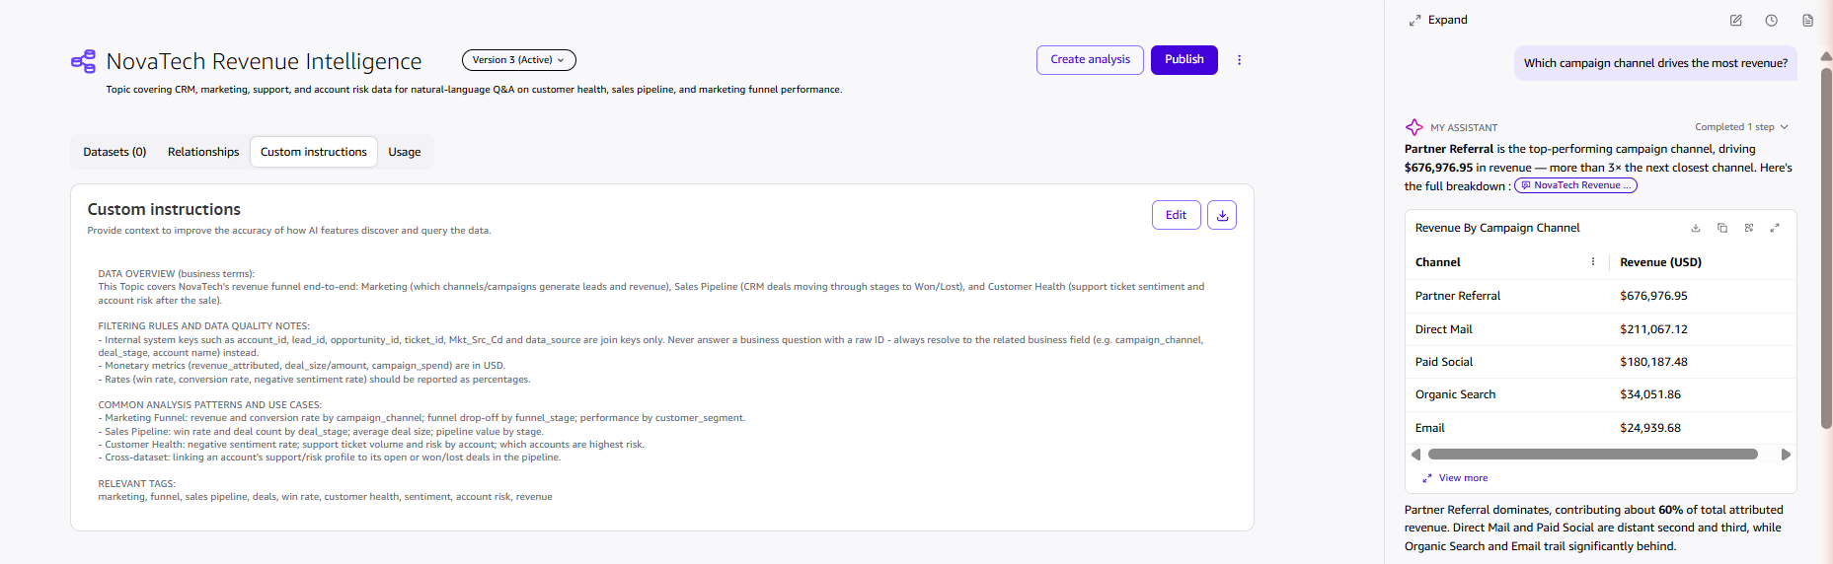
AFTER
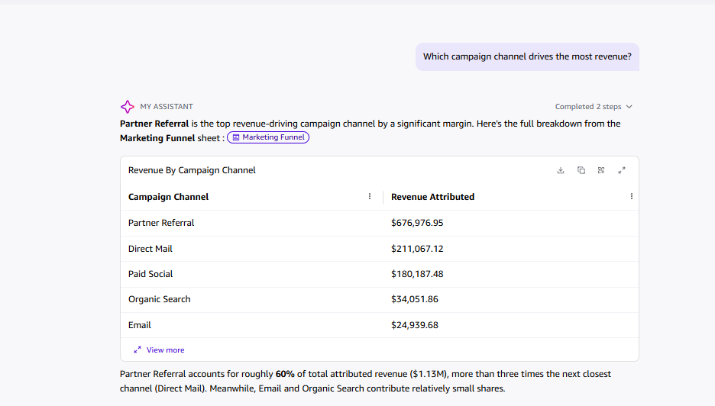
Q: Which campaign channel has the highest average response rate?
BEFORE
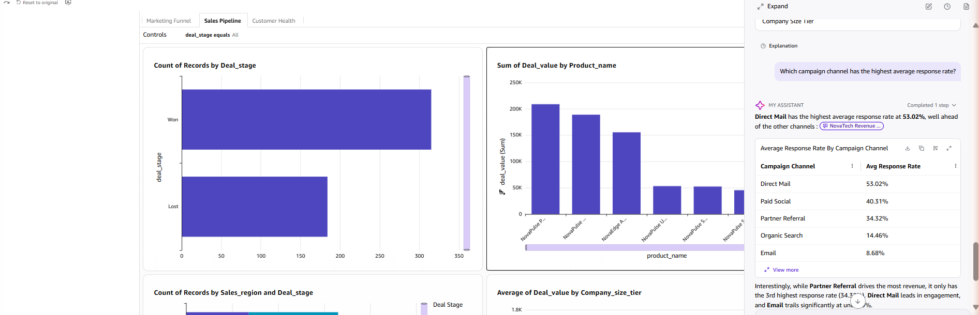
AFTER
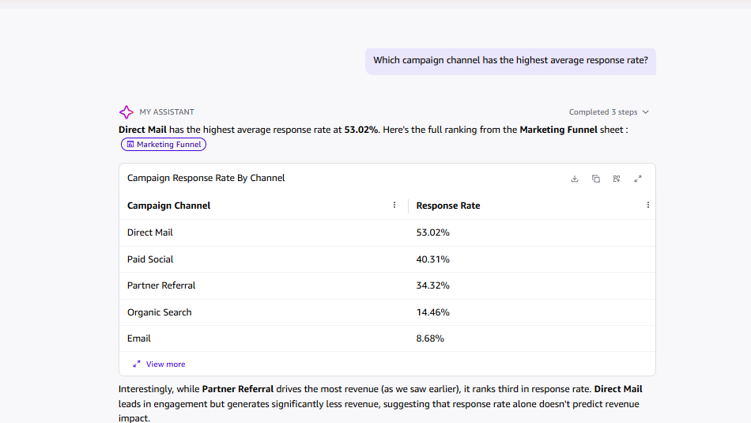
Q: What is the win rate in the Sales Pipeline sheet?
BEFORE
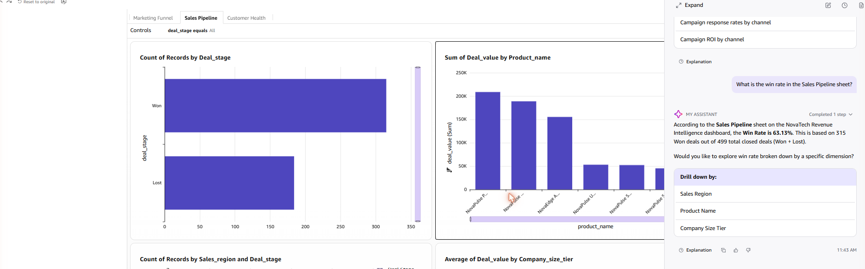
AFTER
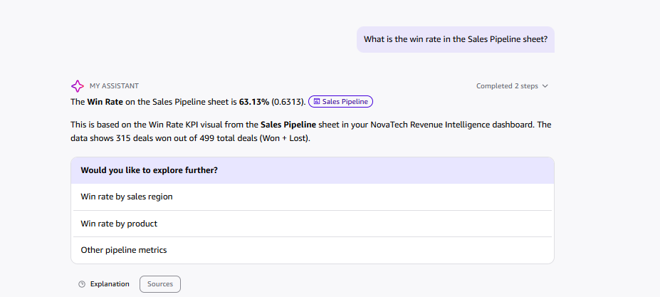
Q: What is the average deal size by company size tier?
BEFORE
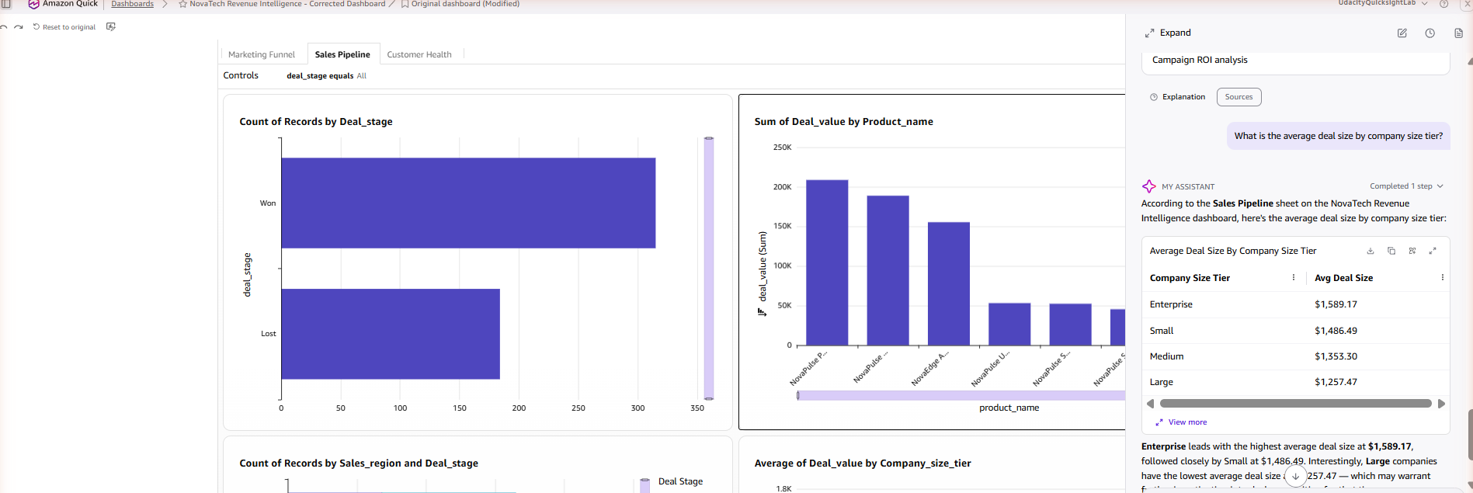
Q: Which product area receives the most support tickets, and what is the average resolution time for critical priority tickets?
BEFORE
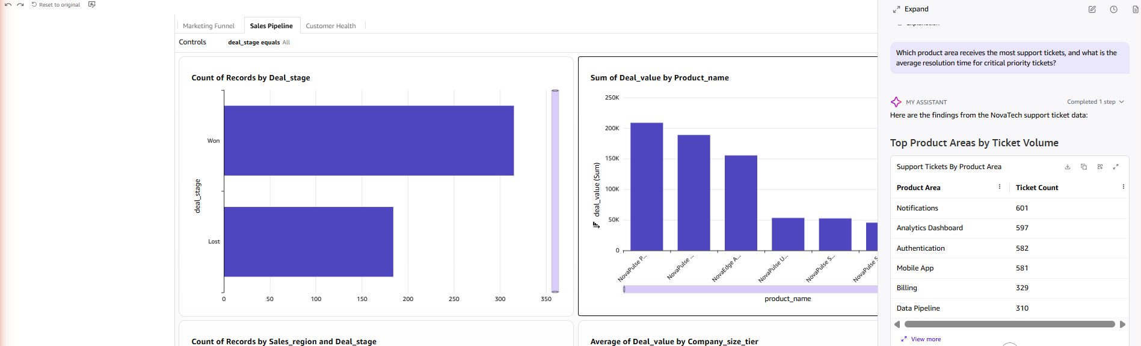
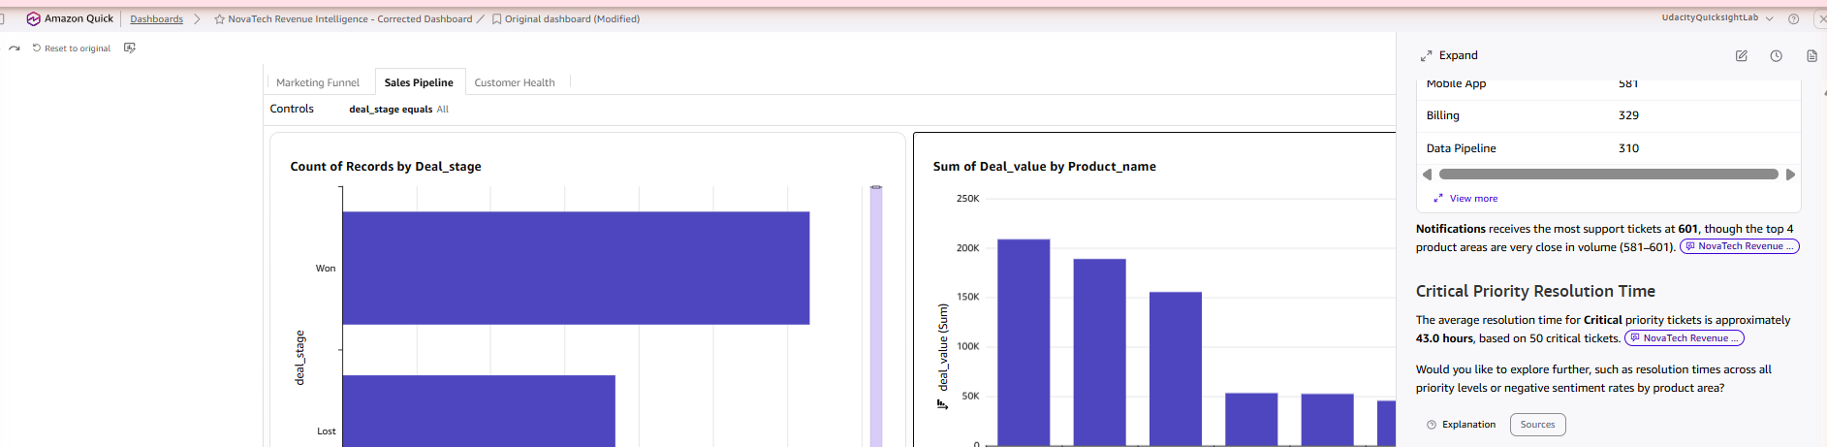
AFTER
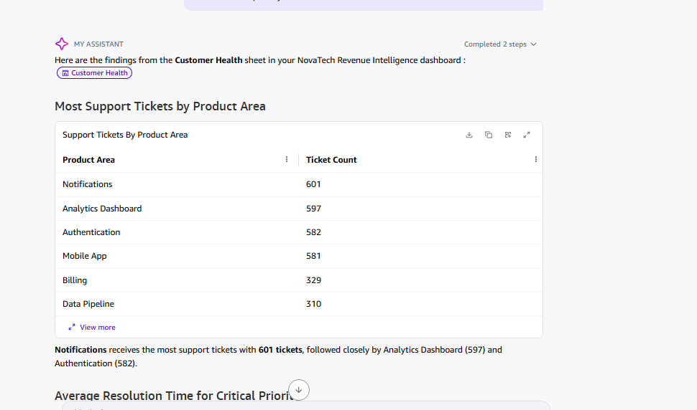
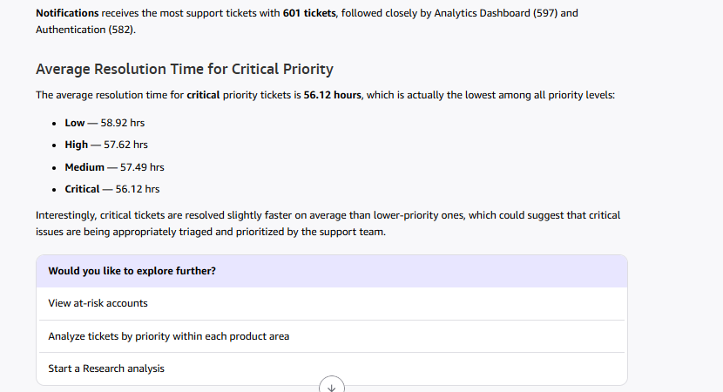
Note: the before answer reported 43.0 hrs average resolution for critical tickets (based on a 50-ticket subset); the after answer reports 56.12 hrs as part of a full priority breakdown, consistent with a separate "average resolution time" query (56.13 hrs). Minor inconsistency, likely due to different underlying filters/sample sizes used by Quick Chat between runs.
Q: Which accounts have both high support ticket volume and high total deal value at risk? (cross-dataset)
BEFORE
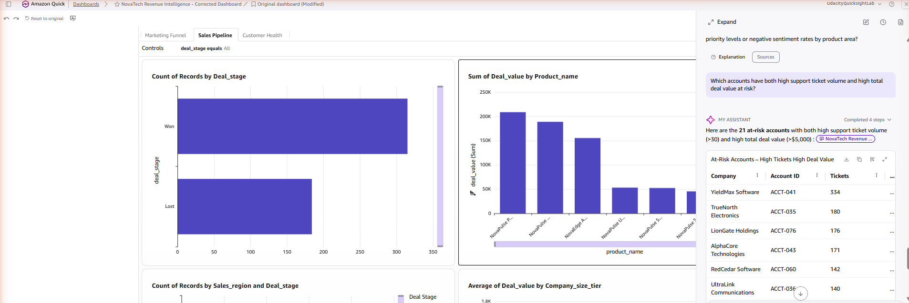
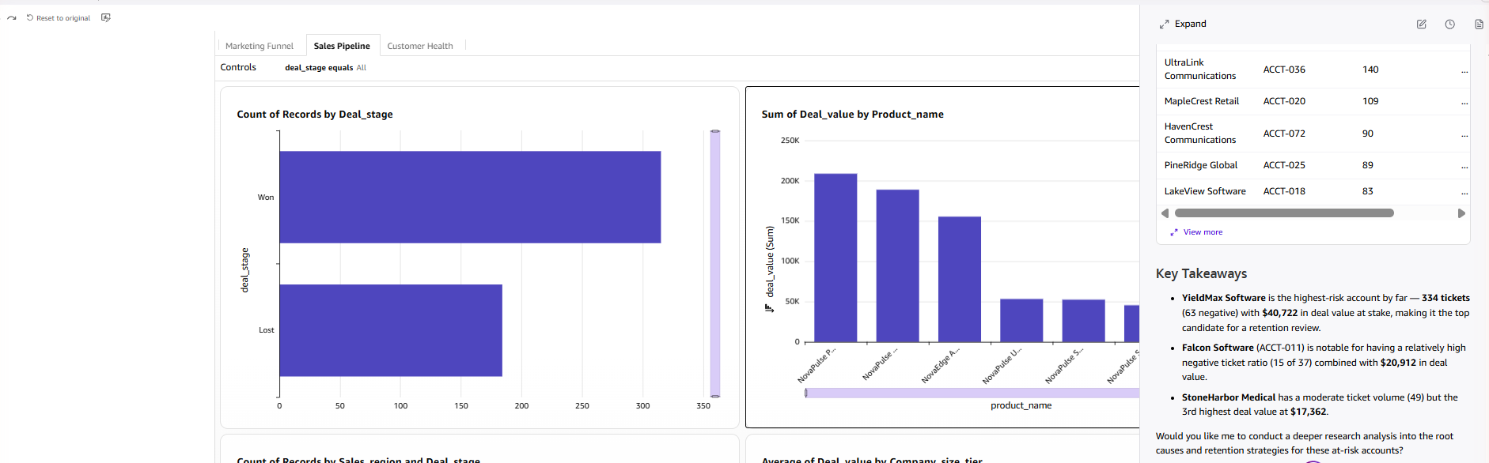
AFTER
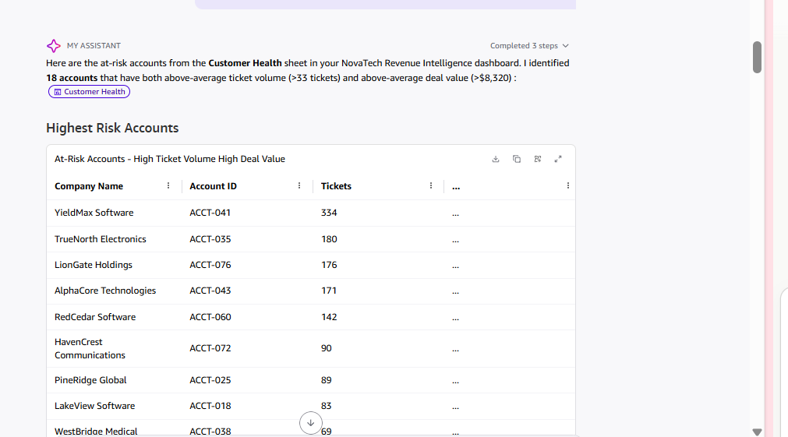
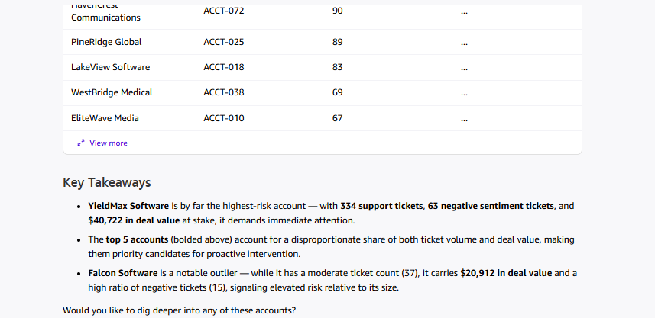
Q: Which campaign has the worst ROI, and what is the average campaign ROI overall?
BEFORE
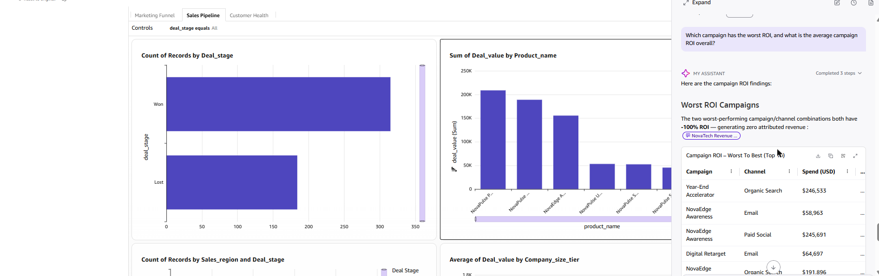
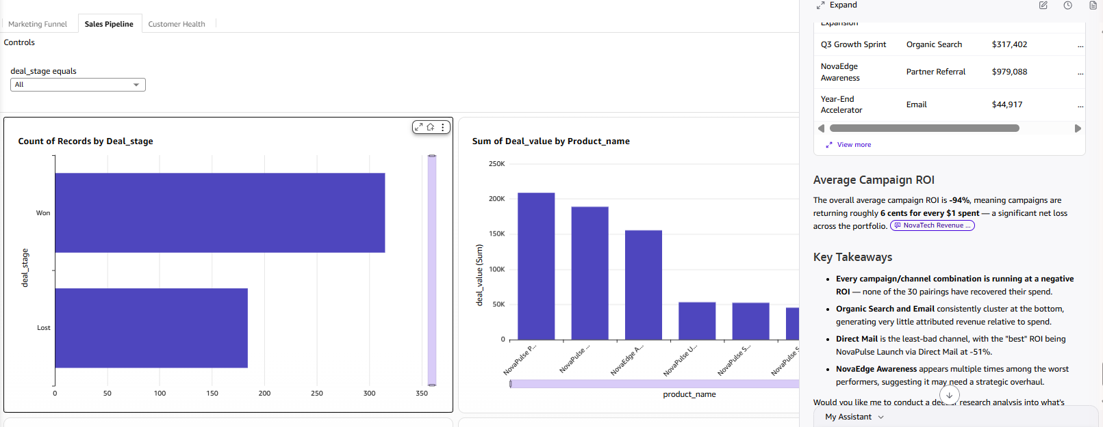
AFTER
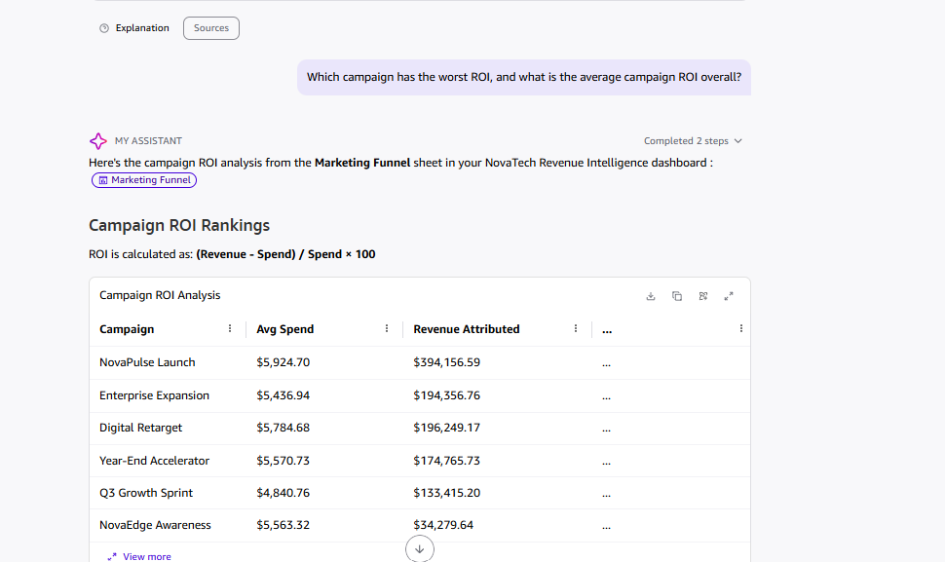
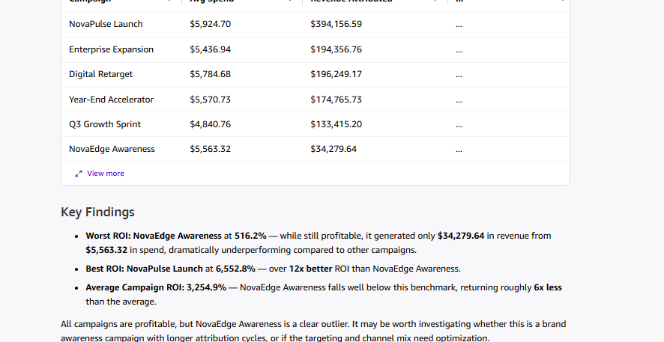
Note – measurable accuracy improvement from the Topic (Task 10/11 finding): the before-Topic baseline computed ROI per campaign–channel pairing by summing campaign_spend across all lead-level rows, yielding an inflated, all-negative result (average −94%). A follow-up query of the underlying Marketing Funnel dataset shows why: campaign_spend is a campaign-level value duplicated ("fanned out") across every lead row of that campaign, so SUMing it multiplies the true spend by the number of leads – a classic data-fan-out trap. After Topic configuration, Quick Chat instead uses the campaign-level average spend (the dashboard's own visual is explicitly labeled “Avg Campaign Spend vs Total Revenue by Campaign – spend fan-out corrected”), which correctly recovers the true single per-campaign spend figure, while revenue_attributed is a genuine per-lead value that still sums correctly across channels (channel sums for NovaPulse Launch total exactly $394,156.59, matching the campaign total). The after-Topic ROI (average +3,254.9%; worst NovaEdge Awareness at 516.2%, best NovaPulse Launch at 6,552.8%) is therefore the accurate figure. This is a concrete, verifiable example of the Topic measurably improving Quick Chat's accuracy on this dataset – exactly the goal of Task 10 – and is documented here as a key before/after finding for Task 11.
New Questions (After / Topic-Fixed State Only)
Q: What is the conversion rate by campaign channel?
AFTER
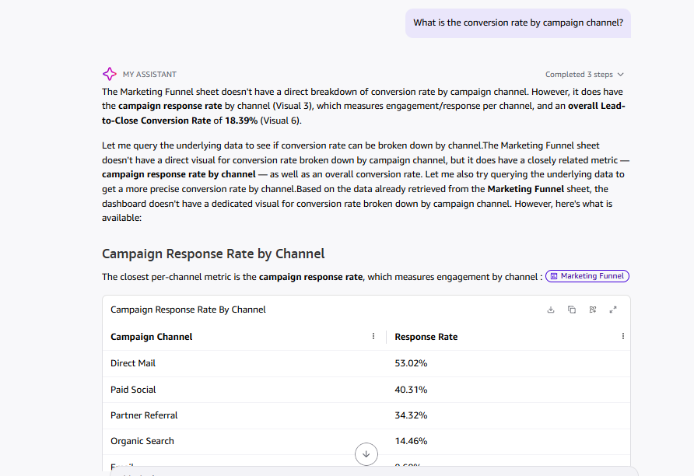
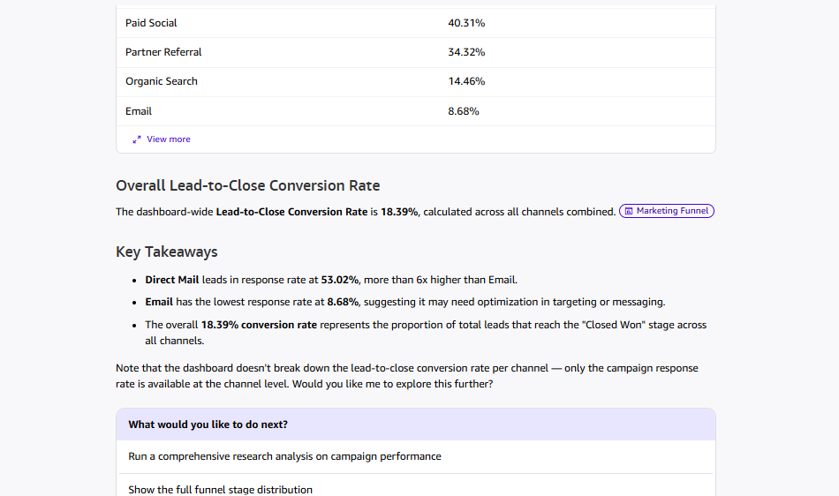
Q: What is the total pipeline value by deal stage?
AFTER
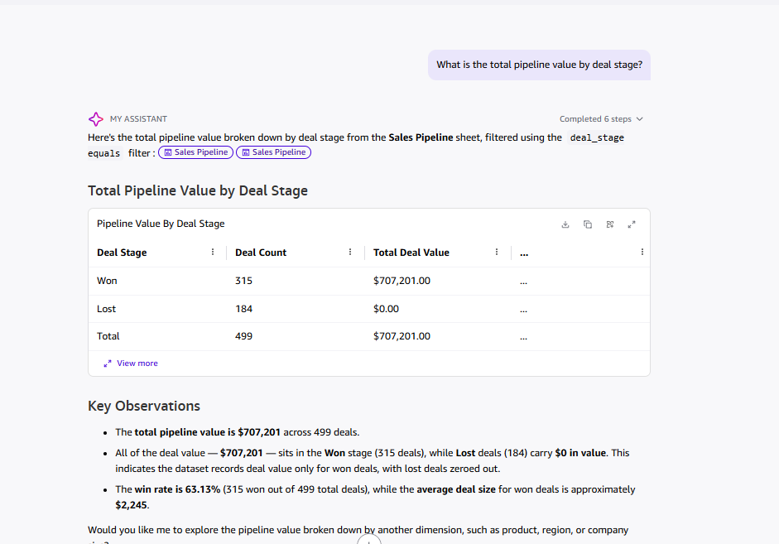
Q: What is the negative sentiment rate by account, and which accounts have the highest negative sentiment rate?
AFTER
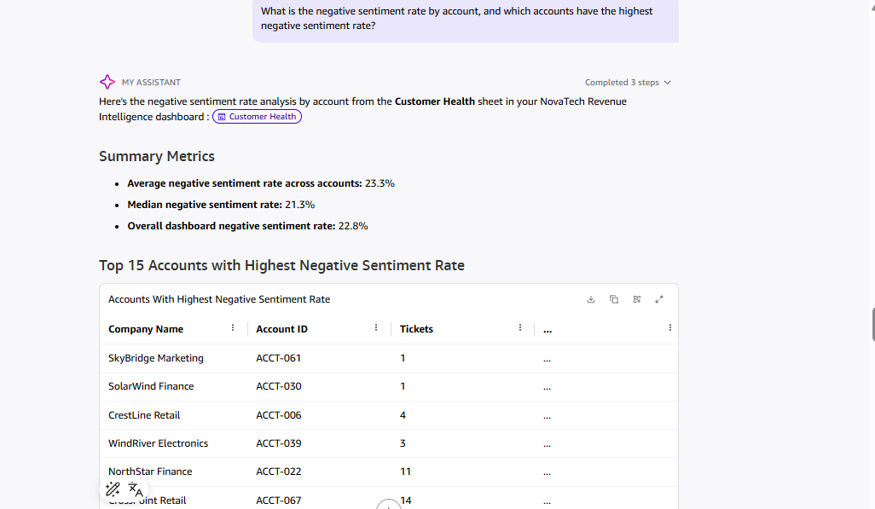
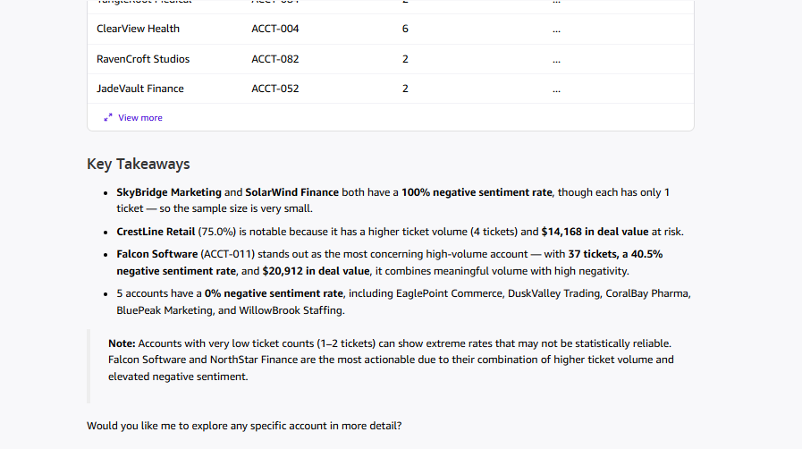
Q: How does an account's support ticket risk profile relate to whether their deal was Won or Lost? (cross-dataset)
AFTER
