NovaTech Revenue Intelligence Dashboard

Step-by-Step Guide — how this project was built, click by click
Student: Ecem Bökenheide
Course: Future AWS Agentic AI Business Professional → Business Intelligence and Knowlege Management Foundations with Amazon Quick → Project: Revenue Intelligence Dashboard for NovaTech Solutions
This document logs, in order, every step taken to complete the project — what was clicked, which option was chosen, and why — so it can be reproduced independently. Screenshots are included where relevant. The full Verification Log table is included at the end.

Step 0 — Read the reference materials
1. Opened the Instructions, Project Overview, Environment Setup, and Project Rubric pages in the Udacity classroom to understand the full task list, deliverables, and grading criteria.
2. Opened Lesson Resources → Download and downloaded Project-Starter-Resources.zip — it contains the 3 starter CSVs, the data dictionary, Sarah Chen's dashboard requirements brief, the company background brief, and the two log templates.
3. Read the Data Dictionary (field definitions, expected row counts: CRM 499, Marketing 2,240, Support 3,000; known data-quality issues: 24 nulls in annual_income, 59 nulls in ticket_resolved_date; shared join key account_id), Sarah Chen's brief (the 3 dashboard views and their required metrics/filters), and the Company Background (NovaTech Solutions context).
Key decisions this informed: join key across all 3 datasets is account_id; Marketing and Support each contain ~150–204 "orphan" account IDs (ACCT-101–115) not present in CRM, which is intentional per the data dictionary and directly affects the join-type decision later; calculated fields to build: days_to_close (CRM), campaign_roi (Marketing), resolution_time_hours (Support).

Step 1 — Open the AWS lab environment
1. In the Udacity lesson, clicked the Cloud Resources tab (bottom toolbar) → Open Cloud Console. This is the Vocareum-provided, pre-configured AWS account for the lab (no personal AWS account needed) — it has a $25 budget cap and session time limits.
2. This opened a new browser tab/window that federates into Amazon Quick (QuickSight) at us-west-2.quicksight.aws.amazon.com/sn/account/UdacityQuicksightLab/start/home.
Note: the federation link is single-use and expires quickly — if it shows "The link has expired," go back to Cloud Resources and click Open Cloud Console again to mint a fresh link.

Step 2 — Finding the pre-indexed knowledge bases
1. Clicked New chat in the left nav of Amazon Quick.
2. Clicked the data-scope selector under the question box (default "All data") → opens an "Add Quick assets" picker with tabs: Recents, Favorites, Spaces, Topics, Dashboards, Knowledge Bases, Actions, Datasets.
3. The Knowledge Bases tab was empty. In this lab's Amazon Quick setup, the instructor's pre-indexed sources are exposed as regular Datasets, not separate "Knowledge Base" objects — this matches the Environment Setup page: "Locate the pre-indexed knowledge bases under Datasets and in Quick Chat."
4. On the Datasets tab (page 2, since this is a shared/reused Vocareum lab account with prior activity), found the actual instructor-provided sources: novatech_crm_deals.csv, novatech_support_tickets.csv, novatech_marketing_campaigns.csv — all owned by "Others", created 6 months ago. These are treated as the "pre-indexed knowledge bases — created by the instructor, do not modify."
Also present, and deliberately ignored: same-named datasets owned by "Me" from 10 days ago, plus a pre-built "NovaTech Unified Account-Level Dataset" and "Account Risk Summary" owned by "Others" — leftovers from someone else's earlier pass through this shared lab. This project's own deliverables are built from a fresh upload of the starter CSVs instead of reusing them.
5. Checked the boxes for all three "Others" / 6-months-ago datasets at once, then clicked Save, scoping the chat to all three instructor knowledge bases together.
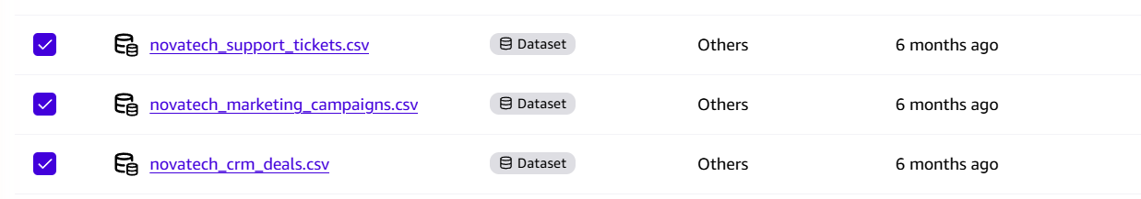
Fig. 1 — "Add Quick assets" picker, Datasets tab, page 2: all three instructor novatech_*.csv datasets (owned by "Others", 6 months old) checked before clicking Save.

Step 3 — Verify the knowledge bases (Verification Log)
Asked 6 questions, 2 per knowledge base, each chosen because the correct answer was already known from the data dictionary (cross-checked against the raw CSVs with pandas beforehand), so Q's answer could be objectively marked Match / No Match rather than just judged as "sounds plausible." Question mix was deliberately varied: row counts, category breakdowns, date ranges, null counts.

CRM Deals
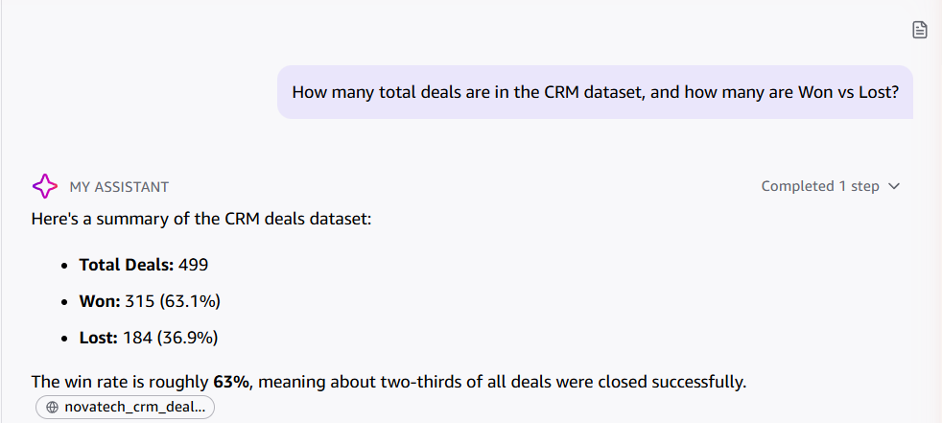
Fig. 2 — Q1: total deals + Won/Lost breakdown. Match: 499 total, 315 Won (63.1%), 184 Lost (36.9%).
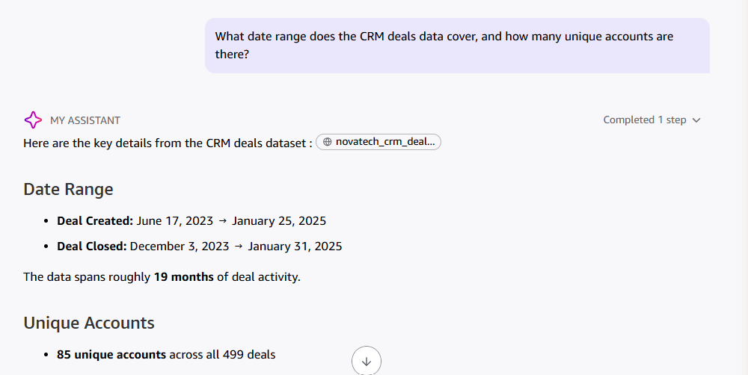
Fig. 3 — Q2: date range + unique accounts. Match: Jun 17 2023 → Jan 25 2025, 85 unique accounts.

Marketing Campaigns
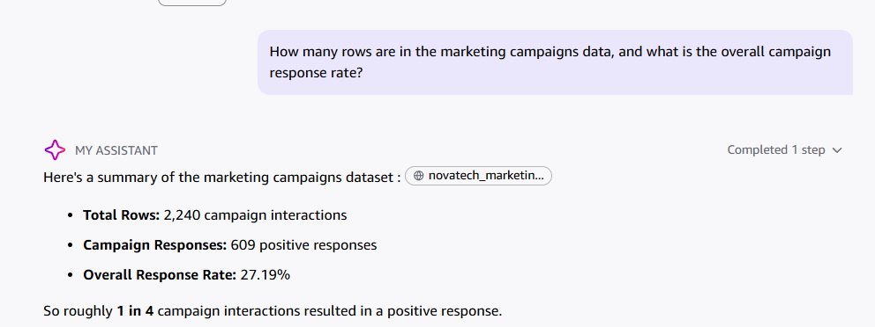
Fig. 4 — Q3: row count + response rate. Match: 2,240 rows, 27.19% response rate.
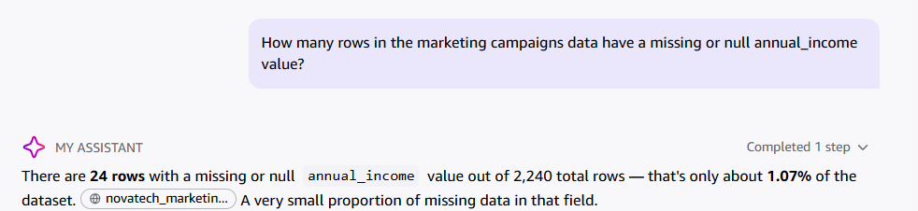
Fig. 5 — Q4: null count on annual_income. Match: 24 rows, 1.07%.

Support Tickets
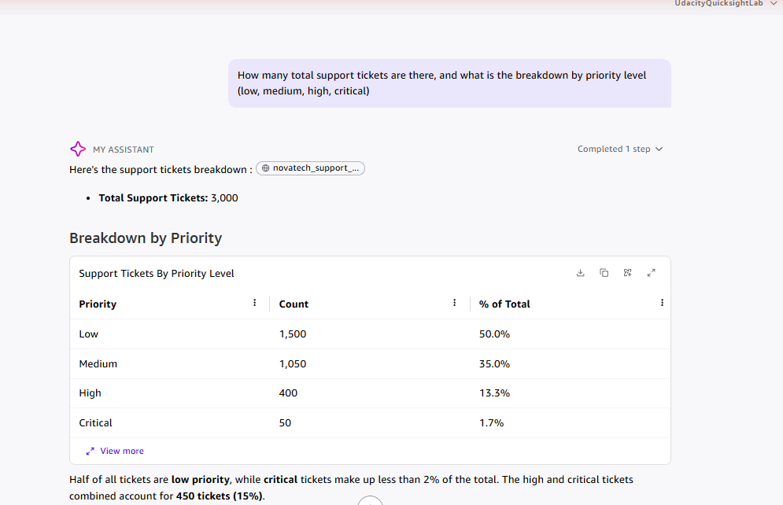
Fig. 6 — Q5: total tickets + priority breakdown. Match: 3,000 total; Low 1,500 / Medium 1,050 / High 400 / Critical 50.
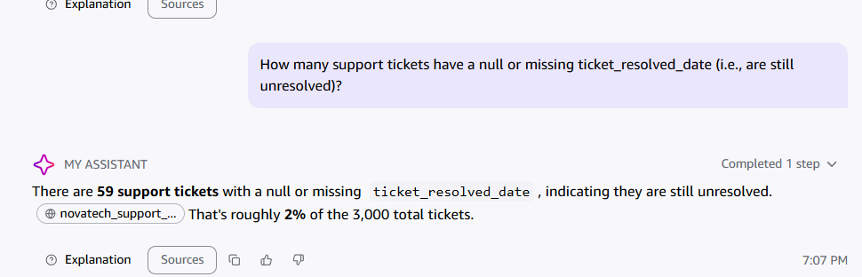
Fig. 7 — Q6: null count on ticket_resolved_date. Match: 59 rows, ~2%.
Result: 6 / 6 Match — Q answered every checkable fact correctly across all three knowledge bases, including one bonus detail on Q1 (deal_closed_date range) that wasn't asked for but was accurate.

Appendix — Verification Log (full table)
Minimum requirement: at least 6 entries covering all three knowledge bases. Result: 6/6, all Matches.
# | Knowledge Base | Question Asked | Expected Answer | Q's Actual Answer | Match? | Notes
1 | NovaTech CRM Deals | How many total deals are in the CRM dataset, and how many are Won vs Lost? | 499 total deals — 315 Won, 184 Lost | Total Deals: 499. Won: 315 (63.1%). Lost: 184 (36.9%). | Yes | Exact match, incl. win rate.
2 | NovaTech CRM Deals | What date range does the CRM deals data cover, and how many unique accounts are there? | 2023-06-17 to 2025-01-25; 85 unique accounts | Deal Created: Jun 17 2023 → Jan 25 2025; 85 unique accounts | Yes | Exact match.
3 | NovaTech Marketing Campaigns | How many rows are in the marketing campaigns data, and what is the overall campaign response rate? | 2,240 rows; 27.2% response rate (609/2,240) | Total Rows: 2,240. Responses: 609. Rate: 27.19%. | Yes | Exact match.
4 | NovaTech Marketing Campaigns | How many rows in the marketing campaigns data have a missing or null annual_income value? | 24 rows (1.1%) | 24 rows, 1.07% of 2,240 | Yes | Exact match.
5 | NovaTech Support Tickets | How many total support tickets are there, and what is the breakdown by priority level? | 3,000 total — low 1,500, medium 1,050, high 400, critical 50 | 3,000 total. Low 1,500 (50%), Medium 1,050 (35%), High 400 (13.3%), Critical 50 (1.7%) | Yes | Exact match, table shown.
6 | NovaTech Support Tickets | How many support tickets have a null or missing ticket_resolved_date (still unresolved)? | 59 rows (2.0%) | 59 tickets, ~2% of 3,000 | Yes | Exact match.

