**Pre-Setup: Install PostgreSQL 10 with PgAdmin4**

* **Preferred method**: Utilize the enterprise DB installation to get both PgAdmin4 and Postgres 10.5 (link: https://www.enterprisedb.com/downloads/postgres-postgresql-downloads)
* Alternative Method: Install PostgreSQL 10 and PgAdmin4 separately. o PostgreSQL 10 (link: https://www.postgresql.org/download/) o PgAdmin 4 (link: https://www.pgadmin.org/download/)  ▪▪ Windows users please use the interactive installer by EnterpriseDB (link: https://www.postgresql.org/download/windows/), which includes pgAdmin 4.  Start PgAdmin4 and ensure the postgres server is 'running' (it generally will be by default after installation).

**Step 1: Check your servers list. If you already have one named 'localhost' please SKIP THIS STEP!**

**Otherwise: Add your computer to the list of connections**

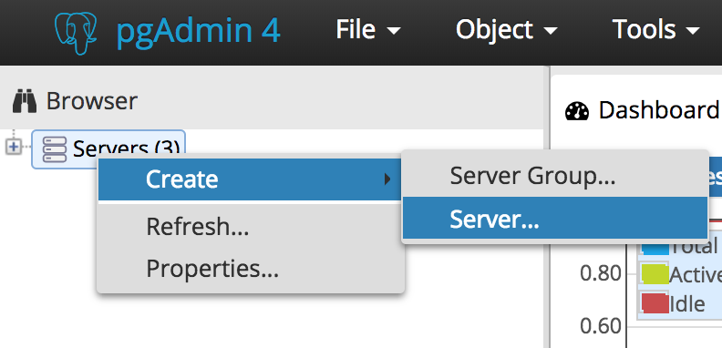

1. Right Click on Servers and Select Create then Server
2. Under the "General" tab, give the connection a name, for example, GDI
3. Then switch to the "Connection" tab to use the hostname: "localhost" and use your username and password, or the default postgres username and password, to connect to the server.

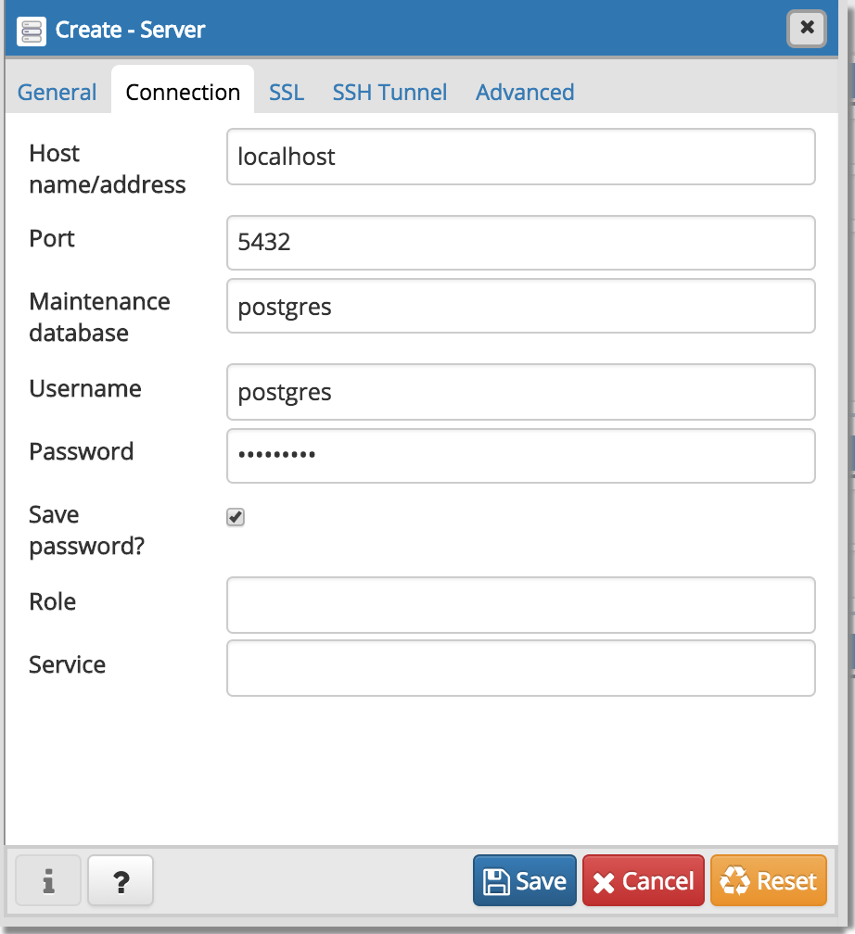

**Step 2: Add a database to be utilized for the class**

* Expand the localhost server by clicking the '+' sign
* Right-click on 'Databases' and select 'Create -> Database..."

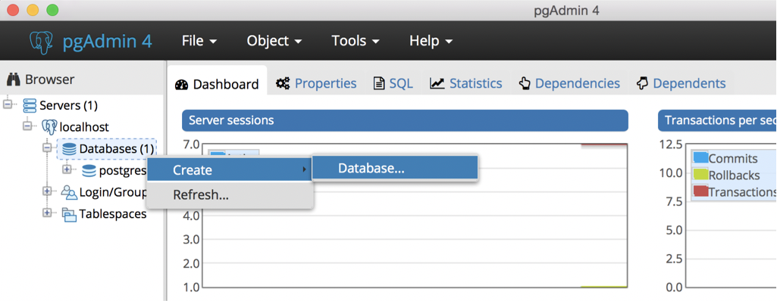

In the general tab give the database a name, for example, intro_gdi_db

**Step 3: Start the "Query Tool"**

* Click on the database to 'highlight' it
* Click on the "Tools" dropdown in PgAdmin
* Select 'Query Tool' from the drop down

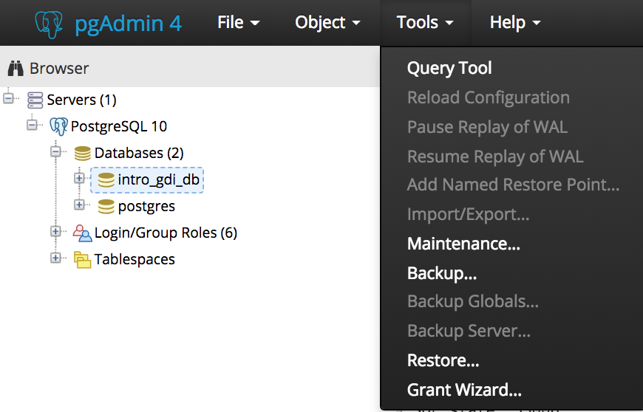

**Step 4: Seed the database by copy pasting this entire file into the query tool and 'Execute'**

* Utilize this link to get the file - <https://github.com/ebollwerk/Introduction-to-PostgreSQL/blob/master/intro_to_postgres_setup.sql>
* Copy the entire file into the query tool and execute the command with F5 or the lightning bolt button.

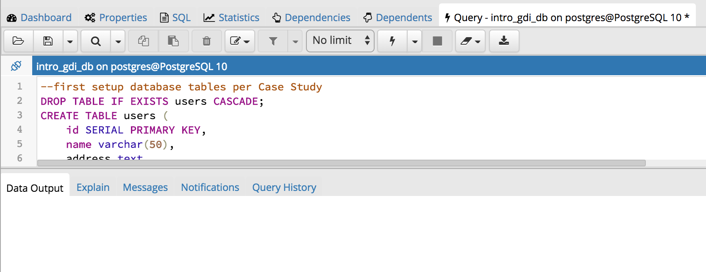

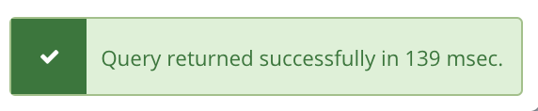

Adopted from: https://github.com/Jess88/Introduction-to-PostgreSQL