An ordinal measure for quality of employment in countries lacking specific surveys

INDICAR: equal weight to indicators (IEW), equal weight to dimensions (DEW)

Introduction
A society becomes more democratic as the opportunities to reach individual objectives are equally distributed and are not different based on the assigned characteristics of the people. A society in which the ethnic race, gender or physical aspect make a difference in the opportunities, is a less democratic kind of society. The degree of democracy of the countries depends on how evenly the possibilities of accessing the rights that come from being part of a society are distributed; in such a way that the access or not to them is as completely linked to individual efforts as possible. The management of public policies that aim at improving the degree of equity requires monitoring strategies to watch the rhythm and the distribution of the advances in that direction.
In modern societies, the opportunities are mediated by labor activity, as a source of income that allows access to goods and services and as a source of personal satisfaction, providing a sense of social integration. However, not everyone who has got a job has access to these rights. The reforms that aim at relaxing employment relationships, that may allow to open up new job opportunities, are usually oriented towards the deterioration of employment conditions. Therefore, the improvements of the unemployment rate should not be seen as an immediate positive result if they go hand in hand with people working in poor conditions. The need to measure the quality of employment is based on the fact that the increase in the quantity of working people, or the reduction of the unemployment rate, are not signs of improvement of the condition of the people’s lives. Having a job is a necessary condition to be integrated in a society and to enjoy the benefits of civilization but it is not enough since not all the jobs allow access to these rights.
Besides, the information about the differences in the quality of the labor insertion of the different subsets of population, is necessary to inform the decisions related to public policies that are oriented towards the reduction of inequalities in a country. And this information has to be available in a linear and transversal perspective. The first one is an approximation of the way in which a society progresses towards more inclusive ways, or goes backwards towards discriminating for reasons that are not up to the will or effort of the people. The latter shows the way in which, within a country, the accomplishments related to equity are not synchronic and that the regional heterogeneity is also a source of inequity. Finally, this information has to be expressed in a clear and understandable way and based on sources of information whose reliability is agreed upon. This requisite must be watched closely in countries where there are no regular surveys that look for information about the aspects that make a difference regarding the quality of employment.

In this paper an elaboration of an index that measures the quality of the labor insertion, recognizing the limitations of the data sources available to measure the differences between population subsets is proposed. Only objective indicators are used since subjective perceptions of the quality of our own jobs are influenced by personal preferences and expectations of social position. The use of a synthetic measure has the advantage of presenting in a concise manner complex and multidimensional information, besides it is the most adequate way to interpret longitudinal comparisons and observations. However, the operations used for its creation must be explicit and understandable; otherwise, it might be used to base the decisions on misunderstood or excessively simplified information. As regards methodology, the choice of indicators, of the weight assigned to each of them, as well as of the way to combine them, are fields of dispute. This choice becomes more unsolvable as the statistical operations darken the decisions (González et al., 2021; Nardo et al., 2008; Sehnbruch et al., 2020)⁠.
As has been widely discussed in the literature on multidimensional indicators, the relative values of different deprivations in multidimensional approaches can be obtained in three ways: data-driven statistical analysis; market price approaches; and normative methods (Sehnbruch, 2020). Here we propose a normative approach, that makes it possible to clarify and make explicit the criteria used in its construction.
Besides the construction of the index, the comparison of its values between men and women and between regions of Argentina, for four years: 2005, 2010, 2015 and 2020 are offered.
Following the principles of open data and in order to make the procedure more transparent, the syntax that leads to the construction of the index and the results of its application is available as an appendix.

Background: job quality debates

In Western societies, labor plays a key role in the articulation of the social life of most of the population. Either if we count it as years of the life course or in hours of each day, the time devoted to working takes up a large part of human existence. As a goal for the development of a society, employment should not only be a source of income but also of relationships, of personal growth and of professional satisfaction; consequently, the efforts to improve the quality of life of the inhabitants should be closely related to improving the quality of the activities at work. What is more, the assessment of the degree of human development of a country should take into account the quality of the jobs its inhabitants perform as well as the characteristics of who do the best and the worst jobs. This requires a measure that, at least, allows that the job posts can be considered as better or worse in relation to their quality.
It is not an easy task because the concept of the job quality is complex and multidimensional; (Burchell et al., 2014)⁠ make a revision of the attempts to measure it, whose origin goes back to the end of the decade of 1960, with the “Social Indicators Movement”, linked to the idea of life quality and as an option to surpass the assessment of the social and economic changes through macro indicators such as the GDP. From there, according to the authors, research lines about the job quality from the subjective satisfaction of the worker were developed. One of these lines comes from the critical sociology (Braverman, 1977)⁠, paying special attention to the autonomy and personal development of the worker and focusing on the process of disqualification of the workers. The other line is the one that derives from the labor psychology that prioritized the inquiry about the aspects that would contribute to the workers’ satisfaction, such as teamwork and the challenging and significant nature of the tasks. The origins of this line can be traced back to the first attempts to take into account the social and human aspects in the workers’ performance (Drobnič, 2018)⁠.
These studies focused on the inspection of specific companies, with the objective of improving the conditions of the posts and the workers’ productivity. Since the decade of the 80s, different theoretical frameworks that take into account subjective or objective aspects of the positions have been developed.
The statistics offices in the different countries of the world have developed synthetic indexes to measure the quality of employment. The most simple ones are the ones that only take into account the compensation and the working hours, such is the case of the Job Quality Index of the United States (Alpert, Ferry, Hockett, & Khaleghi, 2019). The most elaborate attempts of operationalization of the job quality include, apart from compensation, the following: job security, training, worker’s autonomy, and the relationships at the workplace. One of these is the Good Work Index, that the CIPD (2020) publishes periodically and, at the European Union level, the Job Quality Index (etui, 2018). Recently, Cascales Mira (2021) proposed an index, called the European Intrinsic Job Quality Index, that takes into account eleven indicators that come from the European Working Conditions Surveys (Eurofound, 2021). The indicators are reduced to four dimensions with the peculiarity of not taking into account the workers’ compensation.
In Latin America, there are antecedents on job quality measurement, using household surveys (Sehnbruch et al., 2020)⁠ as well as surveys on working conditions (González et al., 2021)⁠
At an international level and to establish a reference that allows the evaluation of the job quality, the International Labor Organization generated in 1999 a definition of “decent work” as a summary of the aspirations of the people in their working lives (ILO, 2021). According to this definition, decent work is one that gives you:
“... opportunities for work that is productive and delivers a fair income, security in the workplace and social protection for families, better prospects for personal development and social integration, freedom for people to express their concerns, organize and participate in the decisions that affect their lives and equality of opportunity and treatment for all women and men.” (ILO, 2021).
This idea of decent work not only applies for the workers of the regular economy but also for informal economy, independent workers and homeworkers (Ghai, 2003).
The above mentioned is a multidimensional definition that has been transformed into observable indicators in different ways to construct synthetic measures. According to Burchell et al., 2014, the question that arises from broad definitions, such as the one of the ILO, - which are based upon the workers’ rights- is “can they be operationalized?”. According to these authors, this question has not been answered yet. However, indexes that take into account diverse characteristics of the occupations have been built, none of which have reached enough consensus to allow transverse or longitudinal comparisons - neither international nor subnational - and, for this to happen, it is necessary to choose the data source with which to measure the chosen indicators.
The core countries have the statistics about the employment conditions which get updated periodically with field data. OECD (2017) offers a list of twenty of them that have national surveys related to the quality of the working environment; among Latin American countries, only Chile is on the list. For most of the developing countries these surveys are not available. On the contrary, household surveys are conducted in a great number of countries and there is effort made to broaden its use and harmonize its methodological designs, such as the one of the UNO (2021). These surveys can provide a point of reference to evaluate the job quality in countries that lack specific surveys and that experience more deeply the problem of the creation of poor quality job positions.

Index Definition
In order to reduce the limitations that affect brief expressions of complex concepts, as well as its possible consequences when used to make decisions related to public policy, the index built takes as a point of reference the definition offered by the International Labor Organization, and is based on the objective aspects of the labor insertion. The assessments made by the people about the quality of their jobs are not included; in the first place because the source of data available does not show that information, but even if it did, this subjective assessment could be a poor approximation of the quality of the job. As a matter of fact, as described by Agassi (1982), the satisfaction expressed, —not only general but also specific of some dimensions of the job — derives from the combination of the quality of the job and the expectations of the worker, and these expectations may be correlated, as shown by Dhamija, Gupta & Bag (2019), with gender, age and working experience. Besides, the aspects that the people take into account when defining their own job satisfaction vary depending on the group.

The index proposed here in not intended to reveal in a thorough way the complexity of the concept of job quality. On the contrary, the focus is on the comparison between population groups to look at the degree of differentiation between them. This degree of differentiation is the object of analysis, in terms of its regional variations and throughout time.

For this paper, three indicators are taken into account: i. the security offered by the job post, ii. the relation between the employee’s education and the qualification demanded to perform the task, and iii. relative wages.
security: It is obtained through a combination of the stability of the economic activity and the availability of a service of health risk coverage. The concept of stability has an operational meaning that varies depending if the person works under an employment contract or on its own. For the former, it is about time that establishes the difference between permanent, seasonal and sporadic jobs. For the latter, stability is linked to having at stake some capital and to the fact that they work for only one client or many. Among the people that perform tasks related to domestic service, the degree of stability comes from the employee benefits they have, which change the level of formality of the job.
The health coverage is obtained, for the three groups, through the health insurance. This component makes reference to the predictability offered by a job, the possibility to make plans counting on the continuity of the job and without any threats that could come from accidents or illnesses that interrupted the activity or benefits provided.
The consistency between education and qualification demanded by a job is a source of gratification, anxiety or frustration for the employee. When the demands at a workplace are above their own qualifications, the employees have to face their own limitations and efforts to reach the required level. On the contrary, when qualified employees have to perform tasks that require less of what they could do, they feel frustrated because of the loss in the investment on education and the boredom the task brings about. As a consequence, this component is an approximation of the subjective satisfaction the economic activity generates.
The wages make up the most important component of the quality of the occupation since its value will allow or not to access the best life conditions. However, the income must be analyzed in two aspects; in terms of the hours worked and of the geographical distribution. The former is evident since it is expected that there is a certain correlation between the wagee and the time spent in performing the job. The latter is especially important in countries with huge regional differences since the different prices of food, housing, transport and recreation cause that the gross income cannot be compared between the regions. In effect, the concept of “relative deprivation” emphasises the discomfort of those whose income is lower that the one of the group they belong to (Chen 2015). Taking this concept into account, the wages are measured in relation to the urban agglomeration they belong to.

Data and methods
Like any other knowledge building process, the creation of an index to measure the job quality involves relating the theoretical concepts with the available data. No synthetic measure can reproduce in a comprehensive manner the social phenomenon it is trying to describe, its appropriateness depends on the aspects of reality chosen to be observed. In some cases it is possible to construct resources of systematic analysis that reproduce closely the theoretical concepts present in the definitions, as is the case with Europe or the United States, where there are public or private organisms that conduct specific surveys about aspects of the work life (Eurofound, 2021, RAND, 2021).
In Argentina, the Department of Production and Labour (“Ministerio de Producción y Trabajo”) (2018) gathered information about the characteristics of labor insertion through two specific studies: The 1st National Survey to Workers about Employment, Work, Conditions and Working Environment (MTESS, 2009) and the 2nd National Survey to Workers about the Conditions at Work, Job, Health and security (MTESS, 2018)
These surveys describe many dimensions of the occupation: characteristics of the employees, the employment, the workplace, the risk factors, autonomy, security, health, etc. However, these surveys do not currently have enough continuity to allow longitudinal studies, which would allow to follow the evolution of the employment conditions.
In order to give continuity to the analysis, it is intended that the index can be calculated from a data regular production source. In the case of Argentina, the option is the Permanent Survey of Households (“Encuesta Permanente de Hogares - EPH”), which describes some characteristics of the working activity of the residents in the main urban agglomerations of the country. It is a national program of systematic and permanent production of social indicators that allow us to know the sociodemographic and socioeconomic characteristics of the population. This survey, using its original method, has been applied in Argentina since 1973 twice a year (once in May and once in October). Based on this survey the official employment, unemployment, underemployment and poverty rates are regularly provided.
Due to the fact that the survey keeps the same set of variables on its regular editions, it can be used to make comparisons over time. Its limitation is that it does not take into account the aspects that are considered in the construction of indexes in the core countries: autonomy, demand level, significance of the tasks, satisfaction, or elements related to labor relations. However, in the countries that only have these types of surveys, it is a means to make an approximation about the changes over time in relation to the job quality and about the differences between population subsets.

This paper has a methodological approach and it aims at the construction of the index and the evaluation of its appropriateness to observe the construct “quality of employment”, within the framework of the restrictions imposed by the data of the countries that do not have regular surveys that show detailed descriptions of the employment conditions. The diagnosis of the appropriateness is based on the capacity of the index to reveal differences between the different population subsets, in a way that can be used as a reference for the comparisons between regions (transverse comparisons) and across time (longitudinal comparisons).
Due to the characteristics of the variables included in the index, it is not possible to achieve a ratio level measurement (Stevens, 1946)⁠, on the contrary, the index assesses job quality in ordinal terms, thus allowing to distinguish between higher or lower quality occupations. Therefore, comparisons are made with non-parametric methods: the differences between the groups are analyzed through Wilcoxon and Kruskall-Wallis tests and correlations are calculated with Spearman´s ρ coefficient. Linear regressions are replaced for quantile regressions. Violin plots have been chosen to help the visualization of comparison of the index values and, at the same time, the shape of the distributions. When used, the activity rates are calculated in relation to the total population.
An open data source has been used and it is available at INDEC (2021). All the operations that lead to the construction of the index and the applications that are presented here, are available in the appendix.

security
People who work for an employer, are self employed or work at domestic service have a differential treatment in these surveys since the household survey has specific questions for each of these subsets of workers. For the first two occupational categories, security is a consequence of the combination between the predictability of the job post and the supply of health coverage. Those who are domestic workers answer specific questions.

Employment relationship | Predictability | Health Coverage
People working for an employer | Job stability | Health insurance, prepaid health care plan, etc.
Self employed | Capital supplies  Clients | Health insurance, prepaid health care plan, etc.
Domestic workers | Paid holidays and bonus | Sick leave and health insurance
Used variables (from the individual questionnaire of the household survey)
- Job stability: Six ordinal levels from the ones who have sporadic jobs up to the ones who have permanent jobs.
- Capital supplies: Shop, vehicle, machines; each with three ordinal levels: own, rented or non-existent.
- Clients; dichotomy: only one client or many clients.
- Health insurance, prepaid health care plan, etc: dichotomy.
- Paid holidays, bonus, sick leave and health insurance: ordinal between zero and four benefits.
The additive indicator is scaled with the min-max normalization procedure (Ebert & Welsch, 2004)⁠.

Consistency education - qualification
Two ordinal variables are used: the highest education level reached and the occupational qualification, which is obtained from the fifth digit of the code assigned by the National Classifier of Occupations. It is considered that there is consistency between the demand of the job and the level of education of the employee when both of the traits are above their corresponding medians or are both below them. Otherwise, it is an inconsistent relation. The resultant is a dichotomous variable, whose values are zero and a hundred.

Income - hours
Even if the data related to income obtained through a survey cannot be truly trusted, it is impossible not to include them as a means of measuring the quality of labor insertion since they constitute the material expression of the transaction that the employee makes of his time for money. In order to get a comparable measure between the people that devote their time differently at their jobs, what is taken into account is the quotient between the income and the amount of hours worked in the period. More precisely, the quotient between the monthly income declared and four times the hours worked in the week in question. That quotient measures an hourly wage, adequate enough to establish comparisons between the payment received by the working people. If we are dealing with underemployed people, 70% of the hourly wage is taken.
The basic food basket has been dismissed (INDEC, 2021) because it was not updated and because, in relation to the quality of employment, what matters is the subjective perception of the incomes. Even though employees are not asked about this perception, it is mediated by the average income of the residential area. In order to take these differences into account, the value of hourly wage of each person is transformed into z-score in relation to the mean and standard deviation of the income of each urban agglomeration that the household survey reveals, after it has taken the natural logarithm of the hourly wages. Having been transformed in this way, those scores evaluate how many standard deviations, above or below the logarithm of the mean of hourly wage of the agglomeration, the logarithm of the value each person declares is. This measure is more realistic and adequate to introduce income as an indicator of the quality of labor insertion because it describes the income of each individual in reference to the average of his agglomeration. The z-scores generated in this way are normalized to the interval 0 -100 to assure the comparability to the other indicators.

Correlations between the components
The workplaces with the highest security level partially coincide with the best wages (). But this relation does not occur with consistency and wages (), the data do not show a significant correlation of these two aspects of quality. Consistency and security have a weak correlation but it is still significant ()

The index
Three indicators, representatives of three dimensions of the labor insertion, are considered: personal and family security that characterizes the labor activity, the relation between the employee's education and the demand at his job, and the hourly wage relating to the geographic region the employee lives in. These indicators construct the index, in an additive way, the income is considered as four in relation to security and consistency because it is more important for the well-being of the employed people.
Because of the way in which it is constructed, the index takes over values in the interval [0, 100], these values indicate a better quality of the labor activity as they get closer to one hundred.
In order to compare the quality of the labor insertion of men and women, a gender gap is defined in the quality of employment similar to the one OECD (2012) uses as the difference of the index medians between men and women, divided by the median of the men.

Index values up to the year 2020
In order to interpret the values that the index of the quality of employment assumes, the following are the statistical descriptive data calculated from the data of the household survey of the first quarter of 2020.

Min | 6.48
Max | 99.89
P25 | 57.29
P50 | 67.86
P75 | 78.86

The distribution has the following shape:

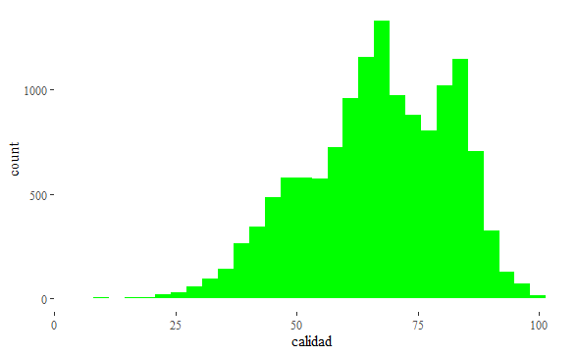

quality

The bimodal distribution suggests the existence of two populations that are mixed. As shown later in this paper, the classification by gender, region, and belonging to the private or public sector, does not show that these characteristics of the employed people explains the difference, which besides is kept in the different regions of the country. A hypothesis for this fact is that what matters are the intrinsic aspects of the job, that is to say, that there is a division of two categories of job quality.

Comparison by sectors
The public, private and third sector sectors differ in relation to the characteristics of the job posts. In a concise way, the index of quality shows small differences between the public sector and the third sector and they are both higher than the private sector.

Subset: sector | Quality index
Subset: sector | P25 | P50 | P75 | cases
public | 59.73 | 64.28 | 91.88 | 3,292
private | 42.72 | 59.12 | 82.28 | 12,066
other | 57.91 | 63.70 | 92.30 | 185

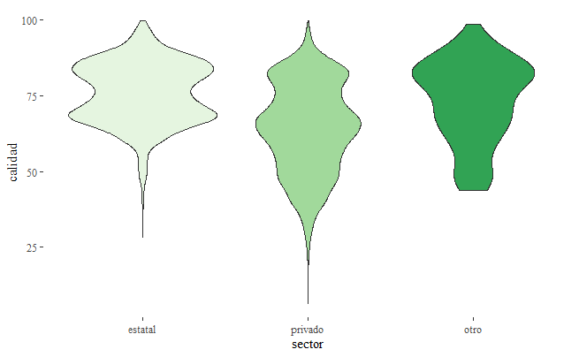

The group comparison test shows that the differences in the quality index between the private sector and the other two are significant (ChiSq2 =1459.4, p<.0000).

Comparison by gender
The group comparison shows a small but significant difference in favor of men. Actually, the scores of the quality index of the occupation of men and women for the first quarter 2020 are:

Subset: gender | Quality index
Subset: gender | P25 | P50 | P75 | cases
men | 49.21 | 60.80 | 88.70 | 8,889
women | 50.11 | 60.11 | 85.69 | 6,654

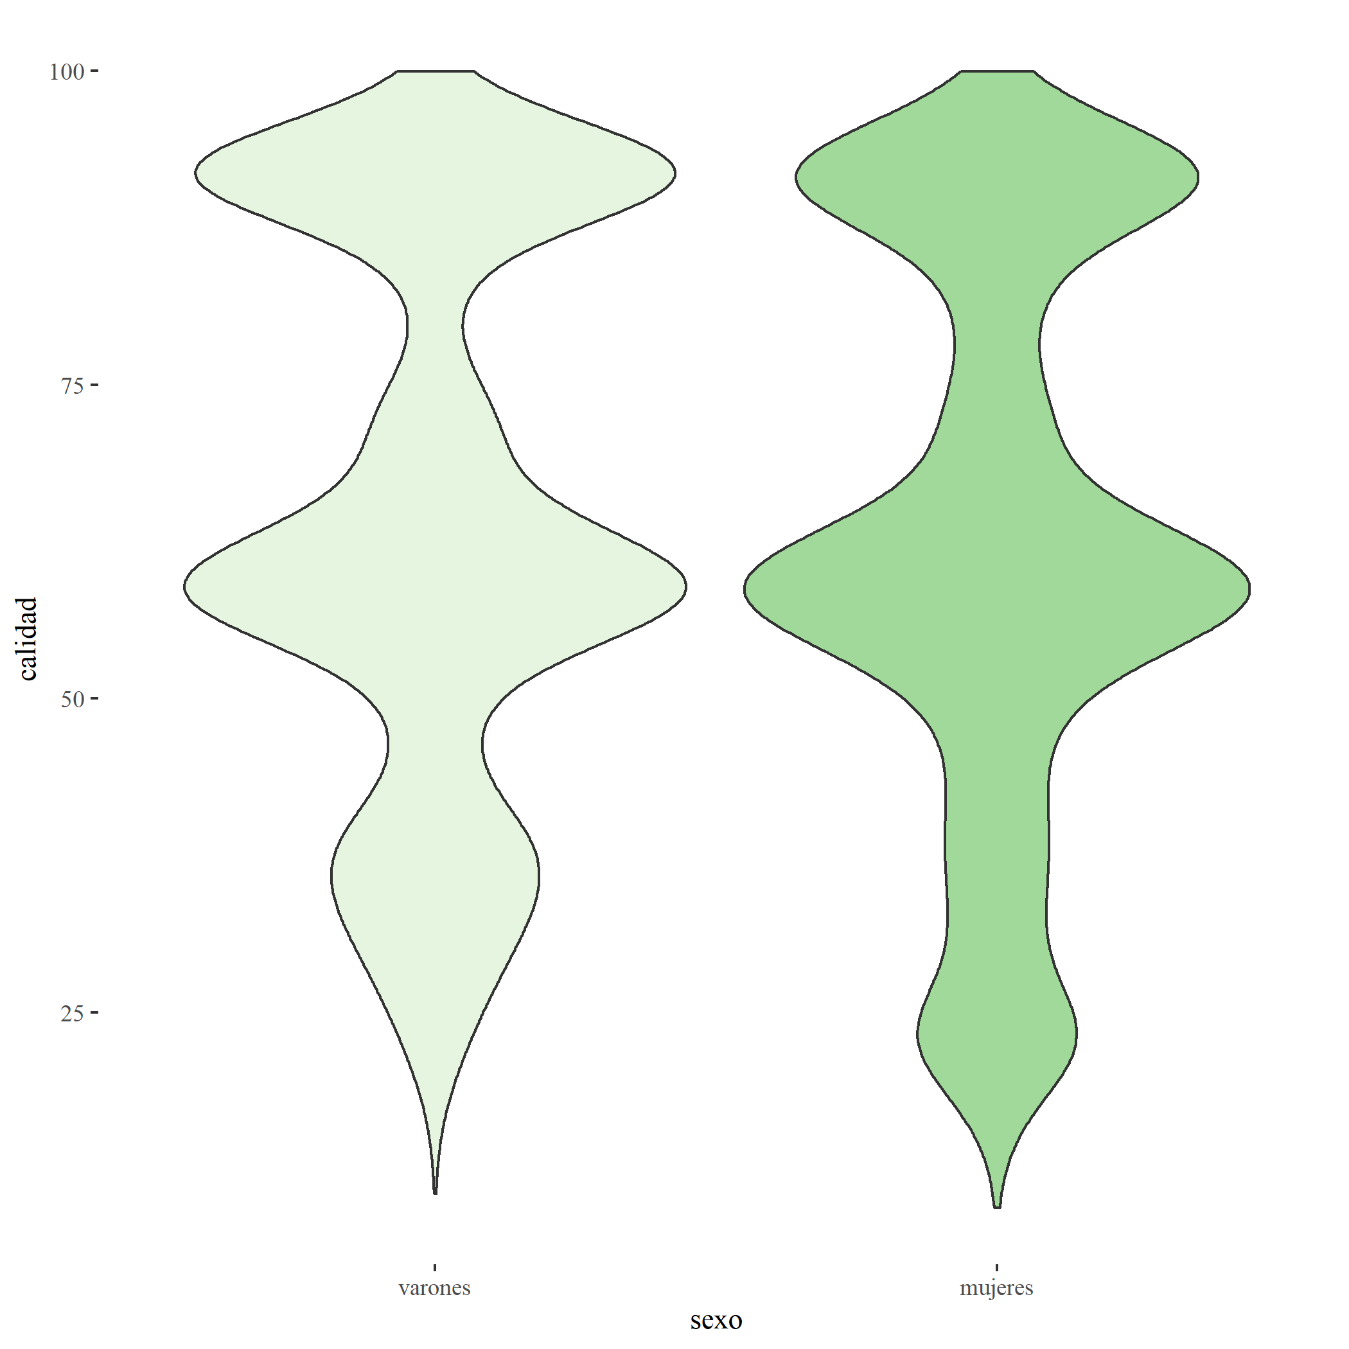

The difference observed, is significant (W = 23803887, p<.0000), the estimate for interval for the difference is [1.42; 2.44].

Comparison by regions
The comparison of regional groups shows that the Argentinean Northeast (NOA), Northwest (NEA) and Cuyo are not significantly different as regards the quality of employment, around a median of 65. Neither are the Pampeana region and Buenos Aires, which a median score around 68. The region of “La Patagonia” is the one with a significantly higher score.

 | Quality index
Subset: region | P25 | P50 | P75 | cases
Gran Buenos Aires | 49.84 | 60.74 | 88.12 | 2,127
NOA | 47.96 | 59.70 | 86.35 | 3,640
NEA | 48.53 | 59.72 | 88.70 | 1,632
Cuyo | 43.44 | 58.55 | 82.60 | 1,756
Pampeana | 49.68 | 60.26 | 87.62 | 4,539
Patagónica | 58.39 | 63.06 | 91.88 | 1,849

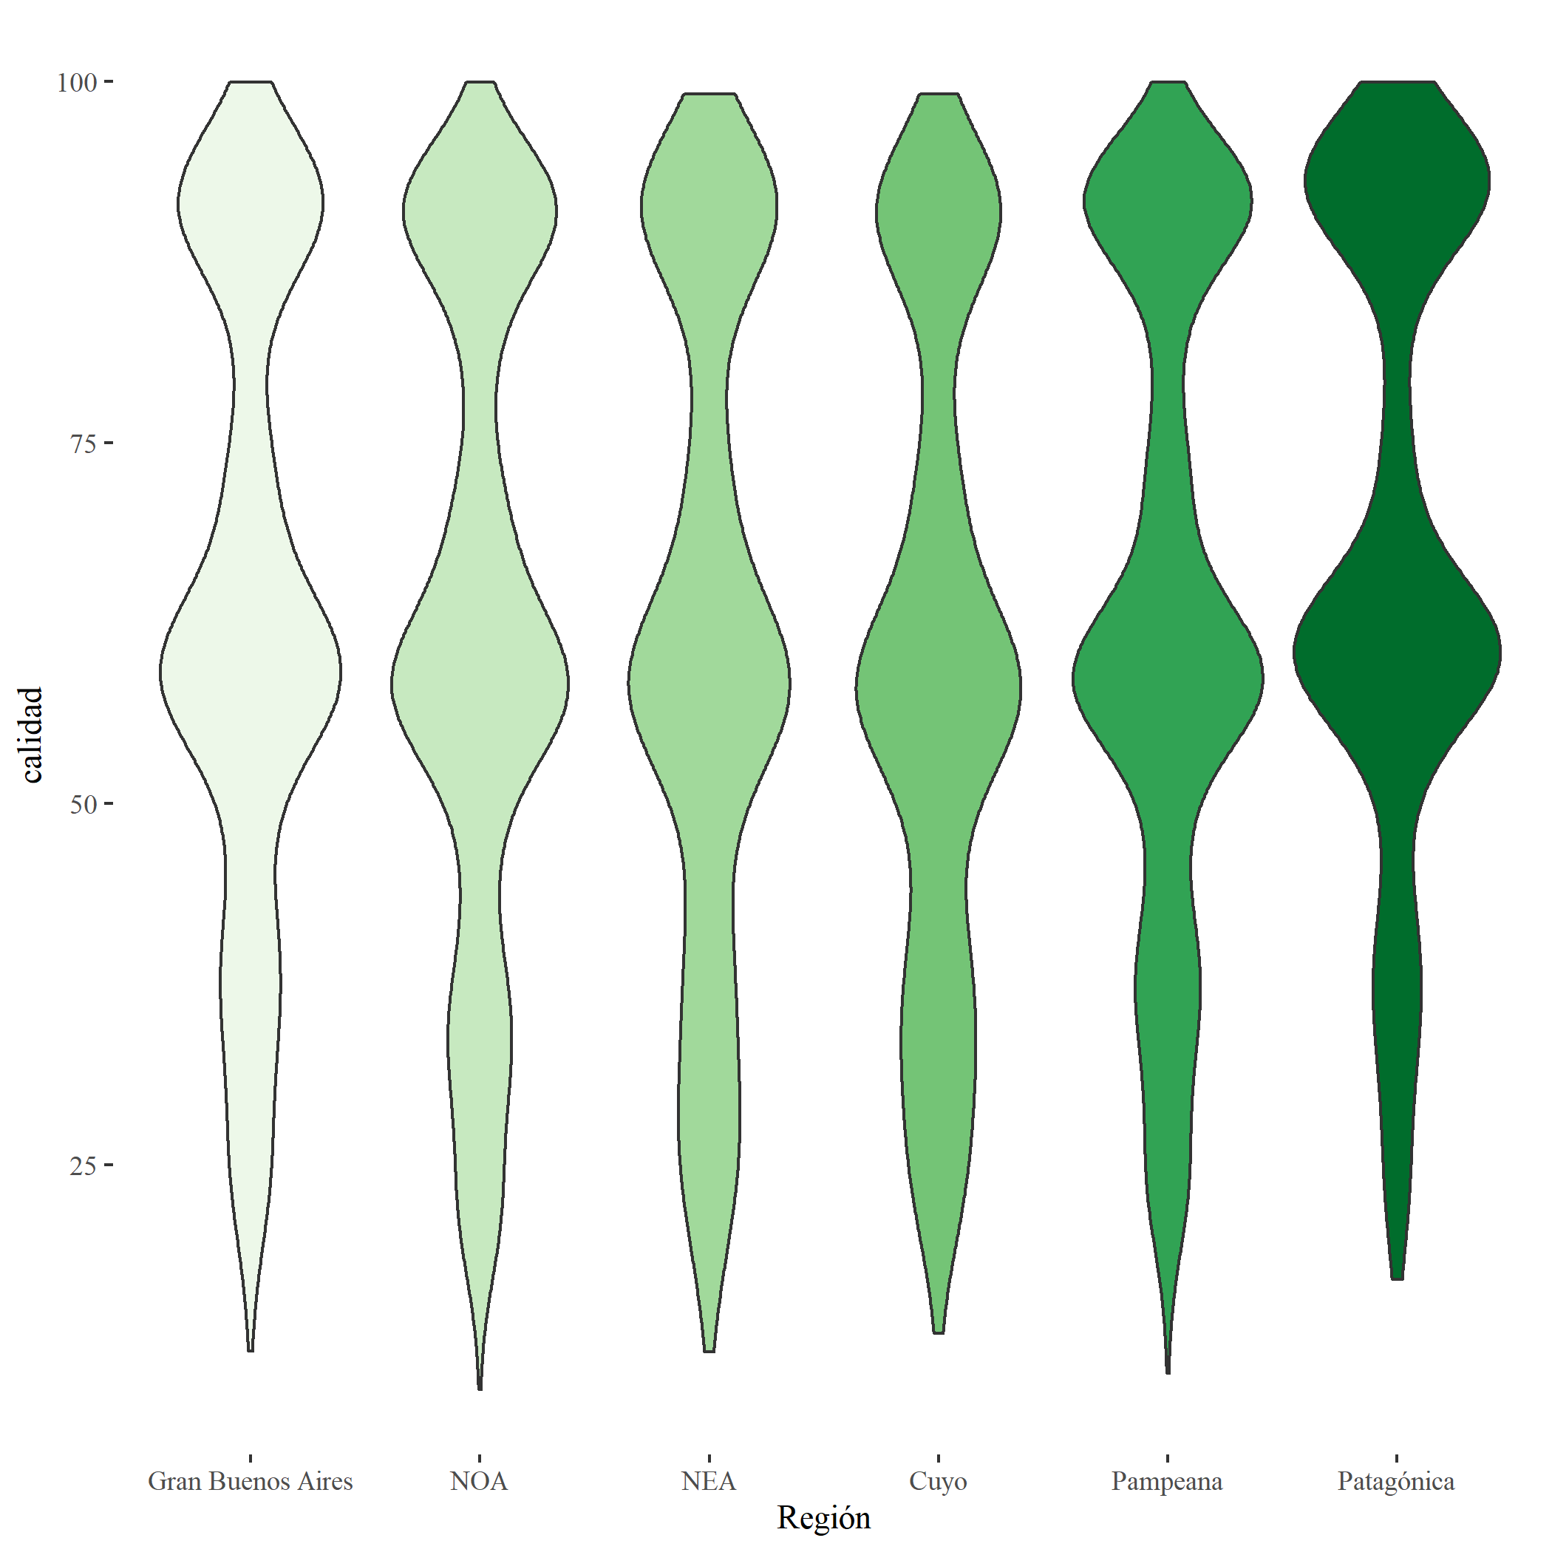

There are three groups of regions: the first one has a low level of quality of employment and is made up of NOE, NEA and Cuyo; the second, made up the Pampeana region and Buenos Aires, has a medium level; and the third with “La Patagonia” stands out for its significantly superior quality of employment.
As can be seen in the graphs, in every group the bimodality of the distribution of the quality index remains. Therefore, these are not the aspects that explain the existence of two concentration sectors. This effect can come from a segmentation of the job posts with a strong presence of people not only in the central values but also in the low ones.
Once identified the sectors and regions between which the differences are not significant, they are fused. For the sector variable, two fussed categories are considered: “private sector” and “public and third sector”. For the region variable, three categories are kept: “NOA, NEA and Cuyo”, “Gran Buenos Aires and Pampeana” and “Patagónica”.

The simultaneous analysis of the differences in the quality of employment according to the sector, gender and region is carried out through three quantile regressions that model the quantiles 0.10, 0.50 and 0.90 of the quality index distribution. Table 12 shows the coefficients for each percentile.
It is seen that the index value that defines the 10% of people who work under the worst conditions is 2.3 points lower for women than for men, with an effect slightly higher in intermediate values of the index and softer for the higher scores. The private sector maximizes its negative effect, with a difference of almost 19 points in relation to the public sector, for the worst quality jobs (percentile 10 of the index) and the difference drops as the job quality improves. A similar effect, but with less intensity, is seen in the more disadvantaged group of regions, while the highest differences of the region of “La Patagonia” take place in the intermediate quality occupations.

Table 13
 | P10 | P50 | P90
Gender: women | -2.29 | -2.98 | -2.00
Sector: private | -18.78 | -11.62 | -5.32
Region: NOA NEA Cuyo | -4.05 | -3.55 | -2.07
Region: Patagónica | 2.94 | 4.06 | 2.65

Magnitude of the difference by gender up to the year 2020
For the the whole employed population, the gender gap in job quality, evaluated as the difference of the medians in relation to the median of men (OECD, 2012), is, for the year 2020, of 2.30%. However, this value changes when sectors and regions are taken into account.
When the gender gap is seen separately for the sector categories, the differences arise:

Grouped sectors | Gender gap
Total | 2.30
Public sector and third sector | 3.96
Private | 4.64

The inclusion of sector as a classification criteria makes evident that the small difference that is seen when the whole set of activities is taken into account, hides substantial differences inside the segments. In this way, the best quality of the public occupations –whose index has a median ten points higher than that of the private sector–, combined with a stronger female presence on this sector – 22% of working women are there, compared to 16% of men –, mitigates the magnitude of the difference when the analysis is carried out taking into account the entire working population. This difference becomes visible when the analysis is done by sector.

In a similar way, taking into account the three big areas in which the regions were fussed, the gender gap shows variations:

Grouped regions | Gender gap
Total | 2.30
NOA, NEA and Cuyo | 2.28
Pampeana and Gran Buenos Aires | 1.86
Patagónica | 3.09

Thus, that geographic region in which there is the best job quality, “La Patagonia”, is also the one that has the highest difference in favor of men. It is also higher than the national average in the set of regions in which the job quality is minimum. On the contrary, in Gran Buenos Aires and the Pampeana region, which are the places in which the quality index has intermediate values, the lowest value of the gender gap is found.

Changes over time
An advantage of standardizing the calculation of the index and of grounding it on data from a regular source is that it allows that the calculation is done similarly for different periods of time. In this case, as an example, we show the changes in the index median for the last 15 years.

Core measures of the job quality index
 | 2005 | 2010 | 2015 | 2020
Median | 64.67 | 66.73 | 67.63 | 67.86

The index median shows, for this period, small variations with a growing monotonous tendency. That is to say that the quality of employment, defined in that way, has improved in the last 15 years.
The behavior of the gender gap is different, since it lacks a steady tendency:

 | 2005 | 2010 | 2015 | 2020
Gender gap in the job quality index | 0.38 | -0.77 | -0.87 | 2.20

Besides, there are two periods in which, even if small, the difference is negative, which shows that the women’s scores are higher than the ones of men in 2010 and 2015. As pointed out above, there is an interaction between the gender and the sector –public or private–, in which the labor activity is performed. Since the index shows higher scores in the occupations of the public sector, the score women get is influenced by their presence in it, and this changes over time. For the years taken into consideration, the following shows the amount of women that have jobs in the public and private sectors:

Percentage of women in occupations of the public and private sector during the period of 2005 - 2020.
 | First quarter of:
sector | 2005 | 2010 | 2015 | 2020
public | 56.3 | 50.8 | 51.5 | 51.5
private | 37.1 | 38.3 | 37.9 | 41.6

The highest value found for the gender gap (2020) occurs in the period in which the proportion of women at jobs of the private sector is also the highest, without having a transference effect, since the proportion in the public sector has no noticeable changes. A bigger presence in both sectors means that there is more labor participation as shown in the following series of rates of economic activity.

 | First quarter of:
Rate of economic activity: | 2005 | 2010 | 2015 | 2020
men | 51.8 | 51.6 | 52.2 | 52.2
women | 35.7 | 34.6 | 34.7 | 38.1

Unlike men, women show, for the last period, an economic activity rate higher than the previous periods. The error estimate of the rates for gender is 0.6%, therefore, the value in 2020 for women is significantly higher than the previous ones.
This is compatible with an increase in the female labor participation in activities of the private sector in the last year, in tasks that lead to low scores in the quality index.

Conclusion
The International Labor Organization (ILO, 2019) points out that a majority of 3,300 million working people in the world in 2018 had to endure lack of material well being, of economic security, of equal opportunities or of perspectives for human development. Having a job is not always the same as having a decent life. The creation of new job posts usually goes hand in hand with a decline in the benefits that these jobs can offer to the people that work. Measuring the amount of available jobs cannot do without its quality because the efforts to reduce unemployment are directed towards improving the wellbeing of citizens. Many countries have taken important steps in relation to this measure, through specific surveys that evaluate not only the objective aspects of the quality of the job posts but also the subjective ones. However, in the less developed countries, these surveys are not carried out in a regular way and it is in these countries where the creation of bad quality job posts is more frequent. According to OECD (2017, table 2.17) only twenty countries that year had regular surveys about the quality of employment.
This paper suggests a synthetic index that evaluates the quality of employment from a conceptual definition, with the restrictions imposed by the data sources that have not been specifically designed to measure it. From the different aspects that can be chosen for that purpose, three have been taken into account: security, the appropriateness or inappropriateness between the demands of the job post and the qualification of the worker, and the wages. Even though this choice does not capture the complexity of the job posts, it is useful as a criteria to analyze the differences between the groups, in a more thorough way than just through the analysis of income.
In its application to the data of Argentina 2020, the following has been found:
- The working population is distributed around two segments of work of different quality. This division remains in all the regions of the country and it is not explained by belonging to the public nor private sector or by the fact of being a man or a woman.
- In the public sector the job posts are of better quality than the ones in the private sector, and this difference gets bigger as the job posts decrease in quality. That is to say that low quality job posts are even worse in the private sector. Among the best quality job posts, the difference is still in favor of the public sector but it is smaller.
- Men have job posts with a slightly higher score than women in the index quality but gender interacts with the sector because the proportion of women in the public sector is bigger. When the sector is taken into account, the differences in favor of men grow and they get to the highest value in the private sector.
- The youngest people take up the worst quality job posts, followed by the oldest. The best scores of the index are for the people in the core ages.
- The regions in which the country is divided are grouped in three categories: low quality, the regions of NOE, NEA and Cuyo; intermediate quality, Gran Buenos Aires and the Pampeana region; and high quality, “La Patagonia”. The first group shows the most defined differences in the lowest levels of quality, while “La Patagonia” maximizes its difference in the intermediate levels of the index.

The unfavorable condition of women in relation to men is more marked in the medium or low quality occupations and it decreases as the occupations increase in quality. The worst quality of the private sector jobs is more marked in the worst jobs and decreases in the best quality jobs.
An unexpected element that arises is the bimodality in the distribution of the index that remains when gender, sector and region are taken into account. This behavior suggests that there is a dualism in the distribution of the quality of the job posts in Argentina, there are two sectors that separately gather parts of the working population.
Among the limitations of this paper, the main one is the set of aspects that make up the definition of quality of employment, this is because of the choice of the data source, which is based on its availability for a broad number of countries. A wider coverage of the data sources has been chosen, instead of choosing one of less depth in the definition of quality index. The comparison of this index between different sectors of economy deserves to be explored.

References
Agassi, J. B. (1982). Comparing the Work Attitudes of Men and Women, Aldershot, Gower
Alpert, D., Ferry, J., Hockett, R. & Khaleghi, A. (2019) The U.S. Private Sector
Braverman, H. (1977). Trabajo y capital monopolista. La degradación del trabajo en el siglo XX. México, Nuestro Tiempo
Burchell, B., Sehnbruch, K., Piasna, A. y Agloni, N. (2014).The quality of employment and decent work: definitions, methodologies, and ongoing debates. Disponible en http://repositorio.uchile.cl/handle/2250/128769
Cascales Mira, M. (2021). New Model for Measuring Job Quality: Developing an European Intrinsic Job Quality Index (EIJQI). Social Indicators Research. https://doi.org/10.1007/s11205-021-02615-9
Chen X. (2015). Relative deprivation and individual well-being: Low status and a feeling of relative deprivation are detrimental to health and happiness. IZA world of labor : evidence-based policy making. https://doi.org/10.15185/izawol.140
CIPD (2020). Chartered Institute of Personnel and Development https://www.cipd.co.uk/knowledge/work/trends/goodwork
Dhamija, P., Gupta, S. & Bag, S. (2019). Measuring of job satisfaction: the use of quality of work life factors, Benchmarking: An International Journal, https://doi.org/10.1108/BIJ-06-2018-0155. https://doi.org/10.1108/BIJ-06-2018-0155
Drobnič, S. (2018). Job Quality. Oxford Bibliographies in Sociology. doi: 10.1093/obo/9780199756384-0207. https://www.oxfordbibliographies.com/view/document/obo-9780199756384/obo-9780199756384-0207.xml
etui (2018) Job Quality Index European Trade Union Institutehttps://www.etui.org/topics/labour-market-employment-social-policy/job-quality-index-jqi
Eurofound (2021). European Working Conditions Surveys. https://www.eurofound.europa.eu/surveys/european-working-conditions-surveys-ewcs
Ghai, D. (2003) Trabajo decente. Concepto e indicadores. Revista Internacional del Trabajo, vol. 122 (2003), núm. 2
ILO(2019). World Employment and Social Outlook – Trends 2019 (resumen ejecutivo). International Labour Organization. https://www.ilo.org/wcmsp5/groups/public/---dgreports/---dcomm/---publ/documents/publication/wcms_670554.pdf
INDEC (2003). La nueva Encuesta Permanente de Hogares de Argentina. 2003 https://www.indec.gob.ar/ftp/cuadros/sociedad/metodologia_eph_continua.pdf
INDEC (2021). Bases de datos Instituto Nacional de Estadística y Censos. Argentina. https://www.indec.gob.ar/indec/web/Institucional-Indec-BasesDeDatos
INDEC (2021). Valorización mensual de la canasta básica alimentaria y de la canasta básica total. Gran Buenos Aires Informes Técnicos Vol 5 No 27 https://www.indec.gob.ar/uploads/informesdeprensa/canasta_02_216F3510C93C.pdf
Job Quality Index (JQI). Cornell Law School disponible en https://d3n8a8pro7vhmx.cloudfront.net/prosperousamerica/pages/5467/attachments/original/1573727821/U.S._Private_Sector_Job_Quailty_Index_White_Paper.pdf?1573727821
Mayo, G. E. (1949 [2007]). The social problems of an industrial civilization. Londres: Routledge.
Ministerio de Producción y Trabajo (2018). Encuesta Nacional a trabajadores sobre Condiciones de Empleo, Trabajo, Salud y Seguridad. Secretaría de Gobierno de Trabajo y Empleo Superintendencia de Riesgos del Trabajo. Buenos Aires. Disponible en http://www.trabajo.gob.ar/downloads/estadisticas/ecetss/ecetss_informe.pdf
MTESS (2009). I Encuesta Nacional a Trabajadores, Empleo, Trabajo, Condiciones y Medio Ambiente Laboral. Ministerio de Trabajo, Empleo y Seguridad Social. Argentina. https://www.argentina.gob.ar/srt/observatorio-srt/encuestas-salud-trabajo/ECTS-2009
MTESS (2018). II Encuesta Nacional a trabajadores sobre Condiciones de Empleo, Trabajo, Salud y Seguridad. Ministerio de Trabajo, Empleo y Seguridad Social. Argentina. https://www.argentina.gob.ar/srt/observatorio-srt/encuestas-salud-trabajo/ECETSS-2018
Nardo, M., Saisana, M., Saltelli, A., Tarantola, S., Hoffmann, A. & Giovannini, E. (2008) Handbook on Constructing Composite Indicators: Methodology and User Guide OECD publishing http://213.253.134.43/oecd/pdfs/browseit/3008251E.PDF
OECD (2012). Closing the gender Gap: Act Now. Organisation for Economic Cooperation and Development (OECD), https://data.oecd.org/earnwage/gender-wage-gap.htm
OECD (2017). Guidelines on Measuring the Quality of the Working, chapter 2, The current situation of data on the quality of the working environment.
OIT (2021). Trabajo decente Página web de la Organización Internacional del Trabajo, https://www.ilo.org/global/topics/decent-work/lang--es/index.htm
ONU (2021). Inter-secretariat Working Group on Household Surveys. División de Estadísticas. Departamento de Asuntos Económicos y Sociales https://unstats.un.org/iswghs/

RAND (2021). American Working Conditions Survey. Research and Development. https://www.rand.org/education-and-labor/projects/american-working-conditions.html

ESTA ES LA BIBLIO QUE ESTA BIEN CITADA, DESDE MENDELEY
Braverman, H. (1977). Trabajo y capital monopolista. La degradación del trabajo en el siglo XX (Nuestro Ti).
Burchell, B., Sehnbruch, K., Piasna, A., & Agloni, N. (2014). The quality of employment and decent work: Definitions, Methodologies, and ongoing debates. Cambridge Journal of Economics, 38(2), 459–477. https://doi.org/10.1093/cje/bet067
Drobnič, S. (2018). Job Quality. In L. Spillman (Ed.), Oxford Bibliographies in Sociology. Oxford University Press. https://doi.org/10.1093/obo/9780199756384-0207
Ebert, U., & Welsch, H. (2004). Meaningful environmental indices: A social choice approach. Journal of Environmental Economics and Management, 47(2), 270–283. https://doi.org/10.1016/j.jeem.2003.09.001
González, P., Sehnbruch, K., Apablaza, M., Méndez Pineda, R., & Arriagada, V. (2021). A Multidimensional Approach to Measuring Quality of Employment (QoE) Deprivation in Six Central American Countries. Social Indicators Research, 1–35. https://doi.org/10.1007/s11205-021-02648-0
Nardo, M., Saisana, M., Saltelli, A., Tarantola, S., Hoffmann, A., & Giovannini, E. (2008). Handbook on Constructing Composite Indicators: Methodology and User Guide. OECD. https://publications.jrc.ec.europa.eu/repository/handle/JRC47008
Sehnbruch, K., González, P., Apablaza, M., Méndez, R., & Arriagada, V. (2020). The Quality of Employment (QoE) in nine Latin American countries: A multidimensional perspective. World Development, 127, 104738. https://doi.org/10.1016/j.worlddev.2019.104738
Stevens, A. S. S. (1946). On the Theory of Scales of Measurement. Science, New Series, 103(2684), 677–680. http://www.jstor.org/stable/1671815

The different costs of living in the different regions is implicit in this relative measure.

