Project 2
Eli (Ilya) Bolotin
10/21/2019

Visualization and Network Summary

Load data and view summary
data(USairports)
full_net <- USairports
The network contains 23.5k edges, 755 nodes, 3 vertex attributes and 5 edge attributes. Due to the fact there are multiple edges and loops, it makes sense to simplify our network by eliminating multiple edges for the purposes of visualization.

Simplify network
net1 <- simplify(USairports)

Analyze network
# Summary overall of network
summary(net1)
## IGRAPH 62cee52 DN-- 755 8228 -- US airports
## + attr: name (g/c), name (v/c), City (v/c), Position (v/c)
# View attribute names
vertex_attr_names(net1)
## [1] "name" "City" "Position"
edge_attr_names(net1)
## character(0)
# Examine city vertex
head(V(net1)$City)
## [1] "Bangor, ME" "Boston, MA" "Anchorage, AK" "New York, NY"
## [5] "Las Vegas, NV" "Miami, FL"
# View density of network
density.n1 <- edge_density(net1)
Network density is density.n1. The closer to 1 the density is, “the more interconnected the network” [1] (p.14, class text). In the context of this data, density is small because of the hub-and-spoke nature of the airline industry. That is, the country consists of mostly regional airports that connect through more central hubs for longer distance flights.

Add state and region vertex vertex
To help visualize the network, it makes sense to map airports to states and regions.
# Derive state from city
net1 <- set.vertex.attribute(net1, "state", index=V(net1), as.character(sapply(strsplit(V(net1)$City, ", ", fixed = TRUE), function(x) x[2])))
# Define region map and lookup table
region_map <- read.csv("states.csv", header = T)
lookup_table <- join(region_map, data.frame("State.Code" = V(net1)$state, "State.Code"))
# Get region from state
net1 <- set.vertex.attribute(net1, "region", index=V(net1), as.character(sapply(V(net1)$state, function(x) as.character(lookup_table[match(x, as.character(lookup_table[,1])),2]))))

Examine complete network
set.seed(30)
net1 <- as.undirected(net1)
plot(net1, vertex.size = 1, vertex.label = NA, edge.arrow.size = 0)
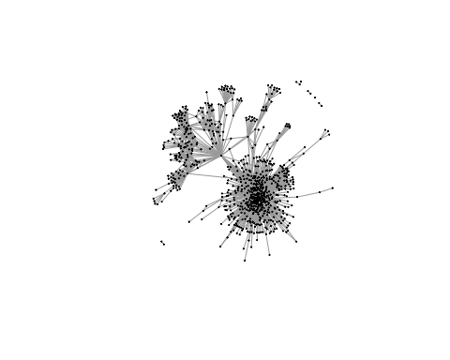
The network is hard to intelligibly decipher at 8.2k edges. Nonetheless, several communities are visible with obvious central nodes.

Calculate centrality
In order to produce a more meaningful visualization, we first need to get a better sense of the most central nodes, i.e., we need to calculate centrality measures: degree and betweenness.
# Add vertex attributes for each centrality measure
net1 <- set.vertex.attribute(net1, "degree", index=V(net1), degree(net1))
net1 <- set.vertex.attribute(net1, "btw", index=V(net1), betweenness(net1))
# View summary of centrality attributes
summary(V(net1)$degree)
## Min. 1st Qu. Median Mean 3rd Qu. Max.
## 0.00 2.00 5.00 12.25 11.00 166.00
summary(V(net1)$btw)
## Min. 1st Qu. Median Mean 3rd Qu. Max.
## 0.0 0.0 2.0 898.3 112.9 105928.4

Prepare sub-network for visualization
Next we will create two sub-networks:
- Sub-network 1: represents the states of the top-10 airports as sorted by degree
- Sub-network 2: represents the states of the top-10 airports as sorted by betweenness
top_states <- function(n, net, centrality) {
sorted_deg <- sort(vertex_attr(net, centrality), index.return=TRUE)
top_x = rev(sorted_deg$ix)[1:n]
states <- V(net)$state
states_tx <- unique(states[top_x])
return(states_tx)
}
top_10_deg <- top_states(10, net1, "degree")
top_10_btw <- top_states(10, net1, "btw")
# Sub-networks 1 and 2
sub1 <- induced_subgraph(net1, vids = V(net1)[V(net1)$state %in% top_10_deg])
sub2 <- induced_subgraph(net1, vids = V(net1)[V(net1)$state %in% top_10_btw])

Plot sub-networks
set.seed(30)
# Convert subnetworks to statnet
sub1_df <- asDF(sub1)
sub2_df <- asDF(sub2)
sub1_converted <- asNetwork(sub1_df$edges, vertices=sub1_df$vertexes, directed=F)
sub2_converted <- asNetwork(sub2_df$edges, vertices=sub2_df$vertexes, directed=F)
op <- par(mar = c(0,0,1,0),mfrow=c(1,2))
# plot sub1
ggnet2(sub1_converted, mode="kamadakawai",
label.size = 2.1,
label.alpha = 0.75,
label = "name",
label.color = "white",
color="state",
color.legend = "State",
size = "degree",
size.min = 2,
palette = "Set1") +
guides(size = FALSE) +
theme(panel.background = element_rect(fill = "grey15")) +
ggtitle("Airport Network", subtitle="Node size signifies degree centrality")
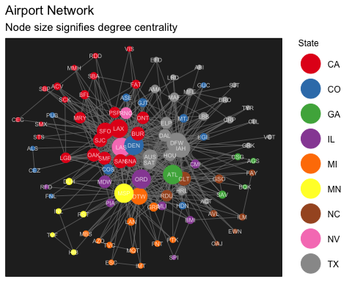
# plot sub2
ggnet2(sub2_converted, mode="kamadakawai",
label.size = 2.1,
label.alpha = 0.75,
label = "name",
label.color = "white",
color="state",
color.legend = "State",
size = "degree",
size.min = 2,
palette = "Set1") +
guides(size = FALSE) +
theme(panel.background = element_rect(fill = "grey15")) +
ggtitle("Airport Network", subtitle="Node size signifies betweenness centrality")
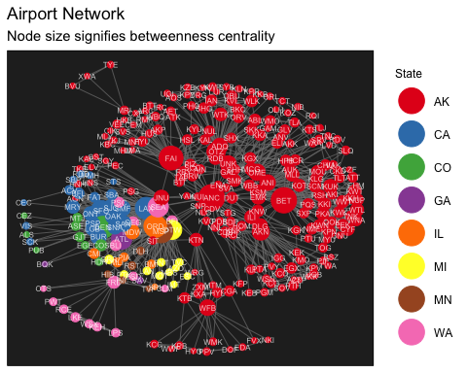
par(op)
The difference in these 2 networks is what makes them interesting. Specifically, the first network contains the top-10 states as measured by airport degree centrality. The 2nd network contains the top-10 states as measured by airport betweenness centrality. The node size in both visualizations reflects airport degree centrality. Therefore:
- The first visualization presents the most central/important airports by number of direct connections.
- The second visualization presents the most central/important airports by number of indirect connections.
- So the first visualization is an absolute importance visualization, while the second visualization is a relative importance visualization.
For example, in the first visualization - airports such as LAX, SFO, DEN, and LAS are among the biggest hubs with the most direct connections in the country. So they have the highest degrees. Compare this to the second visualization, which shows many of the largest nodes (and most numerous) as being from Alaska. This is because Alaska is a huge state with many small/regional airports that depend on a handful of hubs for interstate and international flights. So in the 2nd visualization, Alaska’s hub airports (ANC, FAI, BET, OTZ) have at least equal degree centrality as LAX, PHX, DEN, etc.

Community Detection

Select sample of full network for plotting
sub3 <- induced_subgraph(net1, vids = V(net1)[V(net1)$region %in% c("West","South")])
sub3 <- induced_subgraph(sub3, vids = V(sub3)[names(which(degree(sub3) > 1))])

Algorithm testing and modularity
cw1 <- cluster_leading_eigen(sub3)
cw2 <- cluster_fast_greedy(sub3)
cw3 <- cluster_louvain(sub3)
print(modularity(cw1))
## [1] 0.5611232
print(modularity(cw2))
## [1] 0.5288491
print(modularity(cw3))
## [1] 0.5783097
Out of the 3 community detection algorithms tested above, the one with the highest modularity is the third (“Louvain”). However, all 3 community detection algorithms post a similar modularity between 0.52 and nearly 0.585. This implies that they all detect considerable clustering with respect to node groupings in the network ^{[1]} (p.115, Network Analysis in R).

Plot communities
op <- par(mar = c(0,0,4,0),mfrow=c(1,3))
plot(cw1, sub3,
vertex.label = NA,
vertex.size=4,
edge.arrow.size = 0)
plot(cw2, sub3,
vertex.label = NA,
vertex.size=4,
edge.arrow.size = 0)
plot(cw3, sub3,
vertex.label = NA,
vertex.size=4,
edge.arrow.size = 0)
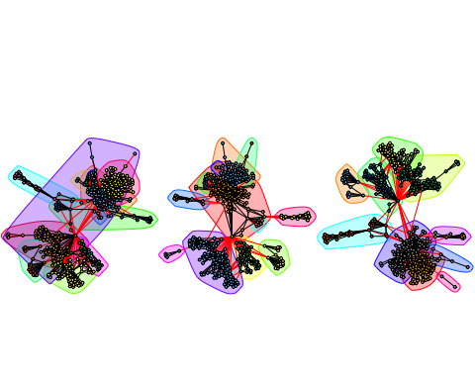
par(op)

View community membership
# Review what are the major groups
membership_table <- table(membership(cw3))
total_members = sum(membership_table)
first_four_groups = sum(membership_table[1:6])
percent <- first_four_groups/total_members
membership_table
##
## 1 2 3 4 5 6 7 8 9 10
## 110 20 70 55 40 31 5 120 10 2
group_1_states <- unique(V(sub3)$state[which(membership(cw3) == 1)])
group_3_states <- unique(V(sub3)$state[which(membership(cw3) == 3)])
group_4_states <- unique(V(sub3)$state[which(membership(cw3) == 4)])
group_8_states <- unique(V(sub3)$state[which(membership(cw3) == 8)])
group_1_states
## [1] "FL" "LA" "TX" "DC" "GA" "NC" "AL" "TN" "MD" "SC" "VA" "WV" "MS" "KY"
## [15] "AR" "OK" "CO" "AZ"
group_3_states
## [1] "AK"
group_4_states
## [1] "AK"
group_8_states
## [1] "NV" "CA" "WA" "TX" "OK" "NM" "CO" "OR" "AZ" "UT" "ID" "HI" "WY" "MT"
The community generated by the Louvain algorithm has the cleanest delineation of communities. In the membership table above, the first six groups make up percent of total members (all nodes) in the plot. Further analysis of the largest groups reveals:
- Groups colored in yellow, green, and light orange at the top of the network are airports in Alaska
- Groups colored in blue, light blue, purple, and red at the bottom of the network pertain to airports in the western and southern USA and their regional connections.
In terms of the membership table:
- Group 1 consists mostly of states classified as Southern
- Group 3 consists mostly of larger hub-airports in Alaska
- Group 4 consists mostly of larger regional-airports in Alaska
- Group 8 consists mostly of states classified as Western

Network modeling

Convert network from igraph to statnet
detach(package:igraph)
df <- asDF(net1)
net1_conv <- asNetwork(df$edges, vertices=df$vertexes, directed = F)

Null model
library(ergm)
null_model <- ergm(net1_conv ~ edges, control=control.ergm(seed=40))
summary(null_model)
##
## ==========================
## Summary of model fit
## ==========================
##
## Formula: net1_conv ~ edges
##
## Iterations: 7 out of 20
##
## Monte Carlo MLE Results:
## Estimate Std. Error MCMC % z value Pr(>|z|)
## edges -4.10379 0.01483 0 -276.8 <1e-04 ***
## ---
## Signif. codes: 0 '***' 0.001 '**' 0.01 '*' 0.05 '.' 0.1 ' ' 1
##
## Null Deviance: 394588 on 284635 degrees of freedom
## Residual Deviance: 47266 on 284634 degrees of freedom
##
## AIC: 47268 BIC: 47278 (Smaller is better.)
The null model produces an AIC of 47.2k. The negative coefficient of edges (-4.104) indicates that network density is less than 50%, which we saw above in the analysis in section 1 of this document.

Linkage hypothesis
Null hypothesis: Vertex attributes do not influence node connectivity/linkage at the population level of US airports.
Alternate hypothesis : Vertex attributes do influence node connectivity/linkage at the population level of US airports.

Test model
test_model <- ergm(net1_conv ~ edges +
nodematch("state", diff=F) +
nodecov("degree"),
control=control.ergm(seed=30))
summary(test_model)
##
## ==========================
## Summary of model fit
## ==========================
##
## Formula: net1_conv ~ edges + nodematch("state", diff = F) + nodecov("degree")
##
## Iterations: 7 out of 20
##
## Monte Carlo MLE Results:
## Estimate Std. Error MCMC % z value Pr(>|z|)
## edges -6.6427829 0.0407844 0 -162.88 <1e-04 ***
## nodematch.state 2.6390144 0.0452579 0 58.31 <1e-04 ***
## nodecov.degree 0.0367348 0.0003279 0 112.03 <1e-04 ***
## ---
## Signif. codes: 0 '***' 0.001 '**' 0.01 '*' 0.05 '.' 0.1 ' ' 1
##
## Null Deviance: 394588 on 284635 degrees of freedom
## Residual Deviance: 30988 on 284632 degrees of freedom
##
## AIC: 30994 BIC: 31025 (Smaller is better.)
Conclusion: At the 0.05 significance level, the node attributes of airport state (P = <1e-04) and degree (P = <1e-04) do significantly influence linkage at the population level of all US airports.

Goodness of fit
test.model.fit <- gof(test_model, GOF = ~ distance + espartners + degree + triadcensus)
#Four Plots
op <- par(mfrow=c(2,2))
plot(test.model.fit, cex.axis=1.6, cex.label=1.6)
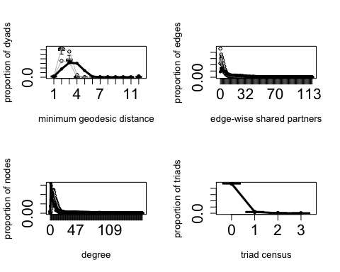
par(op)
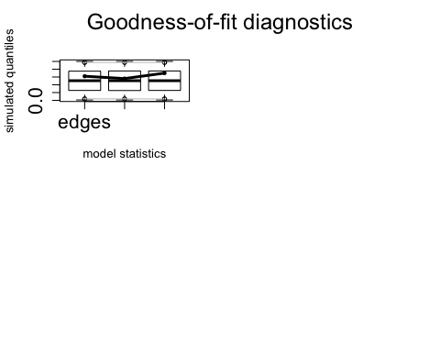
The degree terms have been modeled well because they follow the plotted confidence intervals. However, the dyad-wise partners have not been modeled well - so there is more to be desired from this model.

Simulation
nullsim <- simulate(null_model, verbose = TRUE,seed = 5)
mainsim <- simulate(test_model, verbose = TRUE, seed = 5) #Simulations based on population effect model
rowgof <- rbind(summary(net1_conv ~ edges + degree(0:5) + triangle),
summary(nullsim ~ edges + degree(0:5) + triangle),
summary(mainsim ~ edges + degree(0:5) + triangle))
rownames(rowgof) <- c("Original net", "Null model", "Test model")
rowgof
## edges degree0 degree1 degree2 degree3 degree4 degree5
## Original net 4623 1 120 111 85 51 47
## Null model 4578 0 1 0 6 5 17
## Test model 4635 13 41 55 64 87 73
## triangle
## Original net 26359
## Null model 473
## Test model 17340
The test model is ~9,000 triangles less than the original/true network. It also has less degrees. However - it is much better than the null model.

Plot actual network vs simulated network
op <- par(mfrow=c(1,2), mar=c(0,0,2,0))
plot(net1_conv, usearrows=FALSE,
edge.lwd=0.5,
edge.col="grey75",
main="Observed network")
plot(mainsim,usearrows=FALSE,
edge.lwd=0.5,
edge.col="grey75",
main="Simulated network")
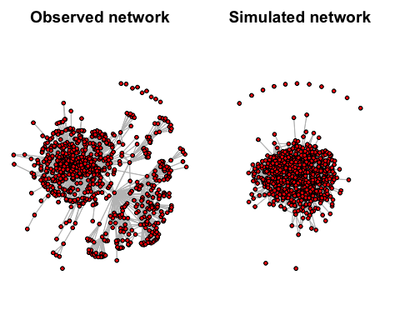
par(op)
The plotted simulation reveals that the test model does not fully predict the multitude of regional airports that are connected to Anchorange International in Alaska. This further means that the test model does not predict the full depth of the US airports network. But it does predict most of the central nodes.

