DS 745: Project 3
Eli (Ilya) Bolotin
11/14/2019

Table of Contents
Dataset description 3
Objective 3
Methodology 3
Text visualization and analysis 3
Read in articles data and compute number of articles 3
Read in comments data 4
Preview comments and compute total classes 5
Split comments into train and test sets 5
Analyze text 5
Tokenize text 6
Examine tokenized data 6
Create binary vectors of words 7
Pad tokenized sequences 7
Create binary matrix of target variables for train/test sets 9
Create Keras model 9
Compile model 10
Define save/load directory 10
Train model 11
Plot model training 11
Load best model for plotting 12
Evaluate model performance 12
Findings along with the discussion 12
References 14

Dataset description
The dataset I have chosen to use for this project is comments and articles data from the New York Times [1]. This open-source dataset contains NYT reader’s comments for articles from January to May 2017 and January to April 2018. The comments data contains “over 2 million comments and 34 features”, while the articles data contains more than 9000 articles and 16 features.
Due to the large size of the data, I have chosen 1 month’s worth of comments data (April 2018) to analyze. As seen below, this month contains well over 240,000 comments, which is a sufficient volume for the scope of this project.

Objective
The objective of this project is perform text classification to predict article topic from comments text. We will perform supervised learning on comments text and section heading to predict article topic. Article topics are defined by editors of the NYT in column entitled “newDesk”.

Methodology
The methodology used in this project to perform text classification is a form of supervised learning known as deep learning. Namely, we will train a neural network (multiple layer perceptron) to make predictions.

Text visualization and analysis
Before viewing comments data, it makes sense to first review the articles for which readers write comments.

Read in articles data and compute number of articles
# read in articles
articles <- read.csv("nyt-comments/ArticlesApril2018.csv", header = T)
articles <- as_tibble(articles[,c("headline","newDesk", "sectionName")])
# num unique articles
num_articles <- length(articles$headline)
# num unique article topics
num_topics <- length(unique(articles$newDesk))
For the month of April 2018, there were 1324 articles published by the NYT (each with distinct headlines). Examples of headlines include:
## # A tibble: 6 x 3
## headline newDesk sectionName
## <fct> <fct> <fct>
## 1 Former N.F.L. Cheerleaders’ Settlement Offer: $1 and a M… Sports Pro Footba…
## 2 E.P.A. to Unveil a New Rule. Its Effect: Less Science in… Climate Unknown
## 3 The New Noma, Explained Dining Unknown
## 4 How a Bag of Texas Dirt Became a Times Tradition Insider Unknown
## 5 Is School a Place for Self-Expression? Learning Unknown
## 6 Commuter Reprogramming Magazine Unknown
All 1324 articles above belong to 39 distinct topics. Below the top-25 most frequent article topics are plotted:
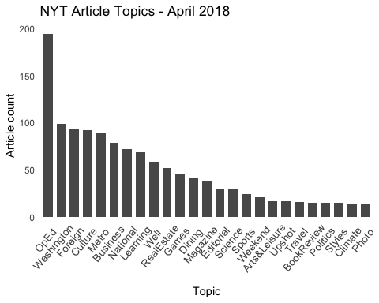
We will be training a neural network to predict the topics above based on user comments and section heading/name.

Read in comments data
# read in data
comments <- read.csv("nyt-comments/CommentsApril2018.csv", header = T)
comments <- as_tibble(comments[,c("commentBody","newDesk", "sectionName")])
# examine dataset size
dim_comments <- dim(comments)
total_comments <- dim_comments[1]
There are a total of 264924 comments for April 2018.

Preview comments and compute total classes
Below is a small sample of user comments:
## # A tibble: 6 x 3
## commentBody newDesk sectionName
## <fct> <fct> <fct>
## 1 "How could the league possibly refuse this offer? " Sports Pro Footba…
## 2 "So then the execs can be like \"yeah...we will sit down … Sports Pro Footba…
## 3 I would not want to play chess against these cheerleaders… Sports Pro Footba…
## 4 "Could the cheerleaders join the Actors' Equity Associati… Sports Pro Footba…
## 5 Seeking conclusions which support preconceived ideas and … Climate Unknown
## 6 "Pruitt: First eliminate the scientists and now eliminat… Climate Unknown
As mentioned above, there are 39 possible comment classes.
Next, we will remove any comments with an “Unknown” section name, as well as any comments with NA, and drop unused levels.
comments <- comments[comments$sectionName != 'Unknown',]
comments$commentBody <- as.character(comments$commentBody)
comments <- na.omit(comments)
comments <- droplevels.data.frame(comments)
num_rows <- nrow(comments)
We now have 117624 comments to train on.

Split comments into train and test sets
set.seed(39)
# shuffle data to ensure train and test subsets contain approximately normally distributed classes
new_indices <- sample(num_rows, replace = FALSE)
comments <- comments[new_indices,]
# sample train and test indices
num_train_samples <- round(num_rows * 0.90)
train_indices <- sample(1:num_rows, num_train_samples, replace = FALSE)
test_indices <- setdiff(1:num_train_samples, train_indices)
# create train/test datasets
x_train <- comments[train_indices, c("commentBody","sectionName")]
y_train <- comments$newDesk[train_indices]
x_test <- comments[test_indices, c("commentBody","sectionName")]
y_test <- comments$newDesk[test_indices]

Analyze text
The comments/text need to be converted into machine readable form (numeric form) before we can work with them. Let’s first analyze how many unique words we have in our dataset. Note that this is just a rough estimate, because we have not (yet) filtered symbols and other non-needed characters from the comments.
comment_id <- tibble(idx = length(x_train), text = as.character(x_train))
tokenized_tibble <- comment_id %>%
unnest_tokens(word, text)
num_unique_words <- length(unique(tokenized_tibble$word))
There are approximately 74406 unique words in our corpus.

Tokenize text
Create a tokenizer that will map words to numbers for every comment (up to a maximum of unique words).
# create a tokenizer that maps words to numbers for every comment
vocab_len = num_unique_words
tokenizer <- text_tokenizer(num_words = vocab_len) %>% fit_text_tokenizer(x_train$commentBody)

Examine tokenized data
# Get actual number of unique words from tokenizer
vocab_len <- length(tokenizer$word_index)
# View first/last word indices
head(tokenizer$word_index)
## $the
## [1] 1
##
## $to
## [1] 2
##
## $and
## [1] 3
##
## $of
## [1] 4
##
## $a
## [1] 5
##
## $br
## [1] 6
tail(tokenizer$word_index)
## $`american'`
## [1] 82094
##
## $chainsaw
## [1] 82095
##
## $supercede
## [1] 82096
##
## $`'expertise'`
## [1] 82097
##
## $`'ghost'`
## [1] 82098
##
## $wheeled
## [1] 82099

Create binary vectors of words
One-hot-coding every word for every comment (i.e. producing a binary word-vector for every word of every comment) is very computationally expensive. Instead, with neural networks we can use an embedded layer to represent word-sequences in more compact form (by using a fixed number of coefficients).
To do this, we need to vectorize every comment according to the tokenized word indices created above.
# vectorize train and test data
train_vectors <- texts_to_sequences(tokenizer, x_train$commentBody)
test_vectors <- texts_to_sequences(tokenizer, x_test$commentBody)
# view sample sequence for first comment
head(train_vectors, 1)
## [[1]]
## [1] 366 5290 5215 93 827 22 2 70 1 3905 22 7387 3 69 436
## [16] 58 19 8400 9022 6 6 36 534 284 430 284 28 496 39 91
## [31] 48 284 13 72

Pad tokenized sequences
Due to the fact that every word-sequence is of variable length, each sequence should be standardized to a fixed length before it can be fed to the neural network (which expects every input to have a common size).
First: Analyze the length of comments
train_vector_lengths <- sapply(train_vectors, length)
hist(train_vector_lengths, main = "Train Vector Lengths Distribution")
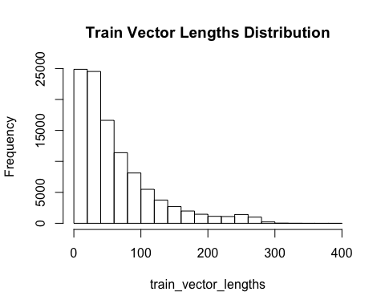
quantiles = quantile(train_vector_lengths, probs = c(0.05, .95))
The histogram shows a highly right-skewed distribution. We can see that length bottoms out near 300 words per comment (sequence). However, the 95% quantile is equal to 195 words per comment. So we can use this length as the input_size.
Next: Set a max sequence length to 195 words and pad vectors less than this with zeros.
# set input dimensions
vector_len = quantiles[2]
# Pad sequences
x_train <- pad_sequences(train_vectors, maxlen = vector_len, padding = "post")
x_test <- pad_sequences(test_vectors, maxlen = vector_len, padding = "post")
# VIew padded sequence (1 sequence shown)
head(x_train, 1)
## [,1] [,2] [,3] [,4] [,5] [,6] [,7] [,8] [,9] [,10] [,11] [,12] [,13] [,14]
## [1,] 366 5290 5215 93 827 22 2 70 1 3905 22 7387 3 69
## [,15] [,16] [,17] [,18] [,19] [,20] [,21] [,22] [,23] [,24] [,25] [,26]
## [1,] 436 58 19 8400 9022 6 6 36 534 284 430 284
## [,27] [,28] [,29] [,30] [,31] [,32] [,33] [,34] [,35] [,36] [,37] [,38]
## [1,] 28 496 39 91 48 284 13 72 0 0 0 0
## [,39] [,40] [,41] [,42] [,43] [,44] [,45] [,46] [,47] [,48] [,49] [,50]
## [1,] 0 0 0 0 0 0 0 0 0 0 0 0
## [,51] [,52] [,53] [,54] [,55] [,56] [,57] [,58] [,59] [,60] [,61] [,62]
## [1,] 0 0 0 0 0 0 0 0 0 0 0 0
## [,63] [,64] [,65] [,66] [,67] [,68] [,69] [,70] [,71] [,72] [,73] [,74]
## [1,] 0 0 0 0 0 0 0 0 0 0 0 0
## [,75] [,76] [,77] [,78] [,79] [,80] [,81] [,82] [,83] [,84] [,85] [,86]
## [1,] 0 0 0 0 0 0 0 0 0 0 0 0
## [,87] [,88] [,89] [,90] [,91] [,92] [,93] [,94] [,95] [,96] [,97] [,98]
## [1,] 0 0 0 0 0 0 0 0 0 0 0 0
## [,99] [,100] [,101] [,102] [,103] [,104] [,105] [,106] [,107] [,108]
## [1,] 0 0 0 0 0 0 0 0 0 0
## [,109] [,110] [,111] [,112] [,113] [,114] [,115] [,116] [,117] [,118]
## [1,] 0 0 0 0 0 0 0 0 0 0
## [,119] [,120] [,121] [,122] [,123] [,124] [,125] [,126] [,127] [,128]
## [1,] 0 0 0 0 0 0 0 0 0 0
## [,129] [,130] [,131] [,132] [,133] [,134] [,135] [,136] [,137] [,138]
## [1,] 0 0 0 0 0 0 0 0 0 0
## [,139] [,140] [,141] [,142] [,143] [,144] [,145] [,146] [,147] [,148]
## [1,] 0 0 0 0 0 0 0 0 0 0
## [,149] [,150] [,151] [,152] [,153] [,154] [,155] [,156] [,157] [,158]
## [1,] 0 0 0 0 0 0 0 0 0 0
## [,159] [,160] [,161] [,162] [,163] [,164] [,165] [,166] [,167] [,168]
## [1,] 0 0 0 0 0 0 0 0 0 0
## [,169] [,170] [,171] [,172] [,173] [,174] [,175] [,176] [,177] [,178]
## [1,] 0 0 0 0 0 0 0 0 0 0
## [,179] [,180] [,181] [,182] [,183] [,184] [,185] [,186] [,187] [,188]
## [1,] 0 0 0 0 0 0 0 0 0 0
## [,189] [,190] [,191] [,192] [,193] [,194] [,195]
## [1,] 0 0 0 0 0 0 0
Above is an example of a padded sequence.

Create binary matrix of target variables for train/test sets
y_train <- as.factor(y_train)
y_train_numeric <- as.numeric(y_train)-1
y_train_bin <- to_categorical(y_train_numeric, num_classes)
y_test <- as.factor(y_test)
y_test_numeric <- as.numeric(y_test)-1
y_test_bin <- to_categorical(y_test_numeric, num_classes)

Create Keras model
Below is the neural network architecture. We are using a sequential model with 4 fully connected layers, 1 pooling layer, and 2 dropout layers. Notice the use of the embedding layer to represent vectorized words in compact form (input dim = 82099 and output = 300).
# create model
model <- keras_model_sequential()
# define layers
model %>%
layer_embedding(input_dim = vocab_len, output_dim = 300) %>%
layer_global_average_pooling_1d() %>%
layer_dense(units = 150, activation = "relu") %>%
layer_dropout(rate = 0.15) %>%
layer_dense(units = 75, activation = "relu") %>%
layer_dropout(rate = 0.15) %>%
layer_dense(units = num_classes, activation = "softmax")
# view summary
summary(model)
## Model: "sequential"
## ________________________________________________________________________________
## Layer (type) Output Shape Param #
## ================================================================================
## embedding (Embedding) (None, None, 300) 24629700
## ________________________________________________________________________________
## global_average_pooling1d (GlobalAve (None, 300) 0
## ________________________________________________________________________________
## dense (Dense) (None, 150) 45150
## ________________________________________________________________________________
## dropout (Dropout) (None, 150) 0
## ________________________________________________________________________________
## dense_1 (Dense) (None, 75) 11325
## ________________________________________________________________________________
## dropout_1 (Dropout) (None, 75) 0
## ________________________________________________________________________________
## dense_2 (Dense) (None, 39) 2964
## ================================================================================
## Total params: 24,689,139
## Trainable params: 24,689,139
## Non-trainable params: 0
## ________________________________________________________________________________

Compile model
Define gradient descent optimizer, loss function, and metrics
model %>% compile(
optimizer = 'adam',
loss = 'categorical_crossentropy',
metrics = 'accuracy'
)

Define save/load directory
# create checkpoints folder to save model while training
checkpoint_dir <- "checkpoints"
dir.create(checkpoint_dir, showWarnings = FALSE)
filepath <- file.path(checkpoint_dir, "best_model.hdf5")

Train model
# Create checkpoint callback
cp_callback <- callback_model_checkpoint(
filepath = filepath,
save_weights_only = TRUE,
save_best_only = TRUE,
verbose = 0
)
early_stopping <- callback_early_stopping(patience = 3)
# train model
history <- model %>% fit(
x_train, y_train_bin,
epochs = 20,
batch_size = 1280,
validation_split = 0.20,
verbose = 1,
callbacks = list(cp_callback, early_stopping) # pass callback to training
)

Plot model training
plot(history)

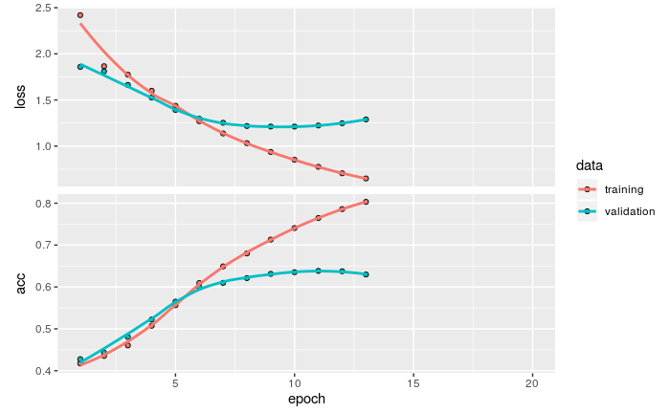

Evaluate model performance
model %>% evaluate(x_test, y_test_bin, verbose = 0)
## $loss
## [1] 1.226128
##
## $accuracy
## [1] 0.6327956

Findings along with the discussion
As we see from the evaluation of the model on the test data, the model produces ~63% classification accuracy on the test set (10599 observations and 39 classes). This is not a good result.
The training plot is highly indicative of what is happening here. From the training plot we see that model begins to overfit the training set by the 5th epoch. By the 10th epoch, validation accuracy has peaked at ~63%. (Training accuracy peaks at 81% at the ~13th epoch.) After the 13th epoch, the model suspends training because validation loss has not increased in 3 epochs (known as patience).
Why does the model have poor prediction accuracy on the test set? This is due to the generic nature of reader comments for NYT articles (and the topics created for them). Many comments are simply not characteristic of any singular topic. Take for example this subset of comments with a newsDesk title of ‘Sports’ and sectionName of ‘Pro Football’:
slice(comments[comments$newDesk == "Sports" & comments$sectionName == "Pro Football",], 50:60)
## # A tibble: 11 x 3
## commentBody newDesk sectionName
## <chr> <fct> <fct>
## 1 "Good move, Cheerleaders !<br/>Poor NFL....they will hav… Sports Pro Footba…
## 2 Their job is to be literal sex objects. Instead of askin… Sports Pro Footba…
## 3 Are cheerleaders in the NFL worth keeping around? They m… Sports Pro Footba…
## 4 "If the women cheerleaders/dancers find it demeaning to … Sports Pro Footba…
## 5 How many women tune in to NFL games to watch cheerleader… Sports Pro Footba…
## 6 I thought the cheerleaders were there to enhance the mal… Sports Pro Footba…
## 7 "If men had filed this lawsuit, citing harassment, low p… Sports Pro Footba…
## 8 Why even have cheerleaders, they are not part of televis… Sports Pro Footba…
## 9 NFL cheerleaders are underpaid, discriminated against an… Sports Pro Footba…
## 10 "A savvy and excellent play by the women! " Sports Pro Footba…
## 11 Giving in to 'uppity women' Sports Pro Footba…
The conversation in these comments is about harassment, lawsuits, and discrimination against cheerleaders. There is no actual conversation about sports, athletes, or NFL games. The more accurate classification topic here is politics or perhaps culture. Such is also the case with reader comments from NYT April 2017 regarding Colin Kaepernick. When Kaepernick created a political movement by taking a knee during the national anthem of a football game, all of the comments in response to the subsequent NYT article had to do with the political repercussions of his actions (as well as the reactions of Donald Trump) – thus diluting any actual sports talk from comments labeled as “sports”. This is naturally confusing to neural nets.
Specifically in this project, the model (which assigns weights to words) has a difficult time correctly classifying statements in the validation set that consist of the same words (but in different context) found in the training set. In the training set the model updates its parameters to minimize the loss function, thus eventually achieving a perfect recognition of which specific comments (meaning – a specific sequence of words) belong to distinct topics. But when these same weights are applied to the validation set, which consists of largely the same words but in different context, the model cannot achieve similar accuracy – because inherently generic words in different order can belong to many topics. As such, the model cannot distinguish the correct classes with high enough probability. This is known as overfitting.
In conclusion, given the small amount of data used in this project and the short duration of training, the neural network cannot yet classify polysemantic comments beyond ~61% accuracy.

References
^{[1]} NYT Dataset, https://www.kaggle.com/aashita/nyt-comments
^{[2]} Keras for R, https://blog.rstudio.com/2017/09/05/keras-for-r/
^{[3]} Intro to text classification, https://www.onceupondata.com/2019/01/21/keras-text-part1/
^{[4]} Preparing data for NLP, https://shirinsplayground.netlify.com/2019/01/text_classification_keras_data_prep/
^{[5]} Text classification in R, https://www.jla-data.net/eng/vocabulary-based-text-classification/

