- Bus Game Technical Report -
Team 1 Black Swans: Emily Bongiorno & Kurtis Volker | Spring 2026

1. Background & Motivation
The original idea for this project was a traffic routing simulation. This application would allow users to input their pathing idea for the current traffic and compare again AI agent generated paths through that traffic. By the time development became practical, a heavy reduction in scope was necessary for time. The idea naturally translated into a simplified node map structure for a game rather than a real-world map. This is the ultimate result of a node-traversal tech demo created over spring break, Bus Game, where one human player and five AI agents simultaneously navigate a procedurally generated 10×10 grid graph. Each is trying to reach shared goal node with the lowest cost path to get there.

2. Algorithm & Design Explanation

2.1 Graph Representation
The game board is a 10×10 undirected grid graph. Each node (r, c) is connected to its cardinally adjacent neighbors. Edge weights are generated at random from the integer range [1, 50] at initialization and are bidirectional (thanks to a sorted key-pair dictionary).

2.2 Greedy Best-First Search
The Greedy agent is the simplest of the algorithms. It chooses each next node via the Manhattan distance relative to the goal (f(n) = h(n)), breaking ties by edge cost. It keeps a visited set to avoid revisiting nodes. In practice this algorithm is short-sighted and performed the worst of the bunch. The board is too large for its short-term decisions to consistently avoid producing a sub-optimal route.

2.3 Simulated Annealing (SA-1, SA-2)
Two SA agents are initialized with the following path seeds and temperatures for 10,000 iterations
SA-1 uses a random-path as its seed with a high initial temperature (400). SA-2 uses a path prioritizing the lowest cost neighbor as seed with a lower initial temperature (150).
In other words SA-1 starts from a random path, explores more widely. SA-2 starts from a more reasonable path and focuses on improving it.
At each iteration, a random subsegment of the current path is replaced with a partially random path between the same endpoints. The acceptance probability for a worse solution is exp(−ΔE / T), with temperature decaying multiplicatively each step (floor: 0.5). This should allow them to escape from local optima early in the search. Both agents showed high variance which is consistent with the random distribution common to annealing. They are also the only ones to fail to find a legal path, which is explored later in the analysis.

2.4 Genetic Algorithm (GA-1)
GA-1 is seeded with a warm population of 60 SA plans generated at varied temperatures, plus SA-1 and SA-2’s final plans, for a starting population of 30 (trimmed from 62). Each generation applies tournament selection (k=4), crossover at shared nodes, and SA-based mutation at a rate decaying from 40% to 10% over 80 generations. The two best solutions are always carried over into the next generation.
These decisions were ultimately made as a work around, as a more cold-start genetic algorithm was poorly suited to the problem, and would’ve required demonstrably more computation, iterations, and time. GA-1 was the second-best agent, utilizing the strengths of the simulated annealing agents in its warm-start population, giving it a highly competitive solution even when no single SA run dominates.

2.5 A* Search
A* maintains a min-priority queue ordered by f(n) = g(n) + h(n), where g(n) is the true cumulative edge cost from the start and h(n) is the Manhattan distance heuristic. Because all edge weights are positive and the heuristic is admissible, A* is guaranteed to return an optimal path. Since Manhattan heuristic doesn't account for cost in a random grid, A* actually behaves similarly to Dijkstra’s algorithm here, exploring a broader portion of the graph than it would in a weighted grid. A* placed 1st in 100/100 trials, a perfect score. It serves as the theoretical performance ceiling for the project.

3. System Architecture
The system is organized into four logical layers: Presentation, Game Logic, Data, and AI. Figure 1 shows the component relationships and control flow.
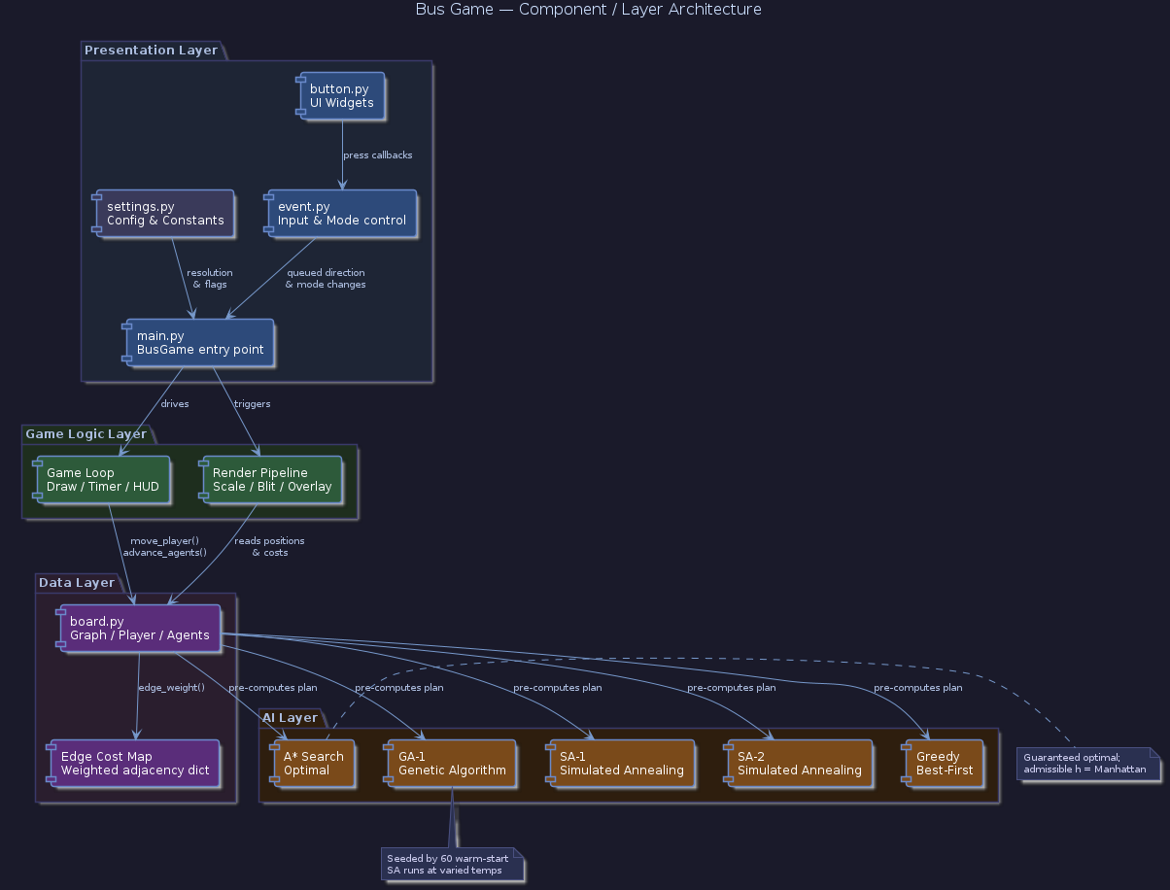
Figure 1a. Component / Layer Architecture — module responsibilities and inter-layer dependencies.
Figure 1b. Game Loop Flowchart — control flow from initialization through AI pre-computation, play loop, and win resolution.

3.1 Module Responsibilities
main.py is the application entry point. It owns the pygame surfaces, sprite assets, and the top-level game loop, which cycles through “Main Menu” and “Play” modes. It delegates input to event.py and board state to board.py.
event.py handles all input events, mode transitions, overlay popups (settings, rules, pause), and queued player directions. It translates raw mouse coordinates from the display window into logical game coordinates via a scaling transform.
button.py provides button logic, click detection, and visual rendering functions independently of game logic.
board.py owns the graph data structure, edge cost map, player state, and all five AI agent definitions. It gives move_player(), advance_agents(), and results() to the main loop. All AI planning is executed once at board initialization; agents advance by one node per game turn following their pre-computed plans.
settings.py defines the logical resolution (2796×1864), window resolution (1440×960), and global flags for sound, timer, and text speed.

4. Experimental Evaluation
4.1 Methodology
One hundred games were run with the human player treated as absent for all trials, isolating algorithmic performance across a large set of random boards. When an agent failed to find a valid path to the goal (a convergence failure), it was recorded as DNF (Did Not Finish) and excluded from placement rankings and cost calculations for that game.
Two main evaluation metrics are used. Placement rank (1 = best, 5 = worst among finishers) measures competitive ordering within each game (excluding DNF games). Path cost ratio measures each agent’s raw path cost as a multiple of the A* optimal cost for that game, capturing margin of quality rather than just ordering. DNF rate (DNFs / 100 trials) is the third.
4.2 Summary Statistics
Table 1 summarizes aggregate performance across all 100 trials.

Table 1. Summary statistics across 100 trials. Mean rank excludes DNF games. Cost ratio = agent cost / A* optimal cost.
Agent | Mean Rank | Std Dev | 1st Place | Wins | DNF | Mean Cost | Cost Ratio
A*-1 | 1.000 | 0.000 | 100 | 100 | 0 (0%) | 261.8 | 1.000
GA-1 | 1.670 | 0.970 | 63 | 63 | 0 (0%) | 265.6 | 1.014
SA-1 | 2.542 | 1.491 | 36 | 36 | 17 (17%) | 284.2 | 1.083
SA-2 | 2.614 | 1.434 | 35 | 35 | 12 (12%) | 283.1 | 1.087
Greedy | 4.410 | 0.826 | 2 | 2 | 0 (0%) | 334.1 | 1.287

4.3 Average Placement
Figure 2. Mean placement per agent ±1 std dev (100 trials, DNF excluded). Lower is better.
4.4 Placement Frequency Distribution
Figure 3. Placement frequency heatmap (100 trials, DNF excluded). Cell values show count per rank per agent.
4.5 Per-Trial Trajectory
Figure 4. 10-game rolling average placement per agent. DNF games are treated as rank 5.5 for visualization.
4.6 DNF Analysis
SA-1 and SA-2 were the only algorithms that had convergence failures. SA-1 in 17% of trial and SA-2 in 12%. All other agents completed every game. It appears the random seeds occasionally produce degenerate starting paths that the annealer cannot recover from within limited iterations.
Figure 5. DNF rate per agent across 100 trials. Only SA-1 and SA-2 experienced convergence failures.
4.7 Cost Analysis
Figures 7 and 8 report raw path costs and cost ratios relative to the A* optimum, capturing the margin of quality rather than just competitive ordering.
Figure 6. Mean path cost per agent ±1 std dev (finished games only). Dashed line marks A* mean cost of 261.8.
4.8 Interpretation
A* kept a perfect record across all 100 trials: 1st place in every game, zero DNFs, and a mean cost ratio of exactly 1.000. As an admissible optimal search algorithm this is the expected result, and the 100-trial dataset confirms there are no edge cases where A* fails on this graph.
GA-1 was the strongest probabilistic agent by every metric: mean rank 1.67, zero DNFs, and a cost ratio of only 1.014. It placed 1st in 63 of 100 games, nearly always tying with A*. The warm-start seeding strategy proved highly effective, by initializing the population with 60 diverse SA solutions, the GA consistently found near-optimal paths while the elitism mechanism prevented regression.
SA-1 and SA-2 showed nearly identical mean cost ratios (~1.085) and similar placement distributions when they finished, but with a noticeable difference in reliability: SA-1 did not finish 17 times vs SA-2’s 12. Increasing the iteration budget or adding a fallback greedy repair step would likely reduce the DNF rate substantially.
Greedy finished every game (0% DNF) but placed last in most trials with a mean rank of 4.41 and cost ratio of 1.287. It only performed well when the board happened to align with Manhattan. The board is simply too large for its short-term decisions to pay off. Greedy’s reliability makes it a safe fallback for completeness (for example, in this implementation of A*), but it consistently produces paths that are around 29% worse than optimal.

5. Discussion, Limitations & Future Work
5.1 Discussion
A*’s perfect record confirms the theoretical guarantee holds on all randomly generated instances of this graph type. GA-1’s near-optimal performance validates that the warm-start seeding strategy when combined with annealing produces consistently high-quality solutions and with no convergence failures at that.
The SA DNF problem is significant. A 17% DNF rate for SA-1 (~1/8 games) and 12% (~1/6) for SA-2. While fine for a game, this would be unacceptable in a practical setting. The issue is that when path mutations fail and no valid neighboring paths exist, the annealing process gets stuck and cannot improve. Increasing the iteration budget or adding a fallback greedy repair step would likely reduce the DNF rate substantially.
Greedy’s consistent 28.7% cost overhead over A* reflects its inability to reason about edge cost globally. On this graph, the Manhattan heuristic provides no useful information about which edges are cheap. This contrasts with real road networks where distance and cost are often correlated.
5.2 Limitations
- DNF exclusion bias: Excluding DNF games from mean rank and cost calculations makes SA-1 and SA-2 look like they performed better than they did.
- Fixed graph type: All trials used a 10×10 grid with random edge weights. Behavior larger, or denser grids may differ substantially.
- Pre-computed plans: All agents compute their full paths before the game begins. In a real-world modeling scenario this is unlikely to be possible, which would change the performance radically.
- Parameter Tuning: SA and GA parameters were set by hand. The observed DNF rates and cost ratios reflect one specific configuration; systematic tuning might substantially improve SA reliability or GA quality.
5.3 Future Work Suggestions
- SA DNF repair: Add a greedy fallback repair step to SA when the path becomes stuck.
- DNF-inclusive metrics: Report a score that penalizes DNF games.
- Variable graph scale: Test agents on 5×5, 15×15, and 20×20 boards to how the metrics scale with problem size.
- Dynamic Implementation: Make agents that update their plans dynamically as new information is found when traversing the board.

Implementation
Bus Game is implemented in Python 3 using the pygame library for rendering and game loop management. All AI algorithms are implemented from scratch in board.py using only the Python standard library (random, math, heapq). Some code is borrowed from an old project in all other .py. Source files: main.py, board.py, event.py, button.py, settings.py.

