**Lab 2 Complexity**

Name: __Tanadon Santisan____________________________

ID: __6538068821______________________________________

Please modify the given source code to find answers in this Lab.

The objective of this lab is to analyze the time complexity of the bubble sort algorithm by experiments.

Follow the instructions and show you graphs in question 5-6:

1. [Version 1] Study the given source code.
2. Run the given Lab03.java or slightly modify to store all running time in an output file (time.csv).
3. [Version 2] Modify the program by commenting out lines 11, 14, 20, and 21. The program will break the outer loop when all data are sorted.
4. Run the program again and save the running time in time1.csv.
5. Run python (you can find your link here: <https://colab.research.google.com/drive/1W69bYLGcS-S1bZd023HWhKIvI4ARWmjp?usp=sharing> ) to create your graph. Your data will be shown in solid lines and the prediction will be a dashed line. Show your graph below.

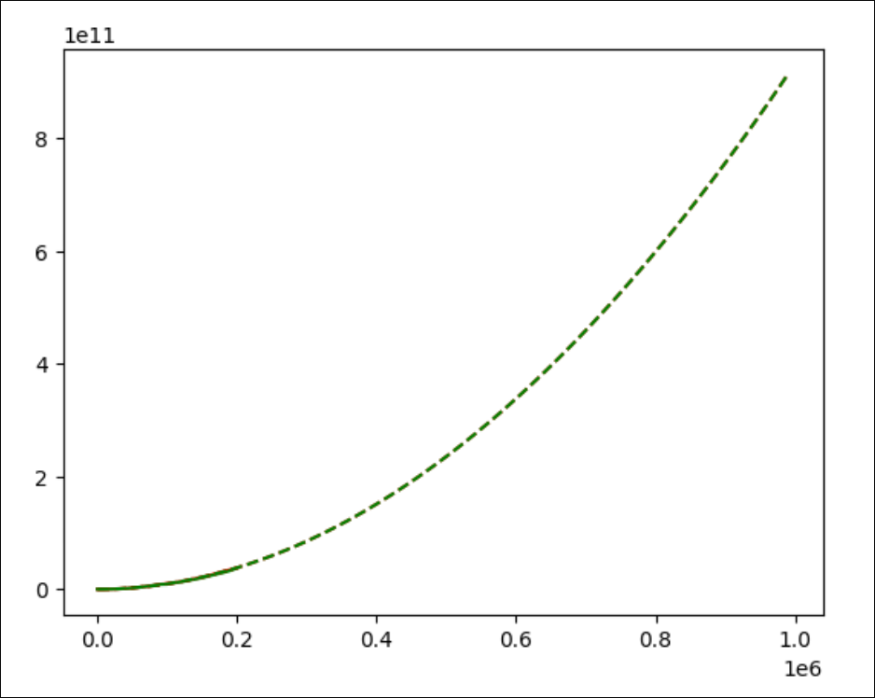

1. Select some n (for example, 100,000 or 300,000) that should take not too long time to test the predicted running time for both versions. Modify the python program to show this data in the graph using the “+” sign. Show your graph below.

