Tree-in-bud

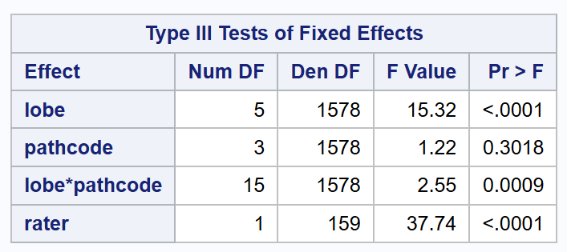
Type 3 Test

type 3 test of the fixed effect parameters of the model, to see if there is a significant interaction between lobe and pathcode (i.e. effect of lobe on score differs between different pathogen groups, or vice versa. evidence that the pathcode effect differs by lobe (or vice versa)

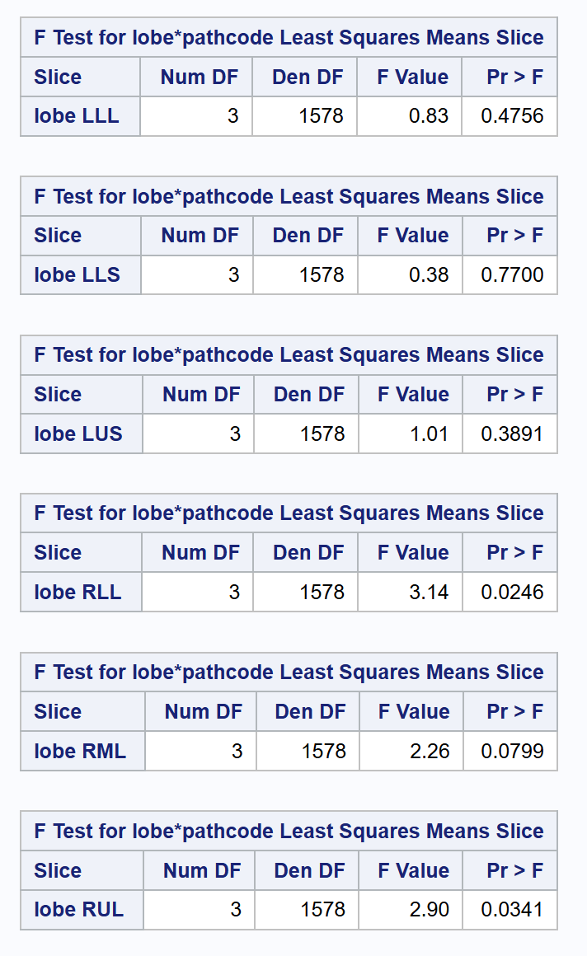
Overall F Test for Effect of Pathcode Within Lobe

slice F-tests: tests of pathcode within each lobe. Those showed significance for RUL and RLL.

Pairwise Comparisons
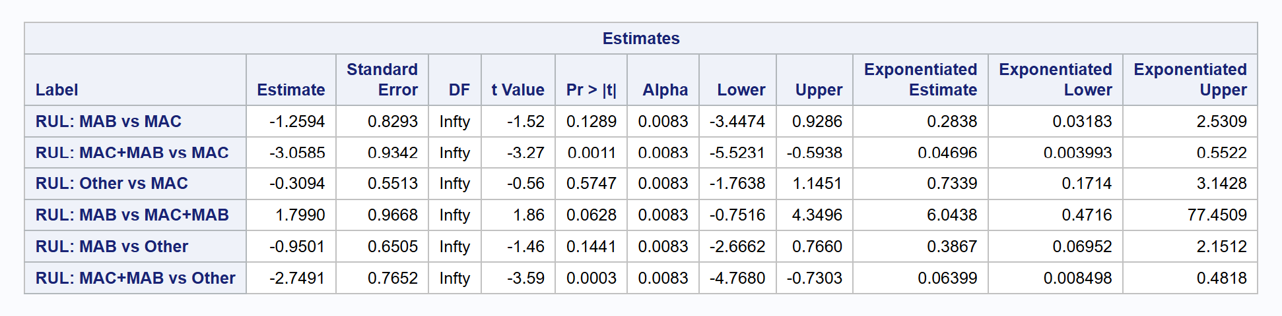
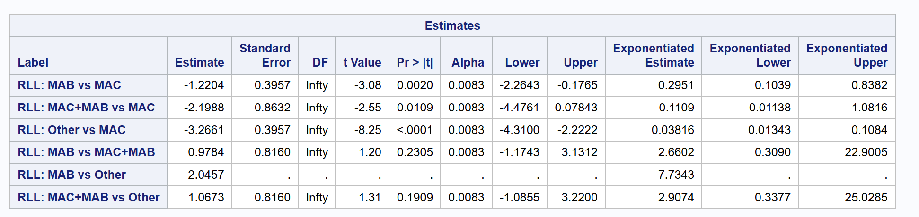

Large Nodules

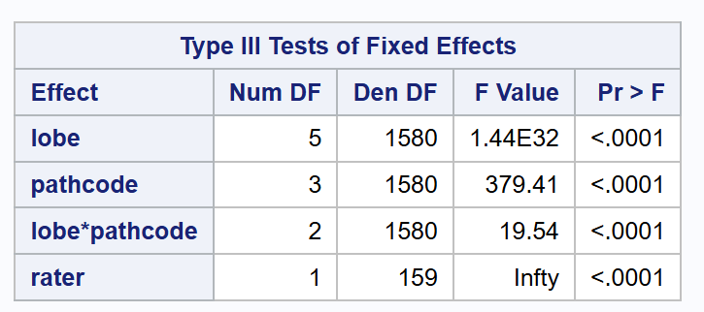
Type 3 Test

Overall F test for effect of pathcode within lobe
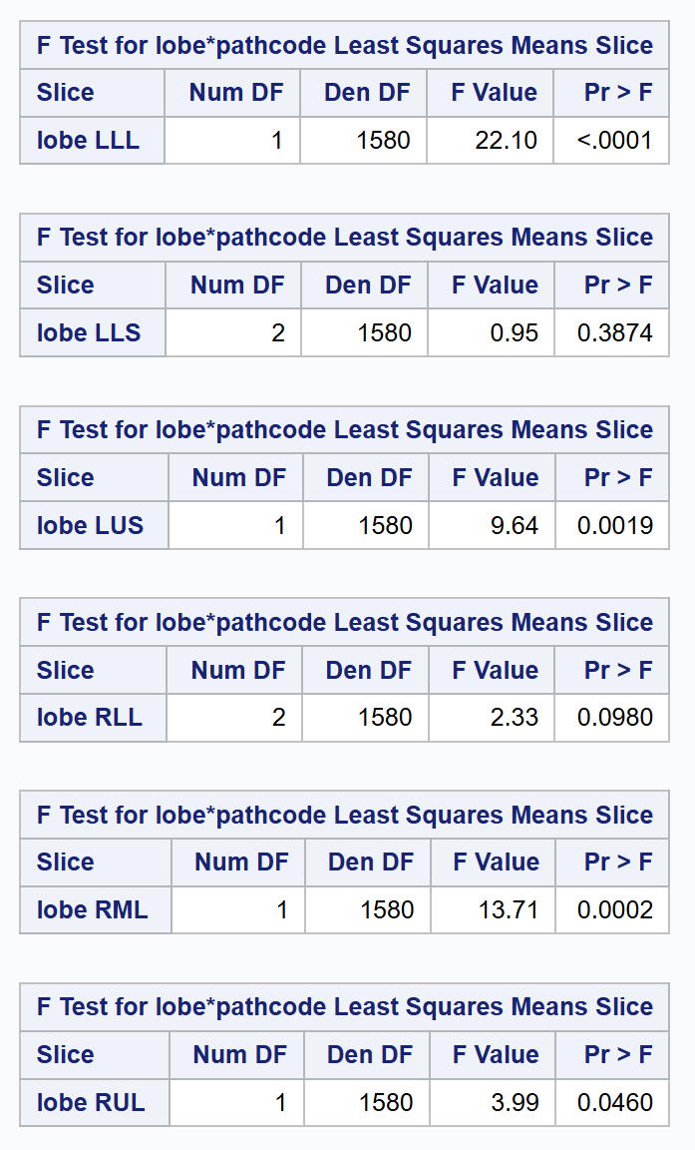
These showed significance for RUL, RML, LUS, LLL

Pairwise Comparisons
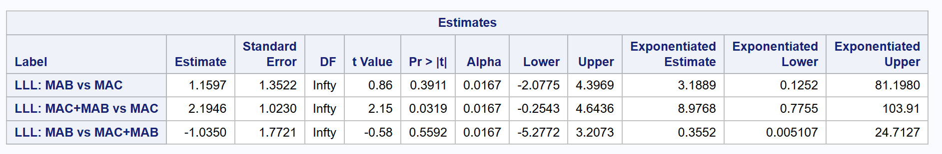
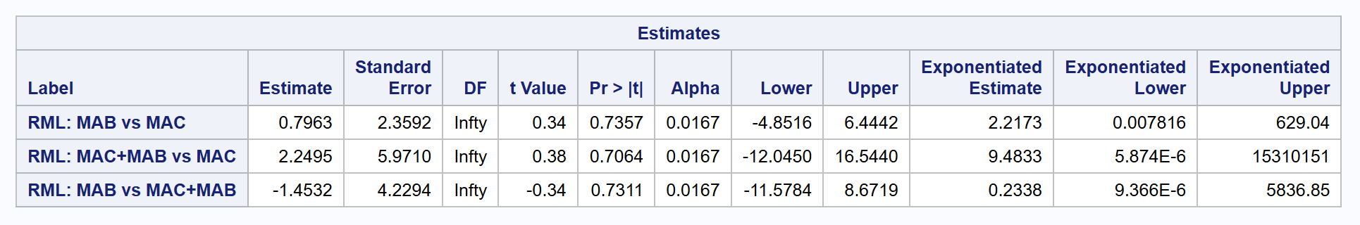
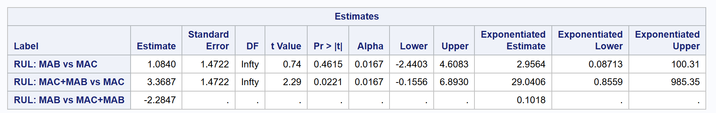
slice results:
For the large nodules feature, the pathcode effect differed by lobe (slice tests): LLL, LUS, RML, and RUL showed significant overall pathcode effects

Pairwise follow-ups (Bonferroni α=0.05/3=0.0167 per lobe for MAC, MAB, MAC+MAB):
Within those lobes, no pairwise comparison among MAC, MAB, and MAC+MAB reached the Bonferroni-adjusted threshold. Point estimates generally suggested higher odds for MAC+MAB vs MAC but CIs were wide.
Several lobes had zero events for ‘Other’ and very low counts overall. This caused quasi-separation, yielding unstable or non-estimable odds ratios and inflated standard errors. The omnibus test can detect a difference driven by these extreme cells, while pairwise mixed-model contrasts either can’t be estimated or lose power after control for FWER.
The LUS pairwise model did not converge due to near-perfect separation.
Overall pathcode effects were detected in LLL, LUS, RML, and RUL, but no prespecified pairwise contrast among MAC, MAB, and MAC+MAB remained significant after Bonferroni correction, largely due to sparse/zero cells; sensitivity analyses using penalized/exact methods support the direction but with imprecise estimates

Ground-Glass Opacity

Type 3 Test
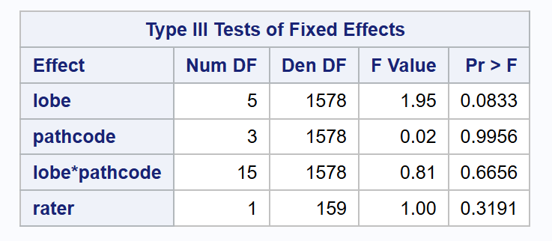

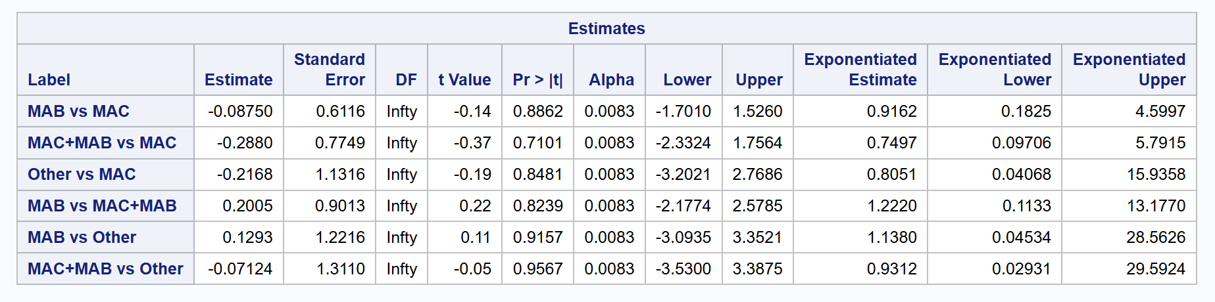
Pairwise Comparisons
In a proportional-odds mixed model (random subject and rater), the lobe×pathcode interaction was not significant (p=0.666), and the main effect of pathcode was also not significant (p=0.996). Reduced model estimates showed no pathogen-group differences in cumulative odds (CIs include 1). Therefore, we find no evidence that disease severity differs by pathogen group for this feature.

Consolidation

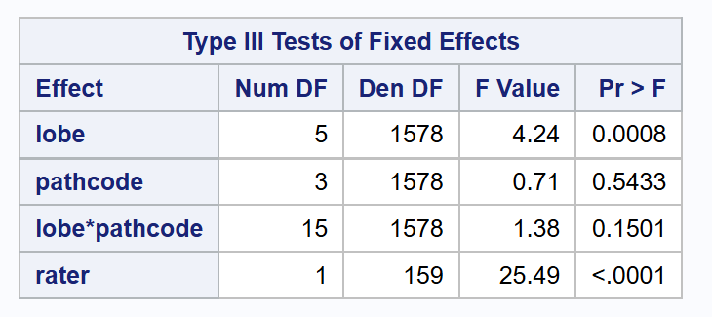
Type 3 Test

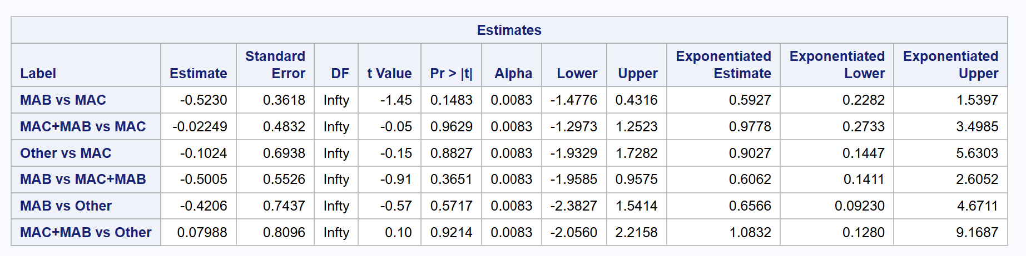
In a proportional-odds mixed model (random subject and rater), lobe was associated with severity (p=0.0008), but pathcode and the lobe×pathcode interaction were not (p=0.5433 and p=0.1501). Pairwise cumulative-odds ratios between pathogen groups were non-significant (all 95% CIs include 1). Thus, no evidence of severity differences by pathogen group for this feature.

Bronchiectasis

Type 3 Test
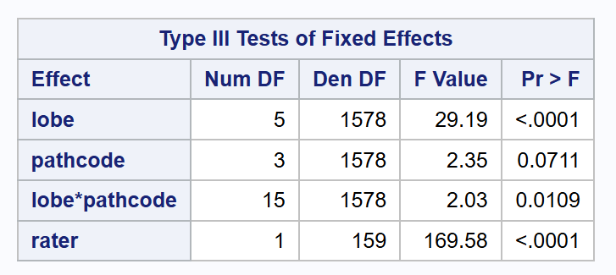

Overall F test for effect of pathcode within lobe
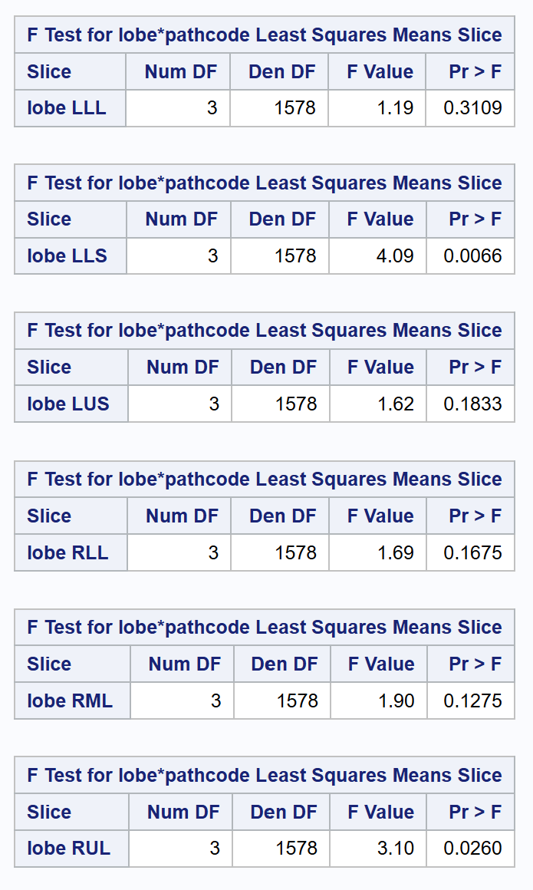

Pairwise Comparisons
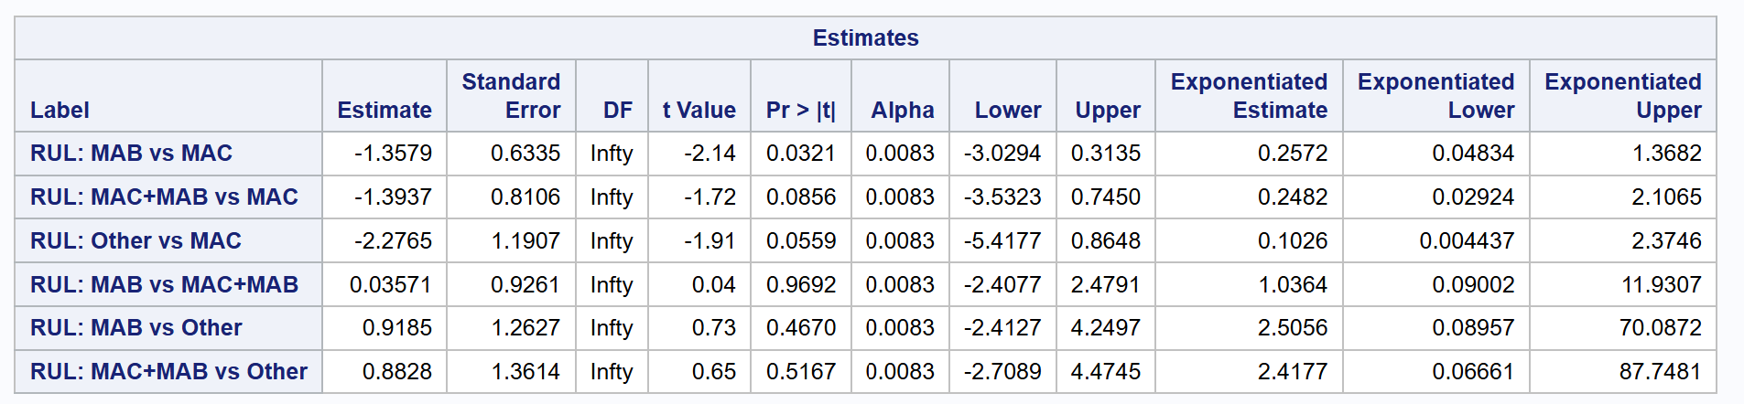
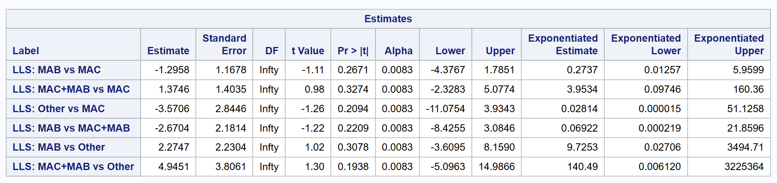
The lobe×pathcode interaction was significant overall; however, within the two lobes flagged by the slice test (RUL, LLS) none of the pairwise pathcode comparisons remained significant after Bonferroni correction for 6 comparisons per lobe (α=0.0083). We report adjusted CIs and odds ratios for completeness.

Atelectasis

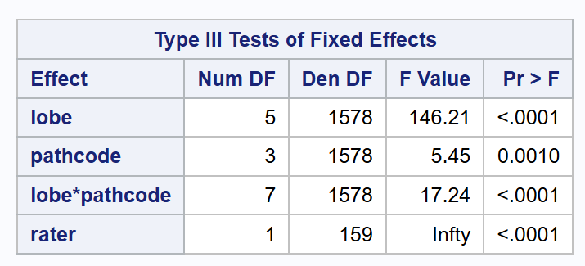
Type 3 Test

Overall F test for effect of pathcode within lobe
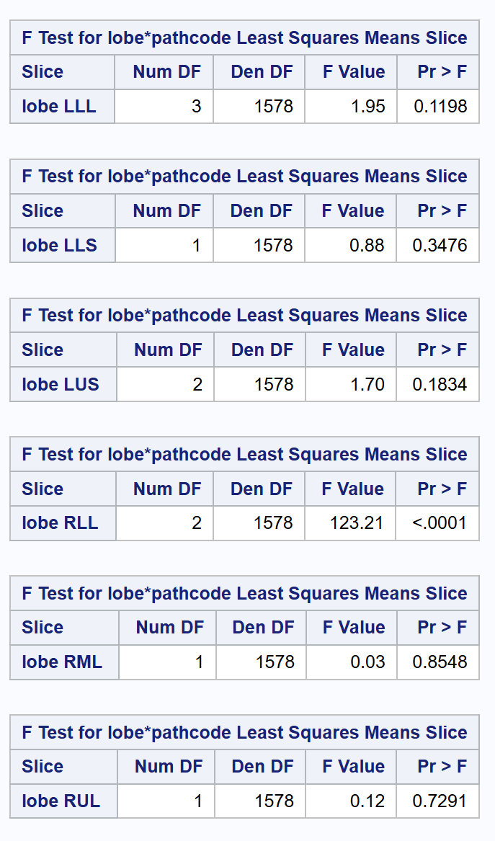

Pairwise Comparisons

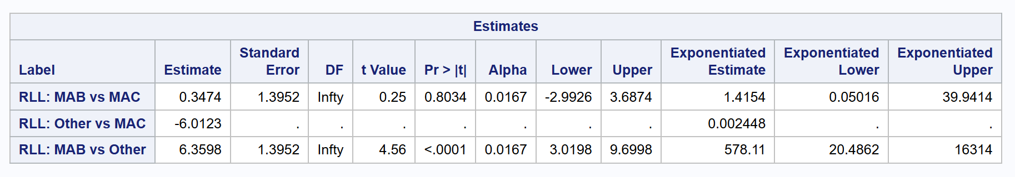
Because several lobe-by-pathogen comparisons had zero (or near-zero) events in one group, the mixed-effects logistic model could not estimate an odds ratio (complete/quasi separation). For those pairs we did not report model estimates. Instead, we present simple 2×2 counts to describe the data and note that the contrast is NE. Some pairwise comparisons were non-estimable (NE) due to sparse cells. For these pairs we report descriptive counts only and make no inferential claim.

Thick Wall Cavity

Type 3 Test
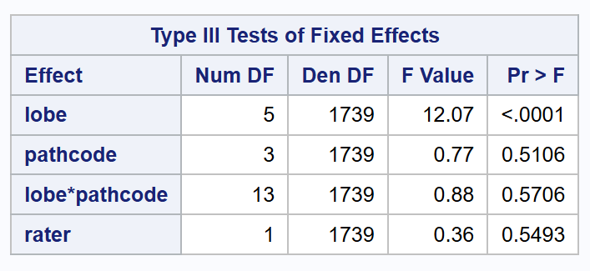

no evidence that pathogen groups differ overall or that the effect varies by lobe for this binary feature

Thin Wall Cavity
not estimable because of separation/too few events.

Modeling Approaches
TIB – Ordinal Full
Bronch – Ordinal Full
Atel – Ordinal reduced
Cons – ordinal full
GGO – ordinal full

