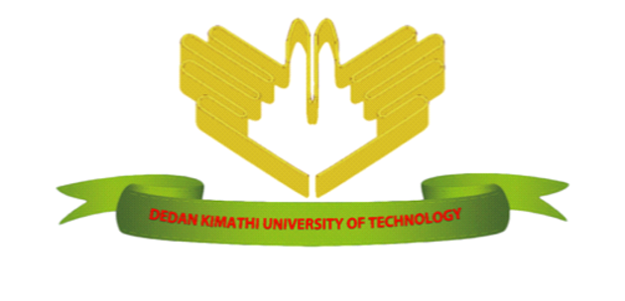

DEDAN KIMATHI UNIVERSITY OF TECHNOLOGY

PROVISIONAL DIPLOMA TRANSCRIPT
Registration No: [ADMISSION_NO]
Name: [NAME]

School: School of Science

Degree: Diploma in Leather Technology
Stage of Study: First
Academic Year: [ACADEMIC_YEAR]

Unit Code | Unit Title | Unit(s) | Grade
SLT 0101  IGS 0201  SLT 0102  TDT 0104  SLT 0103  TDT 0103  SLT 0104  SLT 0105  SLT 0106  SLT 0107  SLT 0108  HNS 1100 | Hand Tools and Equipment  Communication Skills  Leather Machinery  Mathematics I  Leather Manufacturing Processes I  Introduction to ICT  Drawing and Fashion Design  Leather Manufacturing Processes II  Materials for Footwear Manufacture  Workshop Safety and Procedures  Footwear Technology I  Gender HIV&AIDS and Substance Abuse | 1  1  1  1  1  1  1  1  1  1  1  1 | [SLT_0101]  [IGS_0201]  [SLT_0102]  [TDT_0104]  [SLT_0103]  [TDT_0103]  [SLT_0104]  [SLT_0105]  [SLT_0106]  [SLT_0107]  [SLT_0108]  [HNS_1100]
CURRENT MEAN: [CURRENT_MEAN] |  | MEAN GRADE: [MEAN_GRADE]
RECOMMENDATION: [RECOMMENDATION]

KEY TO THE GRADING SYSTEM
NB:
1 unit consists of 39 lecture hours or equivalent (3 Practical hours or two tutorial hours are equivalent to 1 lecture hour)
A = 80-100% Excellent
B = 70-79% Good
C = 60-69% Satisfactory
D = 50-59% Pass
E = 0- 49% Fail
INC Incomplete

Signed: __________________________ Date: [DATE]
Dean, School of Science

