We have three folders BandB/Genetic/LocalSearch on each folder we have project (we have three different projects) each project we should compile and run separately to compile the project you must download cmake

To download and install cmake : <https://cmake.org/download/>

After that we should build the project on each folder we have another folder with name build there we want to build the project

For example if we want to build LocalSearch we set the LocalSearch location as source and choose the build folder as the build see the picture:

1. 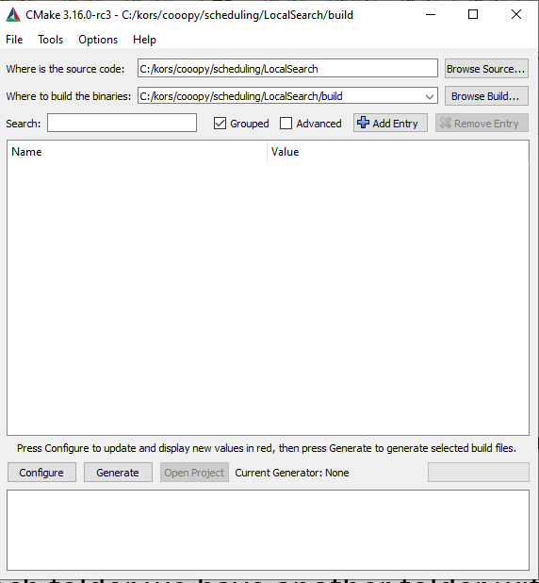
2. After that we choose this option (also visual studio 2017) and win32
3. then We press on configure

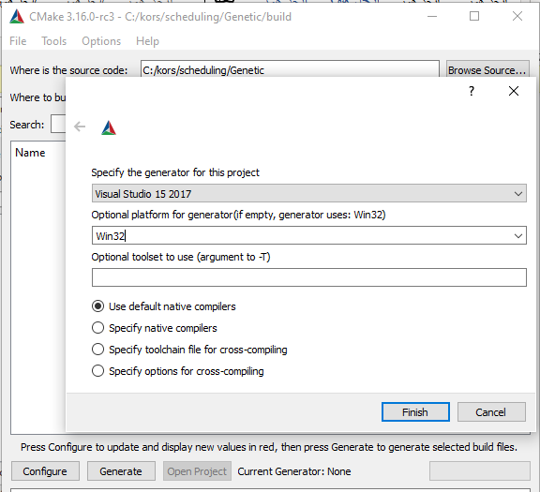

4-we press finish

5-and then we press generate

6-finaly we press open project and it will be open on visual studio

7-after building the second time you can open the project from build folder using visual studio

**Note**: **first you should build input file by running example_gen.py** / or by manually set your input files in build folder

You can find the output result on output folders

On each project you can find folder with examples