We have three folders BandB/Genetic/LocalSearch on each folder we have project each project we should compile and run separately to compile you must download cmake

To download and install cmake : <https://cmake.org/download/>

After that we should build it in each folder we have another folder with name build here we want to build the project

For example if we want to build LocalSearch we set the LocalSearch location as source and choose the build folder on it as the build

1. 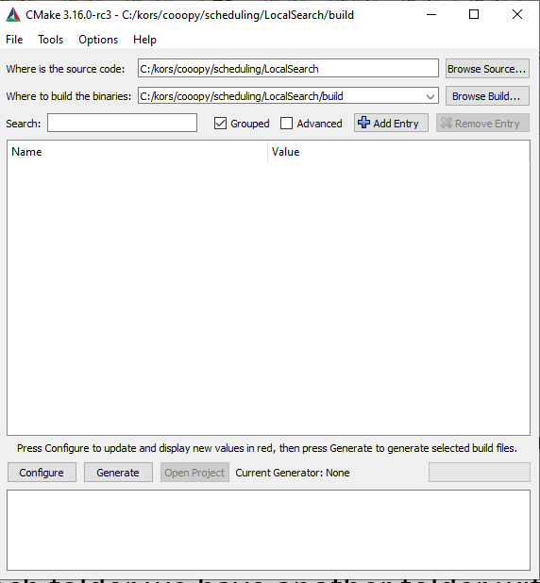
2. We press on configure and we use this option (also visual studio 2017)

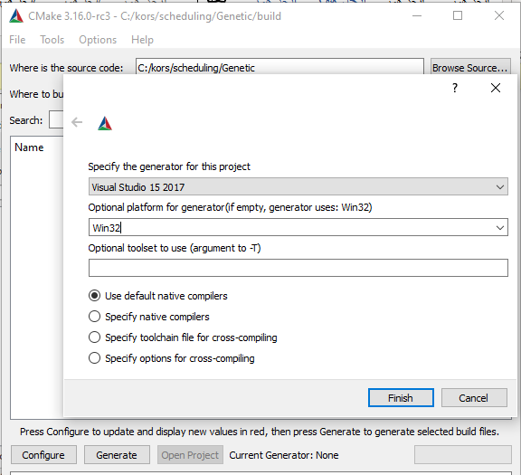

3-we press finish

4-and then we press generate

5-finaly we press open project and it will be open on visual studio

6-after building the second time you can open the project from build folder by visual studio

Note: first you should build input file by running example_gen.py / or by manually set your input files in build folder

You can find the output result on output folders

On each project you can find folder with examples