Install Apache HTTP server

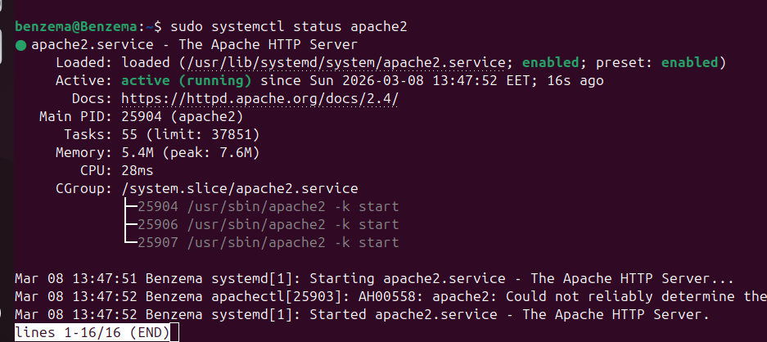
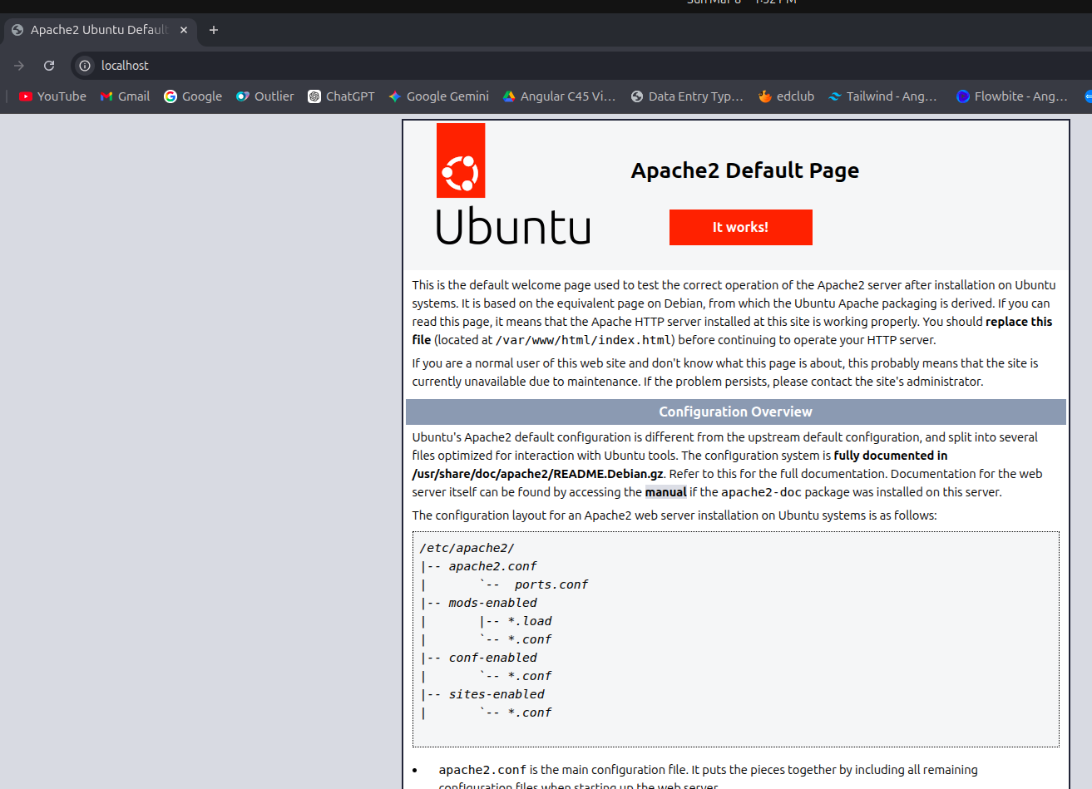
Create two simple html pages named “page1.html, page2.html” then use the suitable directive to automatically redirect from localhost/page1.html to localhost/page2.html.

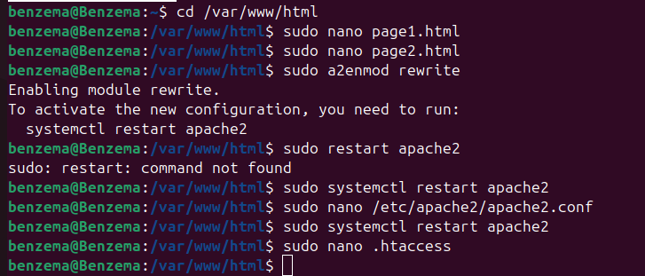



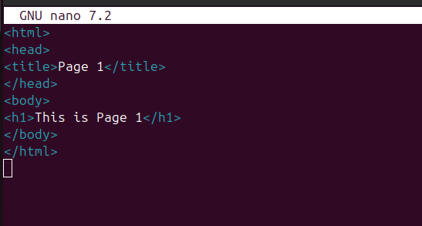
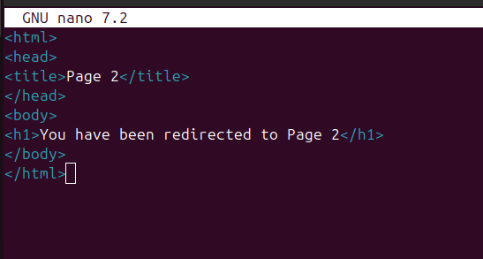


<Directory /var/www/html>
RedirectMatch ^/page1\.html$ /page2.html
</Directory>

Ask for username and password when accessing a directory.


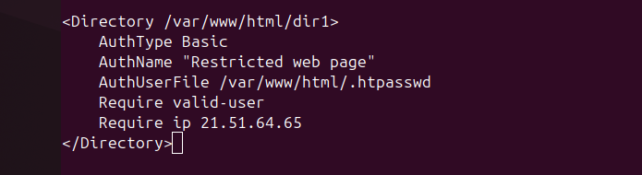
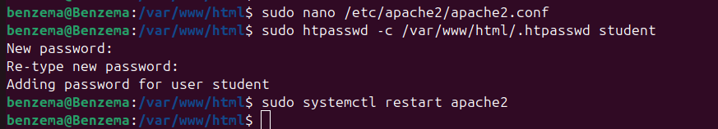
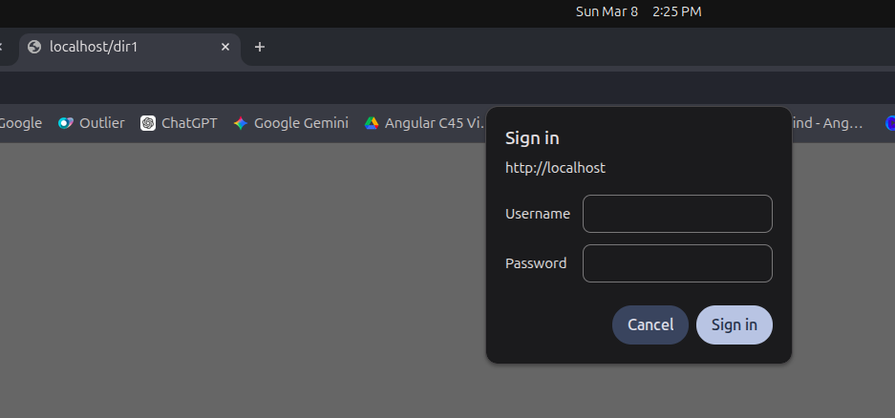


Create a directory then allow access to one of your classmates only.

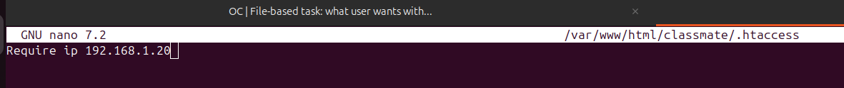
Disable listing the directory content (hint use indexes)


Change the default index page to be default.html instead of index.html

