Install Nginx HTTP server



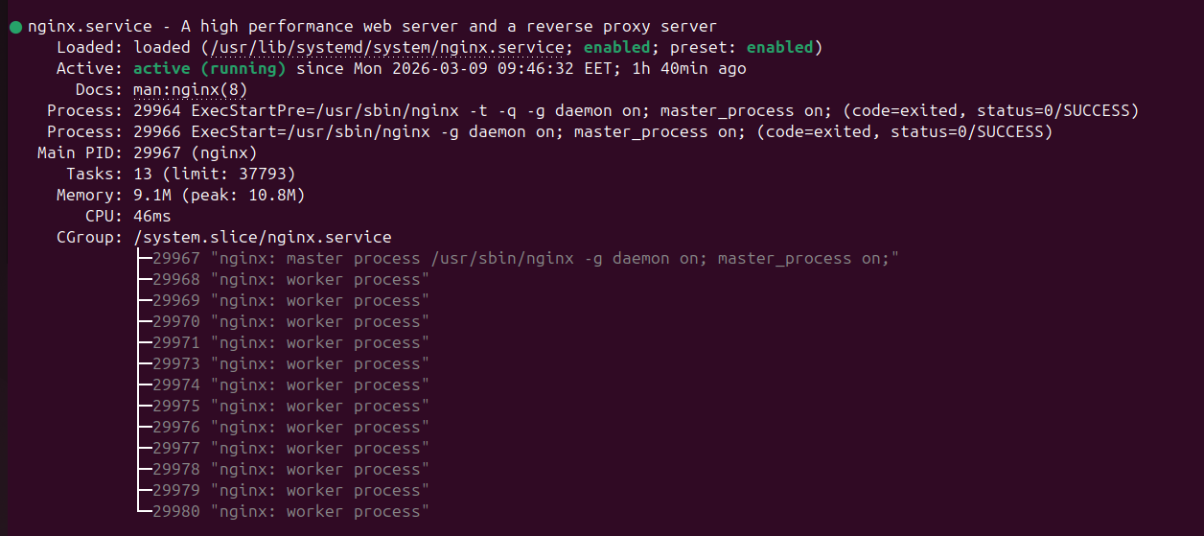

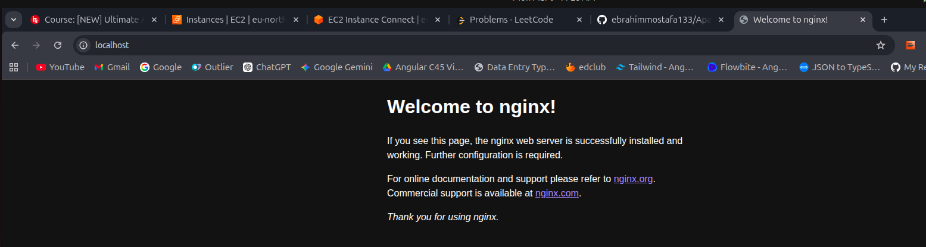

change the default file from index.html to Benzema.html

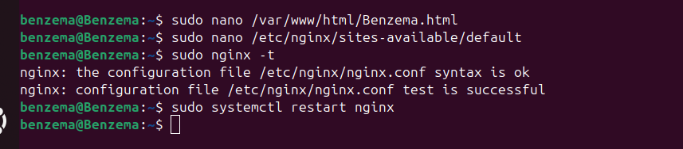

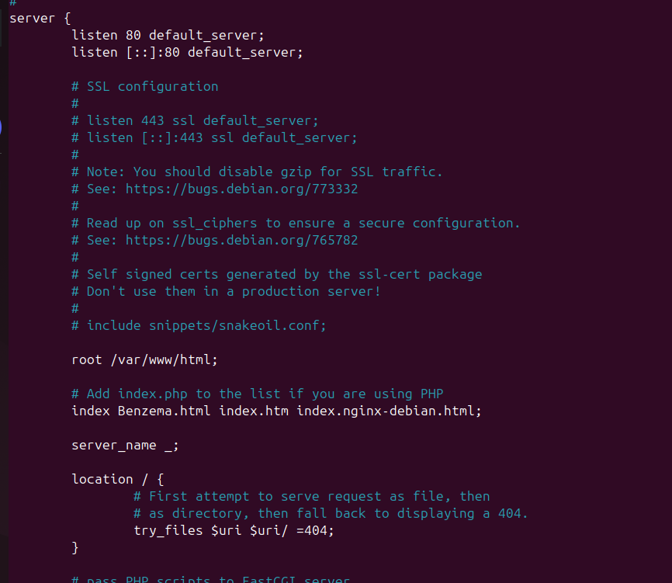

Make two html files and change the configuration file to access the first file on port 81 and access the second file on port 82


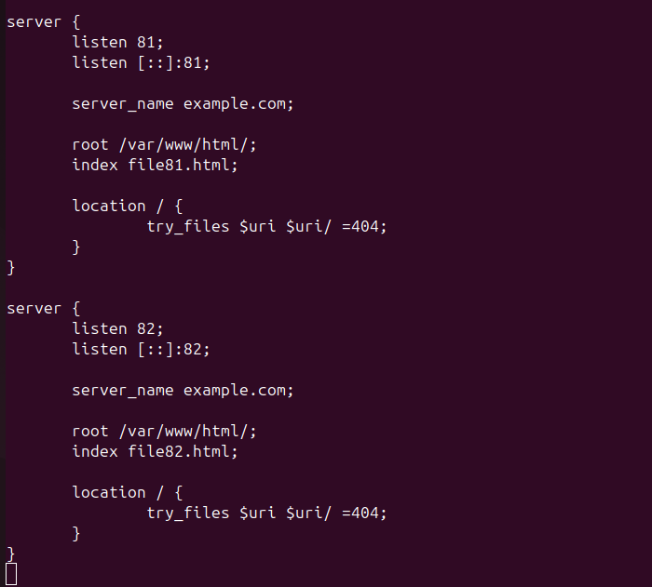



Main diff. Between Apache and Nginx

Nginx:
- Uses event-driven architecture → handles thousands of concurrent users efficiently.
- Excellent for serving static files (HTML, CSS, JS, images) very fast.
- Low resource usage (RAM & CPU) under high load.

Apache:

- Older web server (since 1995) → huge community and support.
- Supports .htaccess per directory → modify settings without restarting the server.
- Can run PHP, Python, Perl directly via modules (mod_php, mod_python).
- Process/thread-based model → each connection uses a process or thread, which can increase resource usage under heavy load.

