Lab2
Ebrahim Mostafa
G1

1. Create a script that asks for user name then send a greeting to him.


2. Create a script called s1 that calls another script s2 where:
a. In s1 there is a variable called x, it's value 5
b. Try to print the value of x in s2 by two different ways.
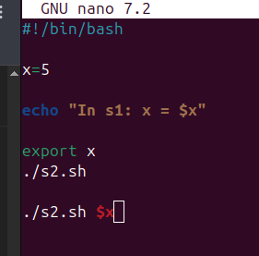
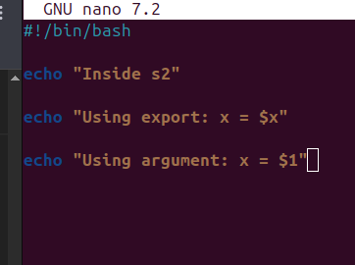

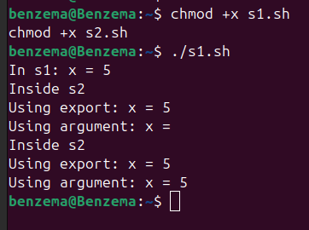

3. Create a script called mycp where:
a. It copies a file to another
b. It copies multiple files to a directory.
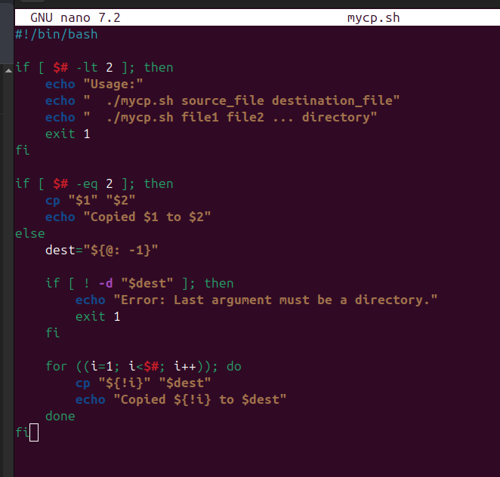
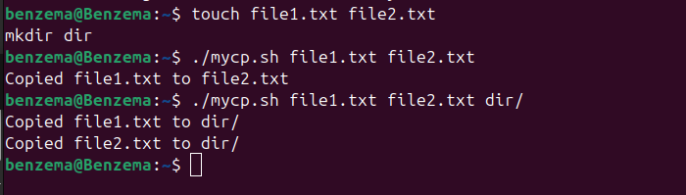
4. Create a script called mycd where:
a. It changed directory to the user home directory, if it is called without arguments.
b. Otherwise, it change directory to the given directory.
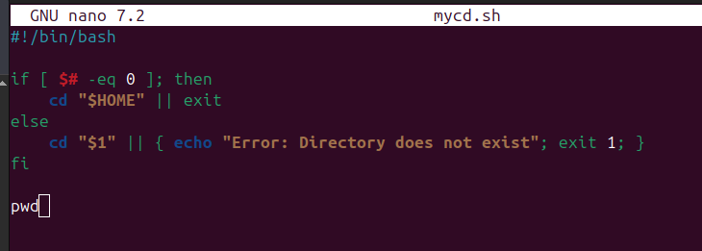
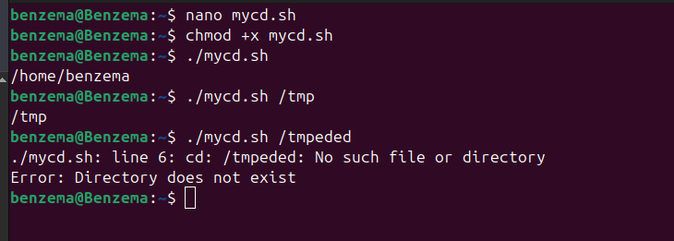

5. Create a script called myls where:
a. It lists the current directory, if it is called without arguments.
b. Otherwise, it lists the given directory.
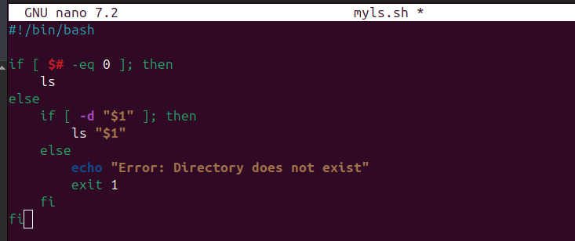
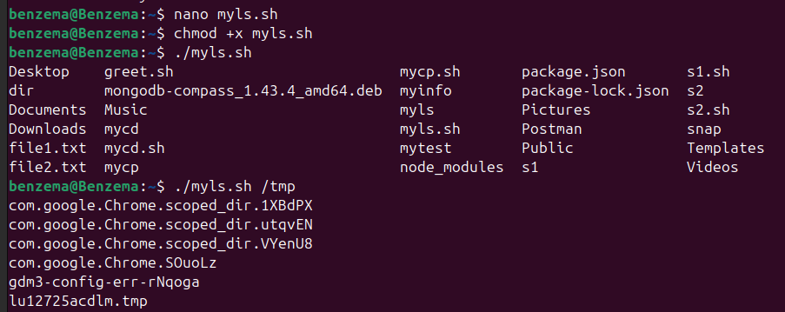
6. Enhance the above script to support the following options individually:
a. –l: list in long format
b. –a: list all entries including the hiding files.
c. –d: if an argument is a directory, list only its name
d. –i: print inode number
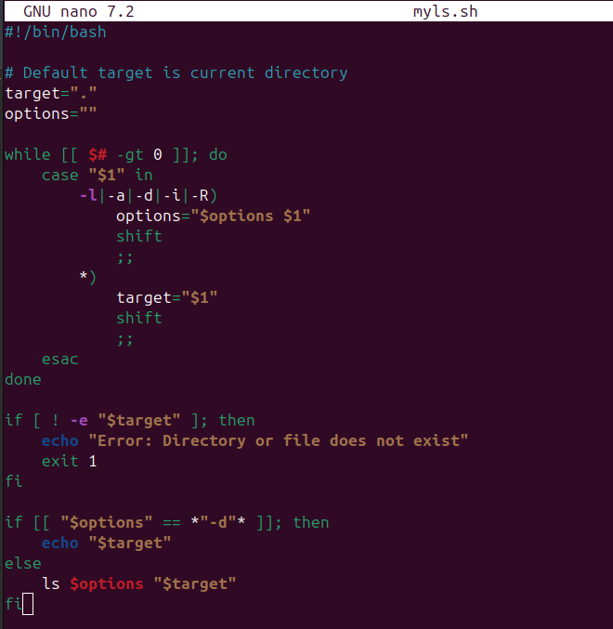
e. –R: recursively list subdirectories
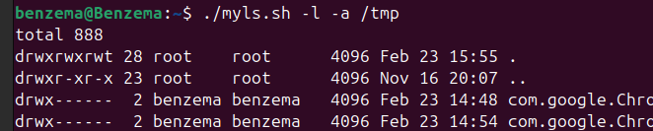
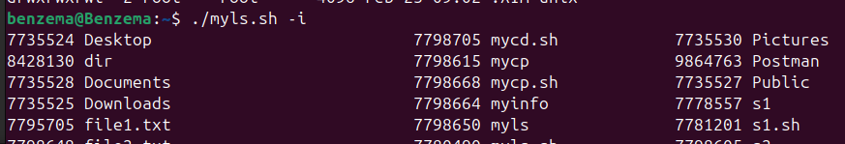
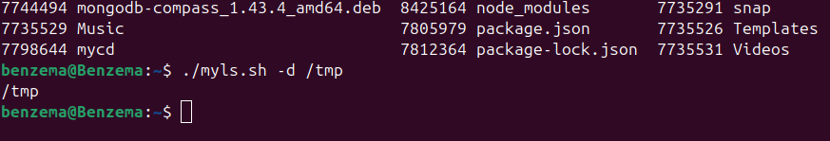
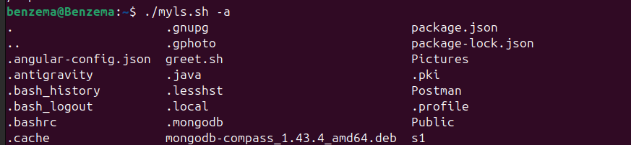
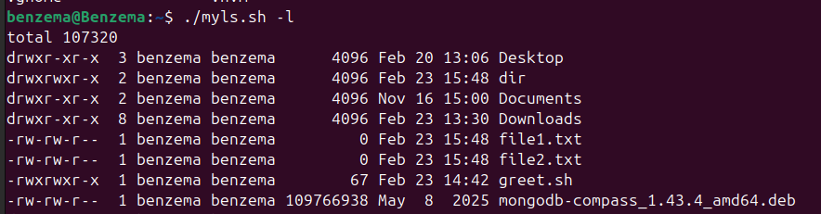


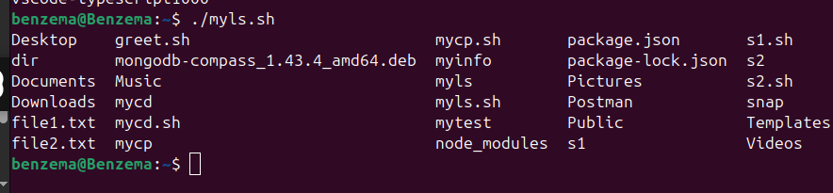
Bonus: enhance the above script to support the following Synopsis:
myls -option1 –option2
myls –option2 –option1
myls –option1option2
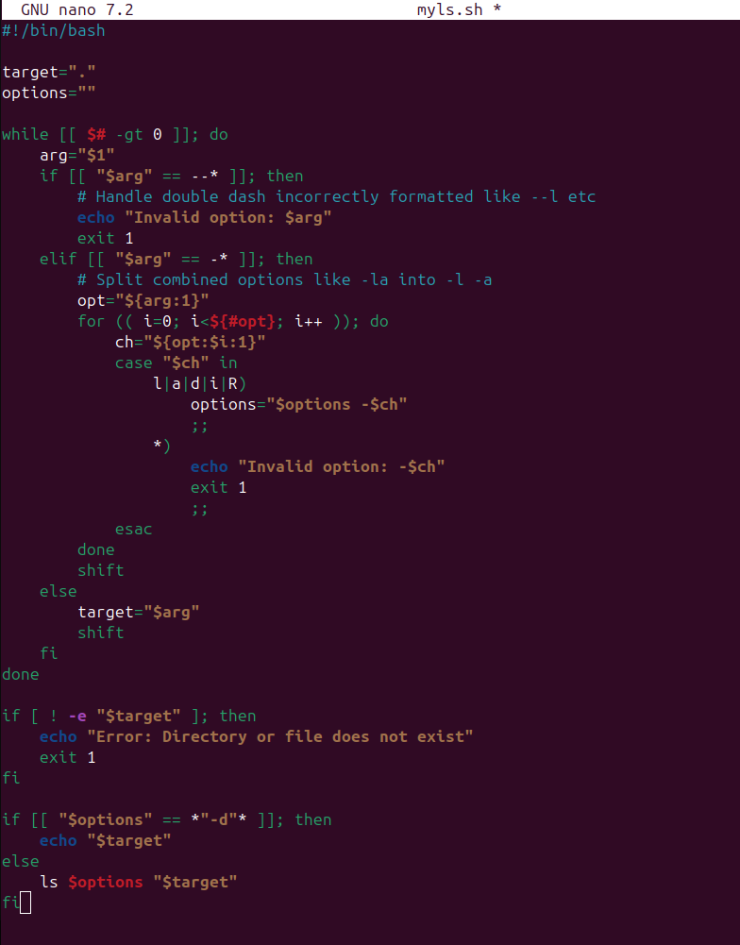
myls –option2option1

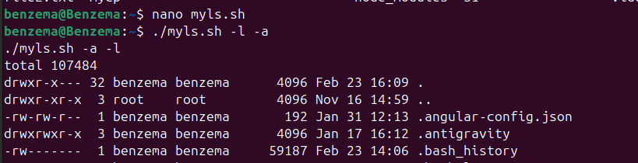
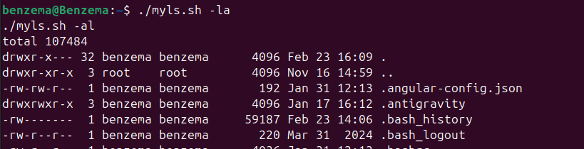
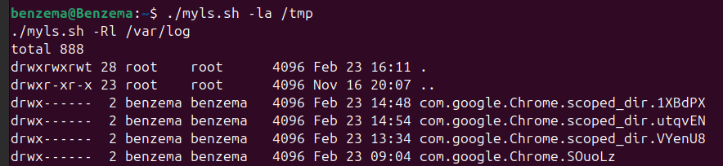

7. Create a script called mytest where:
a. It check the type of the given argument (file/directory)
b. It check the permissions of the given argument (read/write/execute)

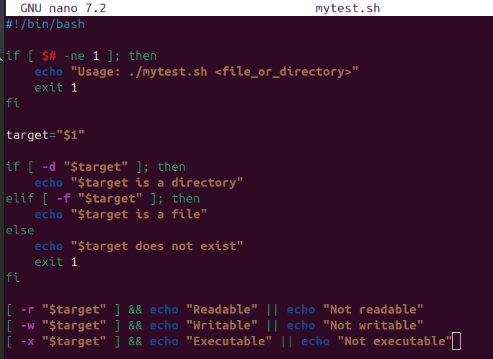
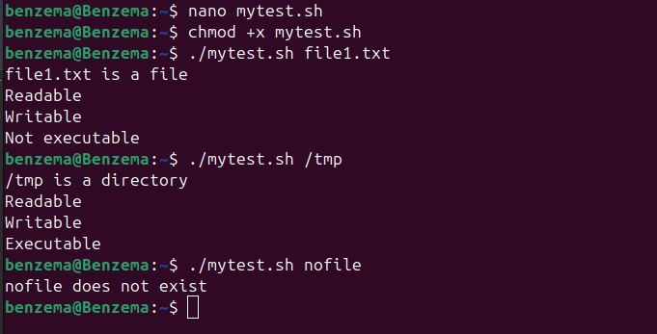

8. Create a script called myinfo where:
a. It asks the user about his/her logname.
b. It print full info about files and directories in his/her home directory
c. Copy his/her files and directories as much as you can in /tmp directory.
d. Gets his current processes status.

