Lab
3
- Write a script called mycase, using the case utility to checks the type of character entered by a user:
  - Upper Case.
  - Lower Case.
  - Number.
  - Nothing.
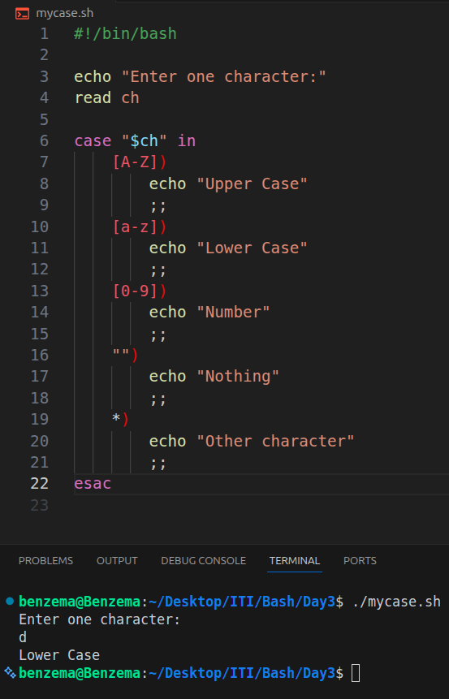

- Enhanced the previous script, by checking the type of string entered by a user:
  - Upper Cases.
  - Lower Cases.
  - Numbers.
  - Mix.
  - Nothing.
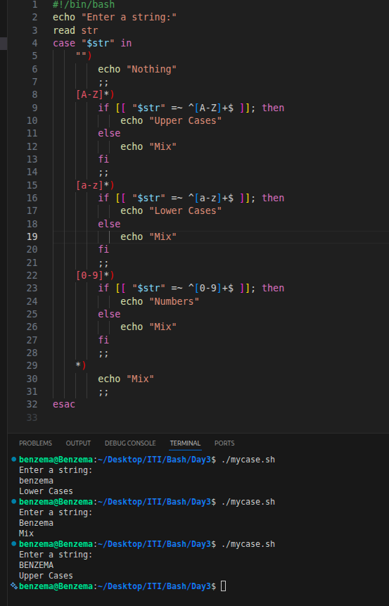

- Write a script called mychmod using for utility to give execute permission to all files and directories in your home directory.
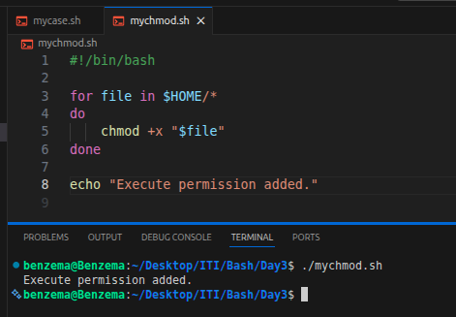

- Write a script called mybackup using for utility to create a backup of only files in your home directory.
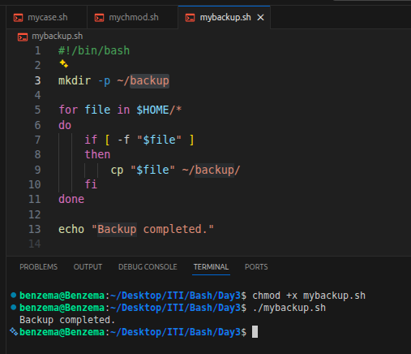

- Write a script called mymail using for utility to send a mail to all users in the system. Note: write the mail body in a file called mtemplate.
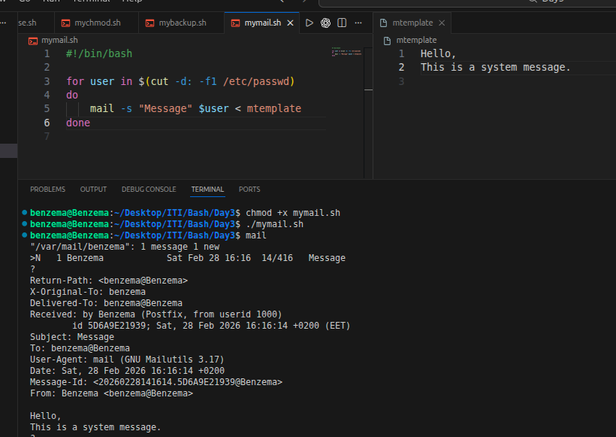

- Write a script called chkmail to check for new mails every 10 seconds. Note: mails are saved in /var/mail/username.
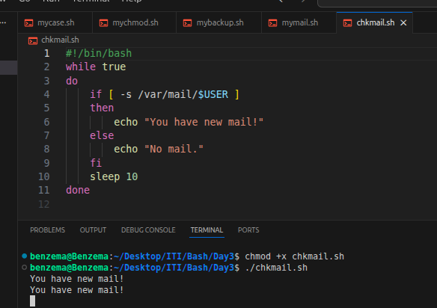

Bonus:
Open a talk session to a certain user when she/he logs into the system.
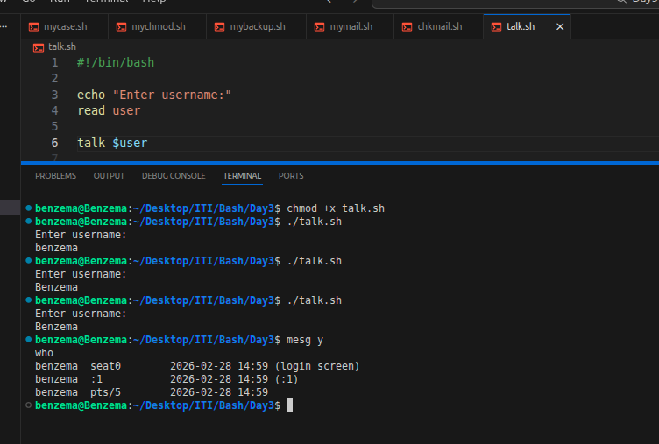

- What is the output of the following script
typeset –i n1
typeset –i n2
n1=1
n2=1
while test $n1 –eq $n2
do
n2=$n2+1
print $n1
if [ $n1 –gt $n2 ]
then
break
else
continue
fi
n1=$n1+1
print $n2
done

The output is:
1
1
1
1
1
(infinite loop)
- Create the following menu:
  - Press 1 to ls
  - Press 2 to ls –a
  - Press 3 to exit
Using select utility then while utility.
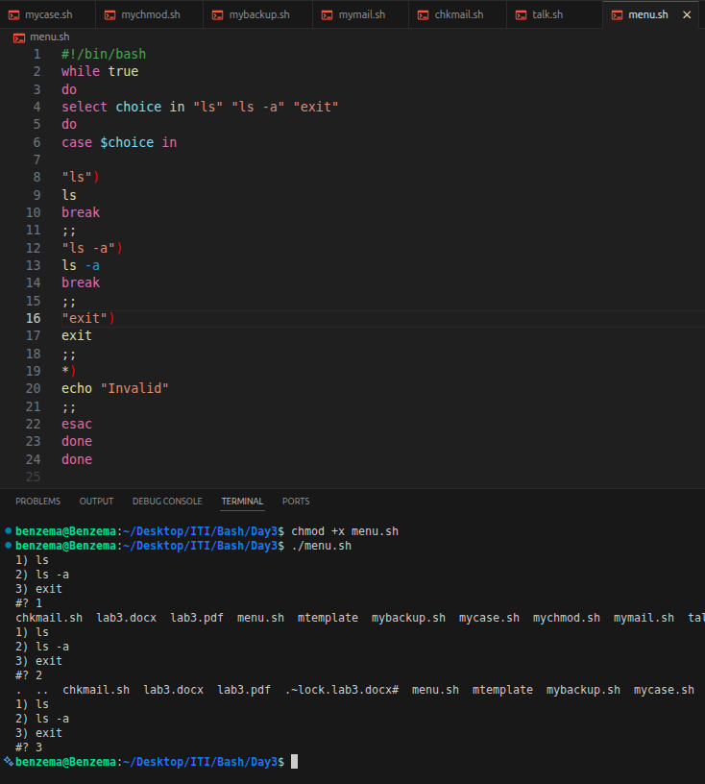

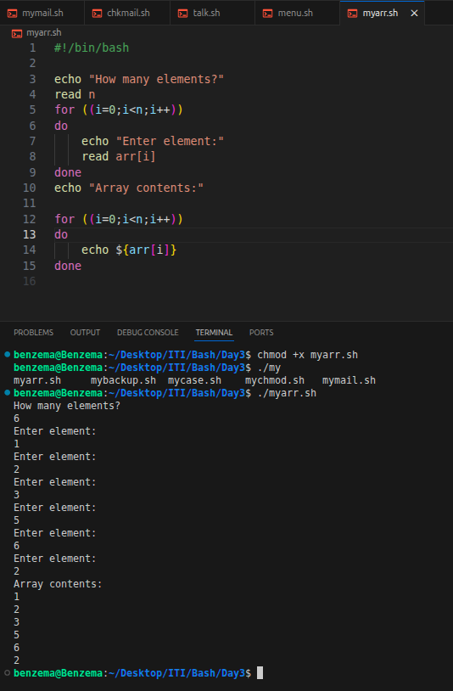
- Write a script called myarr that ask a user how many elements he wants to enter in an array, fill the array and then print it.

- Write a script called myavg
that calculate average of all numbers entered by a user. Note: use arrays
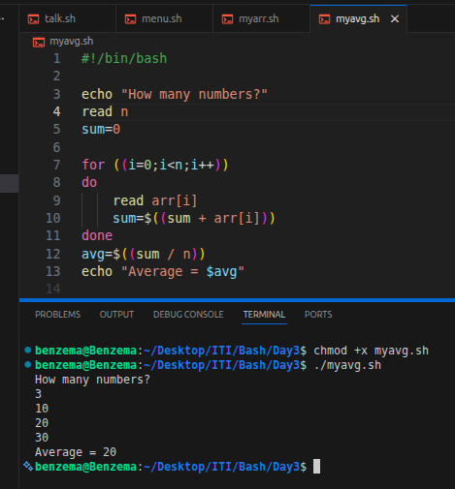

- Write a function called mysq that calculate square if its argument.

