MongoDB Lab1
1- Install mongodb server and mongosh client
ok

2- Add mongo DB folder to your system variables path
Go to -> Edit System environment variables -> Environment varaibles->
inside system variables choose path and add “C:\Program
Files\MongoDB\Server\4.0\bin” apply and exit.
3- Open server (on windows shell using command “mongod”);
4- Open another shell for client using command “mongosh” or noSqlBoost
Tool

5- Create database with name ITI → by typing use ITI

6- start create new collection named instructors and start with following
inserts
iti> db.createCollection("instructors")
{ ok: 1 }
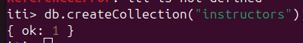

a- Insert many using array contained with lab folder instructors.txt file.

iti> load("instructorsArray.js")
true
iti> db.instructors.insertMany("instructorsArray")
iti> db.instructors.insertMany(instructorsArray)
{
acknowledged: true,
insertedIds: { '0': 6, '1': 7, '2': 8, '3': 9, '4': 10, '5': 2, '6': 3, '7': 4 }
}

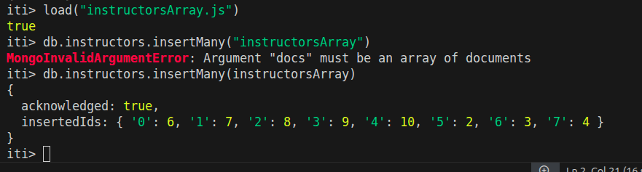

b- Insert your own data

iti> db.instructors.insertOne({ _id:99, firstName:"Ebrahim",lastName:"Mostafa", age:23, salary: 33000, address:{city: "cairo",street:20,building:13 },courses:["js","mvc","signal","express"] })
{ acknowledged: true, insertedId: 99 }
iti>

c- Insert instructor without firstName and LastName (mongo will raise an
error or not ?)
added successfully without any errors
iti> db.instructors.insertOne({ _id:90, age:23, salary: 33000, address:{city: "cairo",street:20,building:13 },courses:["js","mvc","signal","express"] })
{ acknowledged: true, insertedId: 90 }
iti>

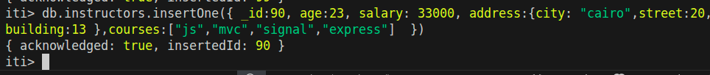

7- Try the following queries: (all queries should be run using find or findOne)
a- db.instructors.find({});

this shows all documets
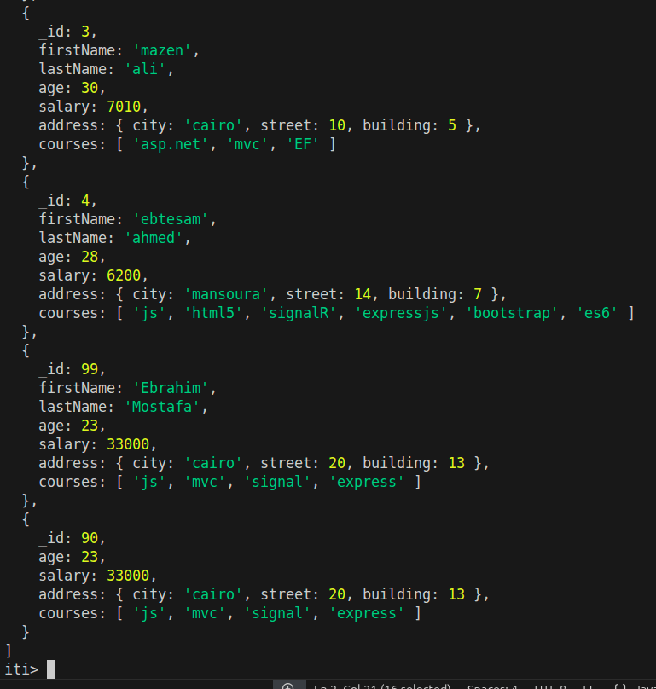

b- db.instructors.find(); //return the cursor object
the same as the above

c- db.instructors.findOne();
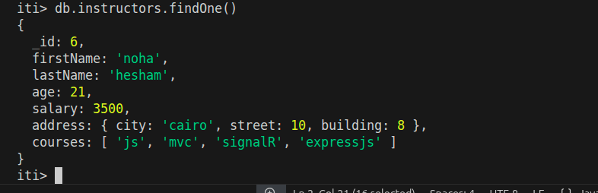
shows only the first document

d- db.instructors.find().constructor.name
return the name of the constructor function which created the object

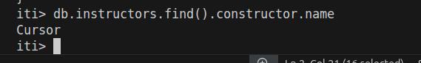

e- db.instructors.find({}).forEach((document)=>{
print(document); })
shows all documents
f-Now from step e try to display only firstName and lastName for each
instructor?!
