MongoDB Lab2

1- run following queries:

a- Display all documents in instructors collection

test> use iti
switched to db iti
iti> db.instructors.find({})
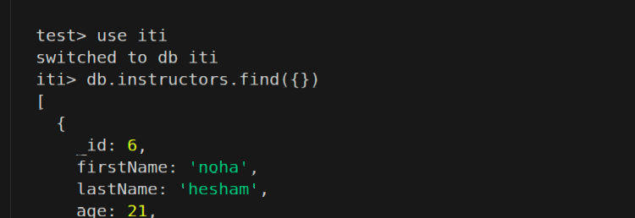

b- Display all instructors with salaries greater than 4000
(only show firstName and salary)

iti> db.instructors.find({salary:{$gt: 4000} },{firstName:1,lastName:1})
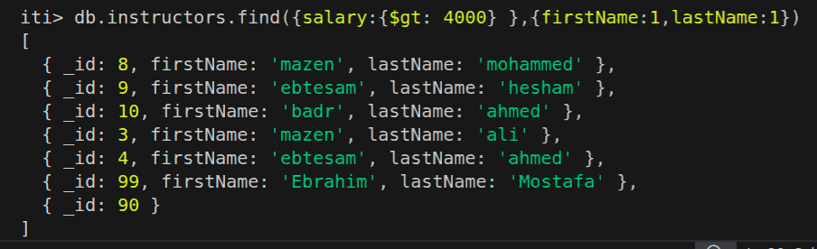

c- Display all instructors with ages less than or equal 25.

iti> db.instructors.find({age:{$lte:25 } } )
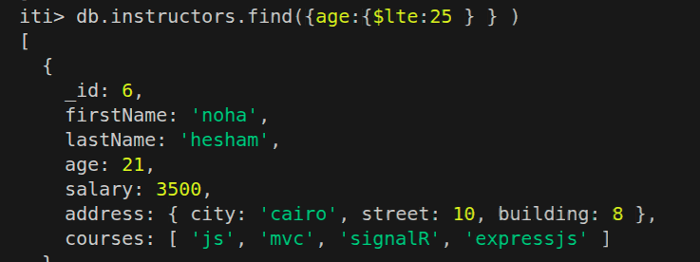

d- Display all instructors with city mansoura and sreet number
10 or 14 only display (firstname,address,salary).

db.instructors.find({$and:[{"address.city": "mansoura"},{"address.street": {$in: [10, 14]}}]},{firstName: 1,address: 1,salary: 1})

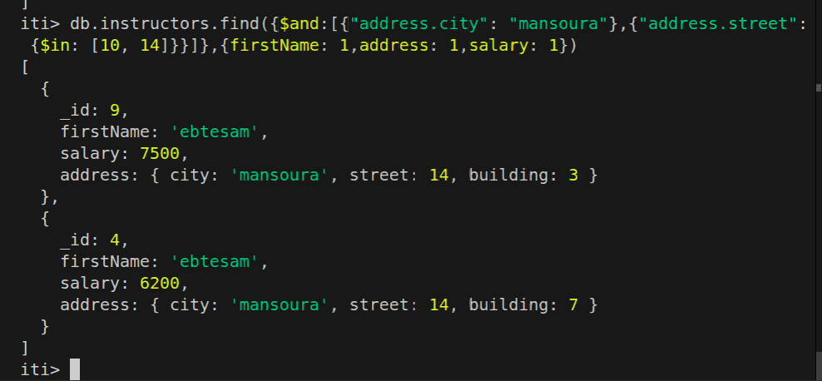

e- Display all instructors that have js and jquery in their courses(both of them not one of them).

db.instructors.find({courses:{ $all:['jquery','js']}} ,{})

f- Display number of courses for each instructor and display first name with number of courses.

iti> db.instructors.find({} ,{firstName:1,numberOfCourses:{$size:"$courses"} } )
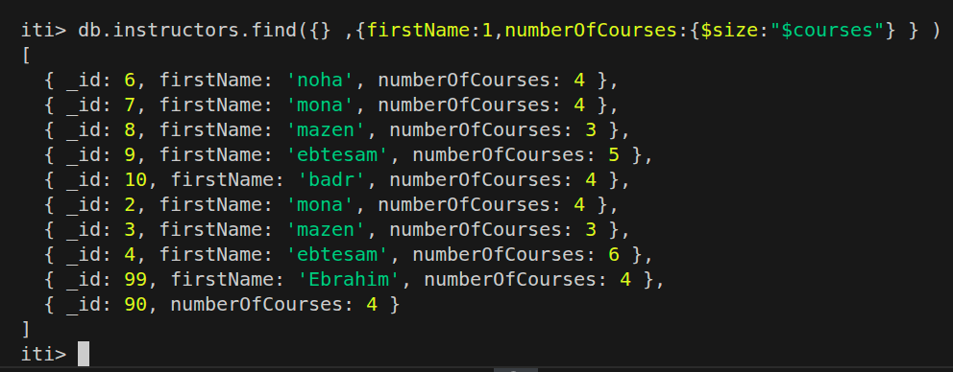

g- Write mongodb query to get all instructors that have firstName and lastName properties , sort them by firstName ascending then by lastName descending and finally display their data FullName and age
Note: use mongoDB sort function
db.instructors.find(
{
firstName: { $exists: true },
lastName: { $exists: true }
},
{
fullName: { $concat: ["$firstName", " ", "$lastName"] },
age: 1
}
).sort(
{
firstName: 1,
lastName: -1
}
)

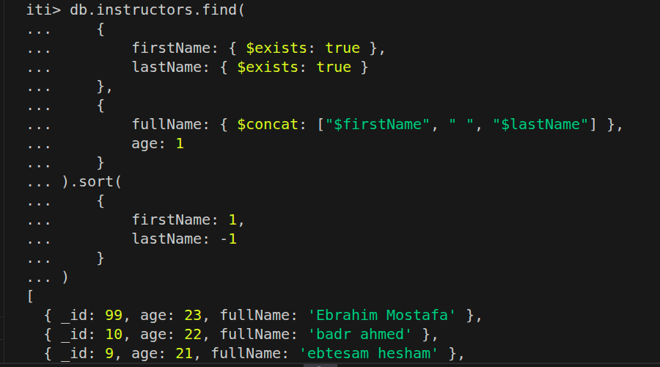

h- Delete instructor with first name “ebtesam” and has only 5 courses in courses array
db.instructors.deleteOne({
firstName: "ebtesam",
courses: { $size: 5 }
})

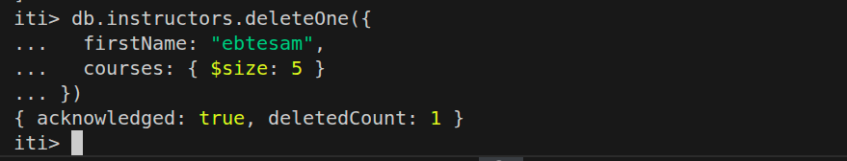

i- Add active property to all instructors and set its value to
true.
db.instructors.updateMany(
{},
{ $set: { active: true } }
)

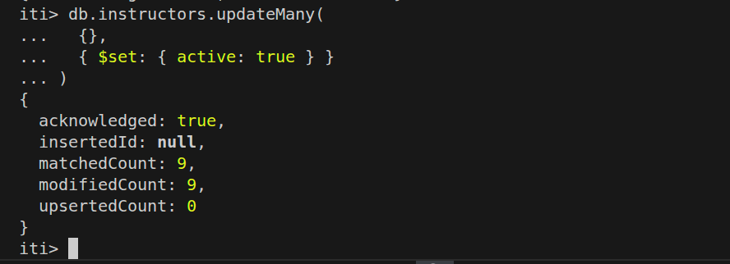

j- Change “EF” course to “jquery” for “mazen mohammed” instructor (without knowing EF Index in courses array)
db.instructors.updateOne(
{ firstName: "mazen", lastName: "mohammed", courses: "EF" },
{ $set: { "courses.$": "jquery" } }
)
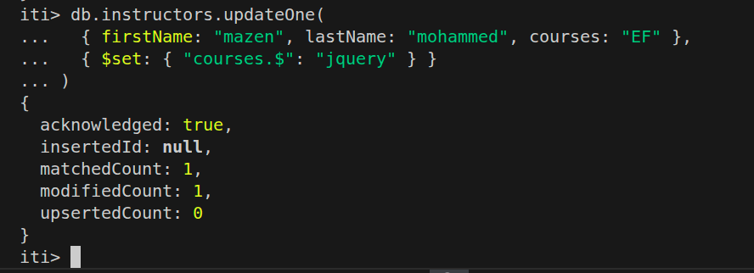

k- Add jquery course for “noha hesham”.
db.instructors.updateOne(
{ firstName: "noha", lastName: "hesham" },
{ $addToSet: { courses: "jquery" } }
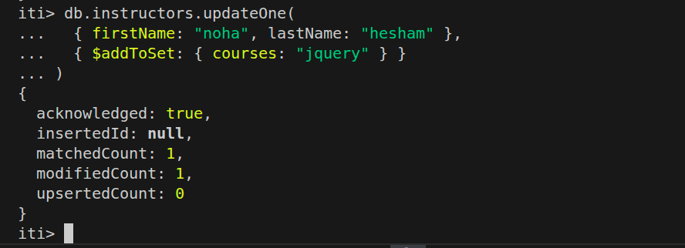
)

l- Remove courses property for “ahmed mohammed ” instructor
db.instructors.updateOne(
{ firstName: "ahmed", lastName: "mohammed" },
{ $unset: { courses: "" } }
)
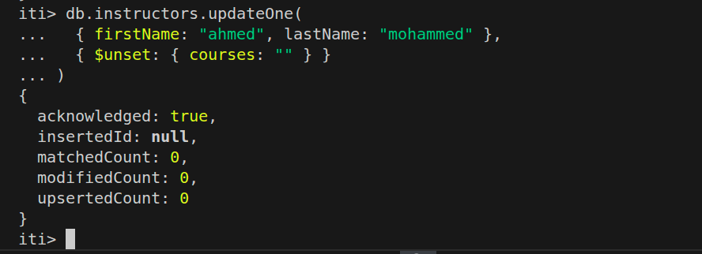

m- Decrease salary by 500 for all instructors that has only 3
courses in their list ($inc)
db.instructors.updateMany(
{ courses: { $size: 3 } },
{ $inc: { salary: -500 } }
)
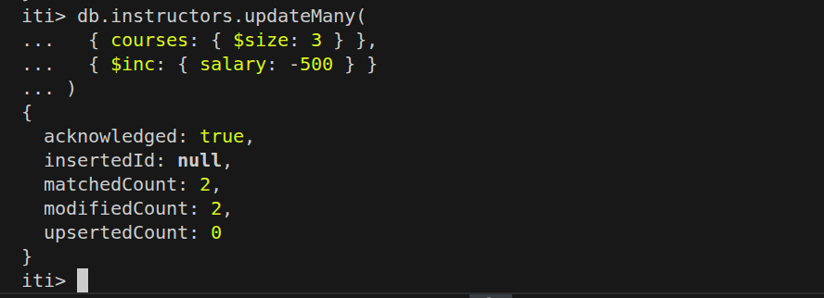

n- Rename address field for all instructors to fullAddress.
db.instructors.updateMany(
{},
{ $rename: { address: "fullAddress" } }
)

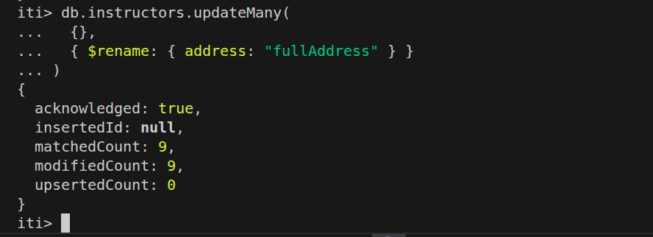
o- Change street number for noha hesham to 20
db.instructors.updateOne(
{ firstName: "noha", lastName: "hesham" },
{ $set: { "fullAddress.street": 20 } }
)
