MongoDB Lab3
Restore inventory database
Write the following command on windows shell
mongorestore -d inventory “write folder path”
Ex: mongorestore -d inventory D:\intake39\MongoDB\Lab2\Inventory

Relations:
a- Display employees fullname and department name for all employees
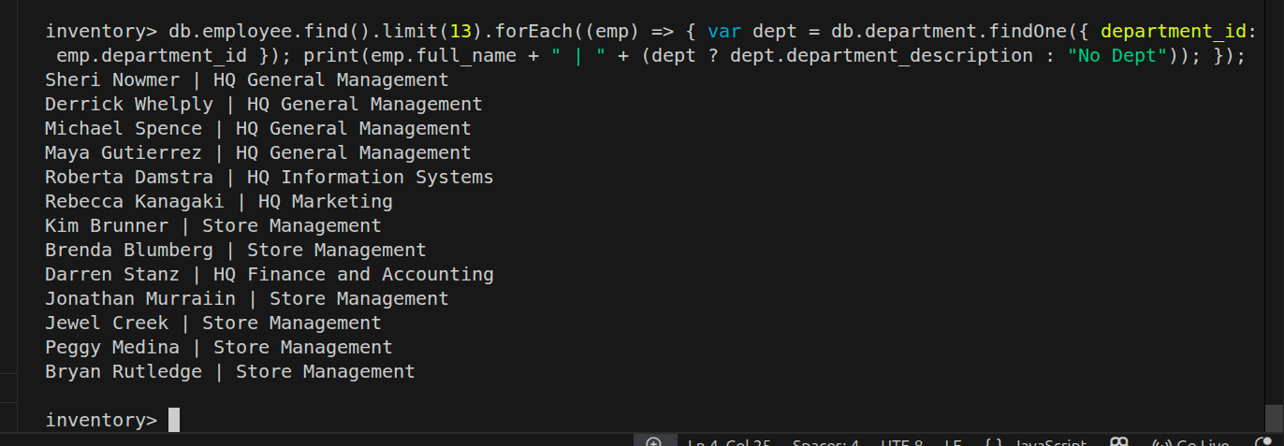
b- Display employees with position “VP Country Manager” (only display employee full name and salary).

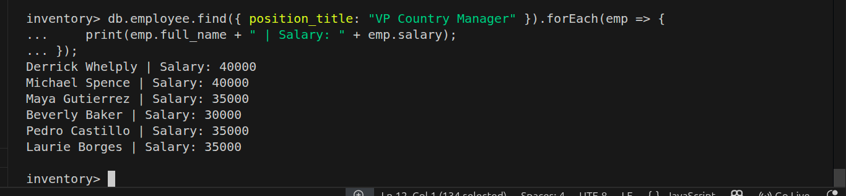
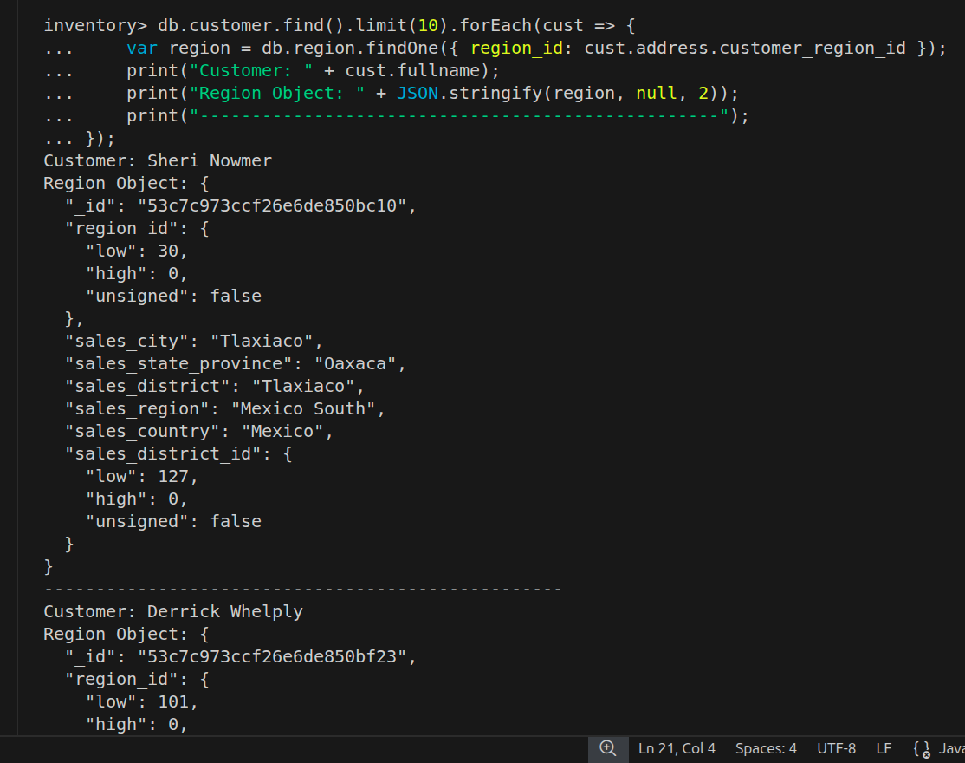
c- Display customers full names and their regions.

d- In product find all products that was branded by " Washington "
(try to createIndex on brand_name and test your query speed)

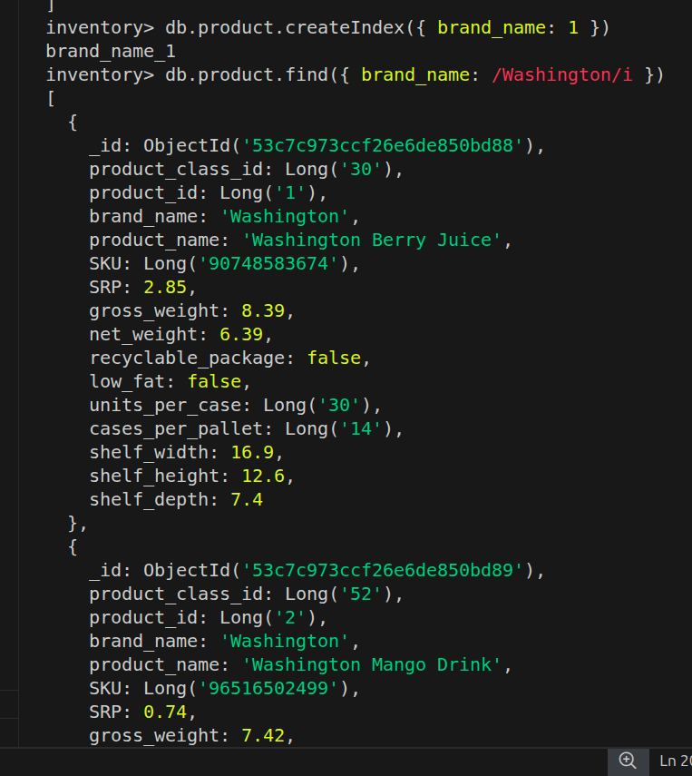

Aggregate function:
a- Group products by brand name, count number
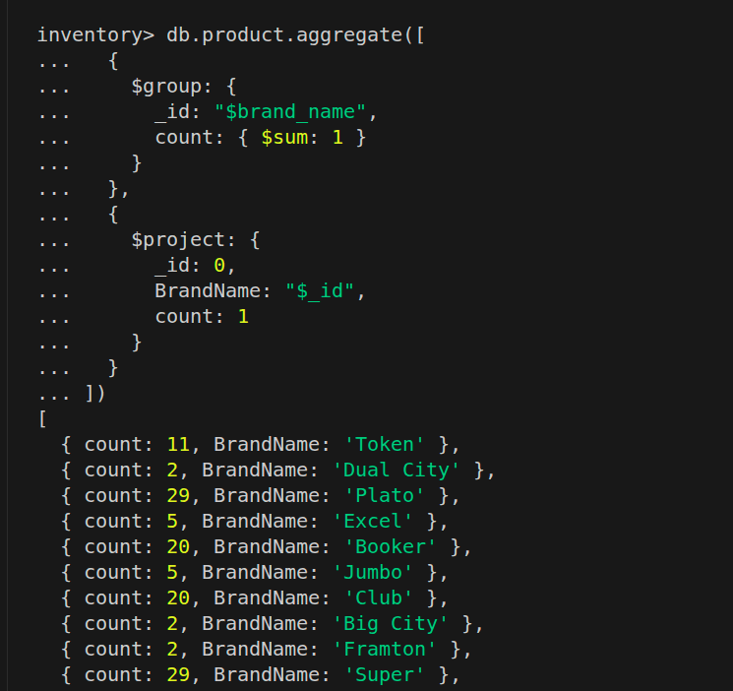

b- Group products by brand_name and product_name ,only select brand names ("Blue Label","King","Washington") then sort them by brand_name and product_name ascending
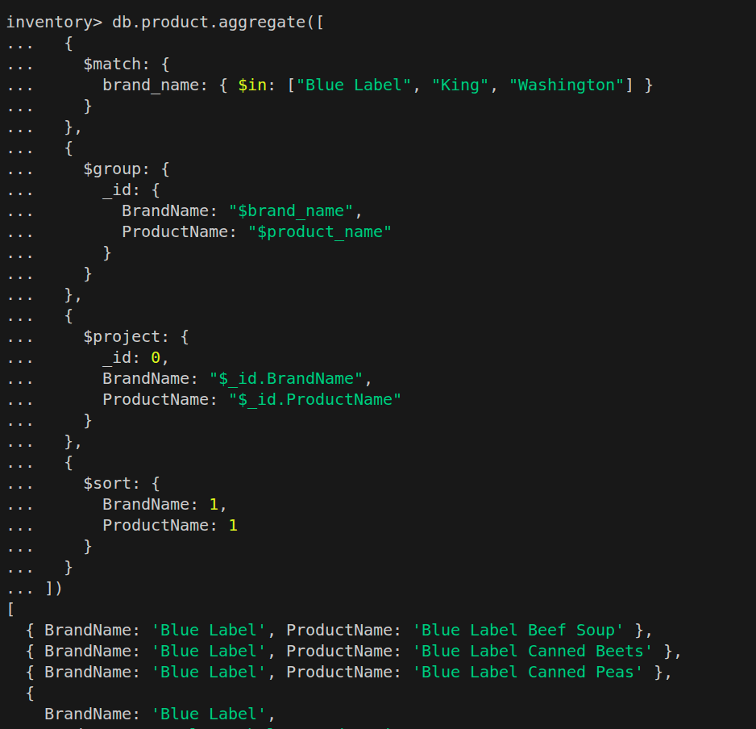

BONUS:Display maximum salary for each department (display department name and maximum salary)
