Steps followed to migrate the contents of a SVN-Repo to GIT

1. I created a test repo in my personal desktop as shown below



1. I populated the above filter with three directories to mimic out actual repo

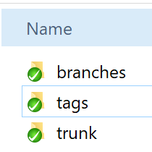

1. I populated the above three folders with some dummy files

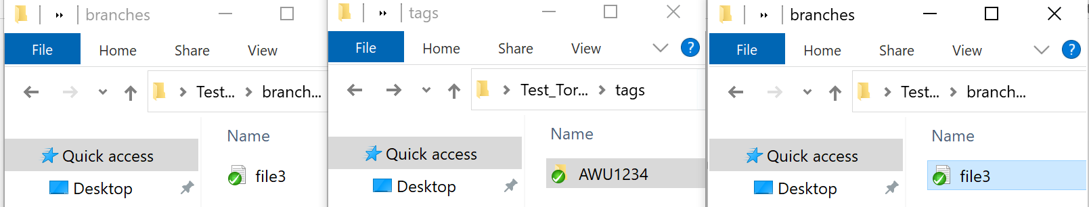

Note-: the contents of the AWU1234 folder is the contents of trunk (file1.txt)

1. Install git hub on your local desktop check the version to make sure the installation is successful

As shown below

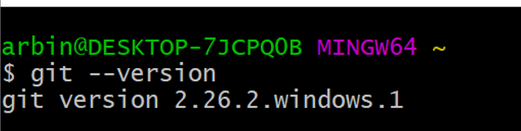

1. Create a new folder anywhere in the windows file system and create a new folder

As shown below



1. Now we need to let git know that this is going to be our working folder. Rich click inside the folder and choose Git Bash Here and execute the commands below

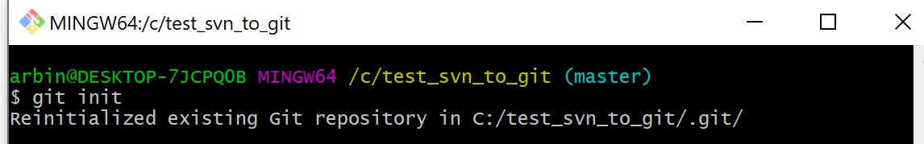

1. Initialize the username and email that git needs for actions on this project

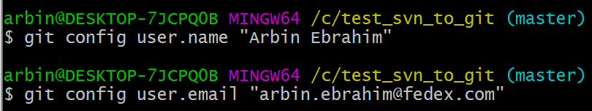

1. Once the folder gets initialized by git you will see the below contents in that folder.(There are hidden files therefore you have to enable viewing hidden files). This shows that this folder is now being tracked by git.

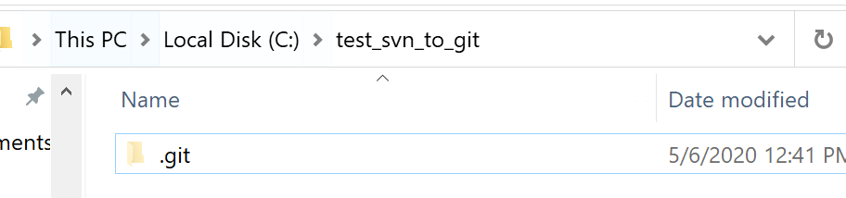

1. Copy and paste the contents of the SVN folder into this git folder

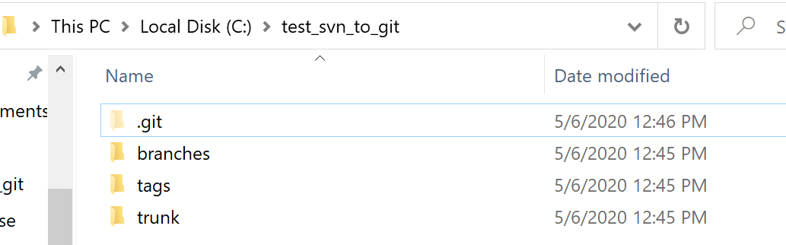

1. Now use the below command to see the status of the folder

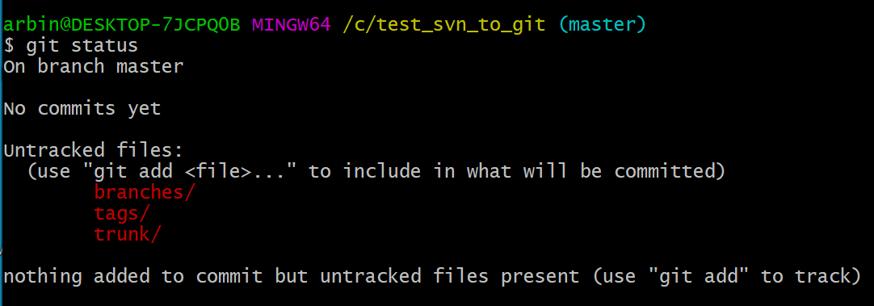

1. Execute the add command below to add the files that are being tracked to the staging area

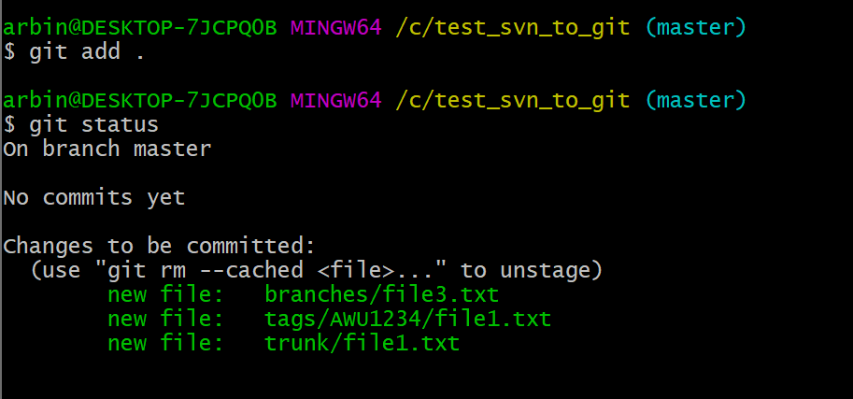

1. Commit the files to the local repository using the command below

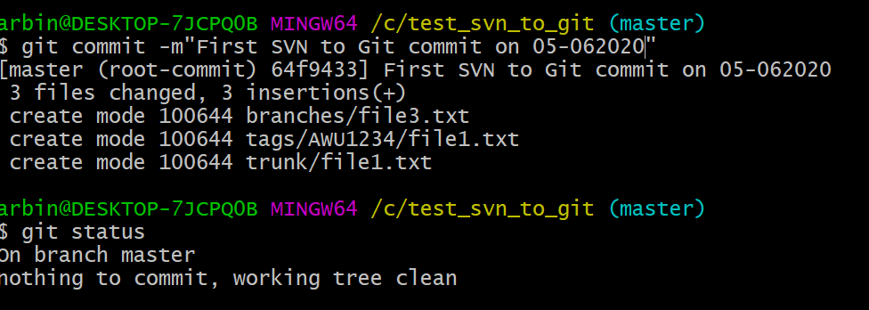

1. Link the local repository to the central repository in GitHub using the command below



1. Now we can push our local repo to the central repo on GitHub using the command below

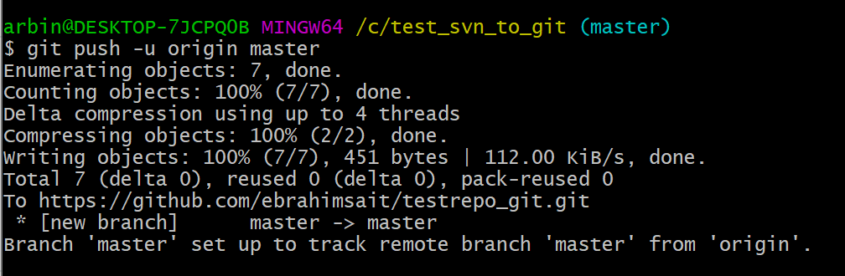

1. Central repo contains the contents of local repo that were pushed

