Freight Rate Prediction
How I approached the problem, how I validated it, and the December forecast.

1. Summary
The task was to predict posted rates for 12,000 loads moving in November and December 2025, using 48,000 labelled loads from January to October. My model combines boosted trees, which learn what a load is (its lane, distance, equipment and weight), with a few simple time terms that capture when it moves (the market index, a rise toward the end of each quarter, and a price level for each quarter).
I tested it on backtests built to look like the real task: train up to the first month of a quarter, then predict the next two months. Its average error was 1.45%. A tree model given every column scored 4.23%, and the best simple baseline scored 4.92%. 12% of the validation loads involve one of 8 cities that never appear in training; on held-out cities the error was 1.62%.
Three things I found in the data drove most of the design. The quote_signal column changes meaning from month to month and is just noise in November and December. The market index is a real signal but easy to misread over long periods. And prices climb toward the end of every quarter, which matters because November and December are the end of Q4.

2. The data and its problems
The training file has 48,000 loads from 1 January to 31 October 2025, and the validation file has 12,000 loads from 1 November to 31 December 2025. There are no duplicates and the equipment labels are clean. Price tracks distance closely (correlation 0.91), so I model the rate per mile on a log scale. That lets the model focus on why one mile costs more than another. Longer trips are cheaper per mile (rank correlation -0.74). The cities that only appear in validation are Allentown, Charlotte, Chicago, Jackson, Knoxville, Laredo, Norfolk and San Diego.
These are the problems I found and what I did about each one:
Problem | Train | Validation | What I did
Negative weights | 292 | 145 | They look like sign errors (flipped, they match the normal weights), so I flip them and keep a flag
Missing weights | 300 | 165 | Left as missing with a flag; the tree model handles gaps on its own
Missing market index | 374 | 249 | Filled with that day's median, since the index is almost the same for every load on a given day
Prices that are clearly wrong (a fifth to five times the expected rate) | 677 | n/a | Left out of training. Their distances look normal, so it's the price that's wrong
Loads involving a city that's not in training | 0 | 1447 | I don't use city names, only coordinates, so new cities still get sensible predictions
Coordinates cut off at the edge of a box (Laredo, Boston, Providence) | - | - | Kept as they are; each city still has one consistent location
Distances that bottom out at 70 miles | 48 | 21 | Kept, but I avoided straight-line distance features, which go haywire on these short lanes
quote_signal means different things in different months | 10 months | 2 months | Left out, because November and December look like the months where it's pure noise

3. What I found while exploring

3.1 quote_signal changes meaning from month to month
In January, February, March, June and September, the quote is within 5% of the real rate per mile for 99% of loads, so it's close to a perfect predictor. In April, May, July and October it runs backwards, and in August it has no relationship to anything (its rank correlation with distance is +0.02).
I can't compare November and December quotes with real prices, but I can check them another way. Real rates per mile always fall as trips get longer (correlation -0.74), so a useful quote should too. In November and December the correlation is +0.018 and +0.011, and the spread of quotes matches August's almost exactly (10th, 50th and 90th percentiles of [1.77, 2.05, 2.34] against [1.76, 2.05, 2.34]). So I treated those months as noise and left the column out. Section 5 shows what happens if you keep it.
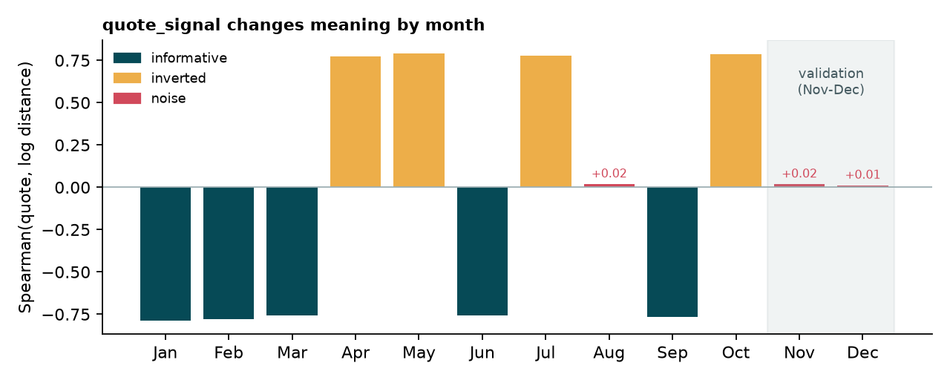

3.2 Prices climb toward the end of every quarter
Once I removed the effect of the lane and the market index, the daily price level turned out to follow a saw-tooth. It stays flat for the first six weeks or so of a quarter, rises faster and faster into the last day, then drops when the next quarter starts. There's no jump between months inside a quarter, only between quarters. The pattern looks almost the same in Q1, Q2 and Q3. How big it gets depends on the equipment type, but not on distance or weight. On top of that, each quarter is a bit more expensive than the last. Compared with Q4, prices were 5.7% lower in Q1, 3.7% lower in Q2, 2.5% lower in Q3.
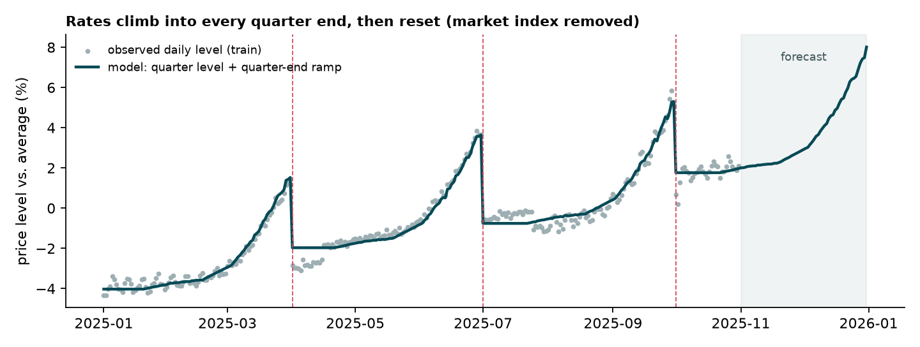
How much higher prices are at different points before the quarter ends, in percent:
Equipment | 8 weeks before | 4 weeks before | 2 weeks before | 1 week before | on the last day
Dry Van | 0.45 | 1.18 | 2.48 | 3.34 | 4.37
Flatbed | -0.01 | 1.36 | 4.82 | 7.24 | 10.12
Reefer | 0.24 | 1.31 | 3.63 | 5.14 | 7.08

3.3 The market index helps, but only if used carefully
Within a quarter, a 1% higher market index goes with a 0.15% higher rate. That's true for every equipment type, weight and distance. The index also has a strong weekly rhythm, peaking on Wednesdays and Thursdays and bottoming out on Sundays. The trouble is over longer periods. By the autumn the index had dropped back to where it was in January, while prices had kept creeping up. A tree model learns that a low index means January prices, and so it underprices the autumn. I handle the index as a simple linear term measured within each quarter, and handle the price level separately.

4. The model
The model predicts the log of the rate per mile as the sum of four parts:
- What the load is. Boosted trees (scikit-learn's HistGradientBoostingRegressor) learn from distance, pickup and delivery coordinates, equipment and weight. I deliberately don't use city names, so a city the model has never seen still gets a sensible prediction from its location.
- The market index, as a single linear term.
- The quarter-end rise, with its own shape for each equipment type.
- A price level for each quarter.
Trees are good at learning differences between lanes, but they can't extend a pattern to dates they haven't seen. That's why the time-related parts are simple linear terms. The trees and the linear terms are fitted in turns: fit the trees, then fit the linear part on what's left, and repeat three times.
Before that, a first rough fit flags rates that are less than 0.7 times or more than 1.4 times what the model expects. That catches 677 loads (1.4%), and I leave them out of training. Their distances look normal, so it's the price that's wrong.
October is in the training data and it's the first month of Q4, so the model already knows Q4's price level when it predicts November and December. I don't have to extrapolate a trend.

5. How I validated it
I designed the validation by working backwards from the real task. The loads I have to predict are from the second and third months of Q4. October, the first month, is in my training data. And 12% of them involve a city that's not in training at all. So each backtest copies that setup, and I never shuffle loads across time.
Backtest | Train on | Predict | What it checks
Q2 | January to April | May and June | Same point in the quarter as Nov and Dec
Q3 | January to July | August and September | Same point in the quarter as Nov and Dec
New cities (4 runs) | Same as above, minus 8 random cities | Loads involving those cities | Cities the model hasn't seen
Next quarter | January to September | October | A quarter whose level the model hasn't seen

Why not a random split? Loads on the same day share the same market conditions and the same point in the quarter. If you shuffle them, the test set leaks into training. I scored the same simple tree model both ways, and the random split made its error look 1.8 times smaller than it really was:
Split | MAE | RMSE | MAPE % | Median APE % | Bias %
Random 80/20 split | 60.39 | 96.33 | 2.51 | 1.90 | 0.01
Time-based (Q3) | 95.07 | 137.68 | 4.44 | 3.49 | -1.50

The scoring metric wasn't specified, so I report several: MAE, RMSE, MAPE, median percentage error and median bias. I score on clean labels by default, with the bad rates removed using one fixed reference fit so no model gets to pick its own outliers. I also show error on all labels. I chose the model using the Q2 and Q3 backtests and only lightly tuned the learning rate and number of trees.
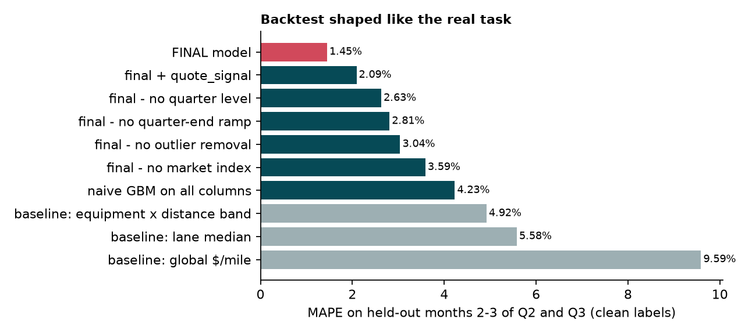
Model (Q2 and Q3 backtests) | MAE | RMSE | MAPE % | Median APE % | Bias % | MAPE % (all labels)
One rate per mile for everything | 201.68 | 279.96 | 9.59 | 8.12 | -2.69 | 11.68
Median by equipment and distance band | 113.70 | 153.27 | 4.92 | 4.50 | -2.82 | 7.09
Median by lane | 134.78 | 335.65 | 5.58 | 4.43 | -2.77 | 7.81
Tree model on every column | 93.38 | 136.60 | 4.23 | 3.31 | -1.49 | 6.43
My model | 35.25 | 51.54 | 1.45 | 1.23 | -0.08 | 3.72
My model, keeping the bad rates | 71.23 | 115.02 | 3.04 | 2.29 | 0.10 | 5.29
My model, without the market index | 85.95 | 111.58 | 3.59 | 3.44 | 2.68 | 5.89
My model, without the quarter-end ramp | 67.82 | 101.06 | 2.81 | 2.30 | -2.17 | 5.02
My model, without the quarter level | 63.05 | 84.90 | 2.63 | 2.52 | -2.52 | 4.82
My model, plus quote_signal | 47.89 | 78.49 | 2.09 | 1.30 | -0.22 | 4.33

To check that each part of the model earns its place, I removed them one at a time. Error went up every time. The market index matters most when it moves between the training month and the months being predicted. In the Q3 backtest it fell from 1.20 in July to 0.94 in August and September, which is why dropping it hurts so much there. In Q2 it moved much less (1.21 in April, 1.29 in May and June). For the real task it goes from 0.96 in October to 0.93 in November and December, and it swings every week.
Model | Q2 | Q3 | Average | Worse by (points)
My model | 1.48 | 1.42 | 1.45 | 0.00
My model, plus quote_signal | 1.62 | 2.55 | 2.09 | 0.64
My model, without the quarter level | 2.14 | 3.12 | 2.63 | 1.18
My model, without the quarter-end ramp | 2.48 | 3.14 | 2.81 | 1.36
My model, keeping the bad rates | 3.25 | 2.84 | 3.04 | 1.59
My model, without the market index | 1.60 | 5.57 | 3.59 | 2.14

Results on cities the model hasn't seen, and on a quarter it hasn't seen:
Model | New cities: MAE | New cities: MAPE % | New cities: Bias % | Next quarter: MAE | Next quarter: MAPE % | Next quarter: Bias %
Median by equipment and distance band | 117.09 | 5.21 | -2.99 | 78.59 | 3.67 | -0.75
Median by lane | 117.09 | 5.21 | -2.99 | 86.55 | 3.81 | -0.98
Tree model on every column | 96.45 | 4.26 | -1.38 | 70.60 | 3.07 | -0.64
My model | 38.45 | 1.62 | -0.15 | 34.63 | 1.51 | -0.85

Finally, error by month, with what quote_signal was doing that month. Adding it helps when the quote is informative and hurts a lot when it's noise. Noise is what November and December look like.
Model | May (inverted) | June (informative) | August (noise) | September (informative)
My model | 1.45 | 1.52 | 1.45 | 1.39
My model, plus quote_signal | 1.66 | 1.59 | 4.10 | 0.98
Tree model on every column | 3.73 | 4.33 | 5.23 | 3.64

6. Final predictions
For the submission I retrained the model on all 48,000 labelled loads and predicted all 12,000 validation loads, cleaning them the same way as the training data. The provided score.py accepts the file: the right two columns, all 12,000 IDs from the template, and every rate positive. Predictions range from $188 to $7,176.

7. The December chart
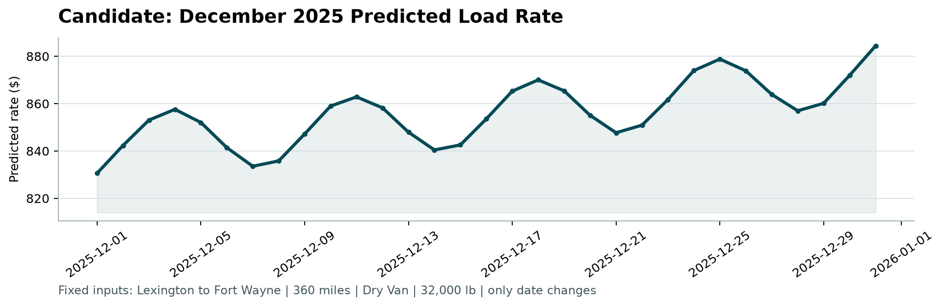
This is the chart from score.py, for a 360-mile dry van load from Lexington to Fort Wayne weighing 32,000 lb. Predictions run from $831 to $884, starting at $831 on December 1st and ending at $884 on the 31st.
You can see two things. There's a weekly wave, because the market index peaks on Thursdays and dips on Sundays. And there's a steady climb toward December 31st, because that's the end of Q4. For dry vans the model puts the last-day premium at 4.4%.
The chart file doesn't include a market index, so for each day I used the median index of the validation loads moving that same day. That only uses inputs, not prices. As a sanity check, the 21 dry van loads on this lane in training had a median of $2.23 per mile at around 27,000 lb. The forecast is $2.31 to $2.46 per mile for a heavier load late in Q4, which seems reasonable.

8. Limitations and what I'd do next
- Q4's price level comes from a single month, October. In the backtests, getting the level from one month left the predictions off by up to 0.8% on average.
- I assume the quarter-end rise looks the same in Q4 as in earlier quarters. Holidays like Thanksgiving and Christmas don't appear in the training data, so the real December peak could be bigger.
- I threw quote_signal away completely. If you could reliably tell in real time which months it's trustworthy, it would be worth using in those months.
- Next steps: add prediction intervals, monitor the market index and quote_signal for changes, and retrain as soon as November's real prices come in.

