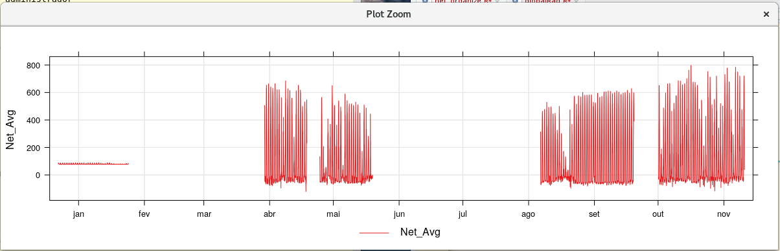
Arquivo mais antigo 30 min

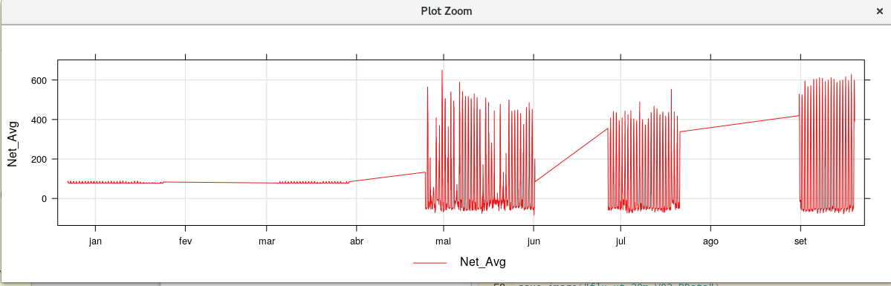

Coleta | Inicio | Fim
024-2017 | 22-12-2016 | 24-01-2017
086-2017 | 04-03-2017 | 29-03-2017
108-2017 | 29-03-2017 | 18-04-2017
137-2017 | 24-04-2017 | 19-05-2017
151-2017 | 19-05-2017 | 01-06-2017
201-2017 | 26-06-2017 | 21-07-2017
241-2017 | 06-08-2017 | 31-08-2017
260-2017 | 31-08-2017 | 19-09-2017
300-2017 | 01-10-2017

