9.04 – Notes
ETR113

Voltage: Potential difference in charge between two points
Current: Rate of flow of electrons in a single instance
Resistance: Material resistance to current

Ohm’s Law: The relationship between these elements

Volts = V
Amperes (Amps) = I
Resistance (Ohms) = Ω

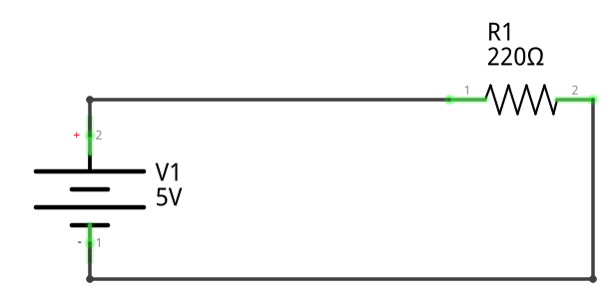
Solve for I:

Series Circuit: Voltage Divider

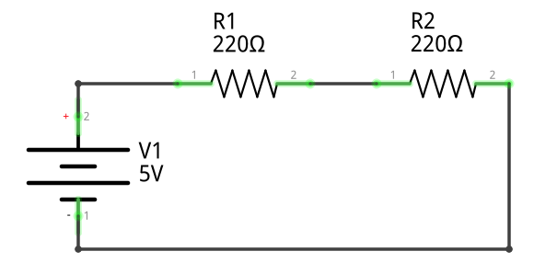

Parallel Circuit: Current Divider

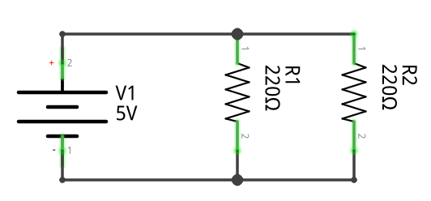
Properties of Series Circuits:

Total Resistance = All resistances added together

Resistor Value of LED: Find values on datasheet

