9.11 – Notes
ETR113

Parallel Circuit: Current Divider

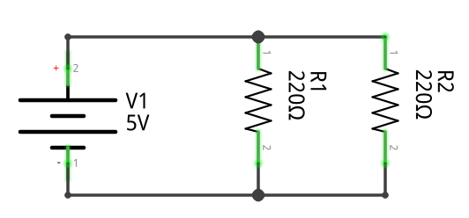
Properties of Parallel Circuits:

Parallel circuits have multiple paths for current to flow.

Voltage is the same for each path.

The Sum of each current path is equal to the total current:

If a path is broken, the other paths still flow...

Total Resistance = NOT - All resistances added together

OR

Which is the same as:

