8.27 – Notes
ELE239

AND Truth Table

A | B | Y
1 | 1 | 1
1 | 0 | 0
0 | 1 | 0
0 | 0 | 0

NAND Truth Table

A | B | Y
1 | 1 | 0
1 | 0 | 1
0 | 1 | 1
0 | 0 | 1

OR Truth Table

A | B | Y
1 | 1 | 1
1 | 0 | 1
0 | 1 | 1
0 | 0 | 0

NOR Truth Table

A | B | Y
1 | 1 | 0
1 | 0 | 0
0 | 1 | 0
0 | 0 | 1

Basic Ladder Logic – IEC Symbols

Inputs:

NO - 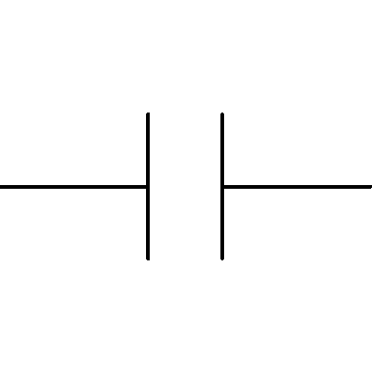
NC - 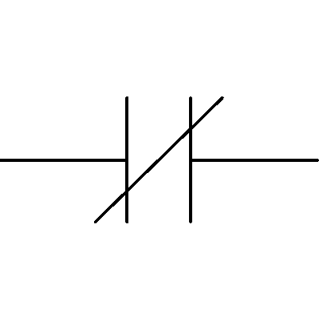

Outputs:

Coil - 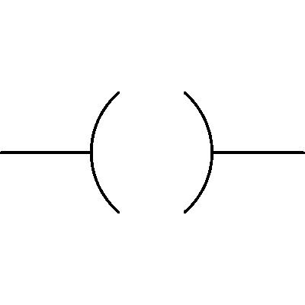
Negated Coil - 