Basic Maps Using CartoDB and JavaScript

The CartoDB JavaScript library makes it easy to customize your maps. With it you can load visualizations, filter your visualization's layers, and even change the visualization's CartoCSS. This cheatsheet summarizes the basics of getting a map on a web page using JavaScript and CartoDB.

Basic Setup
There are three fundamental steps you will follow any time you use JavaScript to add a CartoDB map to your page:
- Load two libraries: CartoDB.js and jQuery. Copy and paste the following near the beginning of your HTML file's head:
<link rel="stylesheet" href="http://libs.cartocdn.com/cartodb.js/v3/themes/css/cartodb.css" />
<!--[if lte IE 8]>
<link rel="stylesheet" href="http://libs.cartocdn.com/cartodb.js/v3/themes/css/cartodb.ie.css" />
<![endif]-->
<script src="http://libs.cartocdn.com/cartodb.js/v3/cartodb.js"></script>
<script src="http://ajax.googleapis.com/ajax/libs/jquery/2.1.0/jquery.min.js"></script>
These load CSS and JavaScript that will help you add your map to your page.
- Make a place for your map to go. In your HTML file's body, add a div with an id that you'll remember. It's common to use “map” for the id:
<div id="map"></div>
This is a standard div element that you can style using CSS. Set the height and width for your map div. If you don't, the height and width will be 0, so you won't see your map! For example:
#map {
height: 100%;
width: 100%;
}
- Create the map. At the bottom of your document's head, add a script element like this:
<script>
$(document).ready(function () {
cartodb.createVis(your_map_id, your_visualization_url);
});
</script>
Replace your_map_id with the id of your map div and your_visualization_url with the url that you copy from the Share dialog of your CartoDB visualization.
What is this code doing?
Step 3 can be hard to read. Let's break it down line by line.
First, JavaScript code goes in a script element. So we create one (usually in the head of your document). The opening and closing tags are the first and fifth lines of the above code.
The second line, $(document).ready(function () { uses jQuery to wait for the page to load before going on. If we didn't do this, there is a chance that your code would try to create your map before the HTML is ready to show it—it would be broken! The fourth line closes the ( and { on the second line with }); without which our code would be broken since it is not closed. This is exactly like CSS and CartoCSS, where each rule must have matching { and } braces.
Finally, the third line, cartodb.createVis(...), creates the map. createVis is a function in cartodb that loads visualizations. Here it is taking two parameters: the id of the HTML element where the visualization should go and the url of the visualization.
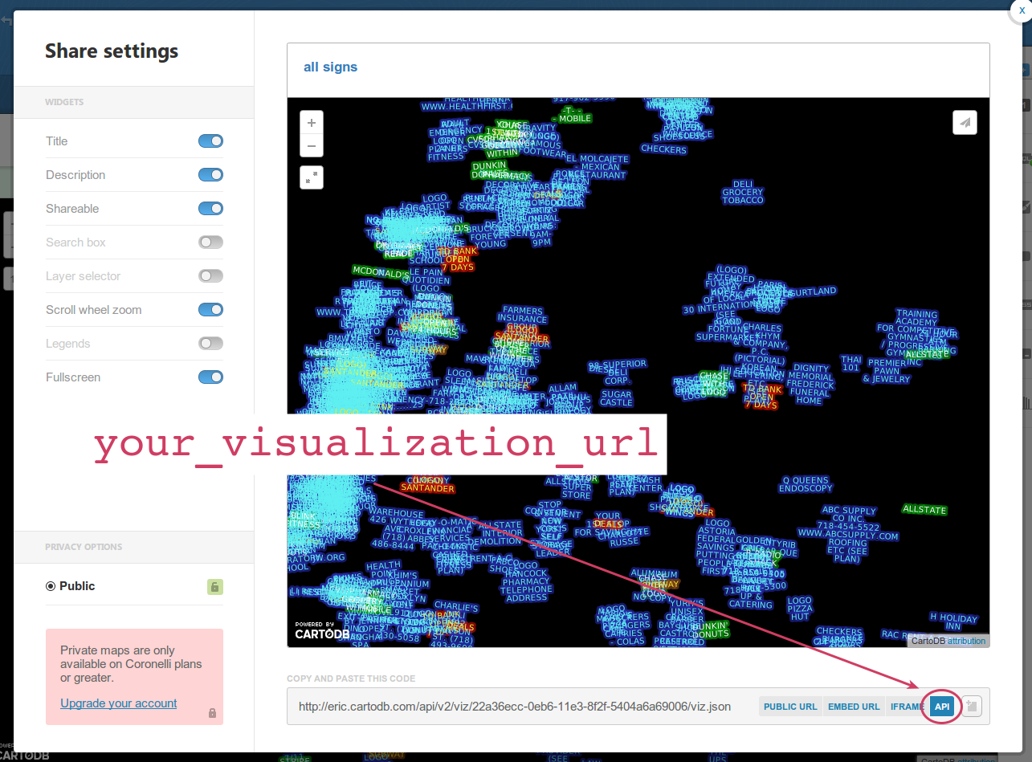

Configuration
Now that you have a map on your page, you can take advantage of extra configuration options that you do not have through CartoDB's Share dialog.
There are numerous settings you can change in this way. They go in a third, optional, parameter to cartodb.createVis(). The options are formatted in a way much like properties in a CSS or CartoCSS rule:
{
option1: value1,
option2: value2
}
Add these options to cartodb.createVis() after your map's id and your visualization's url:
<script>
$(document).ready(function () {
cartodb.createVis(your_map_id, your_visualization_url, your_map_options);
});
</script>

For example:
<script>
$(document).ready(function () {
cartodb.createVis('map', 'http://eric.cartodb.com/api/v2/viz/.../viz.json', {
cartodb_logo: false
});
});
</script>
would create a map and set the cartodb_logo option to false. This hides the CartoDB logo from the resulting map.

Conclusion
Your code should look something like this when you're finished:
<!DOCTYPE html>
<html>
<head>
<link rel="stylesheet" href="http://libs.cartocdn.com/cartodb.js/v3/themes/css/cartodb.css" />
<!--[if lte IE 8]>
<link rel="stylesheet" href="http://libs.cartocdn.com/cartodb.js/v3/themes/css/cartodb.ie.css" />
<![endif]-->
<script src="http://libs.cartocdn.com/cartodb.js/v3/cartodb.js"></script>
<script src="http://ajax.googleapis.com/ajax/libs/jquery/2.1.0/jquery.min.js"></script>
<style>
#map {
height: 500px;
width: 500px;
}
</style>
<script>
$(document).ready(function () {
cartodb.createVis('map', 'your_visualization_url', {
cartodb_logo: false
});
});
</script>
</head>
<body>
<div id="map"></div>
</body>
</html>

Next Steps
Once you have followed the steps above to add a CartoDB map to your page, you can start to make the map even more interactive than it is by default. This will require a bit more coding. See “Advanced Maps Using CartoDB and JavaScript” to learn more.

http://developers.cartodb.com/documentation/cartodb-js.html
Under Options here: http://developers.cartodb.com/documentation/cartodb-js.html#sec-3-1

