CartoDB JavaScript Cheatsheet

The CartoDB JavaScript library makes it easy to customize your maps. Through it you can load visualizations, filter your layers, and even change the visualization's CartoCSS.

Basic Setup
There are three fundamental steps you will follow any time you use JavaScript to add a CartoDB map to your page:
- Load two libraries: CartoDB.js and jQuery. Copy and paste this into the head of your HTML file:
<link rel="stylesheet" href="http://libs.cartocdn.com/cartodb.js/v3/themes/css/cartodb.css" />
<!--[if lte IE 8]>
<link rel="stylesheet" href="http://libs.cartocdn.com/cartodb.js/v3/themes/css/cartodb.ie.css" />
<![endif]-->
<script src="http://libs.cartocdn.com/cartodb.js/v3/cartodb.js"></script>
<script src="http://ajax.googleapis.com/ajax/libs/jquery/2.1.0/jquery.min.js"></script>
These load CSS and JavaScript that will make it easy to add your map to your page.
- Make a place for your map to go. In your document's body, add a div with an id that you'll remember. It's common to use “map” for the id:
<div id="map"></div>
This is a standard div element that you can style using CSS. Set the height and width for your map div. If you don't, the height and width will be 0, so you won't see your map! For example:
#map {
height: 100%;
width: 100%;
}
- Create the map. At the bottom of your document's head, add a script element like this:
<script>
$(document).ready(function () {
cartodb.createVis(your_map_id, your_visualization_url);
});
</script>
Replace your_map_id with the id of your map div and your_visualization_url with the url that you copy from the Share dialog of your CartoDB visualization.
What is this code doing?
First, JavaScript code goes in a script element. So we create one (usually in the head of your document), and these are the first and fifth lines of the above code.
The next line, $(document).ready(...) uses jQuery to wait for the page to load before going on. If we didn't do this, there is a chance that your code would try to create your map before the HTML is ready to show it—it would be broken!
Finally, the third line, cartodb.createVis(...), creates the map. createVis is a function in cartodb that loads visualizations. Here it is taking two parameters: the id of the HTML element where the visualization should go and the url of the visualization.
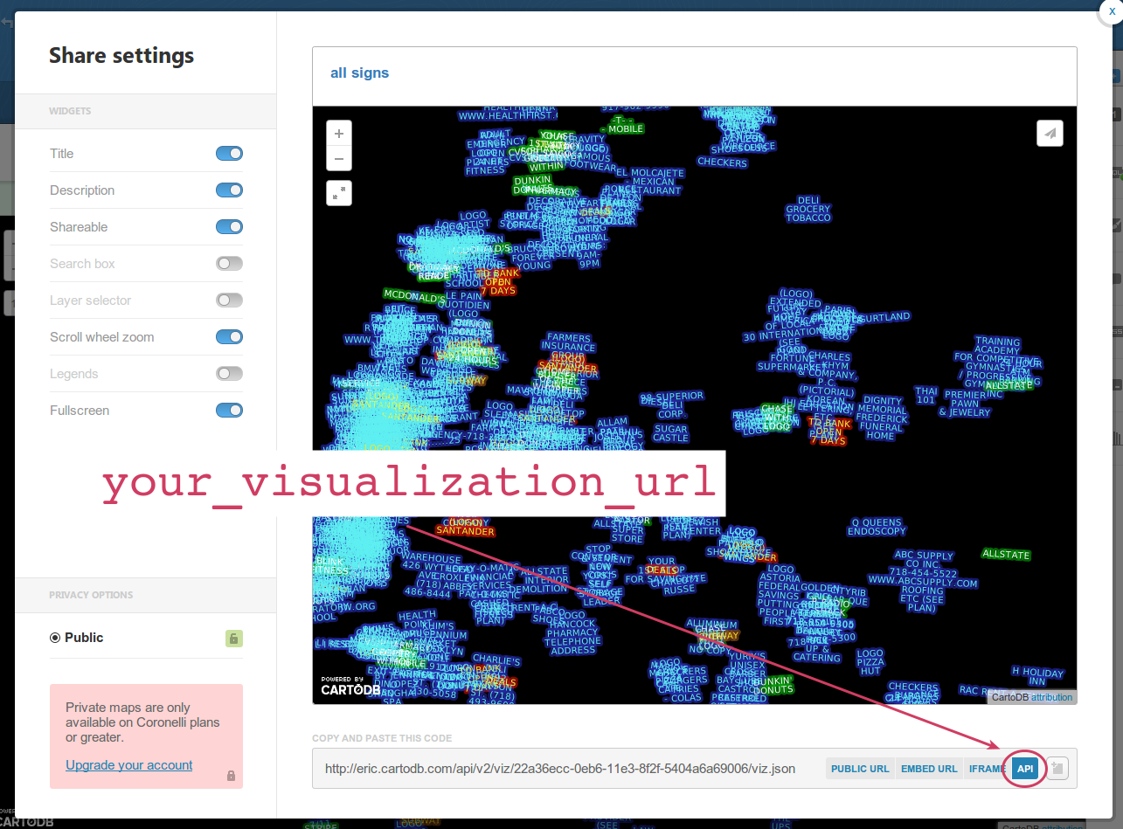

Configuration
Now that you have a map on your page, you can take advantage of extra configuration options that you do not have through CartoDB's Share dialog.
There are numerous settings you can change in this way. They go in a third, optional, parameter to cartodb.createVis(). The options are formatted in a way much like properties in a CSS or CartoCSS rule:
{
option1: value1,
option2: value2
}
Add these options to cartodb.createVis() after your map's id and your visualization's url:
<script>
$(document).ready(function () {
cartodb.createVis(your_map_id, your_visualization_url, your_map_options);
});
</script>

For example:
<script>
$(document).ready(function () {
cartodb.createVis('map', 'http://eric.cartodb.com/api/v2/viz/.../viz.json', {
cartodb_logo: false
});
});
</script>

More Advanced Interactivity
CartoDB includes basic map interactivity such as zooming, infowindows, and layer switchers. Often you will want to add other types of interactivity, such as filtering within a layer (showing only some of the features for a layer). Using the CartoDB and jQuery libraries, it can be relatively simple to add buttons to your map that affect the map.
.click()
.attr('id')
.setSQL()

http://developers.cartodb.com/documentation/cartodb-js.html
Under Options here: http://developers.cartodb.com/documentation/cartodb-js.html#sec-3-1

