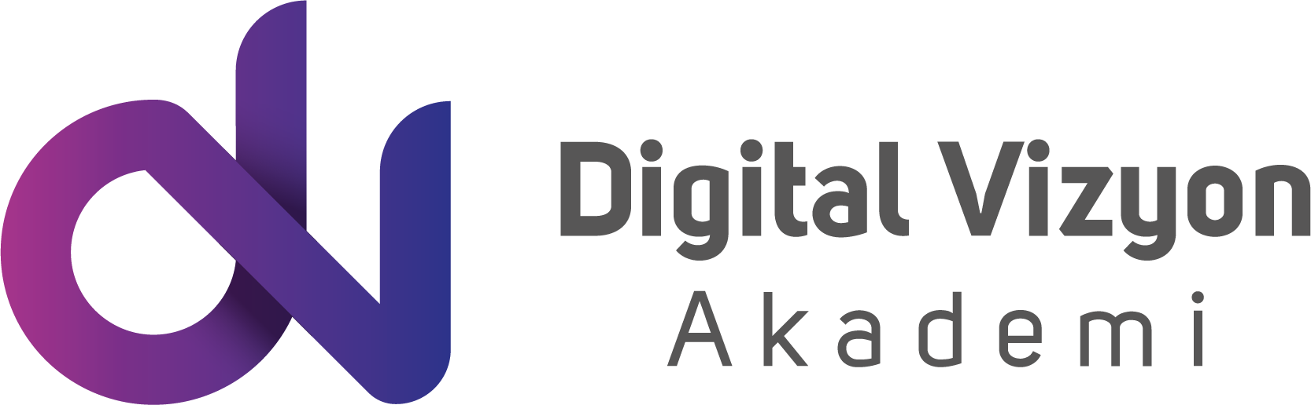

Python Machine Learning Eğitim İçeriği (3 Gün)

Environment Setup
Git and Docker basics
Python for data analysis – Numpy
Python for data analysis – Pandas
Data Visualization – Matplotlib
Data Visualization – Seaborn
Introduction to machine learning
Linear regression
Logistic regression
K nearest neighbours
Decision trees and random forest
Support vector machines
Principal component analysis
Recommender systems
Natural language processing
Neural nets and deep learning

