

**Gulf Aluminium Rolling Mill Company**

**GARMCO E-Tendering System Guideline**

Frequently Asked Questions

How to Login to the E-Tendering System? 2

How to Recover Your Password? 3

How to Register to the E-Tendering System? 3

How to View Published Quotations/RFQs? 5

How to Place a Bid? 6

How to Modify My Current Bid? 8

# How to Login to the E-Tendering System?

* Open any internet browser then go to <https://etendering.garmco.com>

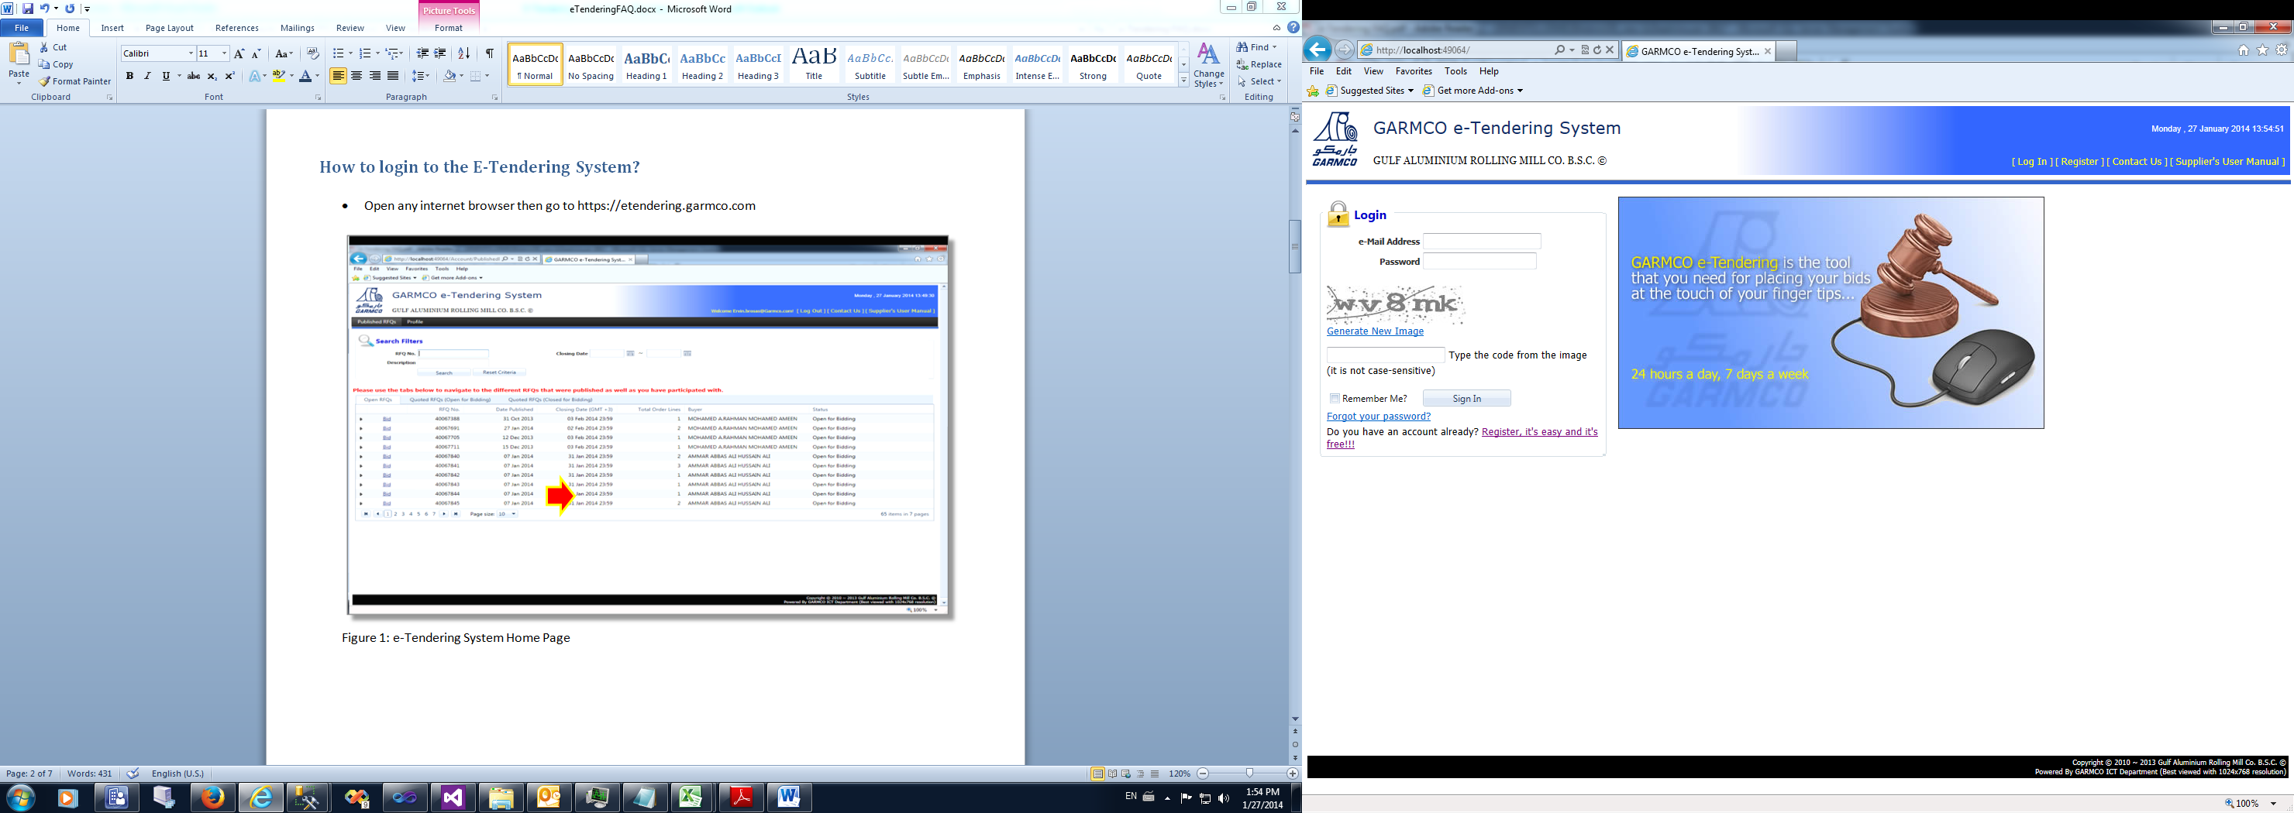

**Figure 1: e-Tendering System Login page**

* To login to the system, enter the registered email address and password. At the same time, enter the system generated random text image. Click the **Sign In** button.
* The Login page also contains links for retrieving forgotten password or registering to the system.

# How to Recover Your Password?

* From the Login page *(Figure 1: e-Tendering System Login page)*, click “**Forgot your password?**” link.

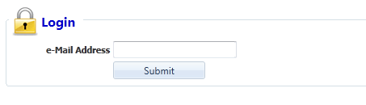

**Figure 2: Forgot Password page**

* Type your registered email address then click the **Submit** button. An email will be sent to the address you’ve specified and contains your current password.

**GO TO TOP**

# How to Register to the E-Tendering System?

* From the Login page *(Figure 1: e-Tendering System Login page)*, click the “**Register, it’s easy and it’s free!!!**” link.

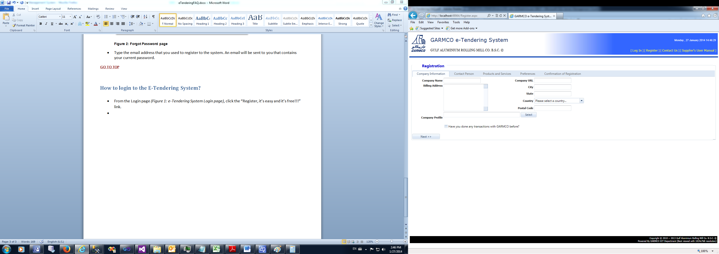

**Figure 3: Registration Form**

* The Registration Form composes of 5 parts namely: Company Information, Contact Person, Products and Services, Preferences, and Confirmation of Registration.
* Data entry begins in the “Company Information” section and ends in the “Confirmation of Registration” section. A data validation error message will be displayed at the top of the page for any invalid entries or when a required field is left blank. Click the **Next** or **Back** button to navigate between sections.

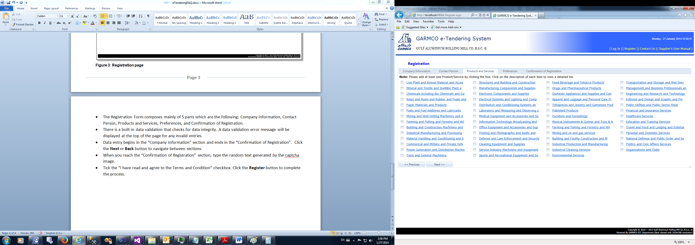

**Figure 4: Registration Form – Products and Services section**

* In the Products and Services section, at least one item must be selected to be notified instantly for any published RFQs that belong to that category. You may tick the box on the left side of each product or service. Clicking the product or service name will open a new form that will allow you to select other products or services that belong to the parent category as shown in the screenshots below.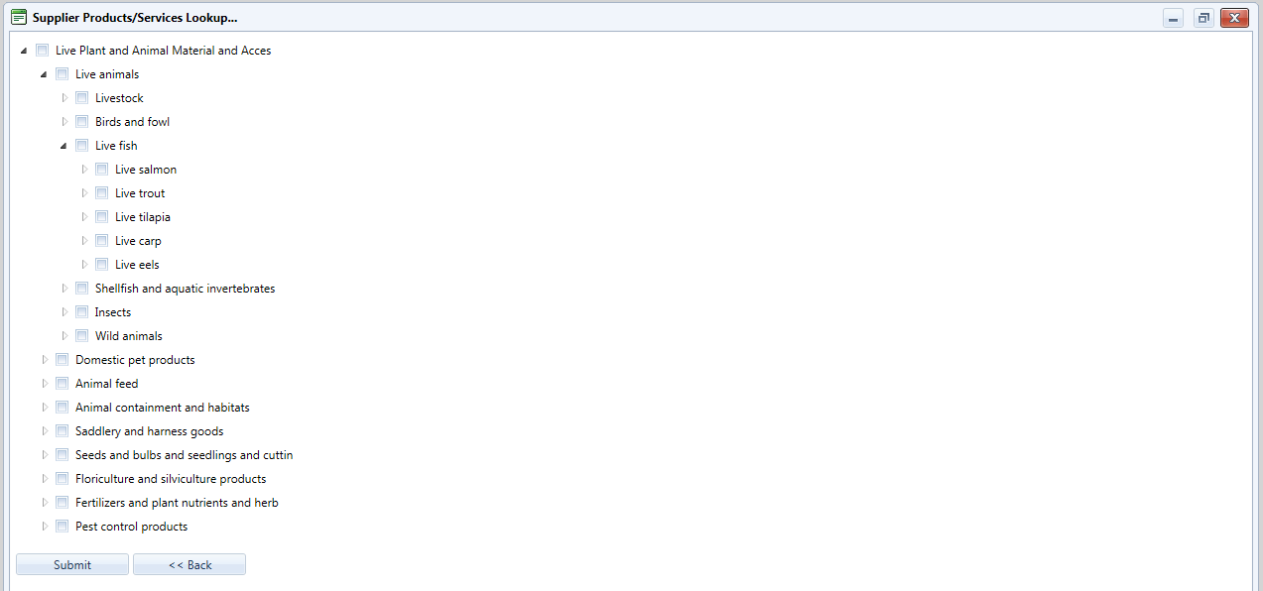

**Figure 5: Supplier Products/Services Lookup Form**

* When you reach the “Confirmation of Registration” section, type the random text image generated by the system.
* Tick the “**I have read and agree to the Terms and Condition**” checkbox. Finally, click the **Register** button to complete the process.

**GO TO TOP**

# How to View Published Quotations/RFQs?

* Login to the system, you will be redirected to the Published RFQs page showing all RFQs available for bidding.

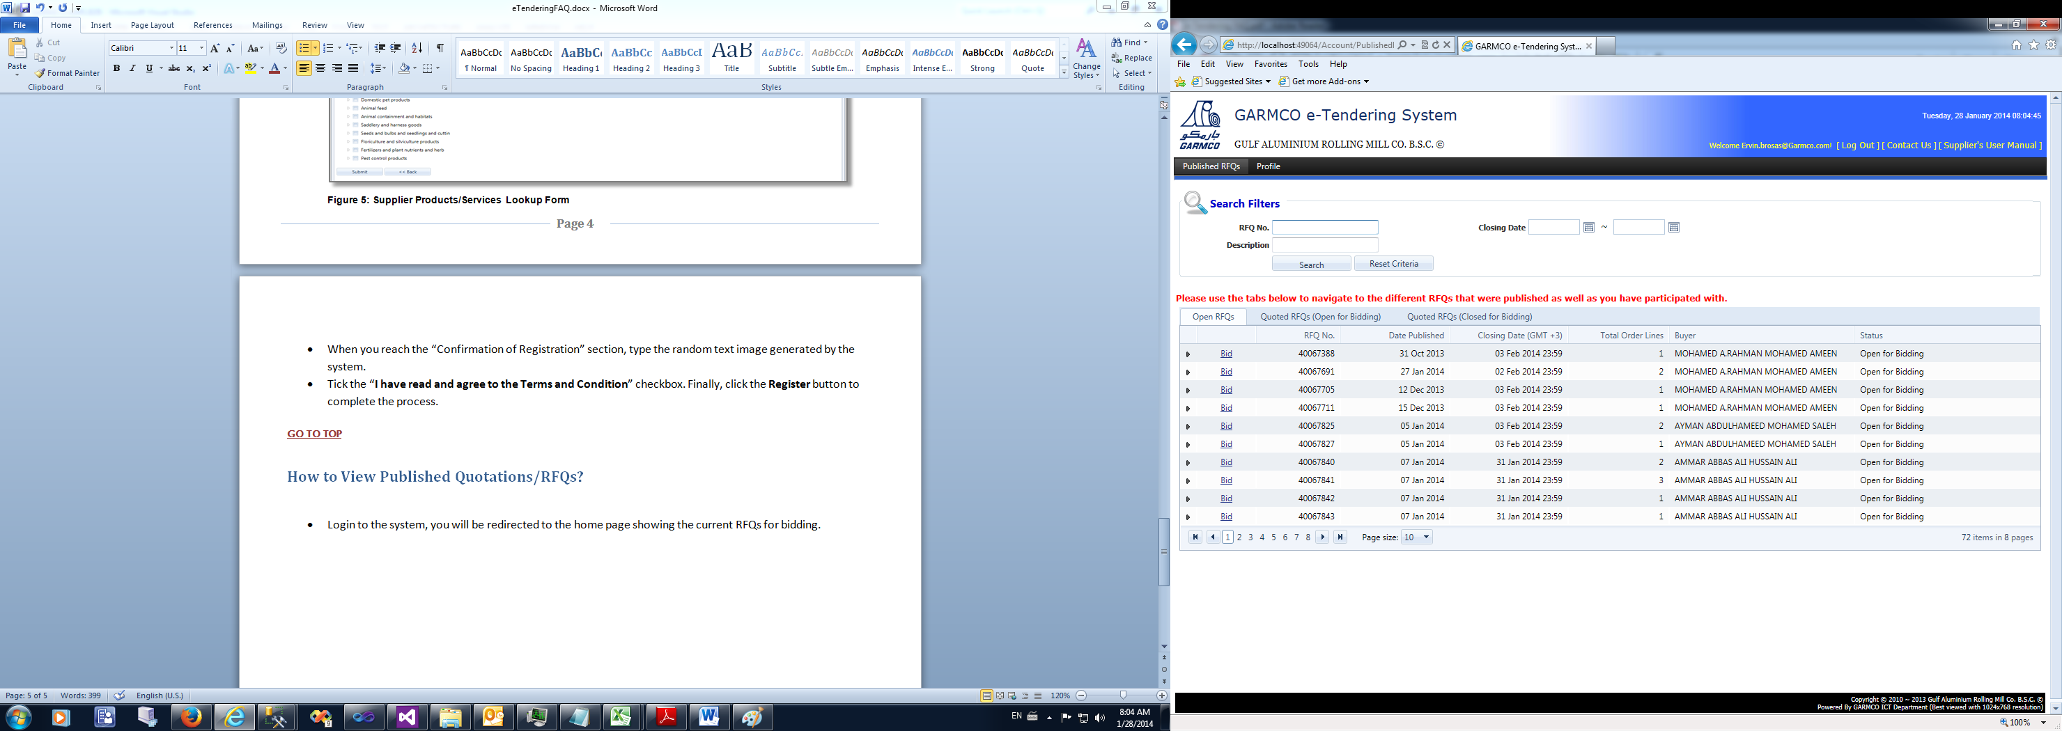

**Figure 5: Published RFQs page**

* The form is divided into 2 sections, the Search Criteria and Search Result. The Search Result section is divided into 3 parts which are the following:
  1. Open RFQS – shows RFQs that are available for bidding
  2. Quoted RFQs (Open for Bidding) – shows RFQs that are not yet closed for bidding wherein you have placed your bid.
  3. Quoted RFQs (Closed for Bidding) – shows RFQs that are already closed for bidding wherein you have placed your bid.

Initially, the “Open RFQs” tab is selected to show all RFQs that are currently available for bidding.

* Click the desired tab to navigate to the different RFQs that were published as well as those you have participated with.

**GO TO TOP**

# How to Place a Bid?

* From the list of open RFQs in the Published RFQs page, select the desired row in the grid then click the **Bid** link.
* A new page will be shown on the screen which is divided into 2 parts: the header and Bid details section. The header section displays information about the RFQ as well as some information about the supplier. The Bid details section is where you can put details about your bid. You can also put information about other charges.
* Click the **Submit My Bid** button to submit your bid for processing. You may also click the **Print My Bid** button if you want to have a printout of your current bid.
* Click the **Print RFQ** button if you want to view and print the RQF inquiry letter.

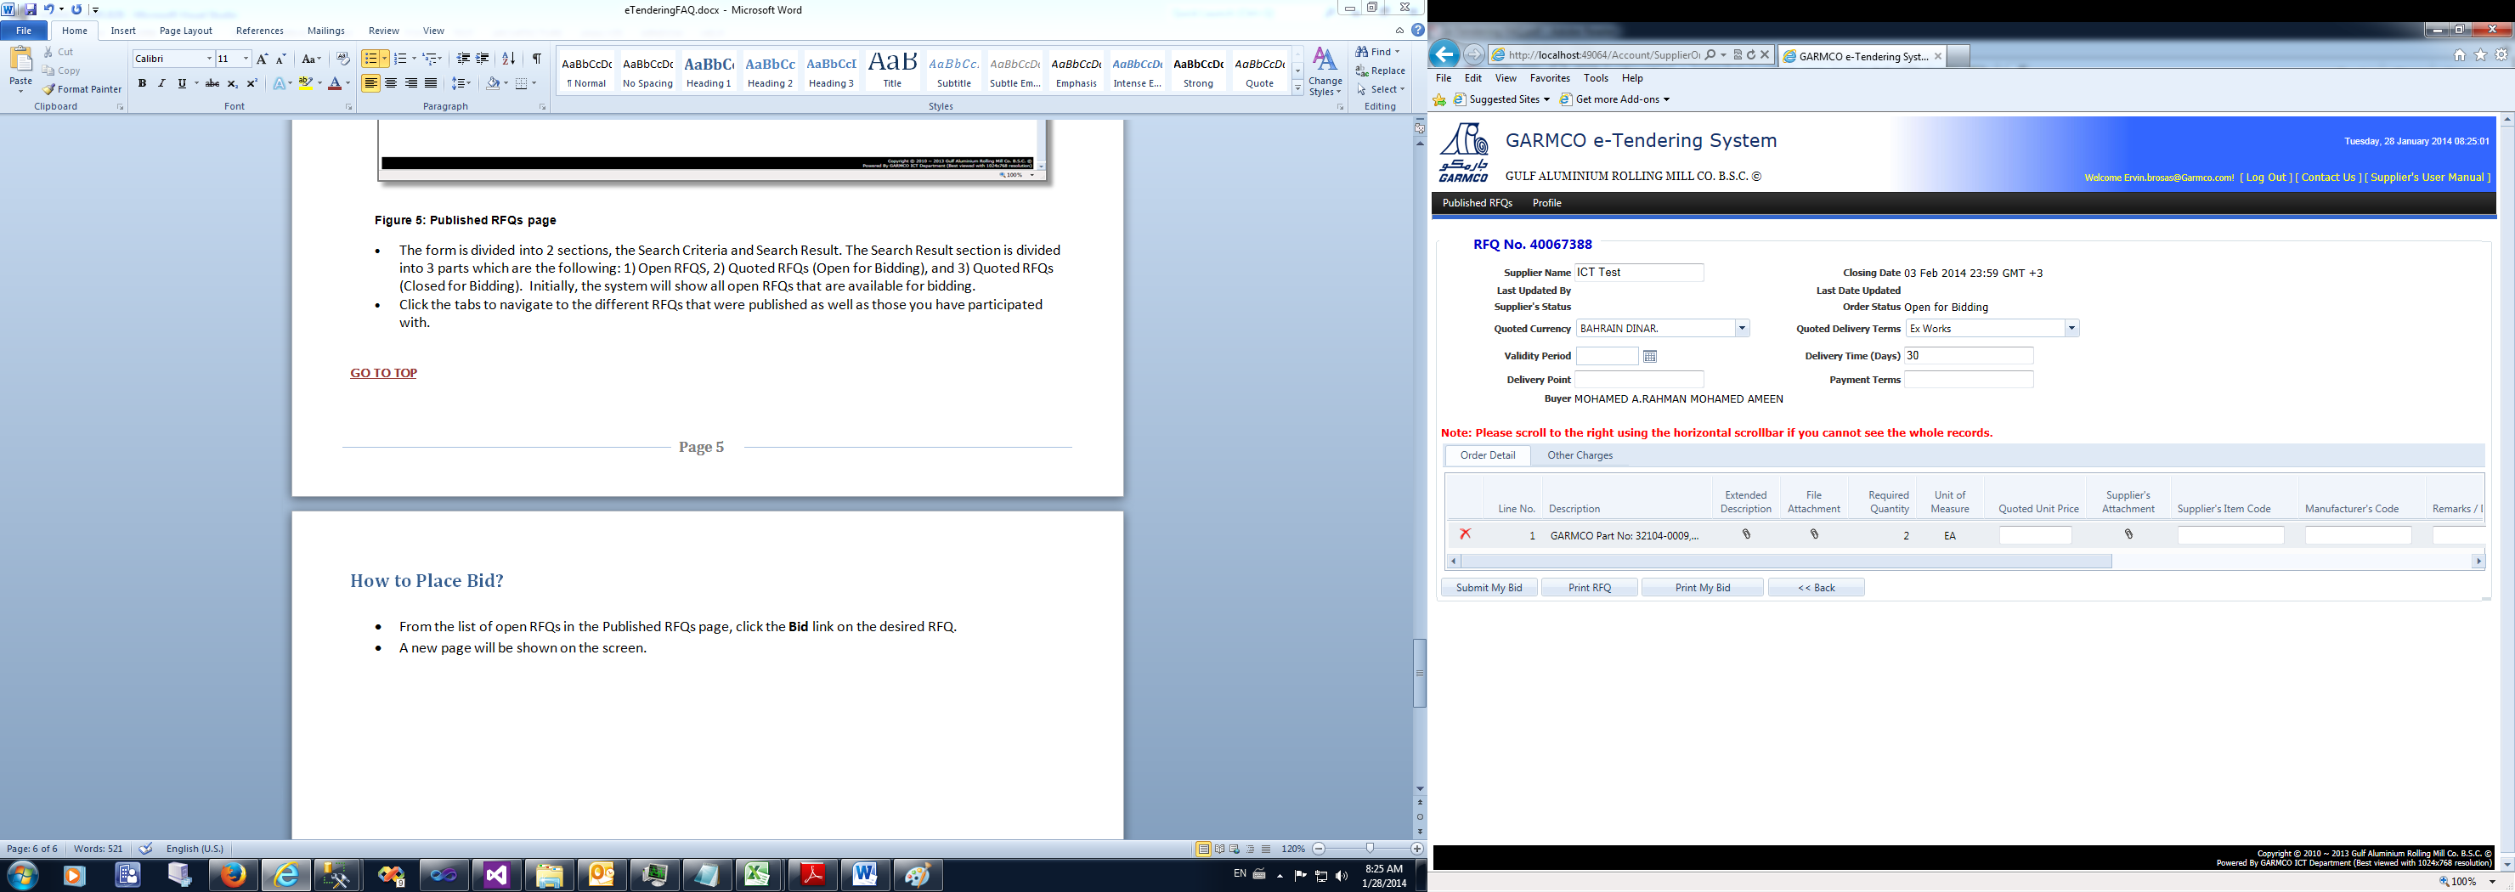

**Figure 6: Place your Bid page**

* You are allowed to bid on all orders or partial only.
* To view the full description of the order line, click the paper clip icon displayed in the “Extended Description” column.
* To view the attachments, click the paper clip icon displayed in the “File Attachment” column.
* To add an attachment, click the paper clip icon displayed in the “Supplier’s Attachment” column. A new page will be shown on the screen. *(Refer to Figure 7: RFQ Attachment page).* To upload a file, click the **Upload a File** button. Click **Select** button to browse the desired file located in your PC. Finally, click the **Upload** button to complete the process.
* To add other offer, scroll to the right side of the Order Detail grid until you find the “Alternative Offers” column. Click the **Add** button to open the Alternative Offer page *(Refer to Figure 8: Alternative Offer page).* Click **Add new alternative offer** button to add new offer record in the grid. Click **Submit** button to complete the process.

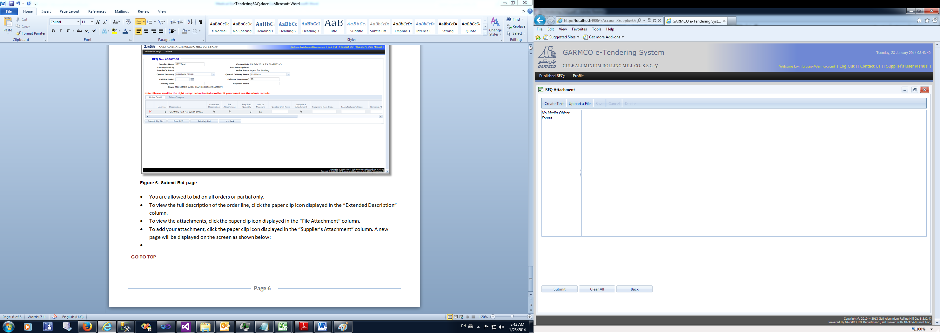

**Figure 7: RFQ Attachment page**

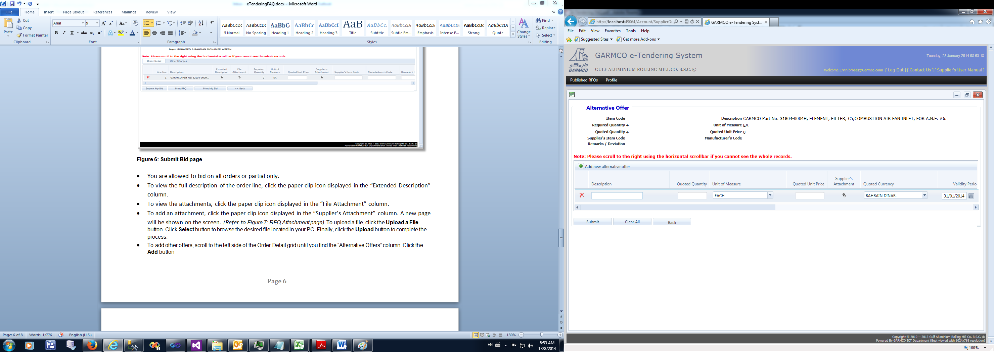

**Figure 8: Alternative Offer page**

**GO TO TOP**

# How to Modify My Current Bid?

* From the Published RFQs page, click the “Quoted RFQs (Open for Bidding)” tab.
* Click the **Re-bid** link of the desired RFQ which is displayed in the grid.

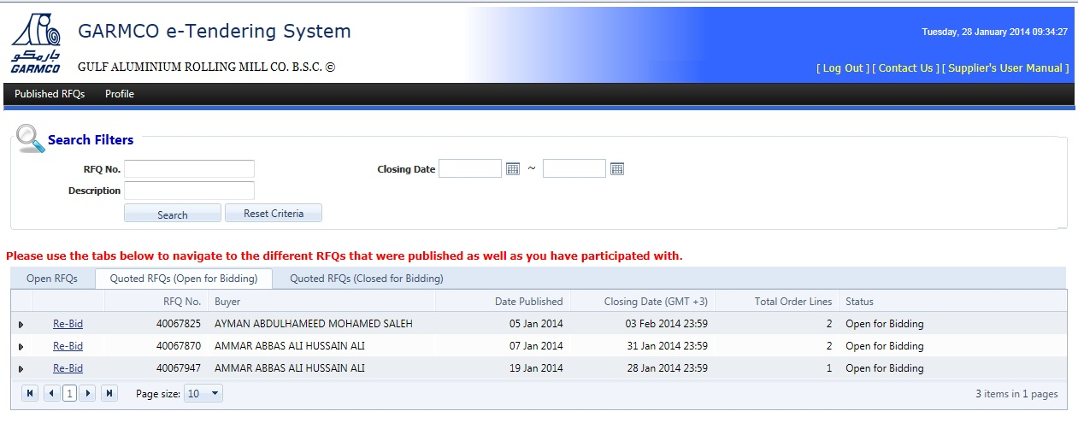

**Figure 9: Quoted RFQs (Open for Bidding) tab**

* The “Update your Bid” page will be shown on the screen (*refer to Figure 10: Update your Bid page*). Modify the desired row in the “Order Detail” grid. You can also update the data you have supplied in the Other Charges grid.
* Click the **Update My Bid** button to submit the changes and complete the process.

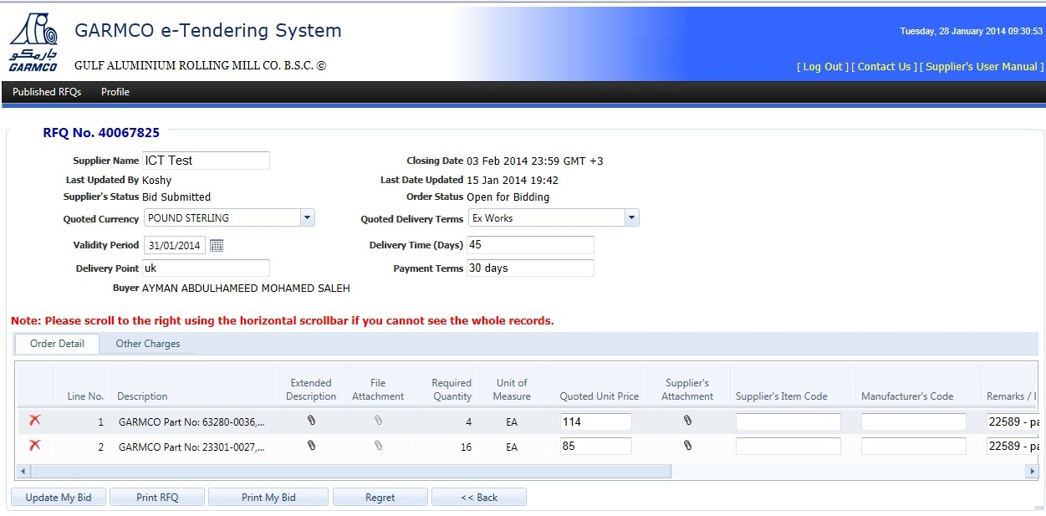

**Figure 10: Update your Bid page**

**GO TO TOP**