**EE568 Project-2**

**EBRU GENÇ**

# Integral Slot Winding Design

Machine design was made according to the below mentioned features.

* 20 pole
* 120 slots
* Full pitch.

Table 1: Winding diagram for full pitched

|  |  |  |  |  |  |  |  |  |  |  |  |
| --- | --- | --- | --- | --- | --- | --- | --- | --- | --- | --- | --- |
| A1 | A2 | -C1 | -C2 | B1 | B2 | -A3 | -A4 | C3 | C4 | -B3 | -B4 |
| A39 | A40 | -C39 | -C40 | B39 | B40 | -A1 | -A2 | C1 | C2 | -B1 | -B2 |

* For

* For
* For

0.258

# 2.Fractional Slot Winding Design

* For 24 slots 22 pole machine

sin (165/2)=0.99

|  |  |  |  |  |  |  |  |  |  |  |  |  |
| --- | --- | --- | --- | --- | --- | --- | --- | --- | --- | --- | --- | --- |
| Slot number | 1 | 2 | 3 | 4 | 5 | 6 | 7 | 8 | 9 | 10 | 11 | 12 |
| Electrical angle ( | 0 | 165 | 330 | 135 | 300 | 105 | 270 | 75 | 240 | 45 | 210 | 15 |

|  |  |  |  |  |  |  |  |  |  |  |  |  |
| --- | --- | --- | --- | --- | --- | --- | --- | --- | --- | --- | --- | --- |
| Slot number | 13 | 14 | 15 | 16 | 17 | 18 | 19 | 20 | 21 | 22 | 23 | 24 |
| Electrical angle ( | 180 | 345 | 150 | 315 | 120 | 285 | 90 | 255 | 60 | 225 | 30 | 195 |

* For 24 slots 20 pole machine

sin (150/2)=0.96

|  |  |  |  |  |  |  |  |  |  |  |  |  |
| --- | --- | --- | --- | --- | --- | --- | --- | --- | --- | --- | --- | --- |
| Slot number | 1 | 2 | 3 | 4 | 5 | 6 | 7 | 8 | 9 | 10 | 11 | 12 |
| Electrical angle ( | 0 | 150 | 300 | 90 | 240 | 30 | 180 | 330 | 120 | 270 | 60 | 210 |

|  |  |  |  |  |  |  |  |  |  |  |  |  |
| --- | --- | --- | --- | --- | --- | --- | --- | --- | --- | --- | --- | --- |
| Slot number | 13 | 14 | 15 | 16 | 17 | 18 | 19 | 20 | 21 | 22 | 23 | 24 |
| Electrical angle ( | 0 | 150 | 300 | 90 | 240 | 30 | 180 | 330 | 120 | 270 | 60 | 210 |

# 2D FEA Modeling

Machine design was made according to the below mentioned features.

* 22 pole
* 24 slots

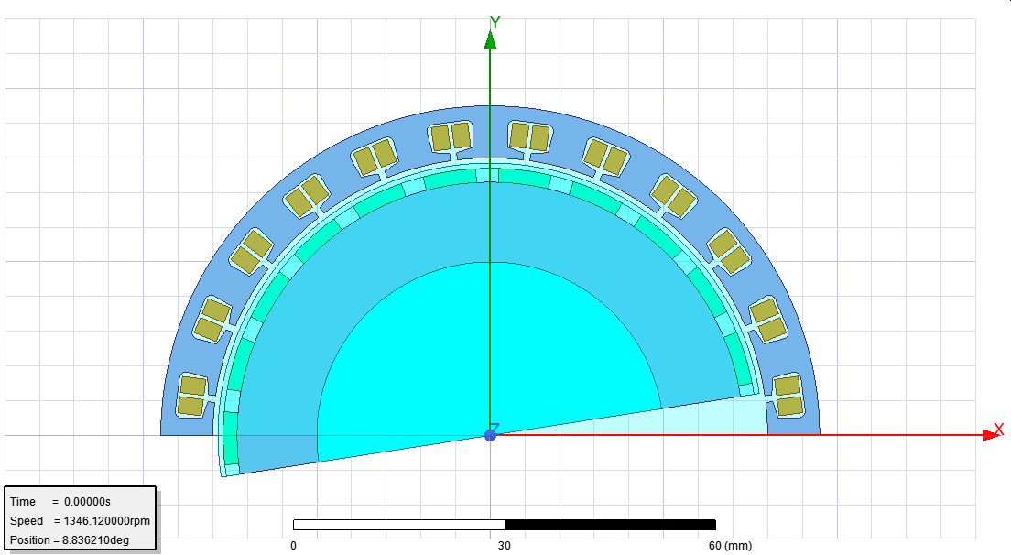

Figure 1: 2D FEA Modeling

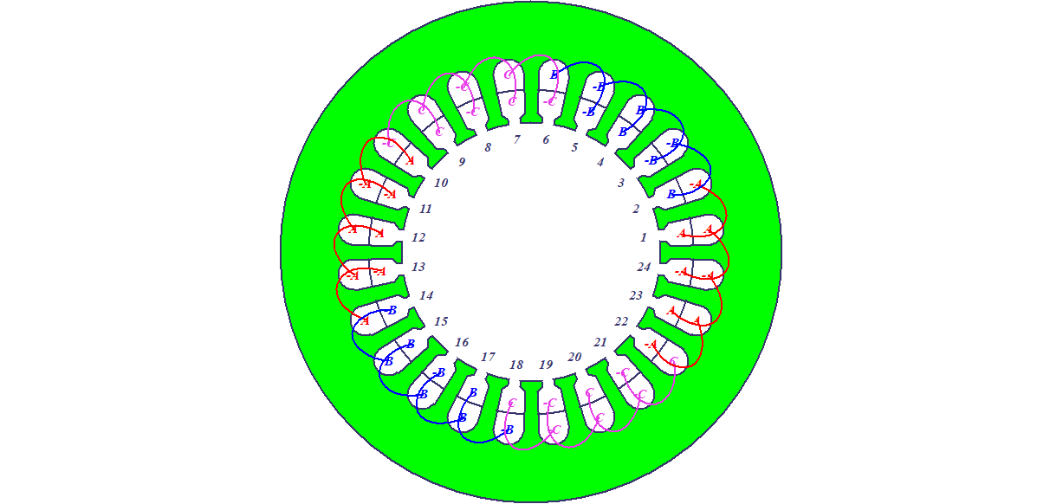

Figure 2: Winding Diagram

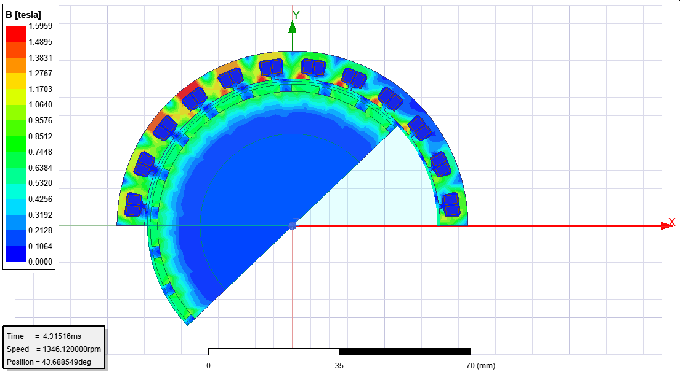

Figure 3. Flux Density Distribution

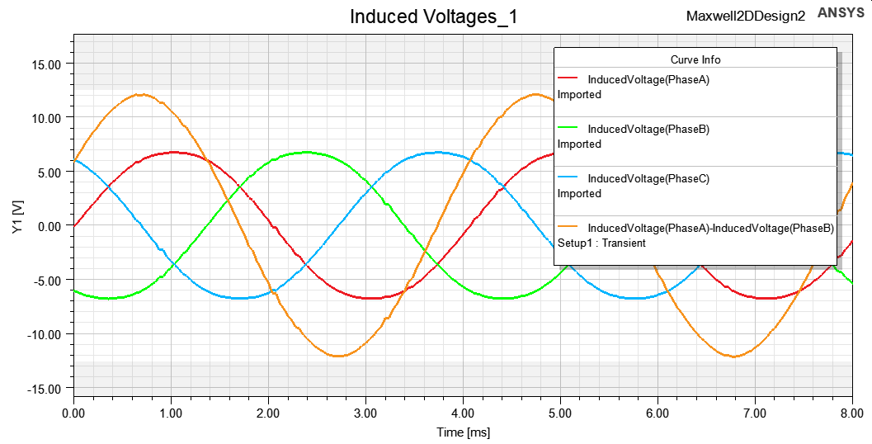

Figure 4. Induced voltage waveforms (for phase and line-to-line)

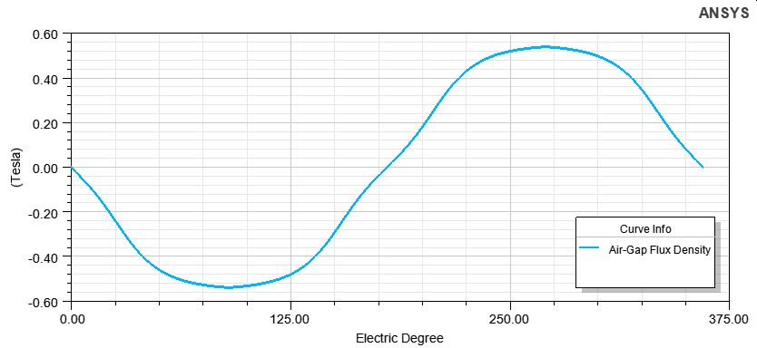

Figure 5. Air-gap Flux Density

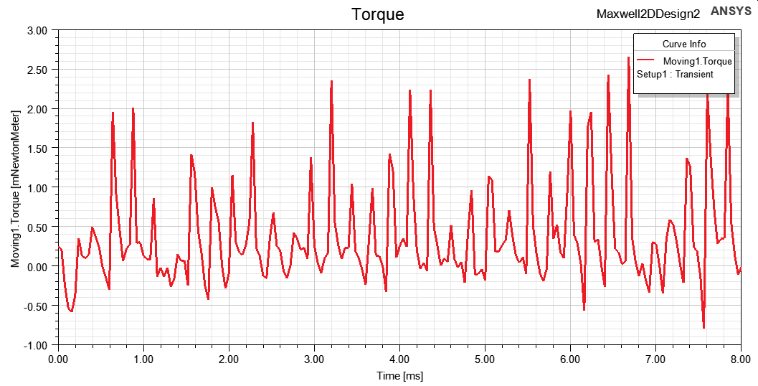

Figure 6.Cogging Torque