T.C.

MARMARA UNIVERSITY

FACULTY of ENGINEERING

COMPUTER ENGINEERING DEPARTMENT

ARTIFICIAL INTELLIGENCE (CSE482)

ASSINGNMENT #1

REPORT

Name: Ebru KIZILKİREN

NUMBER: 150114026

1. PROBLEM DEFINITION:

Peg solitaire ("Solo Test" in Turkish) is a board game for one player involving movement of pegs on a board with 33 holes. The shape of the board can be seen in the figure below. Initially, all the holes except the center hole are filled with pegs(Shown in figure 1.1). A valid move is to jump a peg orthogonally over an adjacent peg into a hole two positions away and then to remove the jumped peg. The objective is, making valid moves, to empty the entire board except for a solitary peg in the central hole(Shown in figure 1.2).

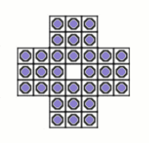 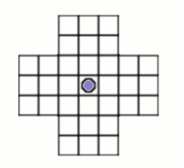

Figure 1.1: Initial State. Figure 1.2: Goal State.

The labels of the slots are as follows:

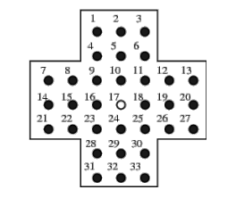

Implement a Java/C/C++ program for solving peg solitaire:

a. Breadth First Search

b. Depth First Search

c. Iterative Deepening Search

d. Depth First Search with Random Selection

e. Depth First Search with a Node Selection Heuristic

1. DESCRIPTIONS OF ALGORITHMS:
   1. Breadth First Search (bfs): is an algorithm for traversing or searching tree or graph data structures. It starts at the tree root (or some arbitrary node of a graph, sometimes referred to as a 'search key'[1]), and explores all of the neighbor nodes at the present depth prior to moving on to the nodes at the next depth level.

For this problem, my bfs algorithm chooses the child node as the most cost-effective descending order from the children who are decreasing in cost.

* 1. Depth First Search (dfs): is an algorithm for traversing or searching tree or graph data structures. The algorithm starts at the root node (selecting some arbitrary node as the root node in the case of a graph) and explores as far as possible along each branch before backtracking.

For this problem, my dfs algorithm chooses the child node as the most cost-effective one from the children who are decreasing in cost.

* 1. Iterative Deepening Search: In computer science, iterative deepening search or more specifically iterative deepening depth-first search[2] (IDS or IDDFS) is a state space/graph search strategy in which a depth-limited version of depth-first search is run repeatedly with increasing depth limits until the goal is found. IDDFS is optimal like breadth-first search, but uses much less memory; at each iteration, it visits the nodes in the search tree in the same order as depth-first search, but the cumulative order in which nodes are first visited is effectively breadth-first.

* 1. Depth First Search with Random Selection:

For this problem, my dfs algorithm chooses the child node randomly.

* 1. Depth First Search with a Node Selection Heuristic:

Two different criteria are taken as the basis for selecting the child node. First is the minimum costed and the second is the most optimal one.

These two criterion is my heuristic function.

This finds optimum solution in 544 milliseconds.

1. ALGORITHM CODES

a.Breadth First Search:

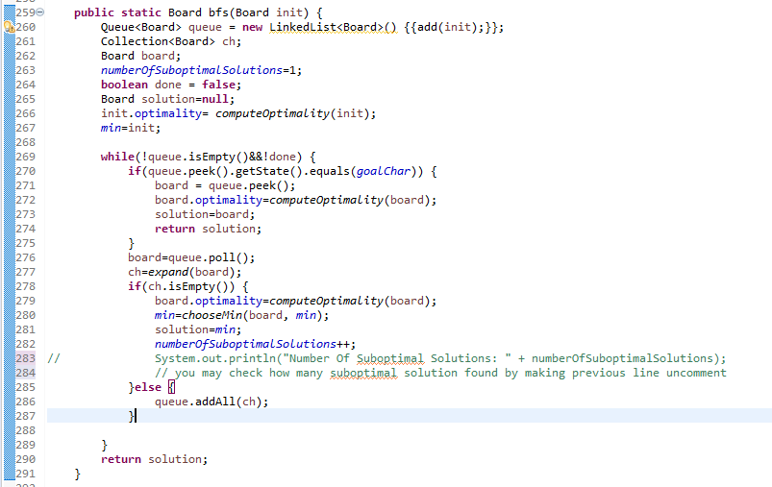

b. Depth First Search:

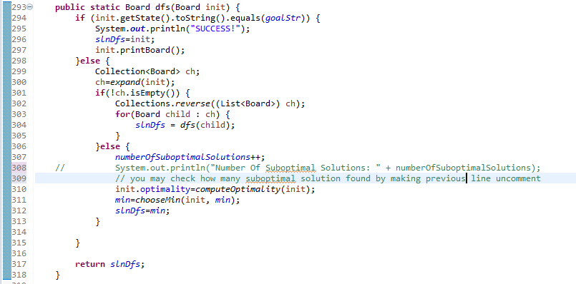

c. Iterative Deepening Depth First Search

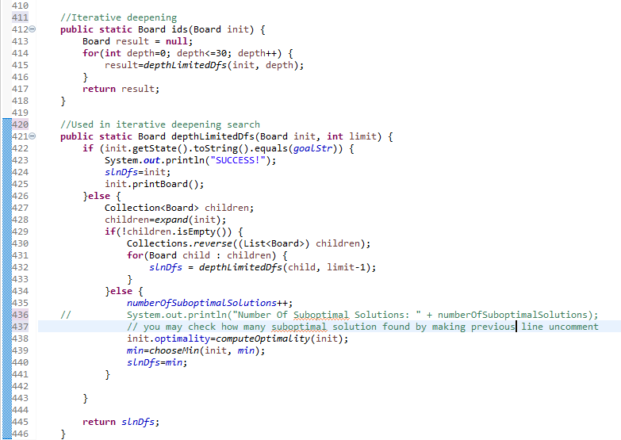

d. Depth First Search With Random Selection:

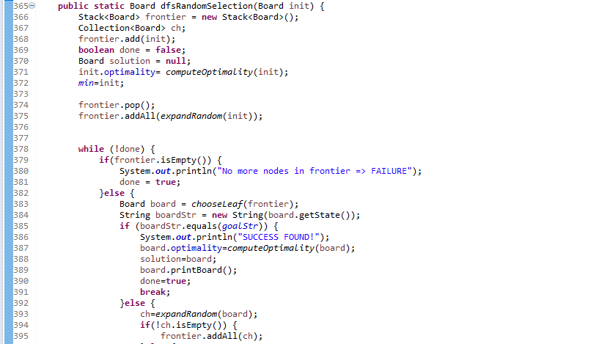

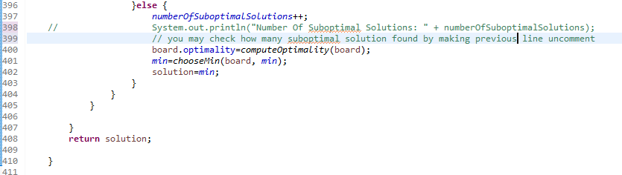

e. Depth First Search with a Node Selection Heuristic:

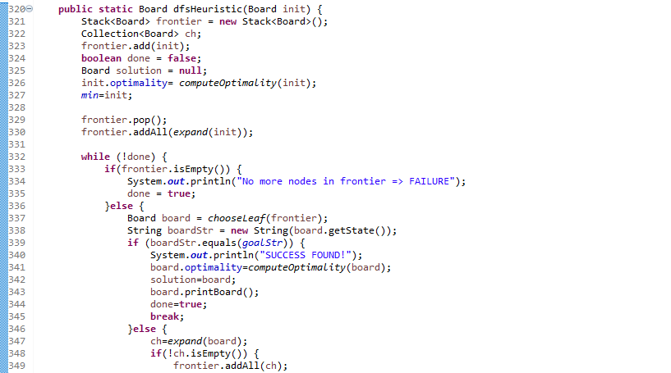

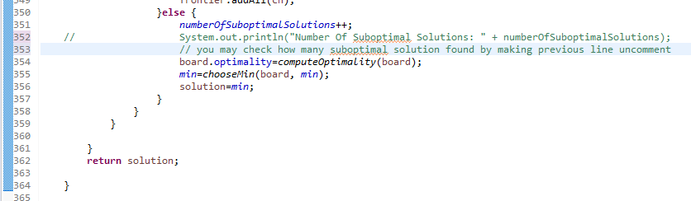

1. MECHANISM & OUTPUTS

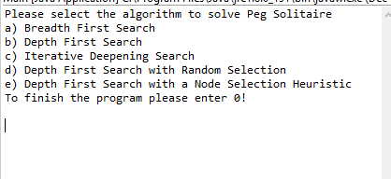

**Let’s select a.**

**This performs Breadth First Search**

OutOfMemory error occured! You will see suboptimum solution!

SUB-OPTIMUM SOLUTION WITH REMAINING 26 PEGS!

time: 482090 milliseconds

x x 1 1 1 x x

x x 1 0 1 x x

1 1 1 1 1 1 1

1 0 1 0 1 0 0

1 1 1 1 1 1 1

x x 1 0 1 x x

x x 1 0 1 x x

STEP 0

x x 1 1 1 x x

x x 1 1 1 x x

1 1 1 1 1 1 1

1 1 1 0 1 1 1

1 1 1 1 1 1 1

x x 1 1 1 x x

x x 1 1 1 x x

STEP 1

x x 1 1 1 x x

x x 1 0 1 x x

1 1 1 0 1 1 1

1 1 1 1 1 1 1

1 1 1 1 1 1 1

x x 1 1 1 x x

x x 1 1 1 x x

STEP 2

x x 1 1 1 x x

x x 1 0 1 x x

1 1 1 1 1 1 1

1 1 1 0 1 1 1

1 1 1 0 1 1 1

x x 1 1 1 x x

x x 1 1 1 x x

STEP 3

x x 1 1 1 x x

x x 1 0 1 x x

1 1 1 1 1 1 1

1 0 0 1 1 1 1

1 1 1 0 1 1 1

x x 1 1 1 x x

x x 1 1 1 x x

STEP 4

x x 1 1 1 x x

x x 1 0 1 x x

1 1 1 1 1 1 1

1 0 1 0 0 1 1

1 1 1 0 1 1 1

x x 1 1 1 x x

x x 1 1 1 x x

STEP 5

x x 1 1 1 x x

x x 1 0 1 x x

1 1 1 1 1 1 1

1 0 1 0 1 0 0

1 1 1 0 1 1 1

x x 1 1 1 x x

x x 1 1 1 x x

STEP 6

x x 1 1 1 x x

x x 1 0 1 x x

1 1 1 1 1 1 1

1 0 1 0 1 0 0

1 1 1 1 1 1 1

x x 1 0 1 x x

x x 1 0 1 x x

**Let’s select b.**

**This performs Depth First Search**

OutOfMemory error occured! You will see suboptimum solution!

SUB-OPTIMUM SOLUTION WITH REMAINING 1 PEGS!

time: 336

x x 0 0 0 x x

x x 0 0 0 x x

0 0 0 0 0 0 0

0 0 0 0 0 0 0

0 0 0 0 0 0 0

x x 0 0 0 x x

x x 0 1 0 x x

STEP 0

x x 1 1 1 x x

x x 1 1 1 x x

1 1 1 1 1 1 1

1 1 1 0 1 1 1

1 1 1 1 1 1 1

x x 1 1 1 x x

x x 1 1 1 x x

STEP 1

x x 1 1 1 x x

x x 1 0 1 x x

1 1 1 0 1 1 1

1 1 1 1 1 1 1

1 1 1 1 1 1 1

x x 1 1 1 x x

x x 1 1 1 x x

STEP 2

x x 1 1 1 x x

x x 1 0 1 x x

1 0 0 1 1 1 1

1 1 1 1 1 1 1

1 1 1 1 1 1 1

x x 1 1 1 x x

x x 1 1 1 x x

STEP 3

x x 0 1 1 x x

x x 0 0 1 x x

1 0 1 1 1 1 1

1 1 1 1 1 1 1

1 1 1 1 1 1 1

x x 1 1 1 x x

x x 1 1 1 x x

STEP 4

x x 1 0 0 x x

x x 0 0 1 x x

1 0 1 1 1 1 1

1 1 1 1 1 1 1

1 1 1 1 1 1 1

x x 1 1 1 x x

x x 1 1 1 x x

STEP 5

x x 1 0 1 x x

x x 0 0 0 x x

1 0 1 1 0 1 1

1 1 1 1 1 1 1

1 1 1 1 1 1 1

x x 1 1 1 x x

x x 1 1 1 x x

STEP 6

x x 1 0 1 x x

x x 0 0 0 x x

1 1 0 0 0 1 1

1 1 1 1 1 1 1

1 1 1 1 1 1 1

x x 1 1 1 x x

x x 1 1 1 x x

STEP 7

x x 1 0 1 x x

x x 0 0 0 x x

0 0 1 0 0 1 1

1 1 1 1 1 1 1

1 1 1 1 1 1 1

x x 1 1 1 x x

x x 1 1 1 x x

STEP 8

x x 1 0 1 x x

x x 0 0 0 x x

0 0 1 0 1 0 0

1 1 1 1 1 1 1

1 1 1 1 1 1 1

x x 1 1 1 x x

x x 1 1 1 x x

STEP 9

x x 1 0 1 x x

x x 1 0 0 x x

0 0 0 0 1 0 0

1 1 0 1 1 1 1

1 1 1 1 1 1 1

x x 1 1 1 x x

x x 1 1 1 x x

STEP 10

x x 0 0 1 x x

x x 0 0 0 x x

0 0 1 0 1 0 0

1 1 0 1 1 1 1

1 1 1 1 1 1 1

x x 1 1 1 x x

x x 1 1 1 x x

STEP 11

x x 0 0 1 x x

x x 0 0 0 x x

0 0 1 0 1 0 0

0 0 1 1 1 1 1

1 1 1 1 1 1 1

x x 1 1 1 x x

x x 1 1 1 x x

STEP 12

x x 0 0 1 x x

x x 1 0 0 x x

0 0 0 0 1 0 0

0 0 0 1 1 1 1

1 1 1 1 1 1 1

x x 1 1 1 x x

x x 1 1 1 x x

STEP 13

x x 0 0 1 x x

x x 1 0 0 x x

0 0 0 0 1 0 0

0 0 1 0 0 1 1

1 1 1 1 1 1 1

x x 1 1 1 x x

x x 1 1 1 x x

STEP 14

x x 0 0 1 x x

x x 1 0 0 x x

0 0 0 0 1 0 0

0 0 1 0 1 0 0

1 1 1 1 1 1 1

x x 1 1 1 x x

x x 1 1 1 x x

STEP 15

x x 0 0 1 x x

x x 1 0 1 x x

0 0 0 0 0 0 0

0 0 1 0 0 0 0

1 1 1 1 1 1 1

x x 1 1 1 x x

x x 1 1 1 x x

STEP 16

x x 0 0 1 x x

x x 1 0 1 x x

0 0 1 0 0 0 0

0 0 0 0 0 0 0

1 1 0 1 1 1 1

x x 1 1 1 x x

x x 1 1 1 x x

STEP 17

x x 0 0 0 x x

x x 1 0 0 x x

0 0 1 0 1 0 0

0 0 0 0 0 0 0

1 1 0 1 1 1 1

x x 1 1 1 x x

x x 1 1 1 x x

STEP 18

x x 0 0 0 x x

x x 1 0 0 x x

0 0 1 0 1 0 0

0 0 0 0 0 0 0

0 0 1 1 1 1 1

x x 1 1 1 x x

x x 1 1 1 x x

STEP 19

x x 0 0 0 x x

x x 1 0 0 x x

0 0 1 0 1 0 0

0 0 0 0 1 0 0

0 0 1 1 0 1 1

x x 1 1 0 x x

x x 1 1 1 x x

STEP 20

x x 0 0 0 x x

x x 0 0 0 x x

0 0 0 0 1 0 0

0 0 1 0 1 0 0

0 0 1 1 0 1 1

x x 1 1 0 x x

x x 1 1 1 x x

STEP 21

x x 0 0 0 x x

x x 0 0 0 x x

0 0 0 0 1 0 0

0 0 1 0 1 0 0

0 0 1 1 1 0 0

x x 1 1 0 x x

x x 1 1 1 x x

STEP 22

x x 0 0 0 x x

x x 0 0 0 x x

0 0 0 0 1 0 0

0 0 1 0 1 0 0

0 0 1 0 0 1 0

x x 1 1 0 x x

x x 1 1 1 x x

STEP 23

x x 0 0 0 x x

x x 0 0 0 x x

0 0 0 0 0 0 0

0 0 1 0 0 0 0

0 0 1 0 1 1 0

x x 1 1 0 x x

x x 1 1 1 x x

STEP 24

x x 0 0 0 x x

x x 0 0 0 x x

0 0 0 0 0 0 0

0 0 1 0 0 0 0

0 0 1 1 0 0 0

x x 1 1 0 x x

x x 1 1 1 x x

STEP 25

x x 0 0 0 x x

x x 0 0 0 x x

0 0 0 0 0 0 0

0 0 1 0 0 0 0

0 1 0 0 0 0 0

x x 1 1 0 x x

x x 1 1 1 x x

STEP 26

x x 0 0 0 x x

x x 0 0 0 x x

0 0 0 0 0 0 0

0 0 1 0 0 0 0

0 1 1 0 0 0 0

x x 0 1 0 x x

x x 0 1 1 x x

STEP 27

x x 0 0 0 x x

x x 0 0 0 x x

0 0 0 0 0 0 0

0 0 1 0 0 0 0

0 1 1 0 0 0 0

x x 0 1 0 x x

x x 1 0 0 x x

STEP 28

x x 0 0 0 x x

x x 0 0 0 x x

0 0 0 0 0 0 0

0 0 0 0 0 0 0

0 1 0 0 0 0 0

x x 1 1 0 x x

x x 1 0 0 x x

STEP 29

x x 0 0 0 x x

x x 0 0 0 x x

0 0 0 0 0 0 0

0 0 0 0 0 0 0

0 1 1 0 0 0 0

x x 0 1 0 x x

x x 0 0 0 x x

STEP 30

x x 0 0 0 x x

x x 0 0 0 x x

0 0 0 0 0 0 0

0 0 0 0 0 0 0

0 0 0 1 0 0 0

x x 0 1 0 x x

x x 0 0 0 x x

STEP 31

x x 0 0 0 x x

x x 0 0 0 x x

0 0 0 0 0 0 0

0 0 0 0 0 0 0

0 0 0 0 0 0 0

x x 0 0 0 x x

x x 0 1 0 x x

**Let’s select c.**

**This performs Iterative Deepening Depth First Search**

OutOfMemory error occured! You will see suboptimum solution!

SUB-OPTIMUM SOLUTION WITH REMAINING 1 PEGS!

time: 1725492

x x 0 0 0 x x

x x 0 0 0 x x

0 0 0 0 0 0 0

0 0 0 0 0 0 0

0 0 0 0 0 0 0

x x 0 0 0 x x

x x 0 1 0 x x

STEP 0

x x 1 1 1 x x

x x 1 1 1 x x

1 1 1 1 1 1 1

1 1 1 0 1 1 1

1 1 1 1 1 1 1

x x 1 1 1 x x

x x 1 1 1 x x

STEP 1

x x 1 1 1 x x

x x 1 0 1 x x

1 1 1 0 1 1 1

1 1 1 1 1 1 1

1 1 1 1 1 1 1

x x 1 1 1 x x

x x 1 1 1 x x

STEP 2

x x 1 1 1 x x

x x 1 0 1 x x

1 0 0 1 1 1 1

1 1 1 1 1 1 1

1 1 1 1 1 1 1

x x 1 1 1 x x

x x 1 1 1 x x

STEP 3

x x 0 1 1 x x

x x 0 0 1 x x

1 0 1 1 1 1 1

1 1 1 1 1 1 1

1 1 1 1 1 1 1

x x 1 1 1 x x

x x 1 1 1 x x

STEP 4

x x 1 0 0 x x

x x 0 0 1 x x

1 0 1 1 1 1 1

1 1 1 1 1 1 1

1 1 1 1 1 1 1

x x 1 1 1 x x

x x 1 1 1 x x

STEP 5

x x 1 0 1 x x

x x 0 0 0 x x

1 0 1 1 0 1 1

1 1 1 1 1 1 1

1 1 1 1 1 1 1

x x 1 1 1 x x

x x 1 1 1 x x

STEP 6

x x 1 0 1 x x

x x 0 0 0 x x

1 1 0 0 0 1 1

1 1 1 1 1 1 1

1 1 1 1 1 1 1

x x 1 1 1 x x

x x 1 1 1 x x

STEP 7

x x 1 0 1 x x

x x 0 0 0 x x

0 0 1 0 0 1 1

1 1 1 1 1 1 1

1 1 1 1 1 1 1

x x 1 1 1 x x

x x 1 1 1 x x

STEP 8

x x 1 0 1 x x

x x 0 0 0 x x

0 0 1 0 1 0 0

1 1 1 1 1 1 1

1 1 1 1 1 1 1

x x 1 1 1 x x

x x 1 1 1 x x

STEP 9

x x 1 0 1 x x

x x 1 0 0 x x

0 0 0 0 1 0 0

1 1 0 1 1 1 1

1 1 1 1 1 1 1

x x 1 1 1 x x

x x 1 1 1 x x

STEP 10

x x 0 0 1 x x

x x 0 0 0 x x

0 0 1 0 1 0 0

1 1 0 1 1 1 1

1 1 1 1 1 1 1

x x 1 1 1 x x

x x 1 1 1 x x

STEP 11

x x 0 0 1 x x

x x 0 0 0 x x

0 0 1 0 1 0 0

0 0 1 1 1 1 1

1 1 1 1 1 1 1

x x 1 1 1 x x

x x 1 1 1 x x

STEP 12

x x 0 0 1 x x

x x 1 0 0 x x

0 0 0 0 1 0 0

0 0 0 1 1 1 1

1 1 1 1 1 1 1

x x 1 1 1 x x

x x 1 1 1 x x

STEP 13

x x 0 0 1 x x

x x 1 0 0 x x

0 0 0 0 1 0 0

0 0 1 0 0 1 1

1 1 1 1 1 1 1

x x 1 1 1 x x

x x 1 1 1 x x

STEP 14

x x 0 0 1 x x

x x 1 0 0 x x

0 0 0 0 1 0 0

0 0 1 0 1 0 0

1 1 1 1 1 1 1

x x 1 1 1 x x

x x 1 1 1 x x

STEP 15

x x 0 0 1 x x

x x 1 0 1 x x

0 0 0 0 0 0 0

0 0 1 0 0 0 0

1 1 1 1 1 1 1

x x 1 1 1 x x

x x 1 1 1 x x

STEP 16

x x 0 0 1 x x

x x 1 0 1 x x

0 0 1 0 0 0 0

0 0 0 0 0 0 0

1 1 0 1 1 1 1

x x 1 1 1 x x

x x 1 1 1 x x

STEP 17

x x 0 0 0 x x

x x 1 0 0 x x

0 0 1 0 1 0 0

0 0 0 0 0 0 0

1 1 0 1 1 1 1

x x 1 1 1 x x

x x 1 1 1 x x

STEP 18

x x 0 0 0 x x

x x 0 0 0 x x

0 0 0 0 1 0 0

0 0 1 0 0 0 0

1 1 0 1 1 1 1

x x 1 1 1 x x

x x 1 1 1 x x

STEP 19

x x 0 0 0 x x

x x 0 0 0 x x

0 0 0 0 1 0 0

0 0 1 0 0 0 0

1 1 1 1 1 1 1

x x 0 1 1 x x

x x 0 1 1 x x

STEP 20

x x 0 0 0 x x

x x 0 0 0 x x

0 0 0 0 1 0 0

0 0 0 0 0 0 0

1 1 0 1 1 1 1

x x 1 1 1 x x

x x 0 1 1 x x

STEP 21

x x 0 0 0 x x

x x 0 0 0 x x

0 0 0 0 1 0 0

0 0 0 0 1 0 0

1 1 0 1 0 1 1

x x 1 1 0 x x

x x 0 1 1 x x

STEP 22

x x 0 0 0 x x

x x 0 0 0 x x

0 0 0 0 1 0 0

0 0 0 0 1 0 0

1 1 0 1 1 0 0

x x 1 1 0 x x

x x 0 1 1 x x

STEP 23

x x 0 0 0 x x

x x 0 0 0 x x

0 0 0 0 1 0 0

0 0 0 0 1 0 0

1 1 0 0 0 1 0

x x 1 1 0 x x

x x 0 1 1 x x

STEP 24

x x 0 0 0 x x

x x 0 0 0 x x

0 0 0 0 1 0 0

0 0 0 0 1 0 0

0 0 1 0 0 1 0

x x 1 1 0 x x

x x 0 1 1 x x

STEP 25

x x 0 0 0 x x

x x 0 0 0 x x

0 0 0 0 0 0 0

0 0 0 0 0 0 0

0 0 1 0 1 1 0

x x 1 1 0 x x

x x 0 1 1 x x

STEP 26

x x 0 0 0 x x

x x 0 0 0 x x

0 0 0 0 0 0 0

0 0 0 0 0 0 0

0 0 1 1 0 0 0

x x 1 1 0 x x

x x 0 1 1 x x

STEP 27

x x 0 0 0 x x

x x 0 0 0 x x

0 0 0 0 0 0 0

0 0 0 0 0 0 0

0 1 0 0 0 0 0

x x 1 1 0 x x

x x 0 1 1 x x

STEP 28

x x 0 0 0 x x

x x 0 0 0 x x

0 0 0 0 0 0 0

0 0 0 0 0 0 0

0 1 0 0 0 0 0

x x 1 1 0 x x

x x 1 0 0 x x

STEP 29

x x 0 0 0 x x

x x 0 0 0 x x

0 0 0 0 0 0 0

0 0 0 0 0 0 0

0 1 1 0 0 0 0

x x 0 1 0 x x

x x 0 0 0 x x

STEP 30

x x 0 0 0 x x

x x 0 0 0 x x

0 0 0 0 0 0 0

0 0 0 0 0 0 0

0 0 0 1 0 0 0

x x 0 1 0 x x

x x 0 0 0 x x

STEP 31

x x 0 0 0 x x

x x 0 0 0 x x

0 0 0 0 0 0 0

0 0 0 0 0 0 0

0 0 0 0 0 0 0

x x 0 0 0 x x

x x 0 1 0 x x

**Let’s select d.**

**This performs Depth First Search with Random Selection**

OutOfMemory error occured! You will see suboptimum solution!

SUB-OPTIMUM SOLUTION WITH REMAINING 5 PEGS!

time: 927743

x x 0 0 0 x x

x x 0 0 0 x x

0 0 0 0 0 0 1

0 0 0 0 0 0 0

1 0 1 0 1 0 1

x x 0 0 0 x x

x x 0 0 0 x x

STEP 0

x x 1 1 1 x x

x x 1 1 1 x x

1 1 1 1 1 1 1

1 1 1 0 1 1 1

1 1 1 1 1 1 1

x x 1 1 1 x x

x x 1 1 1 x x

STEP 1

x x 1 1 1 x x

x x 1 0 1 x x

1 1 1 0 1 1 1

1 1 1 1 1 1 1

1 1 1 1 1 1 1

x x 1 1 1 x x

x x 1 1 1 x x

STEP 2

x x 1 1 1 x x

x x 1 0 1 x x

1 0 0 1 1 1 1

1 1 1 1 1 1 1

1 1 1 1 1 1 1

x x 1 1 1 x x

x x 1 1 1 x x

STEP 3

x x 1 1 1 x x

x x 1 0 1 x x

1 0 1 0 0 1 1

1 1 1 1 1 1 1

1 1 1 1 1 1 1

x x 1 1 1 x x

x x 1 1 1 x x

STEP 4

x x 1 1 1 x x

x x 1 0 1 x x

1 0 1 0 1 0 0

1 1 1 1 1 1 1

1 1 1 1 1 1 1

x x 1 1 1 x x

x x 1 1 1 x x

STEP 5

x x 1 1 1 x x

x x 1 0 1 x x

1 0 1 0 1 0 1

1 1 1 1 1 1 0

1 1 1 1 1 1 0

x x 1 1 1 x x

x x 1 1 1 x x

STEP 6

x x 1 1 1 x x

x x 1 0 1 x x

1 0 1 1 1 0 1

1 1 1 0 1 1 0

1 1 1 0 1 1 0

x x 1 1 1 x x

x x 1 1 1 x x

STEP 7

x x 1 1 1 x x

x x 1 0 1 x x

1 0 1 1 1 0 1

1 1 1 0 1 1 0

1 1 1 0 0 0 1

x x 1 1 1 x x

x x 1 1 1 x x

STEP 8

x x 1 1 1 x x

x x 1 0 1 x x

1 0 1 1 1 0 1

1 1 1 0 1 1 0

1 1 1 0 1 0 1

x x 1 1 0 x x

x x 1 1 0 x x

STEP 9

x x 1 1 1 x x

x x 1 0 1 x x

1 0 1 1 1 0 1

1 1 1 0 1 1 0

1 0 0 1 1 0 1

x x 1 1 0 x x

x x 1 1 0 x x

STEP 10

x x 1 1 1 x x

x x 1 0 1 x x

1 0 1 1 1 0 1

1 1 1 1 1 1 0

1 0 0 0 1 0 1

x x 1 0 0 x x

x x 1 1 0 x x

STEP 11

x x 1 1 1 x x

x x 1 1 1 x x

1 0 1 0 1 0 1

1 1 1 0 1 1 0

1 0 0 0 1 0 1

x x 1 0 0 x x

x x 1 1 0 x x

STEP 12

x x 1 1 1 x x

x x 1 1 1 x x

1 0 1 0 1 0 1

1 1 1 1 0 0 0

1 0 0 0 1 0 1

x x 1 0 0 x x

x x 1 1 0 x x

STEP 13

x x 1 1 1 x x

x x 1 1 1 x x

1 0 1 0 1 0 1

1 1 0 0 1 0 0

1 0 0 0 1 0 1

x x 1 0 0 x x

x x 1 1 0 x x

STEP 14

x x 1 0 1 x x

x x 1 0 1 x x

1 0 1 1 1 0 1

1 1 0 0 1 0 0

1 0 0 0 1 0 1

x x 1 0 0 x x

x x 1 1 0 x x

STEP 15

x x 1 0 1 x x

x x 1 0 1 x x

1 0 1 0 0 1 1

1 1 0 0 1 0 0

1 0 0 0 1 0 1

x x 1 0 0 x x

x x 1 1 0 x x

STEP 16

x x 1 0 1 x x

x x 1 0 1 x x

1 0 1 0 0 1 1

1 1 0 0 0 0 0

1 0 0 0 0 0 1

x x 1 0 1 x x

x x 1 1 0 x x

STEP 17

x x 1 0 0 x x

x x 1 0 0 x x

1 0 1 0 1 1 1

1 1 0 0 0 0 0

1 0 0 0 0 0 1

x x 1 0 1 x x

x x 1 1 0 x x

STEP 18

x x 1 0 0 x x

x x 1 0 0 x x

1 0 1 1 0 0 1

1 1 0 0 0 0 0

1 0 0 0 0 0 1

x x 1 0 1 x x

x x 1 1 0 x x

STEP 19

x x 1 0 0 x x

x x 1 0 0 x x

1 0 1 1 0 0 1

1 1 0 0 0 0 0

1 0 0 0 0 0 1

x x 1 0 1 x x

x x 0 0 1 x x

STEP 20

x x 1 0 0 x x

x x 1 0 0 x x

1 0 1 1 0 0 1

0 0 1 0 0 0 0

1 0 0 0 0 0 1

x x 1 0 1 x x

x x 0 0 1 x x

STEP 21

x x 1 0 0 x x

x x 1 0 0 x x

1 1 0 0 0 0 1

0 0 1 0 0 0 0

1 0 0 0 0 0 1

x x 1 0 1 x x

x x 0 0 1 x x

STEP 22

x x 1 0 0 x x

x x 1 0 0 x x

1 1 0 0 0 0 1

0 0 1 0 0 0 0

1 0 0 0 1 0 1

x x 1 0 0 x x

x x 0 0 0 x x

STEP 23

x x 1 0 0 x x

x x 1 0 0 x x

0 0 1 0 0 0 1

0 0 1 0 0 0 0

1 0 0 0 1 0 1

x x 1 0 0 x x

x x 0 0 0 x x

STEP 24

x x 1 0 0 x x

x x 1 0 0 x x

0 0 0 0 0 0 1

0 0 0 0 0 0 0

1 0 1 0 1 0 1

x x 1 0 0 x x

x x 0 0 0 x x

STEP 25

x x 0 0 0 x x

x x 0 0 0 x x

0 0 1 0 0 0 1

0 0 0 0 0 0 0

1 0 1 0 1 0 1

x x 1 0 0 x x

x x 0 0 0 x x

STEP 26

x x 0 0 0 x x

x x 0 0 0 x x

0 0 1 0 0 0 1

0 0 1 0 0 0 0

1 0 0 0 1 0 1

x x 0 0 0 x x

x x 0 0 0 x x

STEP 27

x x 0 0 0 x x

x x 0 0 0 x x

0 0 0 0 0 0 1

0 0 0 0 0 0 0

1 0 1 0 1 0 1

x x 0 0 0 x x

x x 0 0 0 x x

**Let’s select e.**

**This performs Depth First Search with a Node Selection Heuristic**

SUCCESS FOUND!

x x 0 0 0 x x

x x 0 0 0 x x

0 0 0 0 0 0 0

0 0 0 1 0 0 0

0 0 0 0 0 0 0

x x 0 0 0 x x

x x 0 0 0 x x

**OPTIMUM SOLUTION! found in 489 milliseconds!**

x x 0 0 0 x x

x x 0 0 0 x x

0 0 0 0 0 0 0

0 0 0 1 0 0 0

0 0 0 0 0 0 0

x x 0 0 0 x x

x x 0 0 0 x x

STEP 0

x x 1 1 1 x x

x x 1 1 1 x x

1 1 1 1 1 1 1

1 1 1 0 1 1 1

1 1 1 1 1 1 1

x x 1 1 1 x x

x x 1 1 1 x x

STEP 1

x x 1 1 1 x x

x x 1 0 1 x x

1 1 1 0 1 1 1

1 1 1 1 1 1 1

1 1 1 1 1 1 1

x x 1 1 1 x x

x x 1 1 1 x x

STEP 2

x x 1 1 1 x x

x x 1 0 1 x x

1 0 0 1 1 1 1

1 1 1 1 1 1 1

1 1 1 1 1 1 1

x x 1 1 1 x x

x x 1 1 1 x x

STEP 3

x x 0 1 1 x x

x x 0 0 1 x x

1 0 1 1 1 1 1

1 1 1 1 1 1 1

1 1 1 1 1 1 1

x x 1 1 1 x x

x x 1 1 1 x x

STEP 4

x x 1 0 0 x x

x x 0 0 1 x x

1 0 1 1 1 1 1

1 1 1 1 1 1 1

1 1 1 1 1 1 1

x x 1 1 1 x x

x x 1 1 1 x x

STEP 5

x x 1 0 1 x x

x x 0 0 0 x x

1 0 1 1 0 1 1

1 1 1 1 1 1 1

1 1 1 1 1 1 1

x x 1 1 1 x x

x x 1 1 1 x x

STEP 6

x x 1 0 1 x x

x x 0 0 0 x x

1 1 0 0 0 1 1

1 1 1 1 1 1 1

1 1 1 1 1 1 1

x x 1 1 1 x x

x x 1 1 1 x x

STEP 7

x x 1 0 1 x x

x x 0 0 0 x x

0 0 1 0 0 1 1

1 1 1 1 1 1 1

1 1 1 1 1 1 1

x x 1 1 1 x x

x x 1 1 1 x x

STEP 8

x x 1 0 1 x x

x x 0 0 0 x x

0 0 1 0 1 0 0

1 1 1 1 1 1 1

1 1 1 1 1 1 1

x x 1 1 1 x x

x x 1 1 1 x x

STEP 9

x x 1 0 1 x x

x x 1 0 0 x x

0 0 0 0 1 0 0

1 1 0 1 1 1 1

1 1 1 1 1 1 1

x x 1 1 1 x x

x x 1 1 1 x x

STEP 10

x x 0 0 1 x x

x x 0 0 0 x x

0 0 1 0 1 0 0

1 1 0 1 1 1 1

1 1 1 1 1 1 1

x x 1 1 1 x x

x x 1 1 1 x x

STEP 11

x x 0 0 1 x x

x x 0 0 0 x x

0 0 1 0 1 0 0

0 0 1 1 1 1 1

1 1 1 1 1 1 1

x x 1 1 1 x x

x x 1 1 1 x x

STEP 12

x x 0 0 1 x x

x x 1 0 0 x x

0 0 0 0 1 0 0

0 0 0 1 1 1 1

1 1 1 1 1 1 1

x x 1 1 1 x x

x x 1 1 1 x x

STEP 13

x x 0 0 1 x x

x x 1 0 0 x x

0 0 0 0 1 0 0

0 0 1 0 0 1 1

1 1 1 1 1 1 1

x x 1 1 1 x x

x x 1 1 1 x x

STEP 14

x x 0 0 1 x x

x x 1 0 0 x x

0 0 0 0 1 0 0

0 0 1 0 1 0 0

1 1 1 1 1 1 1

x x 1 1 1 x x

x x 1 1 1 x x

STEP 15

x x 0 0 1 x x

x x 1 0 1 x x

0 0 0 0 0 0 0

0 0 1 0 0 0 0

1 1 1 1 1 1 1

x x 1 1 1 x x

x x 1 1 1 x x

STEP 16

x x 0 0 0 x x

x x 1 0 0 x x

0 0 0 0 1 0 0

0 0 1 0 0 0 0

1 1 1 1 1 1 1

x x 1 1 1 x x

x x 1 1 1 x x

STEP 17

x x 0 0 0 x x

x x 1 0 0 x x

0 0 1 0 1 0 0

0 0 0 0 0 0 0

1 1 0 1 1 1 1

x x 1 1 1 x x

x x 1 1 1 x x

STEP 18

x x 0 0 0 x x

x x 0 0 0 x x

0 0 0 0 1 0 0

0 0 1 0 0 0 0

1 1 0 1 1 1 1

x x 1 1 1 x x

x x 1 1 1 x x

STEP 19

x x 0 0 0 x x

x x 0 0 0 x x

0 0 0 0 1 0 0

0 0 1 0 0 0 0

0 0 1 1 1 1 1

x x 1 1 1 x x

x x 1 1 1 x x

STEP 20

x x 0 0 0 x x

x x 0 0 0 x x

0 0 0 0 1 0 0

0 0 1 0 1 0 0

0 0 1 1 0 1 1

x x 1 1 0 x x

x x 1 1 1 x x

STEP 21

x x 0 0 0 x x

x x 0 0 0 x x

0 0 0 0 1 0 0

0 0 1 0 1 0 0

0 0 1 1 1 0 0

x x 1 1 0 x x

x x 1 1 1 x x

STEP 22

x x 0 0 0 x x

x x 0 0 0 x x

0 0 0 0 1 0 0

0 0 1 0 1 0 0

0 0 1 0 0 1 0

x x 1 1 0 x x

x x 1 1 1 x x

STEP 23

x x 0 0 0 x x

x x 0 0 0 x x

0 0 0 0 0 0 0

0 0 1 0 0 0 0

0 0 1 0 1 1 0

x x 1 1 0 x x

x x 1 1 1 x x

STEP 24

x x 0 0 0 x x

x x 0 0 0 x x

0 0 0 0 0 0 0

0 0 1 0 0 0 0

0 0 1 1 0 0 0

x x 1 1 0 x x

x x 1 1 1 x x

STEP 25

x x 0 0 0 x x

x x 0 0 0 x x

0 0 0 0 0 0 0

0 0 1 0 0 0 0

0 1 0 0 0 0 0

x x 1 1 0 x x

x x 1 1 1 x x

STEP 26

x x 0 0 0 x x

x x 0 0 0 x x

0 0 0 0 0 0 0

0 0 1 0 0 0 0

0 1 1 0 0 0 0

x x 0 1 0 x x

x x 0 1 1 x x

STEP 27

x x 0 0 0 x x

x x 0 0 0 x x

0 0 0 0 0 0 0

0 0 0 0 0 0 0

0 1 0 0 0 0 0

x x 1 1 0 x x

x x 0 1 1 x x

STEP 28

x x 0 0 0 x x

x x 0 0 0 x x

0 0 0 0 0 0 0

0 0 0 0 0 0 0

0 1 0 0 0 0 0

x x 1 1 0 x x

x x 1 0 0 x x

STEP 29

x x 0 0 0 x x

x x 0 0 0 x x

0 0 0 0 0 0 0

0 0 0 0 0 0 0

0 1 1 0 0 0 0

x x 0 1 0 x x

x x 0 0 0 x x

STEP 30

x x 0 0 0 x x

x x 0 0 0 x x

0 0 0 0 0 0 0

0 0 0 0 0 0 0

0 0 0 1 0 0 0

x x 0 1 0 x x

x x 0 0 0 x x

STEP 31

x x 0 0 0 x x

x x 0 0 0 x x

0 0 0 0 0 0 0

0 0 0 1 0 0 0

0 0 0 0 0 0 0

x x 0 0 0 x x

x x 0 0 0 x x

1. REFERENCES
   1. All the informations on the problem definition part is taken from the given homework document.