Quickstart sample, Latest commit 87ad8f5 18 days ago

To set up follow the steps here:

<https://angular.io/docs/ts/latest/guide/setup.html>

1. Install node v4.x.x or higher. Node powers client development and build tools. You can check by running node -v
2. Install npm npm 3.x.x or higher. The npm package manager, itself a node application, installs JavaScript libraries. You can check by running npm -v
3. Clone or download the project located at : <https://github.com/angular/quickstart>
4. Run npm install and npm start

(Maintained by angular.io, great start for any project, up to date)

Explain index.html has:

<my-app>Loading AppComponent content here ...</my-app>

Tag my-app is in app.component.ts. Change “Angular”to Eren”. Page updates.

# Create an http call

src/app/person.ts is all new. It is a semi-POJO for the data

src/app/people.service.ts is all new. Explain what a service does.

Changes in app.component.ts.

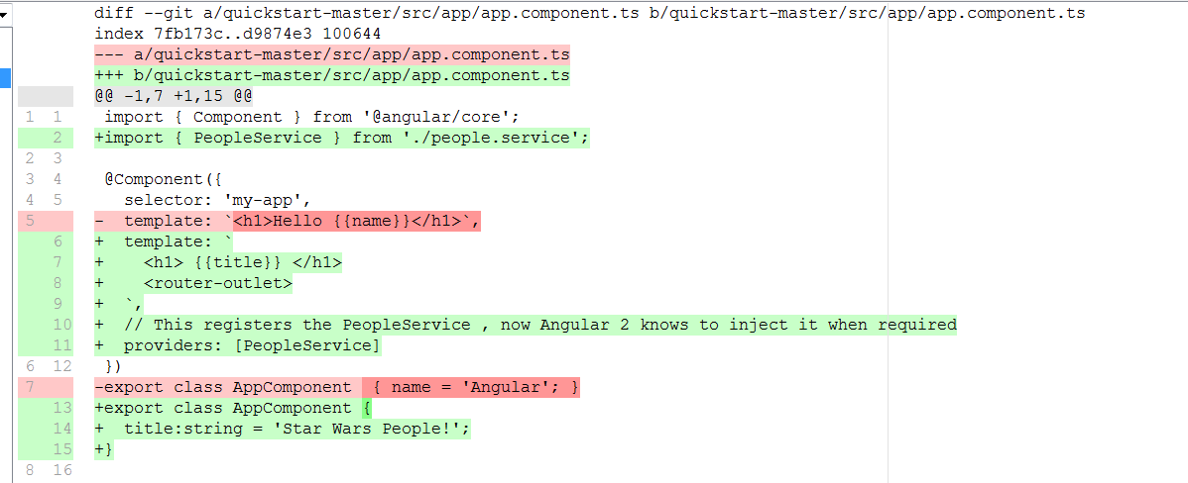

src/app/app.routes.ts is all new. Explain what routes are.

Changes to app.module.ts:

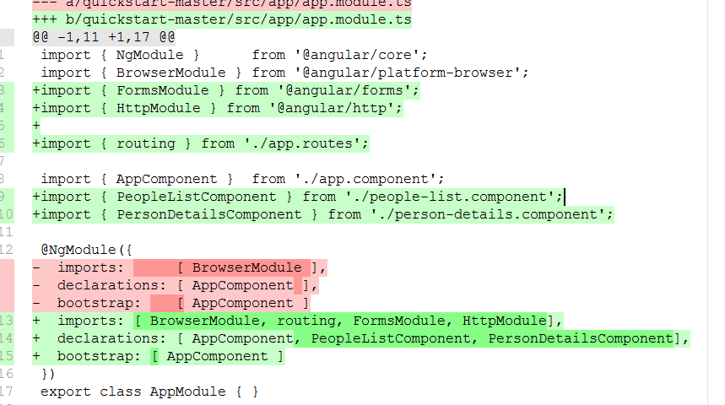

src/app/people-list.component.html is all new. It is the template that displays the list of customer

src/app/people-list.component.ts is all new uses the template src/app/people-list.component.html

src/app/person-details.component.html is all new. It is the template the displays detail data

src/app/person-details.component.ts is all new, uses the template src/app/person-details.component.html

Presentation based on:

https://www.barbarianmeetscoding.com/blog/2016/04/02/getting-started-with-angular-2-step-by-step-6-consuming-real-data-with-http/