Numerical study of two-dimensional flows under constant external influence based on Euler and Navier-Stokes models

Dr. Svetlana V. Fortova1[0000-0001-7444-9925], Dr. Vladimir V. Denisenko1[0000-0003-3324-897X] and Dr. Alexey N. Doludenko2[0000-0003-2211-3826]

1 Institute of Computer Aided Design of the Russian Academy of Sciences, 19/18 Vtoraya Brestskaya st., Moscow 123056, Russia

2 Joint Institute for High Temperatures of the Russian Academy of Sciences (JIHT RAS), 13 Bd.2, Izhorskaya st., Moscow 125412, Russia   
sfortova@mail.ru

**Abstract.** In this paper, the Kolmogorov type flow described by the equations of motion of an inviscid medium is studied. The research was carried out using direct numerical modeling methods. To solve the problem, we used the numerical method of the simplest Godunov linearization [14], developed by the authors. The instability of the considered flows is obtained. In the process of establishing the secondary regime of the considered flows, a reverse cascade of energy transfer was observed.

**Keywords:** 2D turbulence, reverse energy cascade, direct numerical modelling.

# Introduction

The study of the stability of laminar flow in relation to small perturbations that always exist in nature is of particular interest for both theoretical research and practical application [1]. This is due to the fact that the explanation of various complex fluid movements, as well as the problem of large-scale eddy currents are associated with stability issues [1, 2].

This article will focus on the study of the formation of two-dimensional turbulence. The stability of flows under the influence of a periodic external force will be considered. In the two-dimensional case, non-linearity leads to the appearance of movements whose scales significantly exceed the “pumping” scale (the pumping scale refers to the wavelength of the external force) with the appearance of large coherent structures [3]. Energy can be distributed in the reverse cascade (from small structures to large ones) according to the Kreichnan law -5/3 [4, 3], and also transferred from the pumping scale to the small scale (direct cascade) with the law -3 due to enstrophy dissipation. The study of spectral and statistical characteristics of two-dimensional turbulence can be found in [5-10].

The reverse cascade in two-dimensional turbulence has been studied experimentally [11] and numerically [12, 13]. A feature of these studies is the occurrence of intense large-scale movements, including large vortices.

The paper presents the results of direct numerical simulation of the occurrence of a reverse energy transfer cascade of secondary flow pulsations resulting from the overturning of the Kolmogorov type flow. The novelty of the work consists in the fact that usually the Kolmogorov flow is understood as the study of a viscous medium. Based on the hypotheses and methods proposed by O. M. Belotserkovsky [1], we will try to obtain similar results without introducing viscosity into our model. The interest in this case is to compare the results of studies of viscous and non-viscous models.

# Problem statement

Consider an ideal medium described by the equations of motion of an inviscid fluid - Euler's equations. We will impose an external force acting along the axis *Ox* and periodic along *Oy* with the frequency *k*:

*∂ρ∕∂t + ∂(ρu)/∂x + ∂(ρv)/∂y = 0,*

*∂(ρu)∕∂t + ∂(ρu2)/∂x + ∂(ρuv)/∂y = - ∂p/∂x + ρGsin(ky),* (1)

*∂(ρv)∕∂t + ∂(ρuv)/∂x + ∂(ρv2)/∂y = - ∂p/∂y,*

*∂(ρ(u2 + v2)/2 + ρe)∕∂t + ∂[u(ρ(u2 + v2)/2 + ρe + p)]/∂x + ∂[v(ρ(u2 + v2)/2 + ρe + p)]/∂y = 0,*

*p = (γ - 1)ρe*

We close the system (1) with the equation of state of the ideal medium. We will be interested in two tasks:

Problem 1. The reverse cascade resulting from the instability of the Kolmogorov flow in the supercritical mode [1]. To obtain this type of flow, the following task was set.  
 A rectangular area with periodic boundary conditions was considered

*(ρ, u, v, p)|x = 0 = (ρ, u, v, p)|x = Lx*

*(ρ, u, v, p)|y = 0 = (ρ, u, v, p)|y = Ly*

Here, the dimensions *Lx, Ly* of the calculated area along the axes *x, y* respectively. The initial distribution of the components of the velocity, pressure and density:

*u = sin(y) + 0.1sin(y) + 0.001sin(x/2),*

*v = 0.01sin(y) + 0.001sin(x/2),* (2)

*p = 104 Pa, ρ = 1 kg/m3*

Put in (1) *Lx/Ly = 2.5, G = 100, k = 1.* This statement of the problem is called  
  
"supercritical Kolmogorov flow" due to the high intensity of the external force [1]. The dimension of the grid covering the calculated area was *nx × ny = 200 × 200*.

Problem 2. The reverse cascade resulting from the instability of the flow set in a square cell with walls and the following statement. As initial conditions, consider the flow described by the velocity field

*u(t = 0) = 0.1sin(10y)*

*v(t = 0) = - 0.1sin(10x)* (3)

We will put the density of the medium *ρ = 1 kg/m3*, we will "turn off" the external force *G = 0*, i.e. we will put the pressure *p = 103 Па*. Dimension of the grid *nx × ny = 250 × 250*.

# Numerical method

For the numerical solution of the problem (1)-(3), the simplest linearization of the Godunov scheme [14], developed by the authors, was used. The difference between this method and the classical Godunov scheme, which uses an exact solution of the Riemann problem when calculating flows on cell faces, is less computational complexity. A special feature is the recording of the law of conservation of energy in the defining system equations through entropy.

It is based on the fact that certain quantities, called Riemann invariants, are carried along the characteristics without changes. Thus, the calculation of flows on the faces of cells in the computational grid is based on the calculation of Riemann invariants on the previous time layer. It has been experimentally shown that this variant of the scheme has the property of guaranteed non-decreasing entropy, which makes it possible to model its growth on shock waves without any corrections and additional conditions. The calculations used a scheme of the first order of accuracy.  
Next, we will briefly describe the computational method used in a one-dimensional setting. A two-dimensional scheme is obtained by such reasoning.

The step *τn + 1/2 = tn - tn - 1* between successive time steps during the solution calculation is calculated according to a specific scheme. In the initial time *t = tn* in each grid cell *xj – 1 < x < x j* the values *ρnj - 1/2, unj - 1/2, pnj - 1/2,* are specified, it is assumed that they are in each grid cell is constant.

After that, the auxiliary values *cj - 1/2 = (γpj – 1/2/ρj - 1/2)1/2* and *σj –1/2 = pj – 1/2 / (ρj - 1/2)γ* (the speed of sound and the entropy variable) are calculated in each cell. The calculation begins with determining the values *Ujn + 1/2*, *Pjn + 1/2* , *Rjn + 1/2*, at the cell boundaries *xj*, which are assumed to be constant at the time *t* of the interval *tn < t < tn - 1*. We propose:

*Pjn + 1/2=(pj – 1/2n/(ρj – 1/2ncj – 1/2n) + pj – 1/2n/(ρj + 1/2ncj + 1/2n) + uj – 1/2n - uj + 1/2n)/(1/(ρj – 1/2ncj – 1/2n) + 1/(ρj + 1/2ncj + 1/2n)),*

*Ujn + 1/2=(ρj – 1/2ncj – 1/2nuj – 1/2n + ρj + 1/2ncj + 1/2nuj + 1/2n + pj – 1/2n - pj + 1/2n)/(ρj – 1/2ncj – 1/2n + ρj + 1/2ncj + 1/2n),*

These formulas for *Ujn + 1/2* and *Pjn + 1/2* are a consequence of the constancy at the considered time step of Riemann invariants in cells adjacent to the boundary *xj*. This constancy is approximated by equalities

*uj ± 1/2n ± pj ± 1/2n/(ρj ± 1/2ncj ± 1/2n) = Ujn + 1/2 ± Pj ± 1/2n/(ρj ± 1/2ncj ± 1/2n)*

which are equivalent to the above formulas. The density values *Rjn + 1/2* at the boundary point *xj* are defined by the formulas

*Rjn + 1/2 = ρj – 1/2n(1 - (Ujn + 1/2 - uj – 1/2n)/cj - 1/2n), if Ujn + 1/2 > 0,*

*Rjn + 1/2 = ρj + 1/2n(1 - (uj+1/2n - Ujn + 1/2)/cj + 1/2n), if Ujn + 1/2 < 0,*

These formulas are obtained by considering the third invariant along which entropy is transferred: *ρ - p/(ρc2)*.

# Results

Let's consider the results of solving the problem (1)-(2), which are presented in Fig. 1. Here the vorticity Ω = *∂v/∂x - ∂u/∂y* distribution is shown, and the calculation time for which this flow pattern was formed is given.

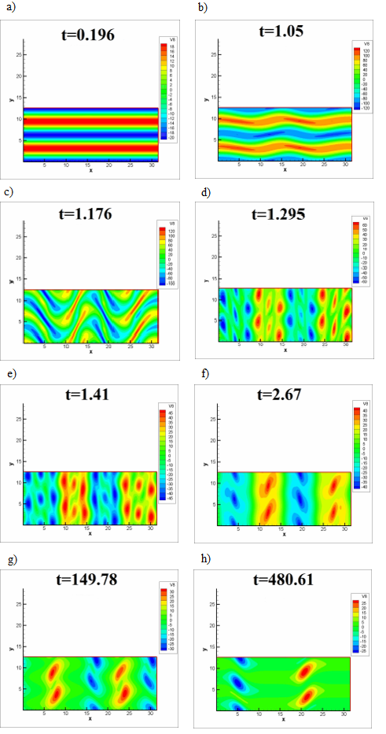**Fig.** **1****.** Numerical solution of the problem (1)-(2). the Reverse cascade resulting from perturbation of the Kolmogorov flow transcritical regime. Figures a)-h) show the vorticity of the flow Ω = *∂v/∂x - ∂u/∂y*. Each figure shows the calculation time *t*.

It can be seen that instability occurs and the flow goes into a vortex mode, with a sufficiently large number of vortices. There is a so-called direct cascade, when the initial vorticity is concentrated in a limited area (first it is a band, then you can distinguish the origin of several relatively large vortices, which then divide into several pieces).  
 If we look at the picture of the vorticity distribution at the intermediate and final stages of the calculation in Fig. 1, we will see the reverse cascade of energy transfer. Several vortices initially present in the flow merge with each other and at the end of calculations there are 4 vortices with zero total vorticity (Fig. 1 h)).

Fig. 2 shows the results of solving the problem (1), (3).

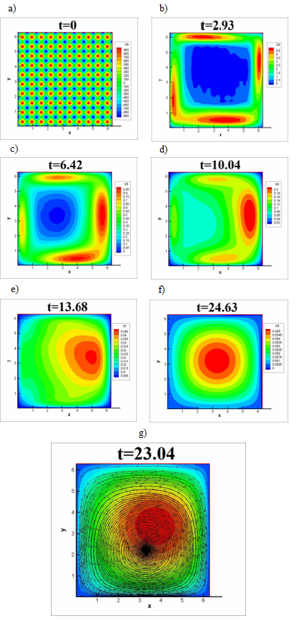**Fig.** **2****.** Numerical solution of the problem (1), (3). Reverse cascade in the absence of an external force. Figures a)-g) show the vorticity of the flow Ω = *∂v/∂x - ∂u/∂y*. Each figure shows the calculation time *t*. Figure g) shows the current lines.

In this setting, due to the presence of walls, we can observe a reverse cascade in the absence of an external force. Here we see that in the initial formulation there are several small vortices, which by the end of calculations turn into one large vortex with dimensions of the order of the size of the calculated area.

Fig. 3 shows the dependence of the flow velocity and its tangential component on the radius of the vortex. The point with the maximum value of vorticity was taken as the center of the vortex.

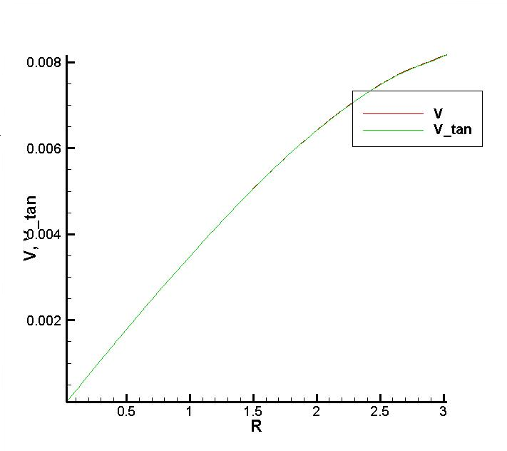

**Fig.** **3****.** Graph of the dependence of the flow velocity *V* and its tangential component *V_tan* on the radius of the vortex *R*.

As you can see, the speed and its tangential component coincide and in the area of the center of the vortex have a linear dependence on the radius, *V(r) = ωr ≡ Vτ(r)*. Coordinates of the vortex center *xv = 3.066, yv = 3.268*.

# Conclusion

In this paper, secondary modes of Kolmogorov flow and flow in a square cell with non-flowing walls are studied. The novelty of the work consists in the fact that models of inviscid flows were studied. For the numerical solution of this problem, the method of the simplest Godunov linearization [14], developed by the authors of this paper, was chosen.

The reverse cascade of the Kolmogorov flow is obtained. It should be noted that to obtain the reverse cascade, one should perturb the Kolmogorov flow in the transcritical mode [1]. The reverse cascade is observed when small vortices formed as a result of instability of the original flow begin to interact with each other and merge into larger ones.

In the problem of studying the flow in a square cell, the reverse cascade is observed even in the absence of an external force. The initial flow is a type described as (3). If we go to vorticity, then in Fig. 2 shows its initial distribution as a set of small vortices. By the end of the calculations, it is clear that there remains one vortex of the order of the characteristic cell size. At the same time, in the area of the vortex center, the flow velocity has a linear dependence on the radius and only a tangential component.

# References

1. Belotserkovskii, O.M., Oparin, A.M.: Numerical experiment: from order to chaos. Nauka, Moscow (2000).

2. Landau, L.D., Lifshits, E.M.: Hydrodynamics. Gostekhteorizdat (1953).

3. Frick, P.G.: Turbulence: models and approaches, part 2. Perm, P. 136 (1999).

4. Kraichnan, R.H.: Inertial Ranges in Two-Dimensional Turbulence. Phys. Fluids 10, 1417 (1967).

5. Kuznetsov, E.A., Sereschenko, E.V.: Isotropization of two-dimensional hydrodynamic turbulence in a direct cascade. JETP Letters, Vol. 105, issue 2, P. 70-76.  
6. Orlov, A.V., Brazhnikov, M.Yu., Levchenko, A.A.: Formation of a large-scale coherent vortex in two-dimensional turbulence. JETP Letters, Vol. 107, issue 3, P. 166-171.

7. Kolokolov, I.V., Lebedev, V.V.: Large-scale flow in two-dimensional turbulence at static pumping. JETP Letters, Vol. 106, issue 10, P. 659-661 (2017).

8. Kolokolov, I.V., Lebedev, V.V.: Velocity statistics inside coherent vortices generated by the inverse cascade of 2-d turbulence. JETP Letters, Vol. 809, P. 809 (2016).

9. Kolokolov, I.V., Lebedev, V.V.: Structure of coherent vortices generated by the inverse cascade of two-dimensional turbulence in a finite box. Physical Review E, Vol. 93, issue 3, P. 033104 (2016).

10. Laurie, J., Falkovich, G., Boffetta, G., Kolokolov, I., Lebedev, V.: Universal profile of the vortex condensate in two-dimensional turbulence. Physical Review Letters, Vol. 113, issue 25, P. 254503 (2014).

11. Sommeria, J. J.: Experimental study of the two-dimensional inverse energy cascade in a square box. Fluid Mech. 170, 139-168 (1986).

12. Smith, L.M., Yakhot, V.: Finite-size effects in forced two-dimensional turbulence. J. Fluid Mech. 274, 115-138 (1994).

13. Boffetta, G., Celani, A., Vergassola, M.: Inverse energy cascade in two-dimensional turbulence: Deviations from Gaussian behavior. Phys. Rev.  E 61, R29 (2000).

14. Godunov, S.K., Klyuchinskii, D.V., Fortova, S.V., Shepelev, V.V.: Experimental studies of difference gas dynamics models with shock waves, Comput. Math. Math. Phys., 58:8, 1201–1216 (2018).