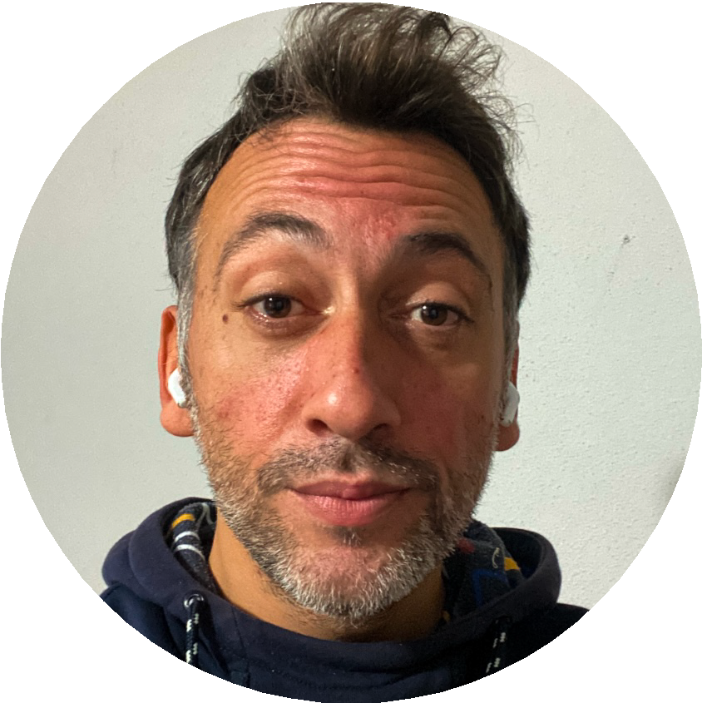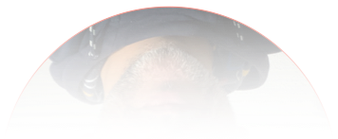

# EMIN BUGRA SARAL

[**www.linkedin.com/in/ebsaral**](https://www.linkedin.com/in/ebsaral)

## Senior Consultant

**Leadership | Culture | Visionary Solutions**

## Artist & Activist

**Lyrical Harmony | Evolution | Equality | Action**

**Location: Trabzon, Türkiye** [**eminbugrasaral@me.com**](mailto:eminbugrasaral@me.com) **| +90 532 258 0093**

# WORK EXPERIENCE

**Senior Consultant**

###### Preferred Work Titles Spirit Guide, Team Lead, People Manager, Project Manager, Product Manager,

###### Engineering Manager, Solutions Engineer.

###### Management Skills

Team leadership, technical strategy, team guidance, personal development, event organization, communication skills, risk management, recruitment & hiring, performance tracking, resource allocation, conflict resolution, cross-functional teamwork, stakeholder engagement, market research, user research, feature prioritization, roadmap planning, agile methodologies, product launches, data analysis, continuous feedback cycle…

### FINN

Munich, Germany — 04.2021 - 04.**2023** (2 years)

*Car Subscription Platform*

**Senior Software Engineer***(visit LinkedIn for more info)*

* Developed backend and frontend services.
* Onboarded and guided new team members.
* Built automations to ease some workflows.
* Led the team in some cross-department projects.
* Contributed to blog posts and open-source libs.
* Became the city guide for some employees.
* Led the necessary amount of fun in events.
* Became the voice of teammates when it’s needed.
* Represented the company in community events.
* Pushed the managers for ethical and fair decisions.

### 3megawatt

Munich, Germany — 10.2016 - 07.**2019** (~ 2.5 years)

*SaaS for Solar Asset Management*

**Team Leader & Senior Software Engineer**

* Maintained codebase and its backend services.
* Onboarded and guided new team members.
* Led a team of several developers and projects.
* Became the city guide for some employees.
* Organized several indoors and outdoors events with and for teammates.
* Represented the company in tech events.
* Became the voice of every employee when it’s needed.
* Designed and contributed to company-wide employee policies.



### Volt Ridesharing

Istanbul, Türkiye — 09.2015 - 10.**2016** (~ 1 year)

*Mobile App for Ride Sharing*

**Senior Software Engineer**

* + Developed backend services.
  + Onboarded and trained new team members.
  + Guided team members for their life struggles.
  + Introduced team members to various cultures and experiences in the city.
  + Represented the company in tech events.

### MovieLaLa

San Francisco, USA — 11.2014 - 09.**2015** (~ 1year)

*Mobile App for Trailers*

**Software Engineer**

* + - Developed backend and mobile services.
    - Guided team members for their career and life struggles.
    - Represented the company in community and tech events.
    - Led discussions for employee rights.

# LIFE EXPERIENCE

**Artist & Activist**

**Favorite Personality Traits**

Empath, creative, (mostly) direct, honest, outgoing,   
fun & humorous, kind, helpful, solution oriented, educative, innovative, witty, curious, visionary, logical, emotional, debater, fast learner, adventurous, spontaneous, authentic, extrovert, cosmopolitan...

**Values**

Seeking Truth. Equality & Freedom.

#### Active Interests & Talents

Social sciences, engineering, logical spirituality, creative writing *(poem, article, story)*, music *(almost all genres)*, freestyle dancing, clubbing, acting, creative cooking, team sports, driving, biking, painting, movies, criticism, activism, picky reading, detailed impersonation, nature synchronization, attention to details, continuous growth...

**Spoken Languages:** Turkish, English (fluent).

# 

# FORMAL EDUCATION

### Koç University

##### Istanbul, Türkiye — 2013 (prep + 4 years) Bachelor of Science Computer Engineering

Clubs: Computer, Drama, Management Memberships: ACM Student Chapter

We think too much, and feel too little.  
**More than machinery,  
we need humanity.**  
More than cleverness,  
we need kindness and gentleness.

* Charlie Chaplin

### BEM - Bordeaux Management School

##### Bordeaux, France — 2013 (5 months) Exchange Student

Business & Marketing courses

Main Topics: International Project Development, Human Resources, Marketing