ATTUNE
Couple Typing Framework
4 Individual Types • 10 Couple Pairings • Design Document v2

The Framework
Rather than hand-crafting a fixed library of couple types, this framework derives couple types from individual designations. Each person receives one of four individual types. The couple type is then a function of the two individual types — a lookup, not a separate construct. This makes the system clean, maintainable, and harder to game.

Two Axes, Four Types
Each individual type is defined by position across two independent behavioural axes:

- Engage ↔ Withdraw — how someone responds when tension enters the relationship. Do they move toward resolution, or do they need space before the conversation is possible?
- Open ↔ Guarded — how freely someone’s interior life surfaces. Do feelings and reactions come out readily, or are they processed privately first?

These two axes form a 2×2 grid. Every person falls somewhere in that space. The four quadrant types represent the four dominant orientations. People who score near the centre of either axis aren’t assigned a fifth ‘balanced’ type — they are plotted at their actual position, which shows up visually in the Couple Map as sitting close to an axis line. Their coordinates are the information, not a category label.

 | Open (expressive, visible) | Guarded (internal, private)
Engage (moves toward resolution) | Type W — The Reacher | Type X — The Driver
Withdraw (needs space first) | Type Y — The Feeler | Type Z — The Quiet One

Why these two axes? They map to the two dimensions that relationship research identifies as most predictive of couple friction: the conflict timing mismatch (Engage vs. Withdraw) and the communication gap (Open vs. Guarded). Every other behavioural dimension in the exercise is either downstream of these two or adds nuance to them.

Why plot positions and not buckets? Two people can both be typed as W (The Reacher) but sit very differently within that quadrant — one close to the centre line, one at the extreme. The couple map shows this. A W who scores 3.6 on both axes is a very different partner dynamic than a W who scores 4.8. The coordinates carry information that a label alone discards.

The Couple Map
The primary visual output is a 2×2 axis chart showing where each partner sits in the space. Two dots. One chart. The distance between them, the quadrants they occupy, and their proximity to the axis lines all carry meaning.

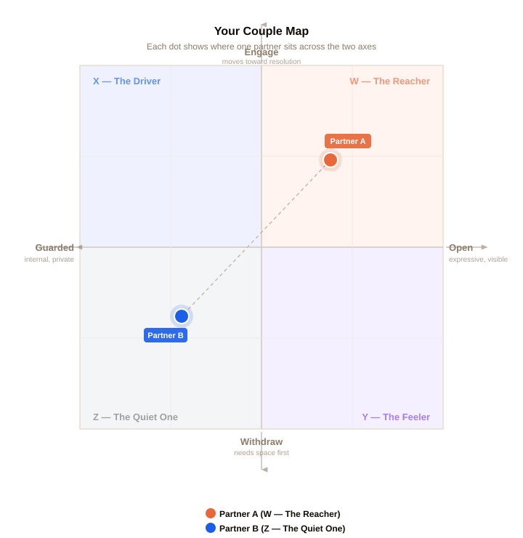

What to notice | What it means
Same quadrant | Both partners share the same dominant orientation. The pairing is same-type. Dynamics tend toward amplification of shared strengths and shared risks.
Adjacent quadrants | Partners share one axis and diverge on the other. The agreement creates common ground; the difference creates a specific, nameable friction point.
Diagonal quadrants | Partners diverge on both axes simultaneously. The widest contrast pairings (W×Z, X×Y). Both the conflict timing and the expressiveness gap need to be named.
Dot near axis line | That partner is closer to balanced on that dimension. Their type label is still accurate, but less dominant — they’re more flexible on that axis than their quadrant partner might be.
Dots close together | Scores are similar, possibly within the same quadrant. High compatibility on these axes — look to the other dimensions for where the differences live.
Dots far apart | Significant divergence. The couple map is making the gap visible. This is where the conversation starts.

The Four Individual Types
Each type is named for its most observable quality — what the person does in the relationship, not what they are as a person. The names are functional, not clinical. No type is better or worse than another.

W | The Reacher  Reaches toward people, reaches toward resolution.  Engage/Withdraw: Engage — moves toward conflict, wants resolution  Open/Guarded: Open — processes and expresses relatively freely  When something is off, the Reacher is usually the one who brings it up. They find unresolved tension hard to carry. They process emotionally outward — feelings surface and get shared, sometimes before they’re fully formed. At their best they create warmth and connection. The thing to watch is the gap between their readiness and their partner’s.  Derived from: Conflict (40%) + Repair (35%) + Stress (25%) → Engage axis • Expression (40%) + Feedback (35%) + Needs (25%) → Open axis

X | The Driver  Pushes toward resolution. Keeps the feeling inside.  Engage/Withdraw: Engage — wants things resolved, low avoidance  Open/Guarded: Guarded — processes internally, shares selectively  The Driver wants things sorted — quickly, logically, without drama. They move toward resolution but don’t necessarily share what’s going on internally while they’re doing it. Partners can experience this as efficient but emotionally distant. The Driver often has more going on beneath the surface than they let on.  Derived from: high Engage axis score • low Open axis score

Y | The Feeler  Needs space first. Carries a lot when withdrawn.  Engage/Withdraw: Withdraw — needs space before the conversation is possible  Open/Guarded: Open — expressive when ready, processes with feeling  The Feeler experiences conflict intensely and needs to step back before they can engage productively. They are not avoiding — they are protecting the quality of the conversation. When they do come back, they bring the full emotional weight of what they’ve been carrying. Partners often misread the withdrawal as rejection when it’s actually preparation.  Derived from: low Engage axis score • high Open axis score

Z | The Quiet One  Withdraws. Holds it close. Returns when ready.  Engage/Withdraw: Withdraw — needs space, low urgency toward resolution  Open/Guarded: Guarded — processes internally, shares when ready  The Quiet One goes inward on both dimensions simultaneously. They need space and they hold things privately. They are not checked out — there is often significant depth and feeling running beneath the surface that simply doesn’t surface readily. The risk is that important things go unsaid indefinitely. Partners often don’t know what they’re carrying.  Derived from: low Engage axis score • low Open axis score

Scoring Formula
Individual type designation is derived from two composite scores, each built from the 10-dimension scores produced by the 50-question exercise. The position on each axis is a continuous number, not a bucket — which is what enables the Couple Map to plot precise dot positions.

Axis 1: Engage ↔ Withdraw Score
Weighted average of three dimensions. Score range: 1–5. Higher = Engage. Lower = Withdraw.

Dimension | Weight | Rationale
Conflict | 40% | Most direct measure of approach-vs-avoidance when tension arrives
Repair | 35% | How quickly someone moves to re-engage after a rupture
Stress | 25% | Whether stress externalises (engage-leaning) or internalises (withdraw-leaning)

Engage/Withdraw threshold: score ≥ 3.4 = Engage quadrant, score ≤ 2.6 = Withdraw quadrant, 2.6–3.4 = near the axis line (plotted accordingly, not re-categorised)

Axis 2: Open ↔ Guarded Score
Weighted average of three dimensions. Score range: 1–5. Higher = Open. Lower = Guarded.

Dimension | Weight | Rationale
Expression | 40% | How readily feelings and reactions surface into the relationship
Feedback | 35% | Openness to receiving honest input — correlates strongly with expressiveness
Needs | 25% | Whether needs are stated directly (open) or signalled indirectly (guarded)

Open/Guarded threshold: score ≥ 3.4 = Open quadrant, score ≤ 2.6 = Guarded quadrant, 2.6–3.4 = near the axis line

Type Assignment
Engage/Withdraw | Open/Guarded | Type | Name
Engage (≥3.4) | Open (≥3.4) | W | The Reacher
Engage (≥3.4) | Guarded (≤2.6) | X | The Driver
Withdraw (≤2.6) | Open (≥3.4) | Y | The Feeler
Withdraw (≤2.6) | Guarded (≤2.6) | Z | The Quiet One

Scores between 2.6 and 3.4 on either axis place the person near the centre of the chart. They are typed by the quadrant side they fall on (even slightly), and their dot position communicates the proximity to centre.

The 10 Couple Pairings
With 4 individual types, there are exactly 10 unique unordered pairings: 4 same-type matches and 6 cross-type combinations. Each pairing produces a couple type with its own dynamic, strengths, and primary risk. The couple type is a direct lookup — no additional scoring required.

Unordered means W×Y = Y×W. The pairing is the same regardless of which partner holds which type.

Same-Type Pairings
Both partners share the same individual type. The dominant pattern is amplification — whatever each person’s strengths and risks are, they tend to be doubled rather than balanced.

Pair | Couple Type | Dynamic • Nuance • Watch
W×W | The Open Fire | Both reach and express freely. High warmth and emotional availability in both directions. Neither partner has to go looking for the other — you’re both already there.  Nuance: The risk isn’t disconnection. It’s feedback loops. When both people are feeling something strongly, the intensity can amplify rather than settle.  Watch: Difficult emotions can land harder than intended. One person naming ‘I think we’re feeding each other right now’ is usually enough to break the loop.
X×X | The Two Drivers | Both move toward resolution and both process internally. Decisions get made. Arguments get resolved. The practical machinery of the relationship runs efficiently.  Nuance: Efficient repair can mean closing the loop before it’s actually through. The emotional texture can get skipped in the move toward resolution.  Watch: Ask each other: ‘Are we actually okay, or are we both just ready to be done?’ The distinction matters for things that keep coming back.
Y×Y | The Quiet Storm | Both need space before repair is possible. Things don’t escalate in the moment. When the conversation does happen, both are calm and the emotional weight is real.  Nuance: Both can wait a very long time for the other to come back first. The waiting can start to feel like abandonment even when it’s just process.  Watch: Someone has to initiate the return. Agree in advance on a low-key signal that means ‘I’m ready when you are’ without requiring a full conversation to say so.
Z×Z | The Still Waters | Both withdraw and both hold things close. Real depth and care running beneath a calm surface. The relationship tends to be stable, private, and low-drama.  Nuance: Important things can go unsaid for a very long time. The comfort with quiet can become avoidance without either person intending it.  Watch: Create a deliberate structure for openness — a regular check-in, even a brief one. It doesn’t have to feel emotional to be effective.

Cross-Type Pairings
Different individual types bring different strengths and different friction points. The character of each pairing is defined by where the two types agree and where they diverge.

Pair | Couple Type | Dynamic • Nuance • Watch
W×X | The Common Goal | Both want resolution. One processes it aloud; one processes it internally. You’re moving in the same direction — just with different instruments. Agreement on outcome, different paths there.  Nuance: The W can feel like the X isn’t sharing what’s actually going on. The X can feel like the W is putting too much into the shared space. Neither is wrong.  Watch: X: share the half-formed version, not just the conclusion. W: give the processing room before asking what’s going on.
W×Y | The Mismatch | The most common friction pairing. When things are hard, one reaches and one pulls back. The reaching can feel like pressure; the withdrawal can feel like abandonment. Both are just wiring.  Nuance: This is highly solvable once it’s named. The couples who navigate it best have agreed in advance on what the withdrawal means and when the return is coming.  Watch: Name it before you’re in it: ‘When I go quiet, I’m processing, not gone. Give me until [time] and I’ll be back.’ That one sentence short-circuits the loop.
W×Z | The Reach & The Reserve | The widest contrast in the framework. One reaches toward resolution and expresses freely; the other pulls back and holds things privately. The gap exists on both axes simultaneously.  Nuance: What the W sends and what the Z receives are often not the same thing, and vice versa. The translation work is significant and ongoing.  Watch: The W’s expressiveness can feel like pressure to the Z. The Z’s privacy can feel like withholding to the W. Name this pattern explicitly — it’s wiring, not character.
X×Y | The Crossed Wires | Both have a strong orientation, but in opposite directions on both axes. The X pushes toward resolution while guarding their interior; the Y needs space while carrying visible emotion. Each can read the other as simultaneously too much and not enough.  Nuance: The X’s drive toward resolution can close off the space the Y needs. The Y’s visible emotion during withdrawal can look to the X like something that needs fixing immediately.  Watch: X: resolution doesn’t mean resolved. Y: tell the X when you’ll be back. The uncertainty is harder for them than the wait.
X×Z | The Quiet Efficiency | Both process internally. Both are guarded. One wants resolution; one needs space first. Low-temperature and rarely explosive. The machinery works quietly.  Nuance: Neither partner is offering a lot of emotional visibility to the other. The relationship can run on logic and practicality while the emotional layer goes largely unaddressed.  Watch: Build a practice of asking. Not ‘are you okay?’ but ‘what’s actually going on for you right now?’ Two guarded people need to be asked before they’ll share.
Y×Z | The Long Pause | Both withdraw. One carries visible feeling during the withdrawal; one holds it privately. The return is slow for both. Hard moments can sit for a long time before either person surfaces them.  Nuance: Real depth runs in this pairing — often more than either partner shows. The risk is that the depth never surfaces because neither person naturally initiates the opening.  Watch: The Y, when ready, tends to be more willing to initiate the return. Let that be the agreed pattern: Y brings it back, Z gets the full space they need without having to ask for it.

Engine Design
The typing engine runs in five steps. The couple map coordinates are computed in Step 2 and are independent of type designation — they show the raw position on each axis before thresholding.

Step 1: Score the 10 Dimensions
Each partner’s 50-question answers produce per-dimension averages on a 1–5 scale. Five questions per dimension, each scored 1 or 5 (or 3 for the explicit middle option where available).

Step 2: Compute Axis Coordinates
Engage/Withdraw (E) = (Conflict × 0.40) + (Repair × 0.35) + (Stress × 0.25)
Open/Guarded (O) = (Expression × 0.40) + (Feedback × 0.35) + (Needs × 0.25)

The (E, O) coordinate pair is plotted directly onto the Couple Map. This happens before thresholding.

Step 3: Apply Thresholds to Assign Type
Threshold each axis at 3.4 (high pole) and 2.6 (low pole). Scores between 2.6 and 3.4 fall near the centre line but are assigned to whichever side they land on, even slightly. Their proximity to centre is visible on the chart.

Step 4: Look Up the Couple Pairing
Once both partners have individual types, the couple type is a direct lookup from the 10-pairing table. No further scoring is required. The couple map is rendered using both partners’ (E, O) coordinates.

Step 5: Layer in Couple-Level Question Signals
The 10 couple-level questions from Part 2 of the exercise are used to add texture within a pairing: adjusting the description framing, selecting the most relevant action plan items, and identifying whether the gap between types has already been named and managed. They do not change the type designation.

Quick Reference Matrix
All 10 pairings at a glance. Read as row × column. Lower-left triangle is blank (pairings are unordered).

 | W — Reacher | X — Driver | Y — Feeler | Z — Quiet One
W | Open Fire | Common Goal | Mismatch | Reach & Reserve
X |  | Two Drivers | Crossed Wires | Quiet Efficiency
Y |  |  | Quiet Storm | Long Pause
Z |  |  |  | Still Waters

Attune • Couple Typing Framework v2 • Internal Working Document

