ATTUNE
Couple Typing Framework
4 Individual Types • 10 Couple Pairings • Design Document v3

The Framework
Rather than hand-crafting a fixed library of couple types, this framework derives couple types from individual designations. Each person receives one of four individual types. The couple type is then a function of the two individual types — a lookup, not a separate construct. This makes the system clean, maintainable, and harder to game.

Two Axes, Four Types
Each individual type is defined by position across two independent behavioral axes:

- Engage ↔ Withdraw — how someone responds when tension enters the relationship. Do they move toward resolution, or do they need space before the conversation is possible?
- Open ↔ Guarded — how freely someone’s interior life surfaces. Do feelings and reactions come out readily, or are they processed privately first?

These two axes form a 2×2 grid. Every person falls somewhere in that space. The four quadrant types represent the four dominant orientations. People who score near the centre of either axis aren’t given a fifth category — they are plotted at their actual position, which shows up visually in the Couple Map as sitting close to an axis line. Their coordinates are the information, not a category label.

 | Open (expressive, visible) | Guarded (internal, private)
Engage (moves toward resolution) | Type W — The Reacher | Type X — The Driver
Withdraw (needs space first) | Type Y — The Feeler | Type Z — The Undercurrent

Why these two axes? They map to the two dimensions that relationship research identifies as most predictive of couple friction: the conflict timing mismatch (Engage vs. Withdraw) and the communication gap (Open vs. Guarded). Every other behavioral dimension in the exercise is either downstream of these two or adds nuance to them.

Why plot positions and not buckets? Two people can both be typed as W (The Reacher) but sit very differently within that quadrant — one close to the centre line, one at the extreme. The Couple Map shows this. A W who scores 3.6 on both axes is a very different partner dynamic than a W who scores 4.8. The coordinates carry information that a label alone discards.

The Couple Map
The primary visual output is a 2×2 axis chart showing where each partner sits in the space. Two dots. One chart. The distance between them, the quadrants they occupy, and their proximity to the axis lines all carry meaning.

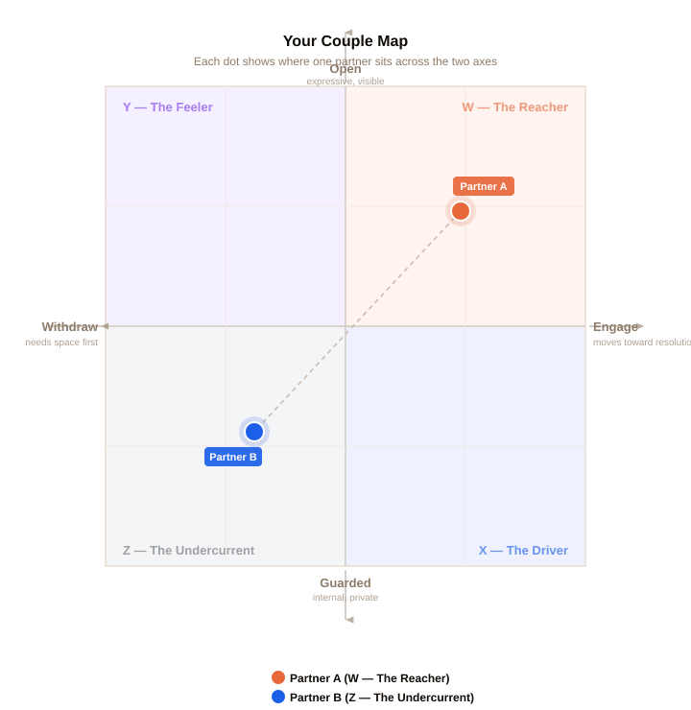

What to notice | What it means
Same quadrant | Both partners share the same dominant orientation. The pairing is same-type. Dynamics tend toward amplification of shared strengths and shared risks.
Adjacent quadrants | Partners share one axis and diverge on the other. The agreement creates common ground; the difference creates a specific, nameable friction point.
Diagonal quadrants | Partners diverge on both axes simultaneously. The widest contrast pairings (W×Z, X×Y). Both the conflict timing and expressiveness gap need to be named.
Dot near axis line | That partner is closer to balanced on that dimension. Their type label is still accurate, but less dominant — they’re more flexible on that axis.
Dots close together | Scores are similar, possibly within the same quadrant. High compatibility on these axes — look to the other dimensions for where differences live.
Dots far apart | Significant divergence. The Couple Map is making the gap visible. This is where the conversation starts.

The Four Individual Types
Each type is named for its most observable quality — what the person does in the relationship, not what they are as a person. The names are functional, not clinical. No type is better or worse than another.

W | The Reacher  Reaches toward people, reaches toward resolution.  Engage/Withdraw: Engage — moves toward conflict, wants resolution  Open/Guarded: Open — processes and expresses relatively freely  When something is off, the Reacher is usually the one who brings it up. They find unresolved tension hard to carry. They process emotionally outward — feelings surface and get shared, sometimes before they’re fully formed. At their best they create warmth and connection. The thing to watch is the gap between their readiness and their partner’s.  Derived from: Conflict (55%) + Stress (30%) + Repair (15%) → Engage axis • Expression (45%) + Feedback (30%) + Needs (25%) → Open axis

X | The Driver  Pushes toward resolution. Keeps the feeling inside.  Engage/Withdraw: Engage — wants things resolved, low avoidance  Open/Guarded: Guarded — processes internally, shares selectively  The Driver wants things sorted — quickly, logically, without drama. They move toward resolution but don’t necessarily share what’s going on internally while they’re doing it. Partners can experience this as efficient but emotionally distant. The Driver often has more going on beneath the surface than they let on.  Derived from: high Engage axis score • low Open axis score

Y | The Feeler  Needs space first. Carries a lot when withdrawn.  Engage/Withdraw: Withdraw — needs space before the conversation is possible  Open/Guarded: Open — expressive when ready, processes with feeling  The Feeler experiences conflict intensely and needs to step back before they can engage productively. They are not avoiding — they are protecting the quality of the conversation. When they do come back, they bring the full emotional weight of what they’ve been carrying. Partners often misread the withdrawal as rejection when it’s actually preparation.  Derived from: low Engage axis score • high Open axis score

Z | The Undercurrent  Withdraws and holds things close. Real depth running quiet.  Engage/Withdraw: Withdraw — needs space, low urgency toward resolution  Open/Guarded: Guarded — processes internally, shares when ready  The Undercurrent goes inward on both dimensions simultaneously. They need space and they hold things privately. They are not checked out — there is often significant depth and feeling running beneath the surface that simply doesn’t surface readily. The risk is that important things go unsaid indefinitely. Partners often don’t know what they’re carrying.  Derived from: low Engage axis score • low Open axis score

Scoring Formula
Individual type designation is derived from two composite scores, each built from the 10-dimension scores produced by the 50-question exercise. The position on each axis is a continuous number, not a bucket — which is what enables the Couple Map to plot precise dot positions.

Axis 1: Engage ↔ Withdraw Score
Formula: (Conflict × 0.55) + (Stress × 0.30) + (Repair × 0.15)
Score ≥3.0 = Engage-leaning. Score <3.0 = Withdraw-leaning. Position is continuous, not binned.

Axis 2: Open ↔ Guarded Score
Formula: (Expression × 0.45) + (Feedback × 0.30) + (Needs × 0.25)
Score ≥3.0 = Open-leaning. Score <3.0 = Guarded-leaning. Position is continuous, not binned.

Type Assignment
Engage/Withdraw | Open/Guarded | Type | Name
Engage (≥3.0) | Open (≥3.0) | W | The Reacher
Engage (≥3.0) | Guarded (<3.0) | X | The Driver
Withdraw (<3.0) | Open (≥3.0) | Y | The Feeler
Withdraw (<3.0) | Guarded (<3.0) | Z | The Undercurrent

Scores between 2.6 and 3.4 on either axis place the person near the centre of the chart. They are typed by whichever side they fall on (even slightly), and their dot position communicates the proximity to centre.

The 10 Couple Pairings
With 4 individual types, there are exactly 10 unique unordered pairings: 4 same-type matches and 6 cross-type combinations. Each pairing produces a couple type with its own dynamic, strengths, and primary risk. The couple type is a direct lookup — no additional scoring required.

Unordered means W×Y = Y×W. The pairing is the same regardless of which partner holds which type.

Same-Type Pairings
Both partners share the same individual type. The dominant pattern is amplification — whatever each person’s strengths and risks are, they tend to be doubled rather than balanced.

Pair | Couple Type | Dynamic • Nuance • Watch
W×W | The Open Fire | Both reach and express freely. High warmth and emotional availability in both directions.  Nuance: The risk isn’t disconnection. It’s feedback loops. When both feel something strongly, the intensity can amplify rather than settle.  Watch: Name it when it’s happening: ‘I think we’re feeding each other right now’ is usually enough to break the loop.
X×X | The Two Drivers | Both move toward resolution and both process internally. Efficient, quiet, effective.  Nuance: Efficient repair can mean closing the loop before it’s actually through. The same conversation can reappear.  Watch: Ask each other: ‘Are we actually okay, or are we both just ready to be done?’
Y×Y | The Quiet Storm | Both need space first. Things don’t escalate. When you come back, you both bring the full weight of what you’ve been carrying.  Nuance: Both can wait a very long time for the other to come back first. That waiting can feel like abandonment.  Watch: Someone has to initiate the return. Agree in advance on a low-key signal for ‘I’m ready when you are.’
Z×Z | The Still Waters | Both withdraw and both hold things close. Real depth beneath a calm surface. Stable, private, genuine.  Nuance: Important things can go unsaid for a very long time. Comfort with quiet can become avoidance.  Watch: Create a deliberate structure for openness — a regular check-in. It doesn’t have to feel emotional to be effective.

Cross-Type Pairings
Different individual types bring different strengths and different friction points. The character of each pairing is defined by where the two types agree and where they diverge.

Pair | Couple Type | Dynamic • Nuance • Watch
W×X | The Common Goal | Both want resolution. One processes it aloud; one processes it internally. Same direction, different instruments.  Nuance: The expressive partner can feel like they’re always the one initiating depth. The guarded one can feel pressure to match an openness they don’t naturally have.  Watch: X: share the half-formed version, not just the conclusion. W: give the processing room before asking what’s going on.
W×Y | The Mismatch | The most common friction pairing. When things are hard, one reaches and one pulls back. The reaching feels like pressure; the withdrawal feels like abandonment.  Nuance: This is highly solvable once named. The couples who navigate it best have agreed in advance on what the withdrawal means and when the return is coming.  Watch: Name it before you’re in it: ‘When I go quiet, I’m processing, not gone. Give me until [time] and I’ll be back.’
W×Z | The Reach & The Reserve | The widest contrast in the framework. One reaches and expresses freely; the other pulls back and holds privately. Gap on both axes simultaneously.  Nuance: What W sends and what Z receives are often not the same thing, and vice versa. The translation work is significant and ongoing.  Watch: W’s expressiveness can feel like pressure to Z. Z’s privacy can feel like withholding to W. Name this as wiring, not character.
X×Y | The Crossed Wires | Both have a strong orientation, in opposite directions on both axes. X pushes toward resolution while guarding; Y needs space while carrying visible emotion.  Nuance: X’s urgency closes the space before Y is ready. Y’s visible emotion looks to X like something that needs fixing immediately.  Watch: X: resolution doesn’t mean resolved. Y: tell X when you’ll be back. The uncertainty is harder for them than the wait.
X×Z | The Quiet Efficiency | Both process internally. Both guard their interior. Low-temperature, rarely explosive. The practical machinery works quietly.  Nuance: Neither partner is offering a lot of emotional visibility. The relationship can feel more okay on the outside than the inside.  Watch: Build a practice of asking: not ‘are you okay?’ but ‘what’s actually going on for you right now?’
Y×Z | The Long Pause | Both withdraw. One carries it visibly; one holds it privately. The return is slow for both. Hard moments can sit for a long time.  Nuance: Real depth runs in this pairing — often more than either shows. The risk is that depth never surfaces because neither naturally initiates the opening.  Watch: The Feeler, when ready, tends to be more willing to bring it back. Let that be the agreed pattern.

Engine Design
The typing engine runs in five steps. The Couple Map coordinates are computed in Step 2 and are independent of type designation — they show raw position on each axis before thresholding.

Step 1: Score the 10 Dimensions
Each partner’s 50-question answers produce per-dimension averages on a 1–5 scale. Five questions per dimension, each scored 1 or 5 (or 3 for the explicit middle option where available).

Step 2: Compute Axis Coordinates
Engage/Withdraw (E) = (Conflict × 0.55) + (Stress × 0.30) + (Repair × 0.15)
Open/Guarded (O) = (Expression × 0.45) + (Feedback × 0.30) + (Needs × 0.25)
The (E, O) coordinate pair is plotted directly onto the Couple Map before thresholding.

Step 3: Apply Thresholds to Assign Type
Threshold each axis at 3.0. Scores at or above = high pole (Engage or Open). Scores below = low pole (Withdraw or Guarded). Scores near centre are assigned to whichever side they land on; their proximity to centre is visible on the chart.

Step 4: Look Up the Couple Pairing
Once both partners have individual types, the couple type is a direct lookup from the 10-pairing table. No further scoring required. The Couple Map is rendered using both partners’ (E, O) coordinates.

Step 5: Layer in Couple-Level Question Signals
The 10 couple-level questions from Part 2 of Exercise 01 are used to add texture within a pairing: adjusting description framing and selecting the most relevant action plan items. They do not change the type designation.

Quick Reference Matrix
All 10 pairings at a glance. Read as row × column.

 | W — Reacher | X — Driver | Y — Feeler | Z — Undercurrent
W | Open Fire | Common Goal | Mismatch | Reach & Reserve
X |  | Two Drivers | Crossed Wires | Quiet Efficiency
Y |  |  | Quiet Storm | Long Pause
Z |  |  |  | Still Waters

Attune • Couple Typing Framework v3 • Internal Working Document

