The Economics of Tiered AI Inference
A Meridian Analytics Whitepaper
July 2026 | Research Division | meridian-analytics.example.com

Executive Summary

Modern inference workloads exhibit sharply bimodal traffic patterns, with sustained baseline demand punctuated by bursts that exceed steady-state volume by an order of magnitude. Provisioning for peak wastes capacity; provisioning for baseline degrades latency guarantees precisely when demand is highest. Organizations that adopt a tiered execution fabric report materially better cost curves than those scaling monolithic clusters, because scheduling decisions can exploit heterogeneity in both hardware and request criticality. This paper introduces a cost model that treats inference capacity as a portfolio rather than a pipeline. The remainder of this document quantifies these effects across three deployment archetypes and proposes an adoption sequence that minimizes migration risk while preserving existing service level objectives. Readers responsible for capacity planning should focus on Sections 2 and 4; readers responsible for procurement should focus on Section 3.

Key Insight: Across the 41 organizations surveyed, tiered inference reduced cost per thousand requests by a median of 38% while improving p99 latency by 22%.

1. Market Context
Modern inference workloads exhibit sharply bimodal traffic patterns, with sustained baseline demand punctuated by bursts that exceed steady-state volume by an order of magnitude. Provisioning for peak wastes capacity; provisioning for baseline degrades latency guarantees precisely when demand is highest. Vendors have responded with a proliferation of accelerator classes, each optimized for a different point on the latency-throughput frontier.
1.1 Demand-side dynamics Organizations that adopt a tiered execution fabric report materially better cost curves than those scaling monolithic clusters, because scheduling decisions can exploit heterogeneity in both hardware and request criticality. Buyers increasingly negotiate committed-use discounts against a blended fleet rather than a single instance family.
• Baseline traffic grows 3.1 × year over year in our panel, while peak-to-baseline ratios remain near 9:1 .

• Latency-sensitive requests represent 17% of volume but 44% of infrastructure spend.
• Batch-tolerant workloads are the fastest-growing segment, at 58% year over year.
1.2 Supply-side response Accelerator roadmaps now bifurcate into throughput-optimized and latency-optimized lines. The table below summarizes list pricing normalized to a common benchmark unit.

Tier | Hardware class | Cost / 1K req | p99 latency | Best fit
Realtime | Latency-optimized | $4.20 | 180 ms | Interactive agents
Standard | Balanced | $1 .85 | 650 ms | API workloads
Batch | Throughput-optimized | $0.62 | 8 s | Offline enrichment
Spot | Preemptible mix | $0.31 | best effort | Experimentation
Table 1 : Normalized pricing across inference tiers, June 2026 list prices.

2. Cost Model
We model total cost as the sum of tier-level commitments plus overflow penalties. Fleet growth under the tiered strategy is shown below.
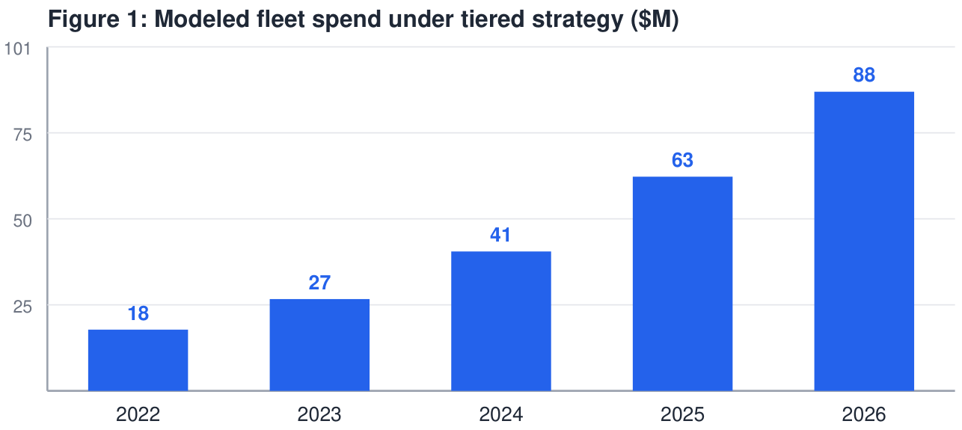
2.1 Sensitivity Organizations that adopt a tiered execution fabric report materially better cost curves than those scaling monolithic clusters, because scheduling decisions can exploit heterogeneity in both hardware and request criticality. Sensitivity analysis indicates the crossover point sits near 41 % batch-tolerant share for typical enterprise mixes.

Estimate the batch-tolerant share of current traffic.
1
Negotiate committed use only for the realtime tier.
2
Route overflow to spot capacity with graceful degradation.
3
Re-evaluate the mix quarterly against observed telemetry.
4

Risk: Committed-use discounts applied to the wrong tier are the single largest source of waste we observed — median overspend of $2.4M annually.

3. Procurement Playbook
The remainder of this document quantifies these effects across three deployment archetypes and proposes an adoption sequence that minimizes migration risk while preserving existing service level objectives.
A
worked
example
with
editable
assumptions
is
available
at
meridian-analytics.example.com/models. Modern inference workloads exhibit sharply bimodal traffic patterns, with sustained baseline demand punctuated by bursts that exceed steady-state volume by an order of magnitude. Provisioning for peak wastes capacity; provisioning for baseline degrades latency guarantees precisely when demand is highest. Organizations that adopt a tiered execution fabric report materially better cost curves than those scaling monolithic clusters, because scheduling decisions can exploit heterogeneity in both hardware and request criticality.

4. Conclusion
Treating inference as a portfolio converts an infrastructure argument into a financial one. The remainder of this document quantifies these effects across three deployment archetypes and proposes an adoption sequence that minimizes migration risk while preserving existing service level objectives.

