State of Agent Operations 2026
Executive brief — Northlight Research Group

Key Findings
Our third annual survey covers 412 organizations operating autonomous agents across customer operations, engineering, and finance. Three numbers define the year:

73%  of enterprises run agents in production | 4.8×  median ROI within the first year | 29 d  average time from pilot to production
The gap between leaders and laggards is widening. Leaders standardize evaluation harnesses and treat prompts as versioned artifacts; laggards still ship prompt changes without regression coverage.

"The bottleneck moved from model quality to operational discipline in a single budget cycle."
— VP Platform Engineering, Fortune 100 retailer

Deployment Trajectory
Active deployments doubled in the trailing twelve months, with growth concentrated in mid-market adopters:
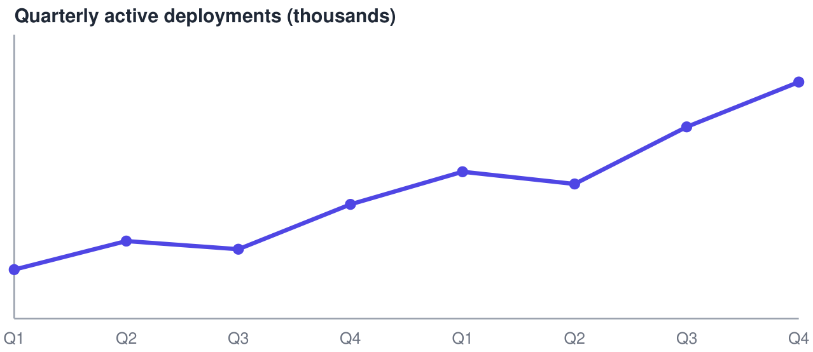

What Leaders Do Differently
• Budget for evaluation infrastructure before scaling headcount.
• Route by task value: premium models for revenue paths only.
Keep humans on exception queues, not approval queues.
• Full methodology and cohort definitions: northlight.example.org/agents-2026.

