Quarterly Operations Review
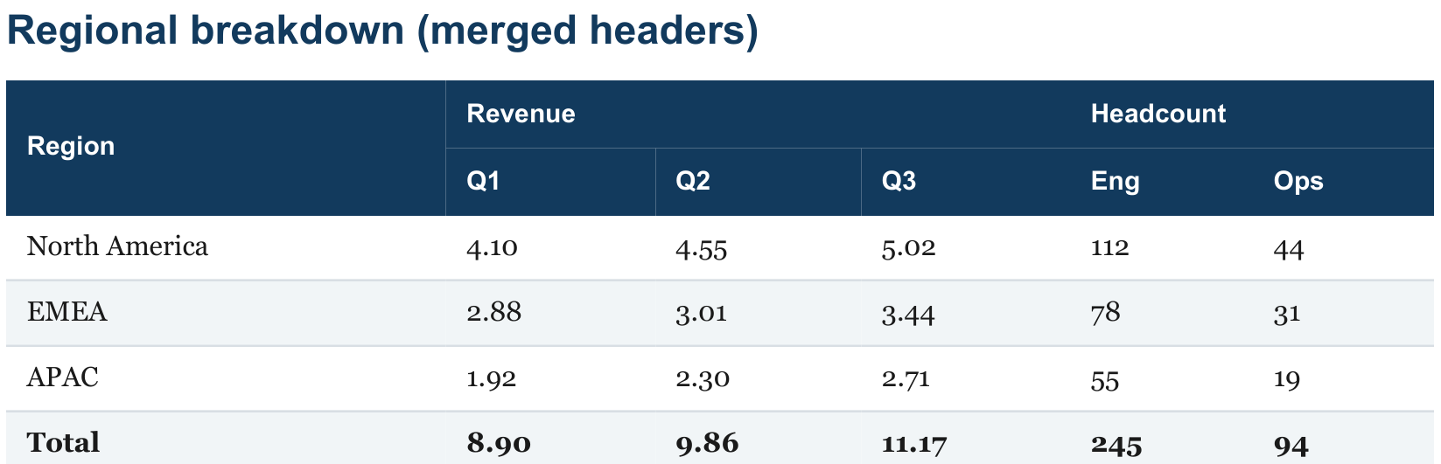

Nested detail
Ingest

Platform
Index

Serve

Long table spanning a page break

#
Item
1
Work item number 1 in the backlog

2
Work item number 2 in the backlog
4
Work item number 4 in the backlog
6
Work item number 6 in the backlog
8
Work item number 8 in the backlog

green

amber

green

Owner
Status
Team B
in review
Team C
done
Team E
in review
Team B
open
Team D
done

Programme | Detail

Safety | Review scheduled for week 34.

3 | Work item number 3 in the backlog | Team D | open

5 | Work item number 5 in the backlog | Team A | done

7 | Work item number 7 in the backlog | Team C | in review

9 | Work item number 9 in the backlog | Team E | open

10
Work item number 10 in the backlog
12
Work item number 12 in the backlog
14
Work item number 14 in the backlog
16
Work item number 16 in the backlog
18
Work item number 18 in the backlog
20
Work item number 20 in the backlog
22
Work item number 22 in the backlog
24
Work item number 24 in the backlog
26
Work item number 26 in the backlog
28
Work item number 28 in the backlog
30
Work item number 30 in the backlog
32
Work item number 32 in the backlog
34
Work item number 34 in the backlog
36
Work item number 36 in the backlog
38
Work item number 38 in the backlog

Team A
in review
Team C
open
Team E
done
Team B
in review
Team D
open
Team A
done
Team C
in review
Team E
open
Team B
done
Team D
in review
Team A
open
Team C
done
Team E
in review
Team B
open
Team D
done

11 | Work item number 11 in the backlog | Team B | done

13 | Work item number 13 in the backlog | Team D | in review

15 | Work item number 15 in the backlog | Team A | open

17 | Work item number 17 in the backlog | Team C | done

19 | Work item number 19 in the backlog | Team E | in review

21 | Work item number 21 in the backlog | Team B | open

23 | Work item number 23 in the backlog | Team D | done

25 | Work item number 25 in the backlog | Team A | in review

27 | Work item number 27 in the backlog | Team C | open

29 | Work item number 29 in the backlog | Team E | done

31 | Work item number 31 in the backlog | Team B | in review

33 | Work item number 33 in the backlog | Team D | open

35 | Work item number 35 in the backlog | Team A | done

37 | Work item number 37 in the backlog | Team C | in review

39 | Work item number 39 in the backlog | Team E | open
40
Work item number 40 in the backlog
Team A
in review

41 | Work item number 41 in the backlog | Team B | done
42
Work item number 42 in the backlog
Team C
open

43 | Work item number 43 in the backlog | Team D | in review
44
Work item number 44 in the backlog
Team E
done

45 | Work item number 45 in the backlog | Team A | open

