Gradient Band
Vector gradients have no OOXML paragraph equivalent.

Inline SVG chart
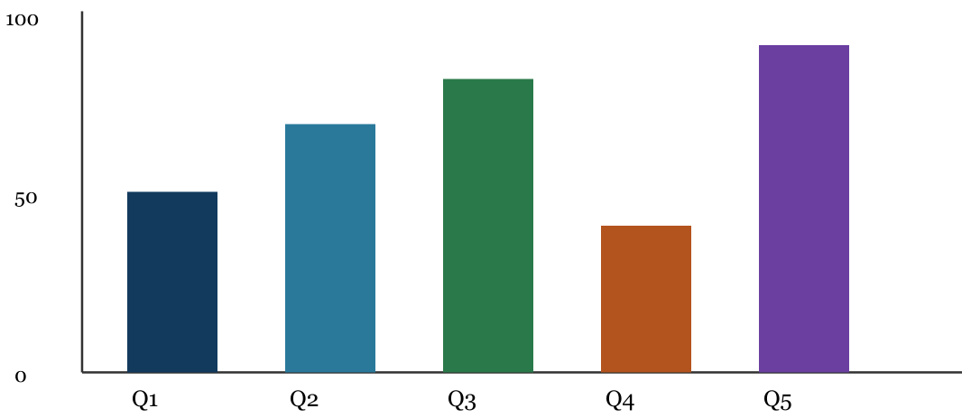
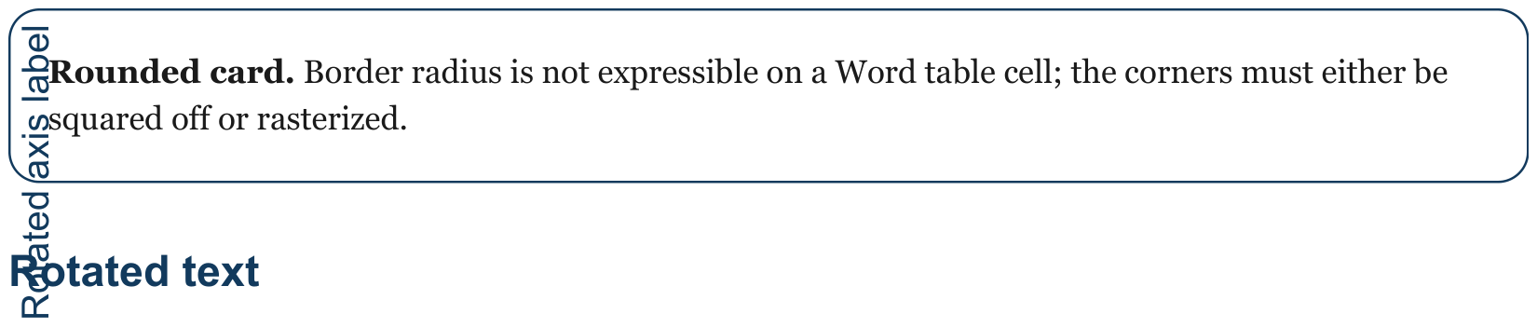

Body after graphics
Retrieval quality degrades non-linearly as the corpus grows past the point where the embedding model was calibrated, and the failure is quiet: recall stays flat while precision collapses in the tail. Teams that measure only average relevance will not see it.

