Adaptive Speculative Decoding under Heterogeneous Draft

Models
Priya Raman Diego Álvarez Hannah Cole
Institute for Efficient Computation, Basel

Abstract
Speculative decoding accelerates autoregressive generation by drafting tokens with a small model and verifying them with a large one. Fixed draft models, however, leave acceptance rates on the table when input difficulty varies. We introduce ASD, a router that selects among heterogeneous draft models per segment using a lightweight difficulty estimator. On a mixed workload, ASD improves throughput by 1.9× over the best fixed draft while matching output distributions exactly.

1 Introduction
Large-model inference remains dominated by sequential token generation. Speculative methods amortize this cost, but their benefit hinges on the acceptance rate of drafted tokens, which varies sharply with content difficulty. Prior work fixes a single draft model ahead of time, implicitly assuming difficulty is stationary. It is not.
We observe that acceptance traces exhibit regime shifts at segment boundaries — code blocks, tables, and quoted material each favor different drafters. This motivates a per-segment routing decision.

2 Method
ASD maintains a pool of draft models spanning three size classes. A difficulty estimator computes features from the last 64 accepted tokens: entropy of the verifier distribution, token rarity, and structural cues. A bandit policy maps the feature vector to a drafter, updating its estimates from observed acceptance.
Crucially, verification is unchanged, so the sampled distribution is identical to standard decoding. The router adds 0.3% overhead.

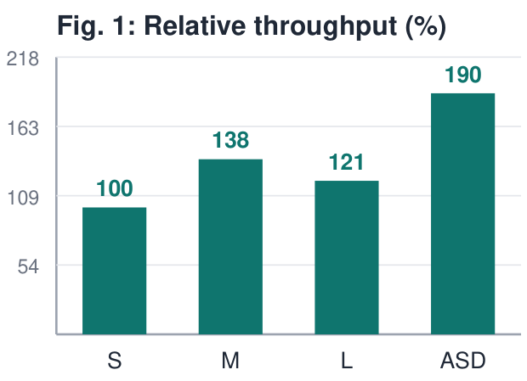

3 Results
Table 1 reports throughput and acceptance across workloads. ASD dominates fixed drafters on mixed content and is never worse than the best fixed choice by more than 2%.

Workload | Best fixed | ASD | ∆
Prose | 1.42× | 1.51× | +6%
Code | 1.66× | 1.83× | +10%
Mixed | 1.31× | 1.90× | +45%
Table 1: Throughput vs. the best fixed draft model.

4 Related Work
Speculative decoding builds on rejection-sampling equivalence results; subsequent variants explore tree drafting, self-drafting, and early exit. Router-based model selection appears in serving literature but has not been applied per-segment within a single generation.

5 Conclusion
Difficulty-aware routing recovers headroom that fixed draft models leave behind, with no distributional cost. Future work extends the estimator to multimodal inputs.

References

[1] Raman, P. et al. Segment-aware inference schedulers. In Proc.
ESC, 2025.
[2] Álvarez, D. and Cole, H. Bandit routing for serving fleets. J.
Systems ML, 2024.
[3] Cole, H. Difficulty estimation from verifier entropy.
Workshop on Eff. NLP, 2025.

