Quarterly Operations Review
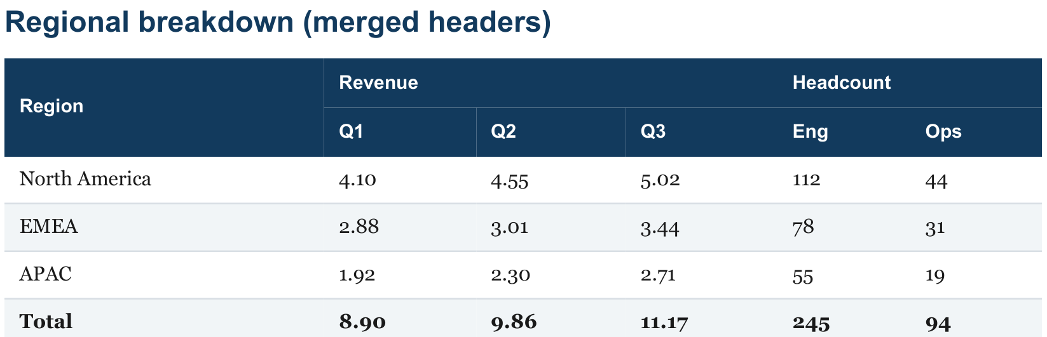

Nested detail

Programme | Detail
Ingest green

Platform
Index amber

Serve green

Safety | Review scheduled for week 34.

Long table spanning a page break

#
Item
Owner
Status
1
Work item number 1 in the backlog
Team B
in review

2 Work item number 2 in the backlog Team C done

3 | Work item number 3 in the backlog | Team D | open
4 Work item number 4 in the backlog Team E in review

5 | Work item number 5 in the backlog | Team A | done
6 Work item number 6 in the backlog Team B open

7 | Work item number 7 in the backlog | Team C | in review
8 Work item number 8 in the backlog Team D done

9 | Work item number 9 in the backlog | Team E | open

10 Work item number 10 in the backlog Team A in review

11 | Work item number 11 in the backlog | Team B | done
12 Work item number 12 in the backlog Team C open

13 | Work item number 13 in the backlog | Team D | in review
14 Work item number 14 in the backlog Team E done

15 | Work item number 15 in the backlog | Team A | open
16 Work item number 16 in the backlog Team B in review

17 | Work item number 17 in the backlog | Team C | done
18 Work item number 18 in the backlog Team D open

19 | Work item number 19 in the backlog | Team E | in review
20 Work item number 20 in the backlog Team A done

21 | Work item number 21 in the backlog | Team B | open
22 Work item number 22 in the backlog Team C in review

23 | Work item number 23 in the backlog | Team D | done
24 Work item number 24 in the backlog Team E open

25 | Work item number 25 in the backlog | Team A | in review
26 Work item number 26 in the backlog Team B done

27 | Work item number 27 in the backlog | Team C | open
28 Work item number 28 in the backlog Team D in review

29 | Work item number 29 in the backlog | Team E | done
30 Work item number 30 in the backlog Team A open

31 | Work item number 31 in the backlog | Team B | in review
32 Work item number 32 in the backlog Team C done

33 | Work item number 33 in the backlog | Team D | open
34 Work item number 34 in the backlog Team E in review

35 | Work item number 35 in the backlog | Team A | done
36 Work item number 36 in the backlog Team B open

37 | Work item number 37 in the backlog | Team C | in review
38 Work item number 38 in the backlog Team D done

39 | Work item number 39 in the backlog | Team E | open
40 Work item number 40 in the backlog Team A in review

41 | Work item number 41 in the backlog | Team B | done
42 Work item number 42 in the backlog Team C open

43 | Work item number 43 in the backlog | Team D | in review
44 Work item number 44 in the backlog Team E done

45 | Work item number 45 in the backlog | Team A | open

