DSN Bootcamp Qualification Hackathon 2026
Predicting Product Sales for DSN Mart
Machine Learning Track | Solution report | September 2026

Executive summary
DSN Mart wants to know what drives product sales across its stores. I analysed 6,818 product-store records and built a model that predicts total sales for 1,705 unseen rows. Predictions are scored by RMSE (lower is better).
1,698  RMSE when predicting the average | 1,071.5  RMSE of the final model (5-fold CV) | 60%  of the variation in sales explained

What I found
- Sales are driven by the store and the product price. Total sales are close to price × units sold, and units sold sit at a steady level for each store (about 2.4 in a corner shop, about 16 in a standard supermarket and about 26 in the flagship hypermarket).
- Almost nothing else matters. Shelf visibility, product weight, fat content and store age show no clear effect. Product category has only a small effect.
- The final model is an average of four models built on engineered features. Its cross-validated RMSE is 1,071.5, which is 37% lower than always predicting the average.
- The noise is the limit, not the model. Many different algorithms finish within a few RMSE points of each other. The remaining error comes from random variation in units sold, which the available columns cannot explain.

1. Problem and approach
The task is a regression problem: for each row in test.csv, predict total_sales for one product in one store. The metric is Root Mean Squared Error (RMSE), which punishes large mistakes more than small ones. The brief asks for a workflow of Understand → Analyse → Model → Predict → Communicate, and this report follows it.
Brief asks for | Where in this report
Explore and understand the dataset | Section 2
Clean and preprocess the data | Section 3
EDA and analysis of what influences sales | Section 4
Engineer features from product and store information | Section 5
Build and evaluate machine learning models | Section 6
Generate predictions for the test data | Section 7
Communicate findings to the business | Sections 8 and 9

Every model was judged with 5-fold cross-validation on the training data: the data is split into five parts, each part is used once as unseen test data, and the five scores are averaged. This is more reliable than a single split because every row is used for testing exactly once.

2. Understanding the data
The training file has 6,818 rows and 13 columns. The test file has 1,705 rows and the same columns without total_sales.
Column | Meaning
id | Row identifier (no predictive value)
product_code | Product identifier (1,555 products, each sold in several stores)
product_weight_kg | Product weight
fat_content | Low Fat or Regular
shelf_visibility | Share of shelf space the product gets
product_category | Type of product
product_price | Price of the product
store_code | Store identifier (10 stores)
store_age_years | Age of the store
store_size | Small, Medium or Large
store_location_tier | Tier_1, Tier_2 or Tier_3 location
store_format | Corner Shop, Standard Supermarket, Superstore or Flagship Hypermarket
total_sales | Target: total sales of that product in that store

Data quality checks
Check | Result
Duplicate rows or ids | None
Test stores that also appear in train | 100%
Test products that also appear in train | 99.6%
Missing product_weight_kg | 18% of train rows, 306 test rows
Missing store_size | 28% of train rows, and it is missing for 3 whole stores (not at random)
product_category spellings | 48 values, which are really 16 categories written in different casings
shelf_visibility equal to zero | 422 rows, which is not realistic for a product on a shelf

Because every test store and almost every test product also appears in the training data, what the model learns from the training data carries over to the test data.

3. Cleaning and preprocessing
Each fix below follows a check that showed a real problem. I did not apply any fix just because it is common practice.
Problem | Fix | Why this fix
Category written in 3 casings | Lower-case and strip spaces | 48 spellings become the 16 real categories
store_size missing for whole stores | Fill with "Unknown" | The gap belongs to the store. A median or mode would be a guess
shelf_visibility = 0 | Treat as missing | A product on a shelf cannot have zero visibility
Missing weight and visibility | Use the product's median from its other rows, then the category median | The same product has almost the same weight everywhere
Price, weight and visibility differ slightly for the same product | Use one value per product (mean price, median weight and visibility) | Price differs by only about 2% across rows, which looks like measurement noise
Text columns | One-hot encoding | Models need numbers
id, product_code, store_code | Not used as raw values | id is unique per row, product_code has 1,555 values. Stores are described by their one-hot columns

How each problem was found
- Get the overview: shape, head, dtypes and the null count per column. Two columns had nulls.
- Inspect every text column: nunique() and value_counts(). product_category had 48 values, and value_counts() showed the same names in different casings. After lower-casing, nunique() dropped to 16.
- Ask whether nulls are random: grouping store_size by store showed 0% or 100% missing for each store, so whole stores are missing.
- Ask whether other rows can help: 1,555 products across 6,818 rows means products repeat, so a missing weight can be recovered from other rows of the same product.
- Ask whether a value is believable: counting shelf_visibility == 0 found 422 rows.
- Protect against leakage: the cleaning uses feature columns only, never the target, so test rows cannot leak information about sales.
The core of the cleaning code:
def clean(df):
df = df.copy()
df["product_category"] = df["product_category"].str.lower().str.strip()
df["store_size"] = df["store_size"].fillna("Unknown")
df.loc[df["shelf_visibility"] == 0, "shelf_visibility"] = np.nan
return df

# one value per product, with the category as a fallback
full["weight_p"] = full.groupby("product_code")["product_weight_kg"].transform("median")
full["weight_p"] = full["weight_p"].fillna(
full.groupby("product_category")["product_weight_kg"].transform("median"))

4. Exploratory data analysis

The target is skewed
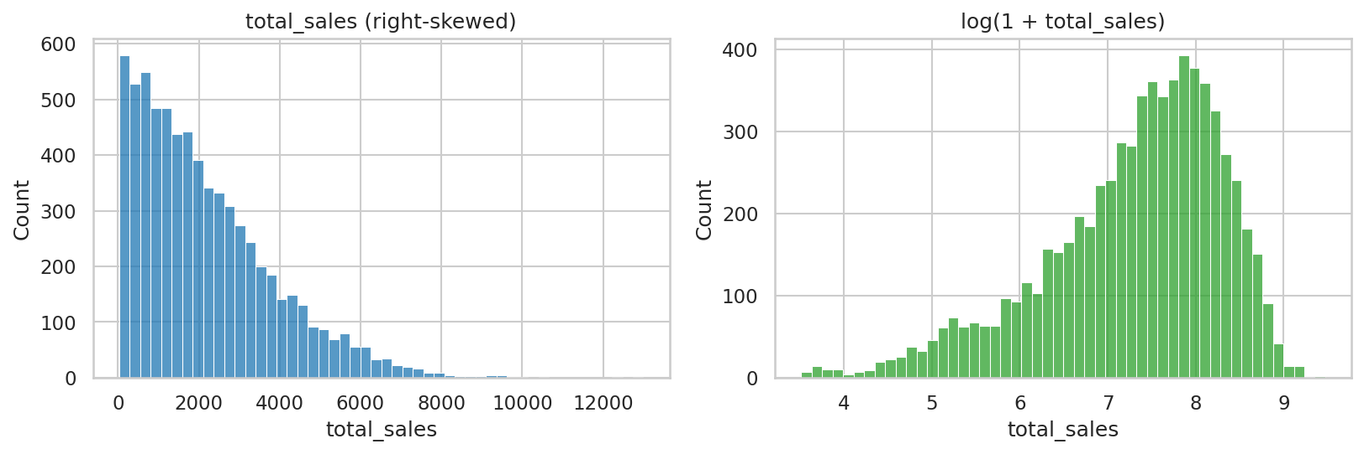
Figure 1. Distribution of total_sales, raw and on a log scale
Most rows sell little and a few sell a lot. Predicting the average would be wrong by about 1,700 on a typical row (the standard deviation), which is the number to beat.

The store is the biggest driver
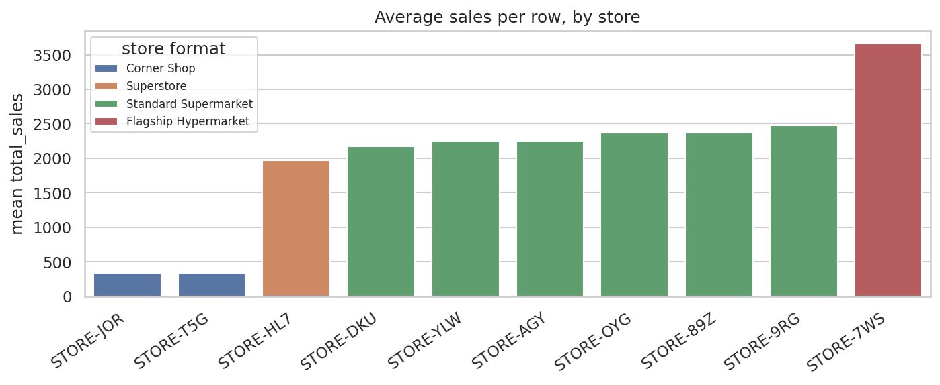
Figure 2. Average sales per row for each store, coloured by store format
The flagship hypermarket sells about 11 times more per row than a corner shop. Within the same format (the standard supermarkets), location tier, size and store age show no clear pattern.
Store | Format | Tier | Size | Age | Mean sales | Units
JOR | Corner Shop | Tier_3 | Unknown | 34 | 334 | 2.4
T5G | Corner Shop | Tier_1 | Small | 47 | 338 | 2.5
HL7 | Superstore | Tier_3 | Medium | 23 | 1,972 | 13.9
DKU | Standard Supermarket | Tier_2 | Unknown | 30 | 2,177 | 15.7
YLW | Standard Supermarket | Tier_1 | Small | 35 | 2,254 | 16.1
AGY | Standard Supermarket | Tier_3 | Large | 45 | 2,255 | 15.9
OYG | Standard Supermarket | Tier_2 | Unknown | 25 | 2,366 | 16.7
89Z | Standard Supermarket | Tier_1 | Medium | 33 | 2,366 | 16.8
9RG | Standard Supermarket | Tier_2 | Small | 28 | 2,479 | 17.1
7WS | Flagship Hypermarket | Tier_3 | Medium | 47 | 3,660 | 26.4
Units = total_sales ÷ product price, a rough measure of units sold.

Sales grow in proportion to price, at a rate set by the store
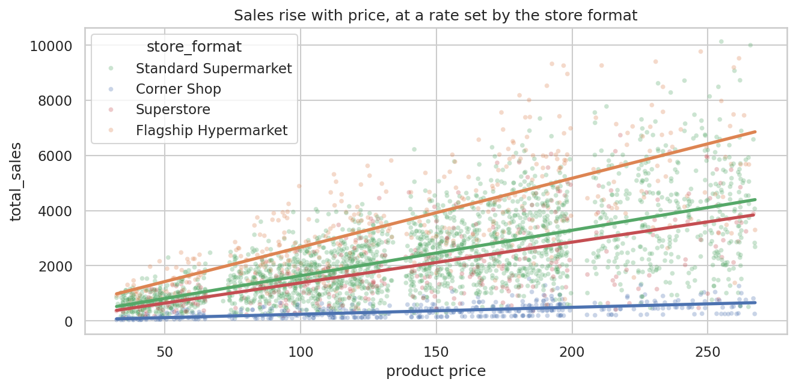
Figure 3. Sales against product price, with one trend line per store format
The relationship is close to a straight line through zero, and the slope depends on the store format. This suggests sales ≈ price × units sold. To test it, I divided sales by price.
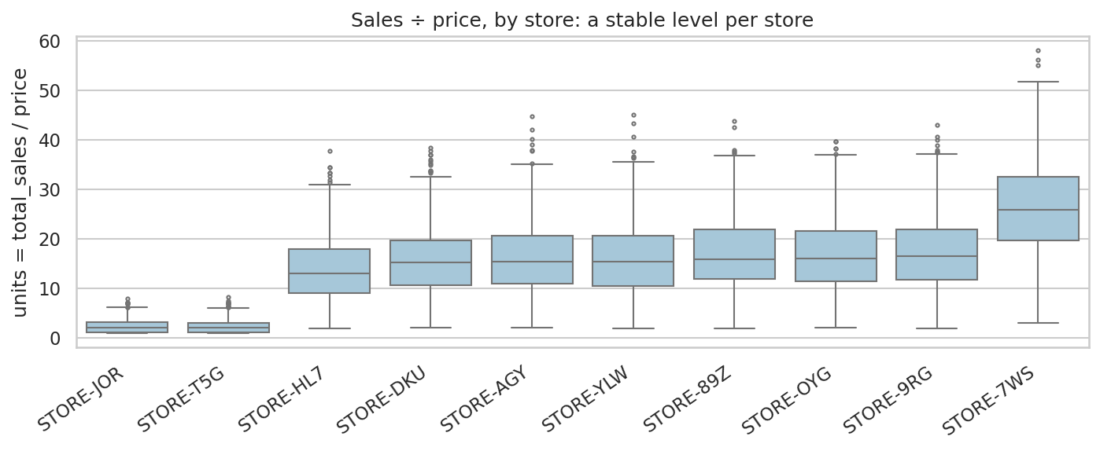
Figure 4. Sales ÷ price for each store
Each store has a steady level of units (about 2.4 for the corner shops, about 14 to 17 for the mid-sized stores and about 26 for the flagship), with a lot of random variation around it: roughly 35% to 60% of the mean. This variation is what limits the accuracy of any model.

What does not matter
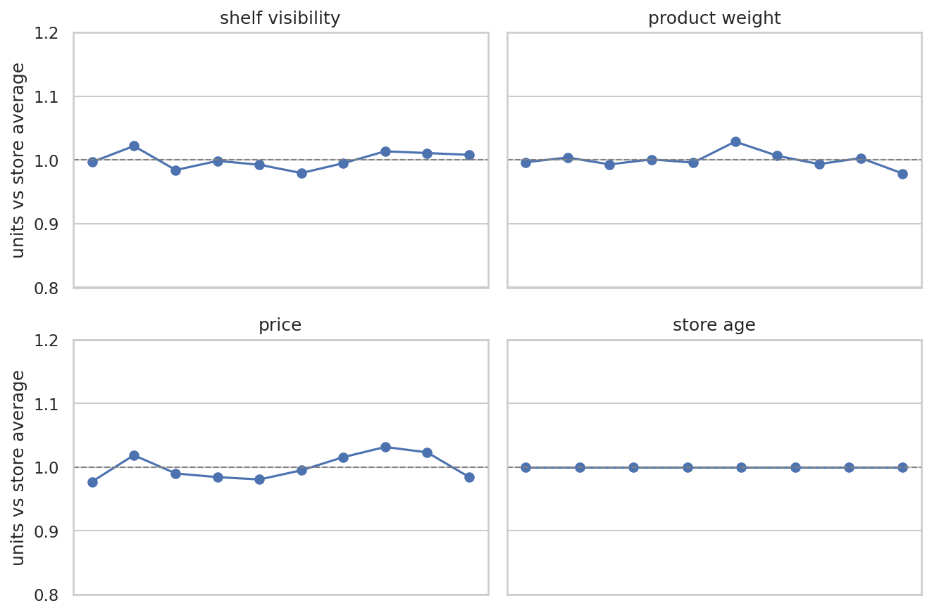
Figure 5. Units sold relative to the store average, by shelf visibility, weight, price and store age (1.0 = normal for that store)
Once the store is known, the lines are flat: shelf visibility, weight, price level and store age do not change how many units sell. Fat content is also flat (0.997 for Low Fat and 1.006 for Regular).
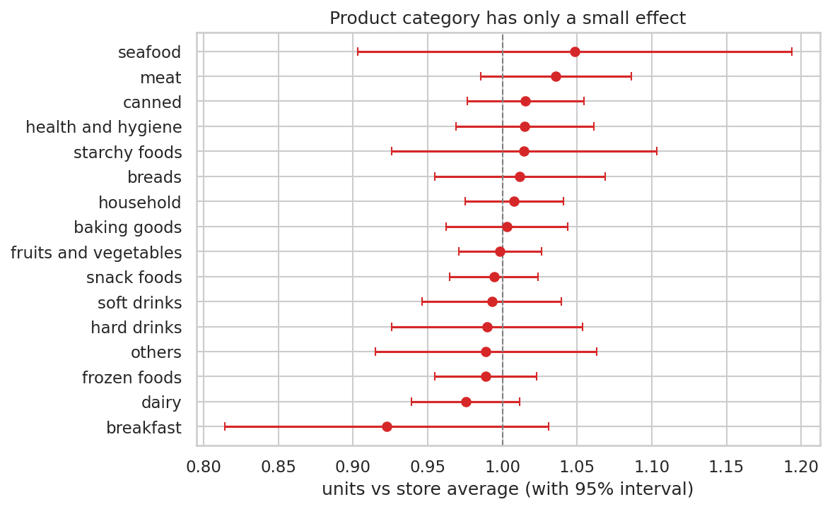
Figure 6. Units sold by product category, relative to the store average, with 95% intervals
Most categories sit close to 1.0 and their intervals overlap it. Breakfast and dairy look a little lower, and seafood and meat a little higher, but the differences are small compared with the noise.

How much does each factor explain?
Model of total_sales | R² (training data)
price only | 0.325
store only | 0.241
price + store (added together) | 0.561
price x store (sales = price * store rate) | 0.604

Combining price and store as a product explains about 60% of the variation, more than adding the two together (56%). This confirms the multiplicative structure. The other 40% is noise that none of the remaining columns explains.

5. Feature engineering
The features come from the EDA findings. All of them use feature columns only.
Feature | Definition | Reason
price_p, weight_p, vis_p | One value per product (mean price, median weight and visibility) | Removes the small row-to-row noise
price_to_cat | Price divided by the category's average price | Is this product expensive for its type?
price_per_kg | Price divided by weight | Value-for-size signal
vis_to_store | Visibility divided by the store's average visibility | Compares shelf space fairly across stores
store one-hot columns | One 0/1 column per store, format, size, tier, category and fat content | Lets models use the store, which is the biggest driver

The most important change is to the target. Instead of predicting total_sales directly, the models predict units = total_sales ÷ price, and the prediction is multiplied back by the price. This builds the finding "sales = price × units" into every model, so none of them has to rediscover it from 6,800 noisy rows.

6. Modelling and evaluation
I ran two experiments with the same 5 folds and the same metric (RMSE): A uses cleaned baseline features and predicts total_sales directly, and B uses the engineered features and predicts units. Seven algorithms were tried: Linear Regression, Ridge, Random Forest, Gradient Boosting, LightGBM, XGBoost and CatBoost, plus a simple "structural" model that predicts price × the store's average units.
Experiment | Model | CV RMSE | Fold spread (sd)
B. engineered | Structural (price x store) | 1,071.1 | 20.8
B. engineered | Ensemble (average) | 1,071.5 | 21.6
B. engineered | XGBoost (tuned) | 1,071.9 | 20.8
B. engineered | Ridge | 1,073.4 | 21.3
B. engineered | XGBoost | 1,075.4 | 22.8
B. engineered | CatBoost | 1,077.8 | 23.6
B. engineered | Gradient Boosting | 1,077.9 | 23.3
B. engineered | LightGBM | 1,078.2 | 24.0
A. baseline | XGBoost | 1,081.9 | 21.7
A. baseline | LightGBM | 1,083.0 | 21.7
A. baseline | CatBoost | 1,083.3 | 22.6
B. engineered | Random Forest | 1,086.2 | 23.2
A. baseline | Gradient Boosting | 1,086.2 | 21.6
A. baseline | Random Forest | 1,087.9 | 20.9
A. baseline | Linear Regression | 1,130.5 | 23.8
A. baseline | Ridge | 1,130.5 | 23.9
Reference | Predict the average | 1,697.9 | -

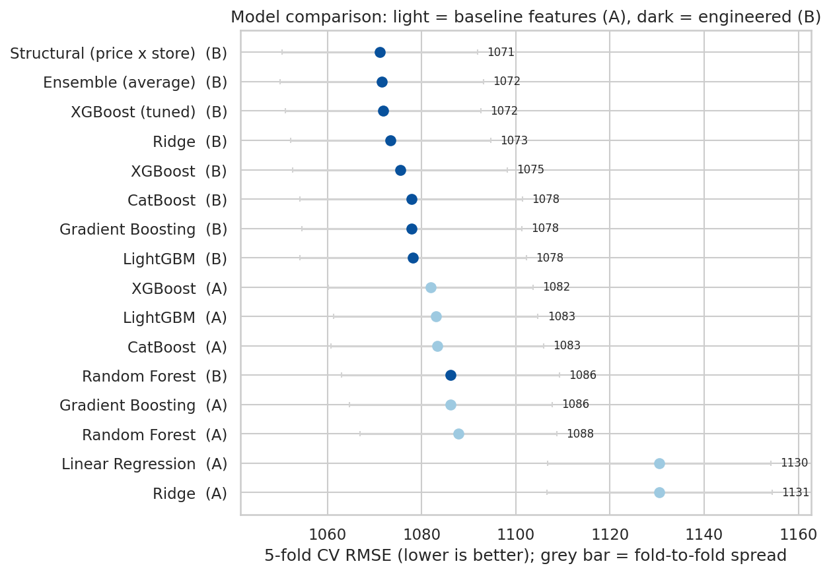
Figure 7. Cross-validated RMSE for every model. Grey bars show the fold-to-fold spread.

Reading the results
- Feature engineering helps most where the model cannot find the structure alone. The linear model improves from 1,130.5 (baseline features) to 1,073.4 (Ridge on engineered features and units).
- Every good model lands in the same narrow band (about 1,071 to 1,088). Differences of a few points are smaller than the fold-to-fold spread of about 21, so they should not be over-read.
- Tuning: a random search over XGBoost's main settings (25 tries) reached about 1,072. The score is slightly optimistic because the same folds choose the settings and report the result.
- Ensemble: the final model averages 4 members (Structural (price x store), Ridge, XGBoost (tuned), CatBoost). Its CV RMSE is 1,071.5, the same as the best single model within the noise. I use the ensemble because averaging protects against one model's quirks on unseen data. The structural model alone would be an equally valid, fully explainable choice.
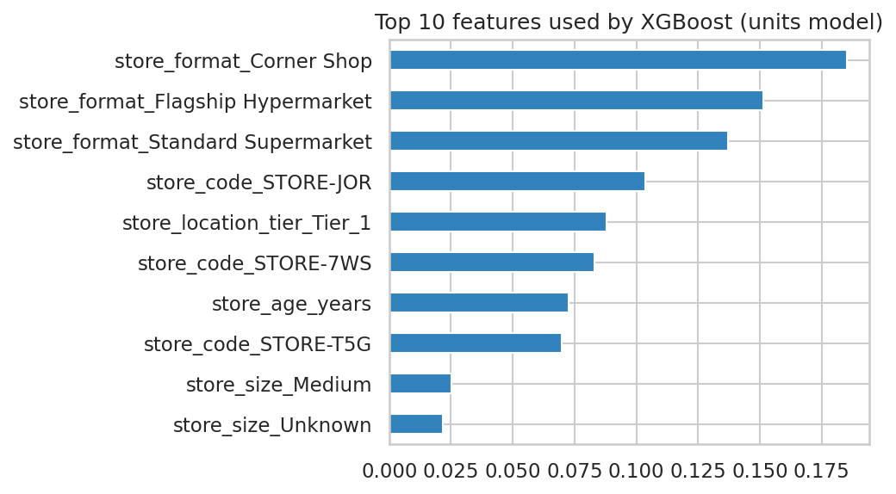
Figure 9. The ten features the tuned XGBoost (units) model uses most
All ten of the most-used features describe the store. This matches the EDA: the store sets the level of units sold, and the other columns add very little on top of it.

7. Predictions and diagnostics
The four members were refit on all training rows, and their predictions for the test rows were averaged. Negative values were clipped to zero. The file submission.csv has the columns id and total_sales.
Sanity check | Result
Rows in submission | 1,705 (equals the test file)
Ids match test.csv in the same order | Yes
Missing predictions | None
Mean: training actuals vs test predictions | 2,175 vs 2,195
Std: training actuals vs test predictions | 1,698 vs 1,322 (a model predicts the typical value, so it is less spread out)

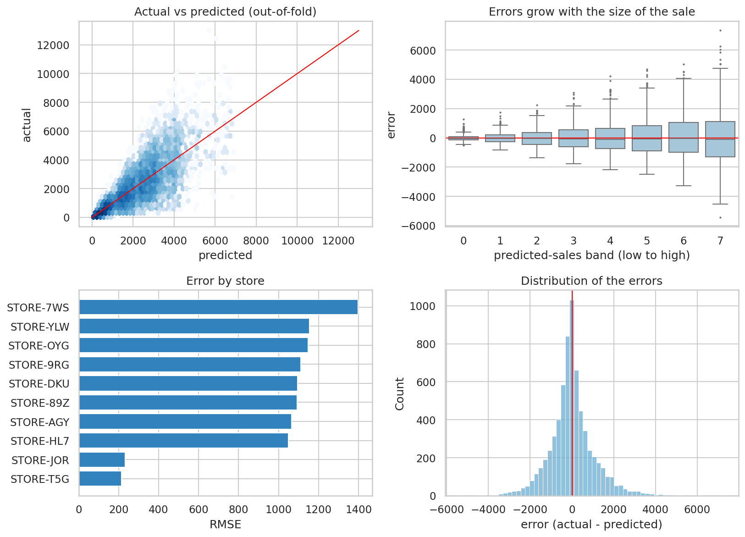
Figure 8. Out-of-fold predictions: actual vs predicted, error by prediction band, error by store, and the error distribution
The predictions follow the actual values without a visible bias. The spread of the errors grows with the size of the sale, which is what multiplicative noise looks like: selling 30% more or fewer units than usual moves a large sale by more than a small one. The flagship store, with the largest sales, therefore carries the biggest RMSE. This is why no model can push the error much below about 1,070 with these columns.
Expect the leaderboard score to be close to the cross-validated 1,072, give or take about 40, because the test set is a different sample of about 1,700 rows.

8. Business insights and recommendations

What drives sales
- The store is the biggest driver. The flagship sells about 11 times more per row than a corner shop, and store format matters far more than location tier or store age.
- Price scales sales. Within a store, sales grow in proportion to price: expected sales ≈ price × the store's typical units.
- Almost nothing else matters. Shelf visibility, weight, fat content and store age show no clear effect, and category has a small one.

Recommendations for DSN Mart
- Stock and pricing plans can start from the store format and the product price, since expected sales are close to price × the store's typical units.
- Investment: the gap between formats is large. Upgrading a location's format is likely to matter far more than adjusting shelf space or the product mix at the margin.
- Shelf space: the data does not show that more visibility raises units sold once the store is known. Test this with a controlled experiment before changing layouts.

9. Limitations and next steps
- Snapshot data. There are no dates, so trends and seasonality cannot be studied.
- Only ten stores. Conclusions about location tier and size rest on very few stores and should be treated with care.
- Weak product effects. Some products may be more popular than others, but with about five rows per product the signal is very weak (correlation of about 0.05 between rows of the same product).
- Next steps: if the competition rules allow, extra data such as promotions, stock-outs or local income is the most likely way to explain the remaining noise.

Appendix: how to reproduce
- Put train.csv, test.csv and DSN_Hackathon_Solution.ipynb in one folder.
- Install the libraries: pandas, numpy, scikit-learn, matplotlib, seaborn and (optionally) lightgbm, xgboost and catboost.
- Run all cells. The notebook saves the figures, results tables and submission.csv in the same folder.
- Upload submission.csv to the Kaggle competition page.

