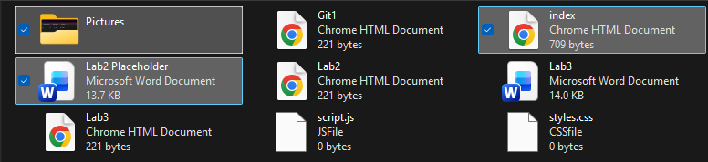
Imported the work from the previous repository into this folder
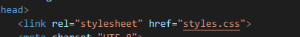

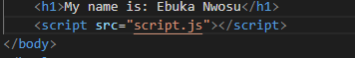
Created a css and javascript file and saved to folder
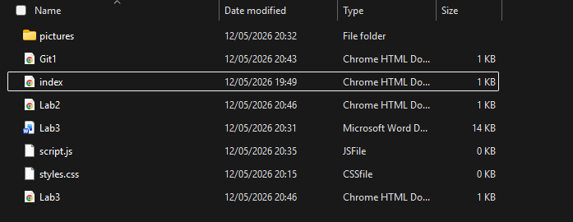
Created html files for each lab that I will link
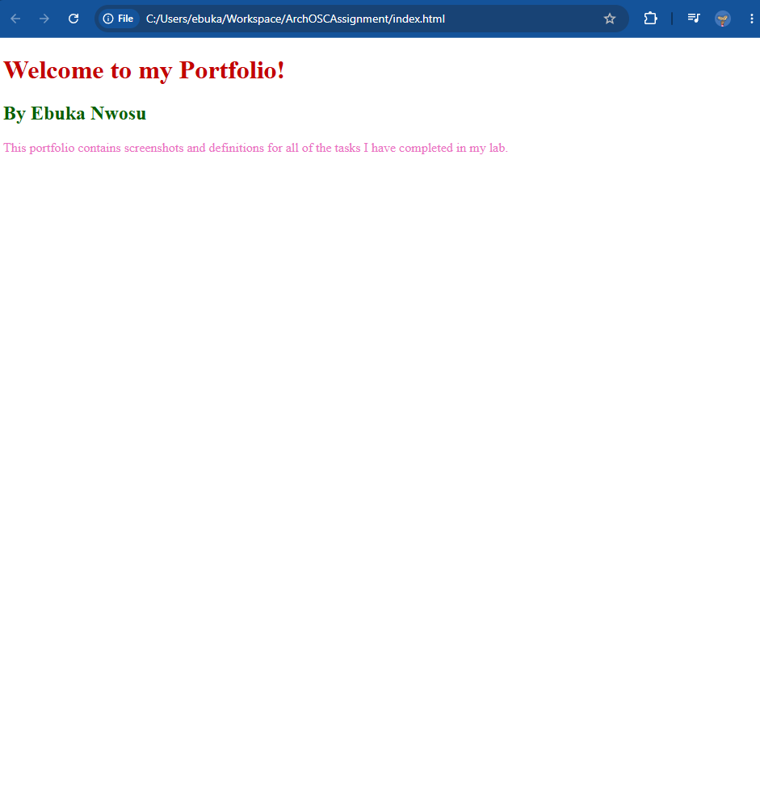
Changed the colour on the webpage
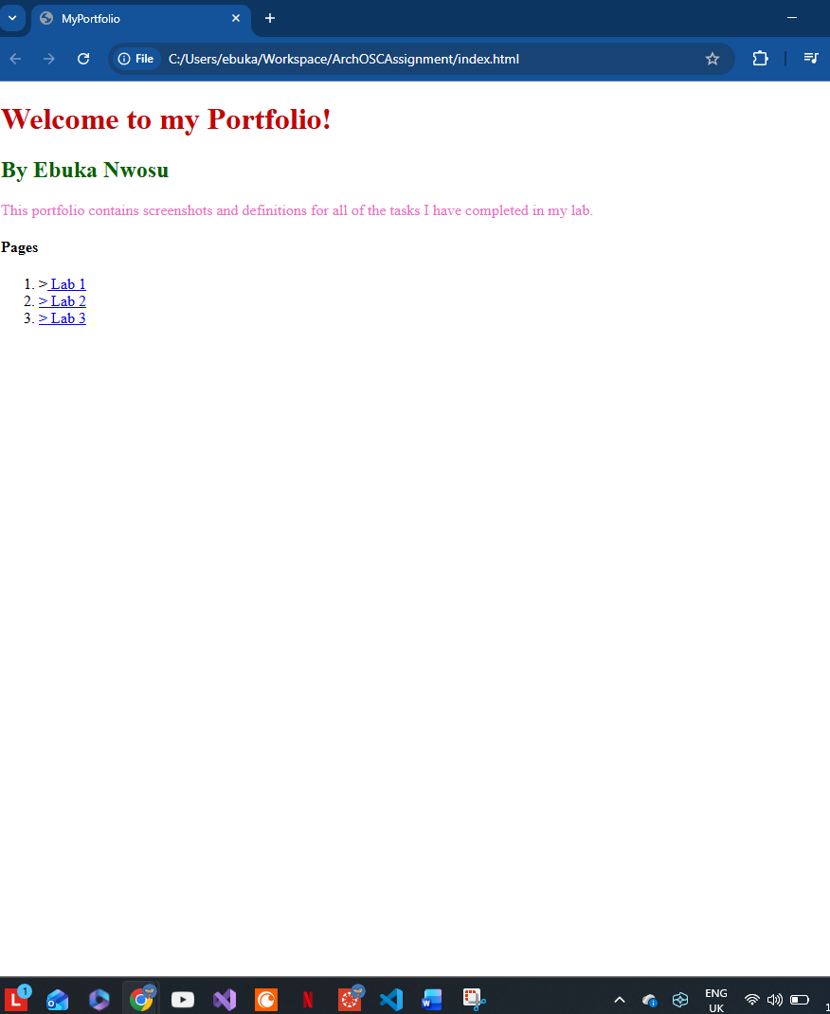
Added links to the labs

