WasteWise
Waste Management, Simplified
Schedule Pickups · Track Collection · Get Rewarded
Comprehensive Project Blueprint & Technical Documentation
waste-wise-x0ra.onrender.com
Built for Ile-Ife neighborhoods

Contents
1. Executive Summary
2. Problem Statement
3. Our Solution
4. Key Features
5. System Architecture
6. Tech Stack
7. Database Schema
8. API Endpoints
9. User Flow
10. Deployment
11. Security & Known Limitations
12. Future Enhancements
13. Project Journey
14. Development Highlights Log

1. Executive Summary
WasteWise is a full-stack web application that lets residents schedule waste pickups, sort waste by category, track collection in real time, and communicate with a waste management admin team — all from a single account. Built for Ile-Ife neighborhoods, WasteWise replaces informal, unreliable waste collection arrangements with a structured, trackable, digital system.
Live application: waste-wise-x0ra.onrender.com

2. Problem Statement
Residential waste collection in many neighborhoods is informal and inconsistent — no fixed schedule, no confirmation a pickup is coming, and no easy way to reach the waste management team. Residents are often left wondering whether their trash will be collected at all.

3. Our Solution

For residents, WasteWise provides:
- A simple way to schedule a pickup, specifying waste type, date, and time window
- A live status tracker for their scheduled pickup (Scheduled → En Route → Arrived → Collected)
- A payment flow for pickup service fees
- A messaging system to receive updates directly from the admin team
- An account history of past pickups and payments

For the admin team, WasteWise provides:
- A dashboard to view all registered users
- A dashboard to view all scheduled pickups, including requester details
- A way to message any user directly, delivered both in-app and by email

4. Key Features
Feature | Description
Account creation & login | Email/password authentication with hashed passwords (bcrypt)
Waste sorting | Users select a waste category before scheduling
Schedule pickup | Date, time window, and address captured per request
Cost estimation | Estimated cost calculated per request
Payment | Payment method selection and confirmation
Live pickup tracking | Status progression shown to the user in real time
Admin dashboard | View all users and all pickups in one place
Admin → user messaging | Admin sends a message; user sees it in-app and via email
Ratings & history | Users rate completed pickups; history is retained
OTP email verification | Built and functional; currently suspended per instructor guidance for the hackathon submission

5. System Architecture
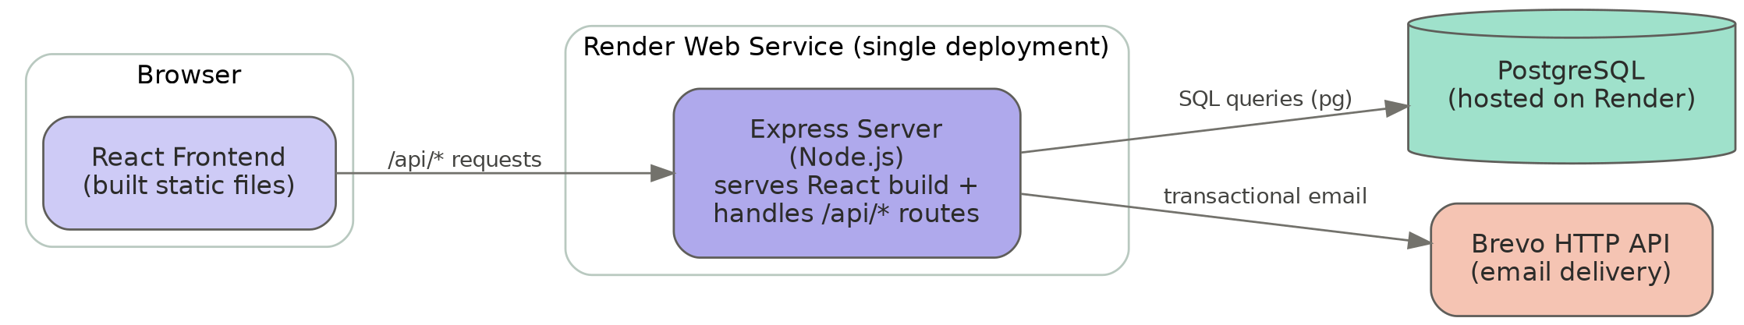
Single-service deployment: rather than hosting frontend and backend separately, the Express server is configured to build and serve the React app's static files directly, while also handling all /api/* requests. This keeps the entire app on one Render web service.

6. Tech Stack
Layer | Technology
Frontend | React (Create React App)
Backend | Node.js, Express
Database | PostgreSQL (pg driver)
Authentication | bcryptjs (password hashing)
Email | Brevo HTTP API
Hosting | Render (Web Service, free tier)
Version control | Git + GitHub

7. Database Schema

users
Column | Type | Notes
id | SERIAL | Primary key
full_name | VARCHAR(255)
email | VARCHAR(255) | Unique
phone | VARCHAR(50) | Optional
password | VARCHAR(255) | Bcrypt hash
address | VARCHAR(255)
created_at | TIMESTAMP | Default NOW()

otps (built, not currently active in the live flow)
Column | Type | Notes
id | SERIAL | Primary key
email | VARCHAR(255)
code | VARCHAR(6)
expires_at | TIMESTAMP | 10-minute expiry
created_at | TIMESTAMP | Default NOW()

payments
Column | Type | Notes
id | SERIAL | Primary key
user_id | INTEGER | References users(id)
amount | NUMERIC
status | VARCHAR(50) | Default 'Paid'
method | VARCHAR(50) | Default 'Card'
paid_at | TIMESTAMP
created_at | TIMESTAMP | Default NOW()

pickups
Column | Type | Notes
id | SERIAL | Primary key
user_id | INTEGER | References users(id)
waste_type | VARCHAR(100) | Default 'General'
pickup_date | DATE
time_window | VARCHAR(100)
status | VARCHAR(50) | Default 'Scheduled'
request_id | VARCHAR(50) | e.g. WW-1234
created_at | TIMESTAMP | Default NOW()

messages
Column | Type | Notes
id | SERIAL | Primary key
user_id | INTEGER | References users(id)
message | TEXT
created_at | TIMESTAMP | Default NOW()

8. API Endpoints
Method | Route | Purpose
GET | /api/ | Health check
POST | /api/register | Create a new user account
POST | /api/login | Authenticate an existing user
POST | /api/send-otp | Generate and email a verification code (built, currently unused)
POST | /api/verify-otp | Verify a submitted code (built, currently unused)
POST | /api/payments | Record a payment for a user
POST | /api/pickups | Schedule a new pickup request
GET | /api/admin/users | List all registered users
GET | /api/admin/pickups | List all pickups with requester details
POST | /api/admin/messages | Send a message + email to a specific user
GET | /api/messages/:userId | Retrieve a user's message history
All routes are prefixed with /api in the frontend; the backend strips this prefix internally so route logic is written without it (e.g. app.post('/login', ...)).

9. User Flow
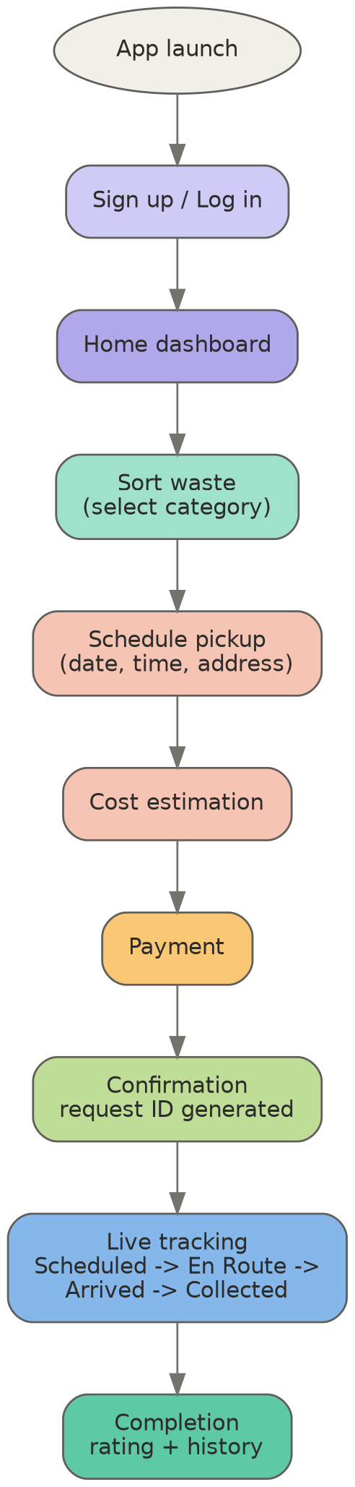

10. Deployment
- Platform: Render (Web Service, Free tier)
- Repository: GitHub (auto-deploys on push to master)

Build command
npm install && npm run build && cd backend && npm install

Start command
node backend/server.js

Environment variables
- DATABASE_URL
- EMAIL_APP_PASSWORD / BREVO_API_KEY
- ADMIN_PASSWORD
- PORT

Database
PostgreSQL, hosted on Render's free tier. Note: free databases expire after 30 days unless upgraded — this instance is provisioned for the current deployment window.

11. Security & Known Limitations
- OTP verification is fully built (backend routes, database table, frontend UI) but suspended per instructor guidance, in favor of a simpler direct-registration flow.
- Email delivery originally used Gmail SMTP via Nodemailer. Render's free tier blocks outbound SMTP traffic (ports 25/465/587) as a platform-wide anti-abuse policy, so email sending is being migrated to Brevo's HTTP API, which operates over standard HTTPS and isn't subject to this restriction.
- Free-tier database expiry: the Render Postgres instance is time-limited on the free plan; for continued use beyond the hackathon, an upgrade or migration would be needed.

12. Future Enhancements
- Re-enable OTP email verification for signup
- SMS notifications (API integration planned)
- Automatic nearest-collector assignment using real geolocation
- Recurring pickup scheduling
- Analytics dashboard for admin (pickup volume, waste type trends)

13. Project Journey
This project went through a full real-world deployment cycle: initial algorithm and flowchart design, React frontend and Express backend development, MySQL-based local development, migration to a multi-service Vercel deployment, and a final migration to PostgreSQL on Render — including converting all database queries, fixing platform-specific routing quirks, and solving an email-delivery restriction unique to free-tier cloud hosting. Every stage surfaced a real, common deployment problem (environment variable scoping, wildcard routing syntax changes, database driver differences, SMTP port blocking) — each diagnosed and resolved methodically.

14. Development Highlights Log

Planning & Design
- Defined the full user algorithm and flowchart: signup/login → dashboard → sort waste → schedule pickup → cost estimate → payment → confirmation & collector assignment → live tracking → completion, rating, and rewards.

Backend Development
- Built a Node.js/Express REST API covering registration, login, payments, pickup scheduling, admin user/pickup views, and admin-to-user messaging.
- Implemented password hashing with bcrypt and structured error handling across all routes.
- Designed and built an email OTP verification system (database table, send/verify routes, frontend UI) — fully functional and available for future re-activation.

Frontend Development
- Built the React application covering authentication, dashboards, scheduling, and admin views.
- Diagnosed and fixed hardcoded local API URLs, replacing them with environment-aware relative paths so the same code works in local development and in production.

Deployment Architecture
- Configured a multi-service deployment (separate frontend and backend services routed through a single domain) using vercel.json, including path rewrites and a stripped /api prefix so Express routes required no restructuring.
- Diagnosed and resolved several deployment-specific issues: incorrect file placement in the repository, missing vercel.json routing rules, a missing public folder in version control, and an Express 5 breaking change in wildcard route syntax.
- Migrated the entire deployment to a single-service architecture on Render, with Express serving the built React frontend directly alongside the API.

Database Migration
Migrated the entire data layer from local MySQL (via XAMPP) to a cloud-hosted PostgreSQL database, including:
  - Rewriting the connection layer from mysql2 to pg with a connection pool.
  - Converting every query from MySQL placeholder syntax (?) to PostgreSQL syntax ($1, $2...) and adapting insert-ID retrieval accordingly.
  - Recreating the full schema (users, otps, payments, pickups, messages) on the new database via a one-time setup script.

Security Hardening
- Identified and remediated an exposed email credential that had been hardcoded in source code: revoked the compromised app password, generated a replacement, and migrated it to an environment variable.
- Moved all sensitive configuration (database connection string, email credentials, admin password) out of source code and into environment variables, both locally and on the hosting platform.

Email Delivery
- Diagnosed two independent causes of failed email delivery: a restrictive local network blocking outbound SMTP ports, and a platform-level SMTP restriction on the hosting provider's free tier.
- Began migrating email delivery from SMTP (Nodemailer) to an HTTP-based email API (Brevo), which operates over standard HTTPS and is unaffected by SMTP port restrictions.

Outcome
A fully deployed, publicly accessible application with a working frontend, backend, and cloud database, built and debugged end-to-end through a complete, realistic software deployment lifecycle.

