WasteWise
App algorithm and process flow
Product documentation draft

Overview
This document describes the step-by-step algorithm behind the WasteWise app: the logic the app follows from the moment a user opens it, through waste sorting, scheduling, payment, live tracking, and post-pickup engagement. It is intended as a reference for design, development, and stakeholder review.

1. App launch
1.1 User opens the WasteWise app.
1.2 App checks whether the user is a first-time user or a returning user.

2. Authentication
2.1 First-time user → app displays a Sign Up screen requesting: full name, email address, phone number, home/pickup address, password and confirm password.
2.2 App validates input (correct email format, password strength, valid phone number format).
2.3 Returning user → app displays a Login screen requesting email/phone number and password.
2.4 App authenticates credentials against the stored database.
2.5 If authentication fails → app displays an error message and prompts the user to retry or reset password.
2.6 If authentication succeeds → app redirects the user to the Home Dashboard.

3. Home dashboard
3.1 App displays the main menu: Schedule Pickup, Waste Sorting Guide, Track Pickup, Payment/Billing, Notifications, Profile/Settings.

4. Waste sorting
4.1 User selects “Sort Waste”, or is prompted to sort waste before scheduling.
4.2 App displays waste categories: organic/biodegradable, plastic, paper/cardboard, glass, metal, e-waste, hazardous waste.
4.3 User selects the category (or categories) that match what they want disposed of.
4.4 App may show sorting tips for correct disposal per category (optional educational feature).

5. Schedule pickup
5.1 User selects “Schedule Pickup.”
5.2 App displays a calendar/time-slot selector.
5.3 User selects a preferred pickup date and time.
5.4 App attaches the waste category selected in Step 4 to this pickup request.
5.5 User confirms pickup address (auto-filled from profile, editable if needed).
5.6 App calculates the estimated cost based on waste type and volume.
5.7 User reviews and confirms the pickup request.

6. Payment
6.1 App displays payment options: card, bank transfer, mobile money, wallet balance.
6.2 User selects a payment method and completes payment.
6.3 App confirms payment success or failure.
6.4 If payment fails → app prompts the user to retry or choose another method.

7. Confirmation and assignment
7.1 App generates a unique pickup request ID.
7.2 App assigns the request to the nearest available waste collector/truck, based on location and schedule.
7.3 App sends a confirmation notification to the user, including pickup date, time, request ID, and assigned collector.

8. Real-time tracking
8.1 User opens “Track Pickup” to view the collector’s live location and status.
8.2 App updates status through: Scheduled → En Route → Arrived → Collected → Completed.
8.3 App sends push notifications at each key status change.

9. Post-pickup
9.1 Once marked “Completed,” app prompts the user to rate and review the service.
9.2 App updates the user’s pickup history log.
9.3 App may award reward points for consistent use or recycling (optional).

10. Ongoing features
10.1 Notifications — reminders, missed pickups, promotions.
10.2 Profile/Settings — update personal info, payment methods, notification preferences.
10.3 Pickup History — view past requests and receipts.

Full process flow chart
The diagram below traces the complete algorithm end to end: authentication, dashboard, waste sorting, scheduling and payment, and tracking through to completion.
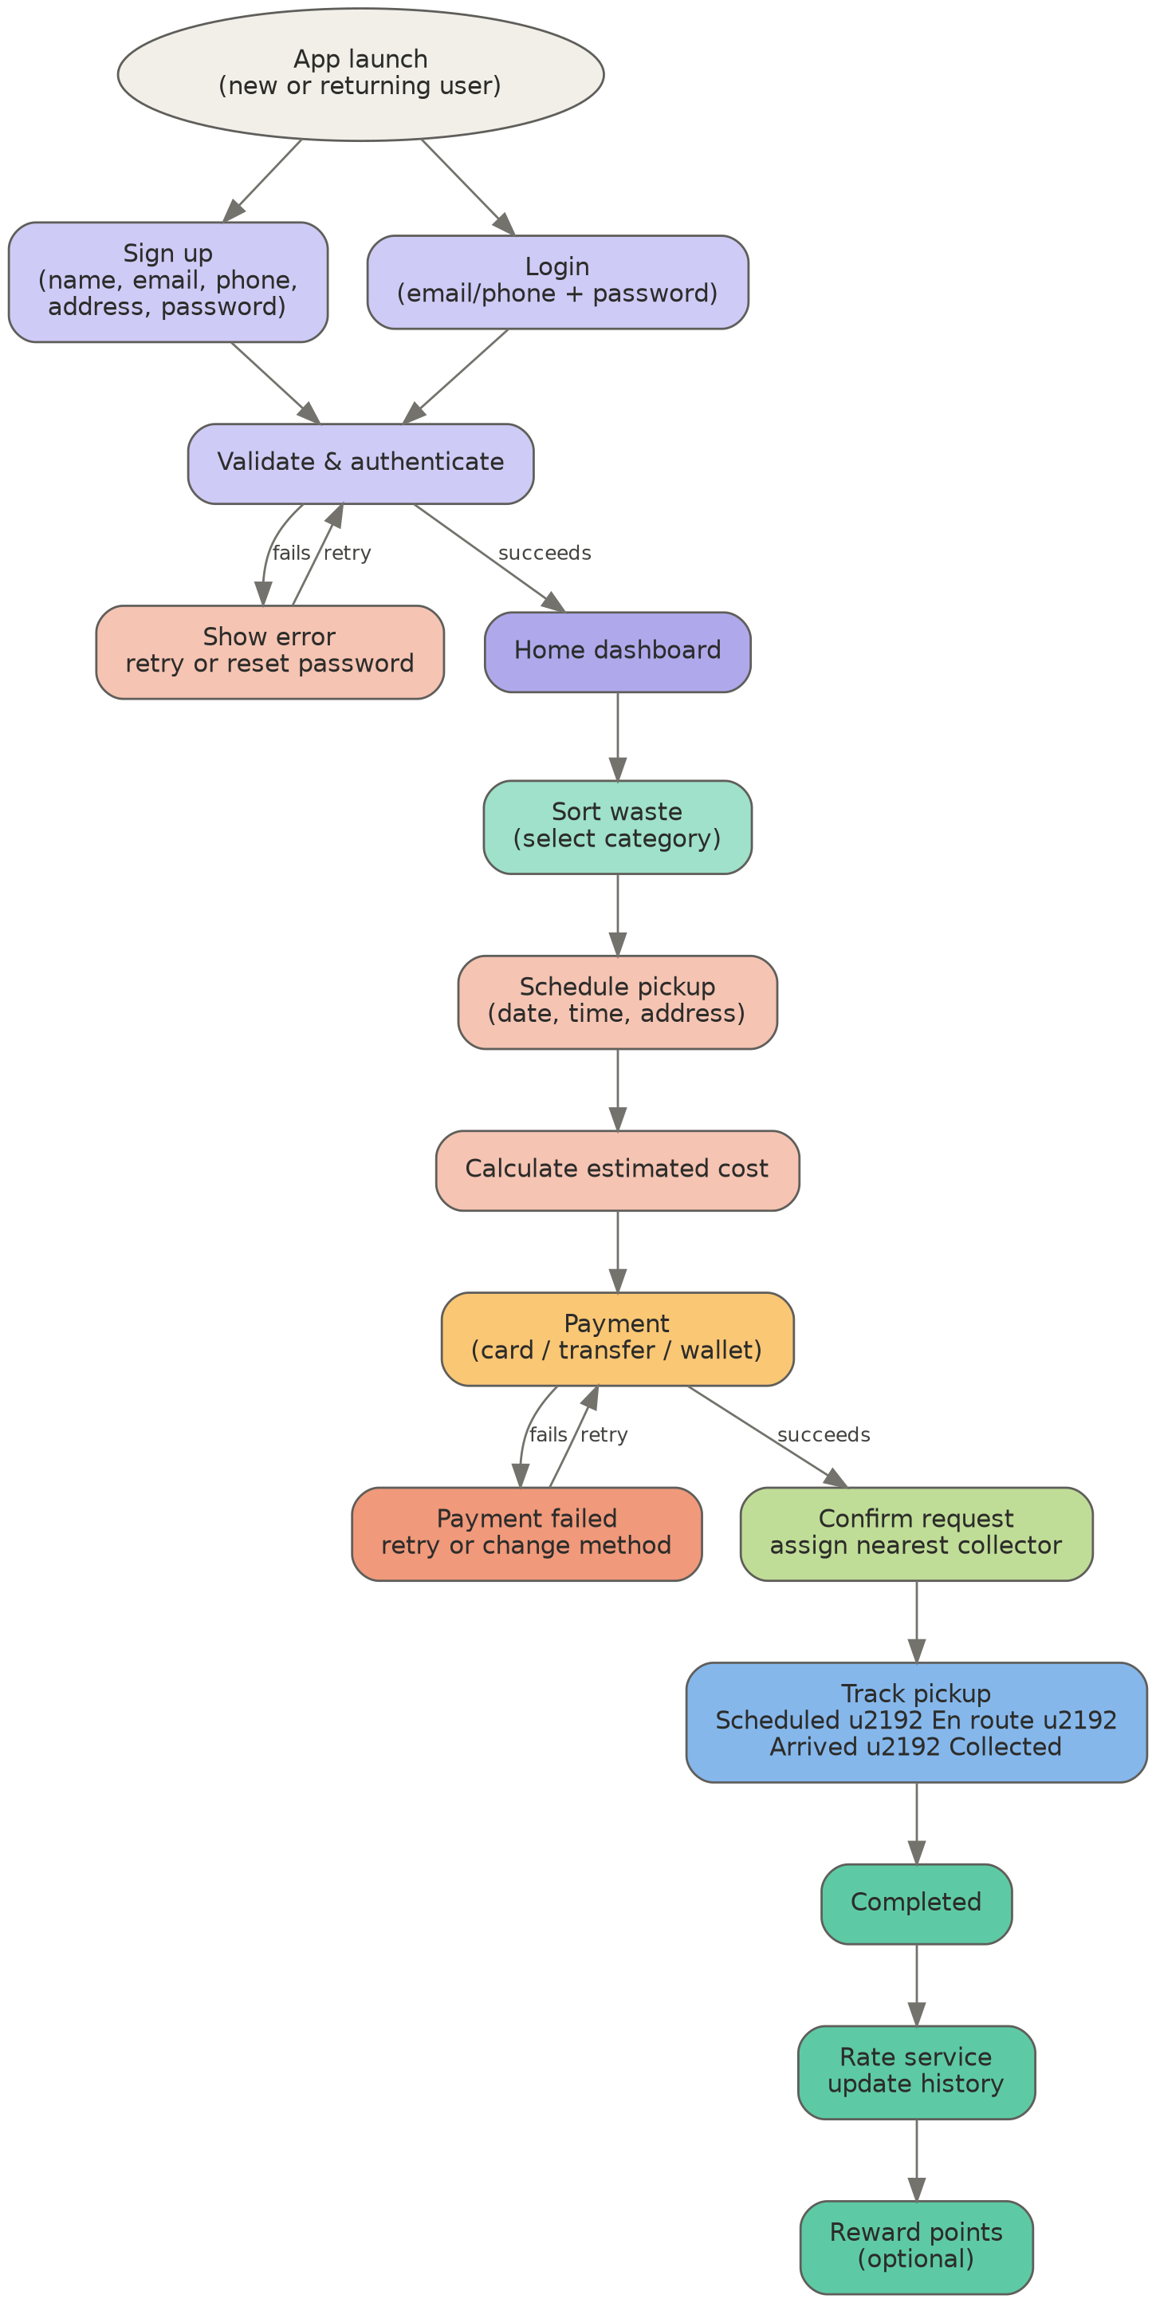

Summary flow
At a glance, the app moves through five major stages:
Stage | Name | What happens
1 | Sign up / Login | User authenticates or creates an account.
2 | Home dashboard | User lands on the main menu.
3 | Sort waste | User selects the waste category to dispose of.
4 | Schedule pickup & pay | User picks date, time, address, and completes payment.
5 | Track & complete | Request is assigned, tracked live, completed, then rated.

Design notes
- Login and Sign Up are handled as separate paths so returning users are never asked to re-enter their details.
- All user input is validated before submission (email format, password strength, phone number format).
- Waste sorting happens before scheduling, since the pickup request needs to know what type of waste is being collected.
- Collector assignment is based on the requester's location and the collector's schedule and proximity.
- Status tracking follows a fixed sequence so the user always knows where their pickup stands.
- Ratings and pickup history build trust and encourage repeat use of the app.

